1 What is an equation of the perpendicular bisector of the line segment shown in the diagram below?

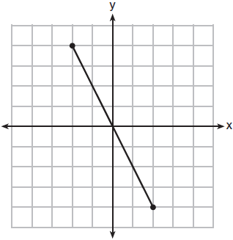
1)
2)
3)
4)

2 The coordinates of the endpoints of are and . The equation of the perpendicular bisector of is
1)
2)
3)
4)

3 Which equation represents the perpendicular bisector of whose endpoints are and ?
1)
2) | 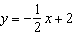
3) | 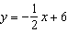
4)

4 Line segment NY has endpoints and . What is the equation of the perpendicular bisector of ?
1) | 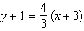
2) | 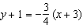
3) | 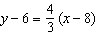
4) | 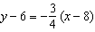

5 Segment JM has endpoints and . An equation of the perpendicular bisector of is
1) | 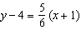
2) | 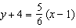
3) | 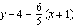
4) | 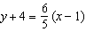

6 The endpoints of are and . Which equation of a line represents the perpendicular bisector of ?
1) | 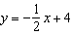
2)
3)
4)

7 Triangle ABC has vertices , , and . Which equation represents the perpendicular bisector of ?
1)
2)
3) | 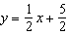
4) | 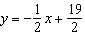

8 If is defined by the endpoints and , write an equation of the line that is the
perpendicular bisector of .

9 Write an equation of the line that is the perpendicular bisector of the line segment having endpoints and . [The use of the grid below is optional]

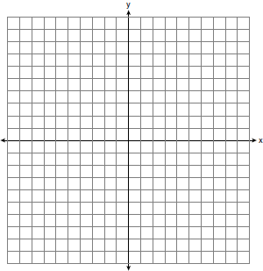

10 Write an equation of the perpendicular bisector of the line segment whose endpoints are and . [The use of the grid below is optional]



11 Determine the distance between point and point . Write an equation of the perpendicular bisector of . [The use of the accompanying grid is optional.]



1 ANS: 4
The segment’s midpoint is the origin and slope is . The slope of a perpendicular line is . 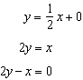

REF: 081724geo

2 ANS: 4
is a vertical line, so its perpendicular bisector is a horizontal line through the midpoint of , which is .

REF: 011225ge

3 ANS: 1
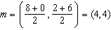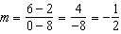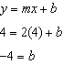

REF: 081126ge

4 ANS: 1
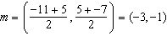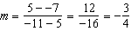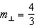

REF: 061612geo

5 ANS: 4
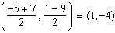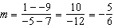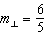

REF: 062220geo

6 ANS: 4
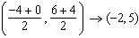; 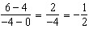; ; 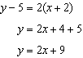

REF: 062324geo

7 ANS: 3
midpoint: 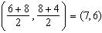. slope: 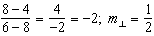. 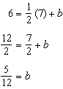

REF: 081327ge

8 ANS:
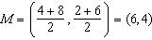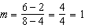

REF: 081536ge

9 ANS:
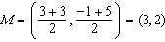. . 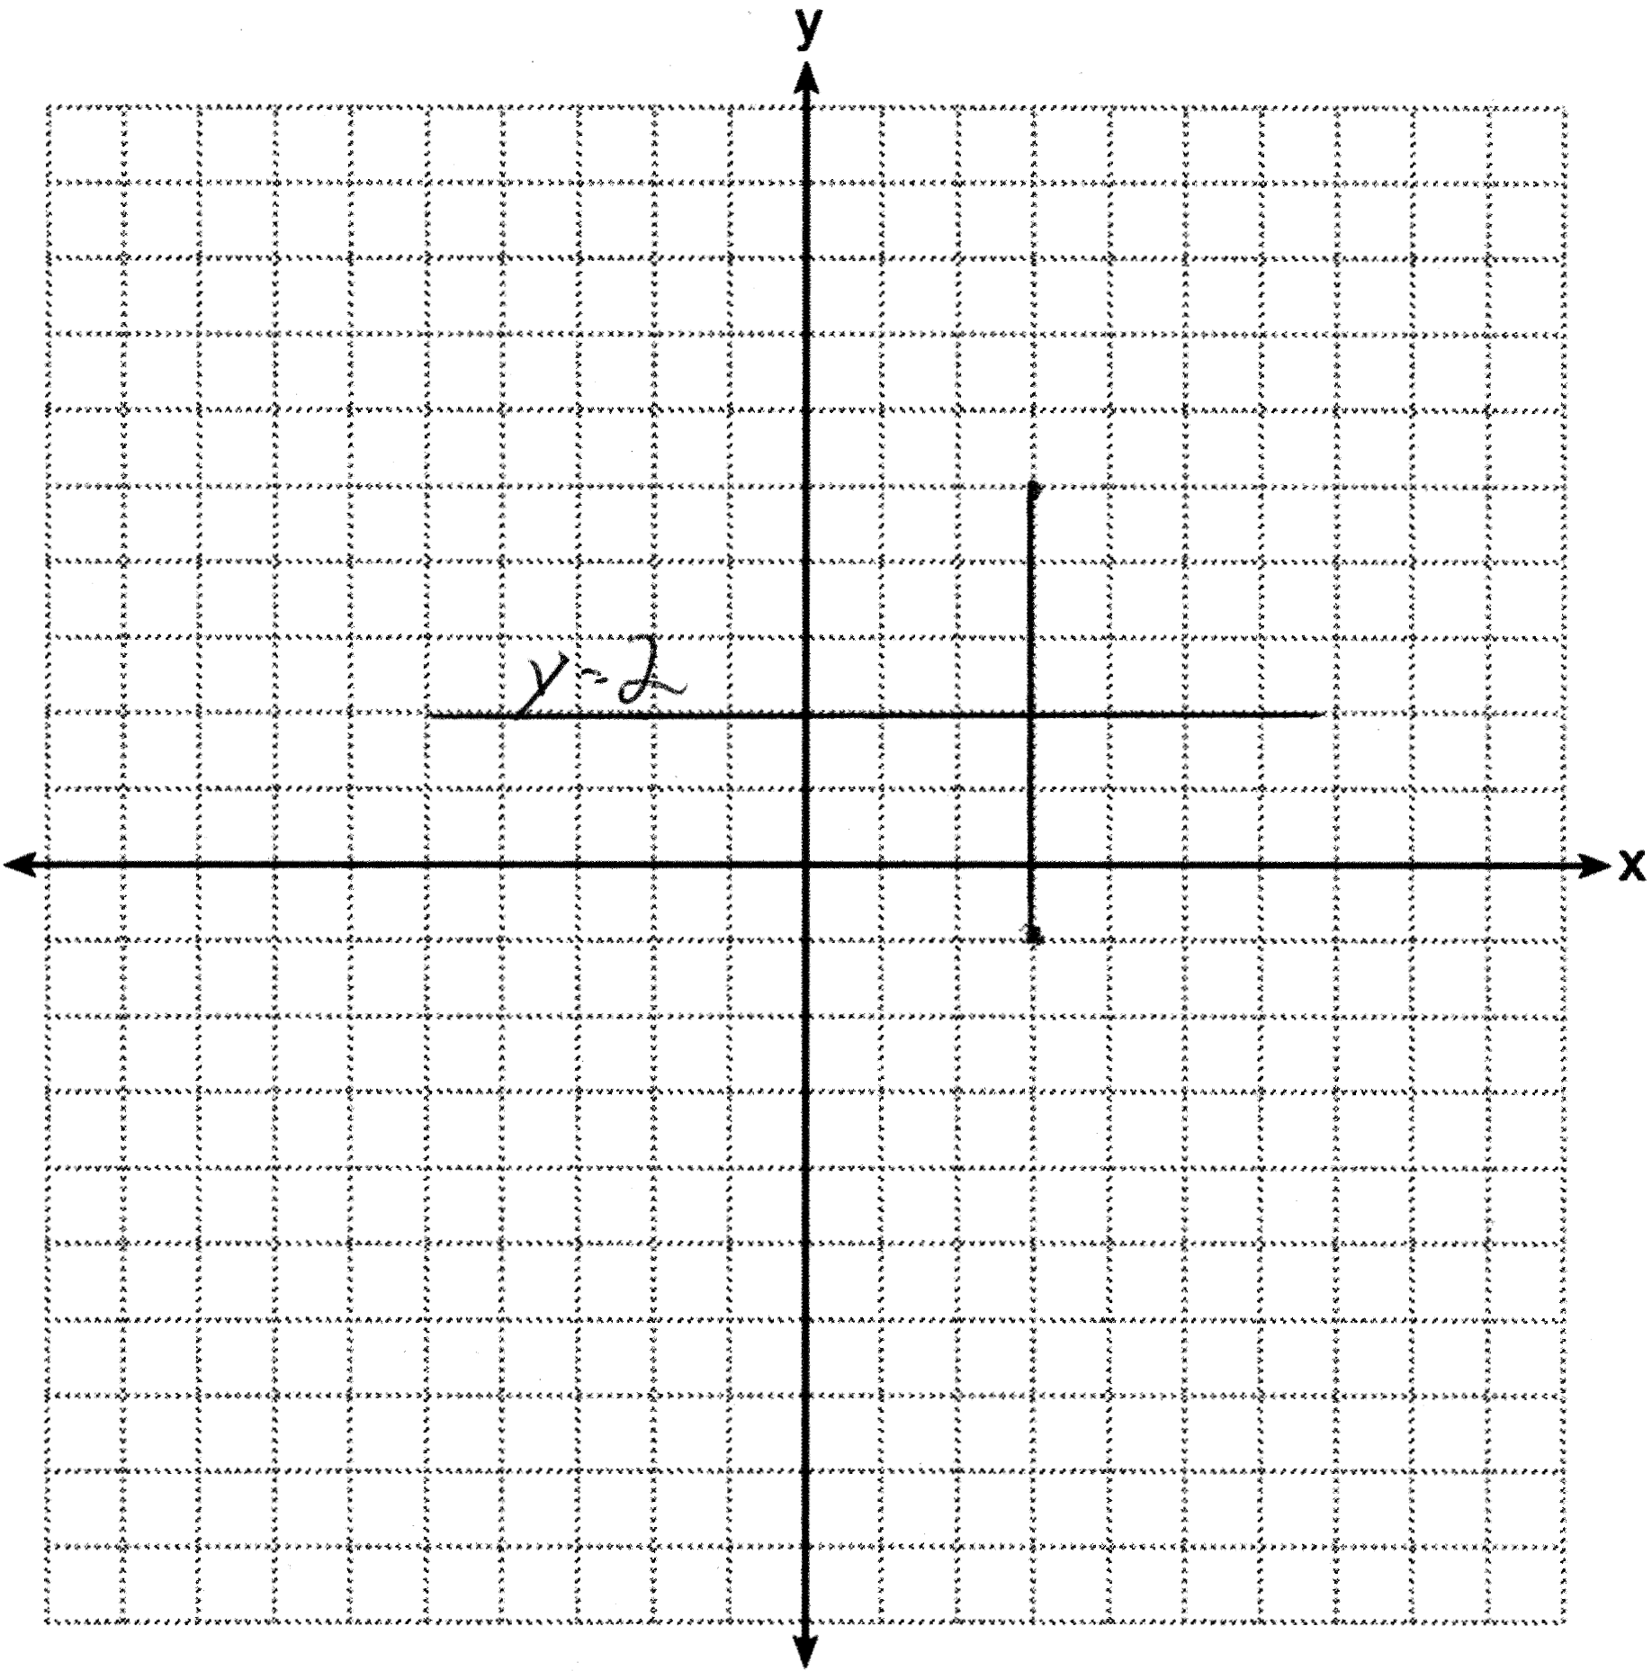

REF: 011334ge

10 ANS:
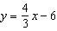. 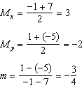 The perpendicular bisector goes through and has a slope of . 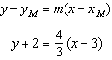. 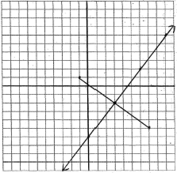

REF: 080935ge

11 ANS:
10, 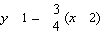. 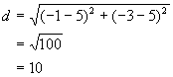. To find the equation of the perpendicular bisector, calculate midpoint and slope. 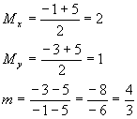. The perpendicular bisector of goes through (2,1) and has a slope of . 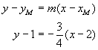. 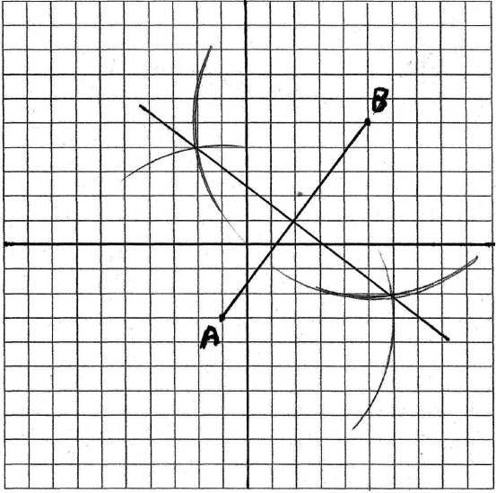

REF: 080235a

