1 The graphs of the lines represented by the equations 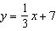 and 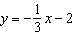 are
1) | parallel
2) | horizontal
3) | perpendicular
4) | intersecting, but not perpendicular

2 Which statement describes the lines whose equations are 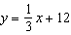 and ?
1) | They are segments.
2) | They are perpendicular to each other.
3) | They intersect each other.
4) | They are parallel to each other.

3 The lines represented by the equations 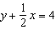 and are
1) | the same line
2) | parallel
3) | perpendicular
4) | neither parallel nor perpendicular

4 The lines and are
1) | parallel
2) | perpendicular
3) | the same line
4) | neither parallel nor perpendicular

5 The equation of line k is 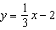. The equation of line m is . Lines k and m are
1) | parallel
2) | perpendicular
3) | the same line
4) | neither parallel nor perpendicular

6 The lines represented by the equations and 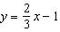 are
1) | parallel
2) | the same line
3) | perpendicular
4) | intersecting, but not perpendicular

7 A student wrote the following equations:
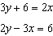
The lines represented by these equations are
1) | parallel
2) | the same line
3) | perpendicular
4) | intersecting, but not perpendicular

8 The two lines represented by the equations below are graphed on a coordinate plane.
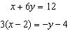
Which statement best describes the two lines?
1) | The lines are parallel.
2) | The lines are the same line.
3) | The lines are perpendicular.
4) | The lines intersect at an angle other than 90°.

9 The equations of lines k, p, and m are given below:
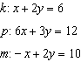
Which statement is true?
1)
2)
3)
4)

10 The equations of lines k, m, and n are given below.
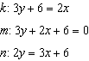
Which statement is true?
1)
2)
3)
4)

11 Determine whether the two lines represented by the equations and are parallel, perpendicular, or neither. Justify your response.

12 Two lines are represented by the equations and . Determine whether these lines are parallel, perpendicular, or neither. Justify your answer.

13 State whether the lines represented by the equations 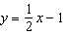 and 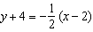 are parallel, perpendicular, or neither. Explain your answer.

14 Points and lie on . Points and lie on . Which statement is true?
1)
2)
3) | and are the same line.
4) | and intersect, but are not perpendicular.

15 Line P and line C lie on a coordinate plane and have equal slopes. Neither line crosses the second or third quadrant. Lines P and C must
1) | form an angle of 45°
2) | be perpendicular
3) | be horizontal
4) | be vertical

1 ANS: 4 REF: 011613ge

2 ANS: 4
The slope of the line of the equation of 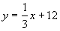 is If you divide each term of the equation by 6, the equation is transformed to 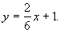 The slope of this line is 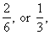 as well. Since the lines have equal slope, they are parallel.

REF: 060722a

3 ANS: 2
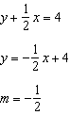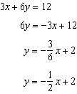

REF: 081014ge

4 ANS: 4
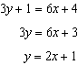. 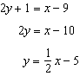

REF: fall0822ge

5 ANS: 1 REF: 061113ge

6 ANS: 4
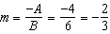

REF: 011520ge

7 ANS: 4
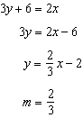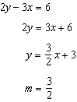

REF: 081315ge

8 ANS: 4
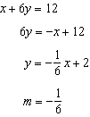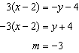

REF: 011119ge

9 ANS: 1
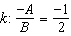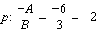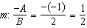

REF: 081426ge

10 ANS: 4
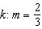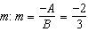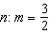

REF: 061518ge

11 ANS:
The slope of is 2. The slope of is 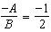. Since the slopes are opposite reciprocals, the lines are perpendicular.

REF: 011231ge

12 ANS:
The slope of is 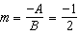. The slope of is 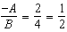. Since the slopes are neither equal nor opposite reciprocals, the lines are neither parallel nor perpendicular.

REF: 061231ge

13 ANS:
Neither. The slope of is . The slope of is . The slopes are neither the same nor opposite reciprocals.
REF: 011433ge

14 ANS: 4
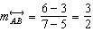. 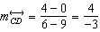
REF: 061318ge

15 ANS: 4
Since line P and line C extend through infinity, unless they are vertical, they would eventually cross the second or third quadrant.
REF: 010309a

