1 What is an equation of the line that passes through the point and is perpendicular to the line whose equation is 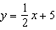?
1)
2)
3)
4)

2 What is an equation of the line that is perpendicular to the line whose equation is 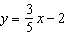 and that passes through the point ?
1) | 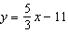
2) | 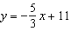
3) | 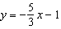
4) | 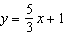

3 What is the equation of the line that passes through the point and is perpendicular to the line ?
1)
2) | 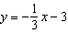
3)
4) | 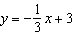

4 What is an equation of the line that contains the point and is perpendicular to the line whose equation is ?
1)
2)
3) | 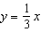
4) | 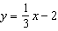

5 The equation of a line is 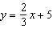. What is an equation of the line that is perpendicular to the given line and that passes through the point ?
1) | 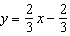
2) | 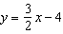
3) | 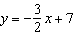
4) | 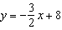

6 What is an equation of the line that passes through and is perpendicular to the line whose equation is 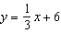?
1) | 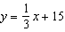
2)
3) | 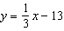
4)

7 An equation of a line perpendicular to the line represented by the equation 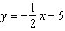 and passing through is
1) | 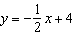
2) | 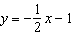
3)
4)

8 Which equation represents the line that is perpendicular to and passes through the point ?
1) | 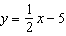
2) | 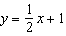
3)
4)

9 What is an equation of the line that passes through the point and is perpendicular to the line whose equation is ?
1) | 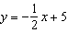
2)
3)
4)

10 What is an equation of a line that is perpendicular to the line whose equation is and passes through ?
1) | 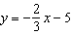
2) | 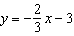
3) | 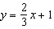
4) | 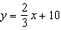

11 What is an equation of the line that passes through the point and is perpendicular to a line with equation 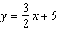?
1) | 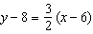
2) | 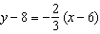
3) | 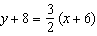
4) | 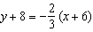

12 Which equation represents the line that passes through the point and is perpendicular to the line whose equation is 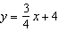?
1) | 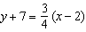
2) | 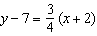
3) | 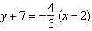
4) | 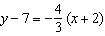

13 An equation of the line perpendicular to the line whose equation is and passes through the point is
1) | 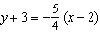
2) | 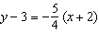
3) | 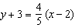
4) | 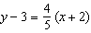

14 What is an equation of a line which passes through and is perpendicular to the line whose equation is ?
1) | 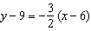
2) | 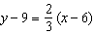
3) | 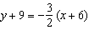
4) | 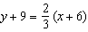

15 Line segment RH has endpoints and . Which equation represents a line perpendicular to that passes through the point ?
1) | 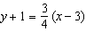
2) | 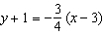
3) | 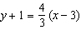
4) | 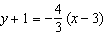

16 Write an equation of a line that is perpendicular to the line and that passes through the point .

17 Write an equation of the line that is perpendicular to the line whose equation is and that passes through the origin.

18 Find an equation of the line passing through the point and perpendicular to the line whose equation is .

19 Determine and state an equation of the line perpendicular to the line and passing through the point .

20 Shanaya graphed the line represented by the equation . Write an equation for a line that is parallel to the given line. Write an equation for a line that is perpendicular to the given line. Write an equation for a line that is identical to the given line but has different coefficients.

1 ANS: 2
The slope of is . The slope of a perpendicular line is . 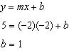.

REF: 060907ge

2 ANS: 3 REF: 011217ge

3 ANS: 4
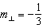. 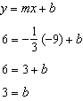

REF: 061215ge

4 ANS: 4
The slope of is . The perpendicular slope is . 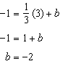

REF: 011018ge

5 ANS: 4
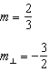. 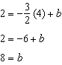

REF: 011319ge

6 ANS: 2
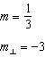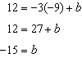

REF: 081404ge

7 ANS: 4
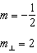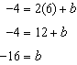

REF: 011602geo

8 ANS: 3
The slope of is , which is the opposite reciprocal of . 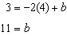

REF: 081228ge

9 ANS: 1
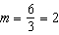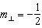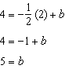

REF: 061507ge

10 ANS: 2
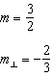. 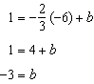

REF: 061719geo

11 ANS: 2

REF: 061812geo

12 ANS: 3
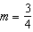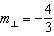

REF: 062406geo

13 ANS: 2
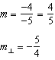

REF: 082308geo

14 ANS: 1
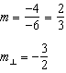

REF: 011820geo

15 ANS: 1
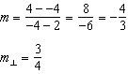

REF: 082418geo

16 ANS:
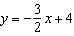. The slope of a line perpendicular to the given line is The given point is the y-intercept. An equation of the perpendicular line is 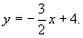

REF: 010834a

17 ANS:
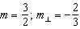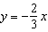

REF: 081533ge

18 ANS:
. 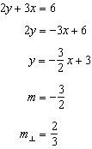. 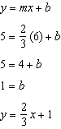

REF: 061036ge

19 ANS:
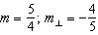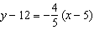
REF: 012031geo

20 ANS:
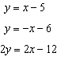. The given line has a slope of 1. A parallel line would also have a slope of 1, but a different y-intercept. A perpendicular line would have a slope of -1, the opposite and reciprocal of 1. Multiple the equation of the given line by any number (other than 1) to find identical lines. There is an infinite number of answers to each of the three questions.
REF: 080130a

