1 The slope of line is . What is an equation of a line that is perpendicular to line ?
1) | 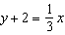
2)
3)
4)

2 Which equation represents a line that is perpendicular to the line represented by 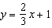?
1)
2)
3) | 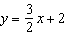
4) | 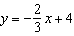

3 Which equation represents a line that is perpendicular to the line whose equation is ?
1) | 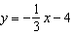
2) | 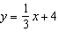
3)
4)

4 Which equation represents a line that is perpendicular to the line whose equation is ?
1)
2)
3) | 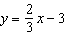
4) | 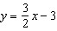

5 Which equation represents a line perpendicular to the line whose equation is ?
1)
2)
3)
4)

6 Which equation represents a line that is perpendicular to the line represented by ?
1) | 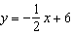
2) | 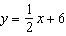
3)
4)

7 Which line is perpendicular to the line whose equation is ?
1) | 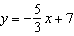
2) | 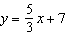
3) | 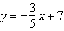
4) | 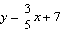

8 What is an equation of a line that is perpendicular to the line whose equation is ?
1) | 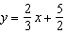
2)
3) | 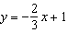
4) | 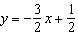

9 Given two lines whose equations are and , determine the value of b such that the two lines will be perpendicular.

1 ANS: 3
The slope of is 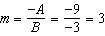, which is the opposite reciprocal of .

REF: 081225ge

2 ANS: 1
The slope of is , which is the opposite reciprocal of .

REF: 081811geo

3 ANS: 1
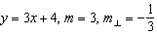

REF: 012405geo

4 ANS: 3
Divide the equation by -2 to transform to the slope intercept form, and note that 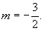 Perpendicular lines have slope that are the opposite and reciprocal of each other. The slope of 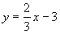 is

REF: 060528a

5 ANS: 2
The slope of is 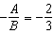. The slope of a perpendicular line is . Rewritten in slope intercept form, (2) becomes 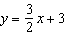.

REF: 060926ge

6 ANS: 1
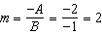
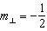

REF: 061509geo

7 ANS: 2
Transform the equation to 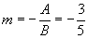. The slope of 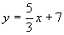 is

REF: 080630a

8 ANS: 1
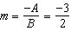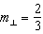

REF: 081908geo

9 ANS:
6. The slope of the line is 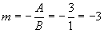. The slope of a line perpendicular to would have a slope the opposite and reciprocal of -3, or 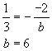.

REF: fall9925b

