1 What is the slope of a line perpendicular to the line whose equation is ?
1) 2) 3) 3 4)

2 What is the slope of a line perpendicular to the line whose equation is 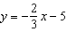?
1) 2) 3) 4)

3 What is the slope of a line perpendicular to the line whose equation is ?
1) 2) 3) 4)

4 What is the slope of a line perpendicular to the line whose equation is ?
1) 2) 3) 4)

5 What is the slope of a line that is perpendicular to the line whose equation is ?
1) 2) 3) 4)

6 The equation of a line is . All lines perpendicular to this line must have a slope of
1) 2) 3) 4)

7 What is the slope of a line that is perpendicular to the line whose equation is ?
1) 2) 3) 4)

8 What is the slope of a line that is perpendicular to the line represented by the equation ?
1) 2) 2 3) 4)

9 What is the slope of the line perpendicular to the line represented by the equation ?
1) 2) 2 3) 4)

10 What is the slope of a line perpendicular to the line whose equation is ?
1) 2) 3) 10 4)

11 What is the slope of a line perpendicular to the line whose equation is ?
1) 2) 3) 3 4)

12 The equation of a line is . What is the slope of the line perpendicular to the given line?
1) 2) 3) 4)

13 The lines whose equations are and will be perpendicular when m is
1) 2) 3) 4)

14 Find the slope of a line perpendicular to the line whose equation is .

15 The slope of is 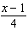 and the slope of is . If , determine and state the value of x.

1 ANS: 2 REF: 061022ge

2 ANS: 4
The slope of is . Perpendicular lines have slope that are opposite reciprocals.

REF: 080917ge

3 ANS: 3
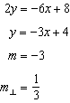 Perpendicular lines have slope the opposite and reciprocal of each other.

REF: 081024ge

4 ANS: 2
The slope of a line in standard form is so the slope of this line is Perpendicular lines have slope that are the opposite and reciprocal of each other.

REF: fall0828ge

5 ANS: 4
The slope of is 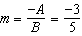. 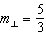.

REF: 061127ge

6 ANS: 4
The slope of a line in standard form is so the slope of this line is Perpendicular lines have slope that are the opposite and reciprocal of each other.

REF: 012313geo

7 ANS: 3
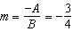

REF: 011025ge

8 ANS: 2
The slope of is 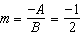. .

REF: 081122ge

9 ANS: 2
The slope of is 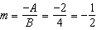. .

REF: 011310ge

10 ANS: 2
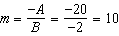. 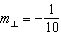

REF: 061219ge

11 ANS: 2
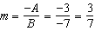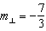

REF: 081414ge

12 ANS: 2
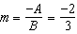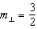

REF: 061417ge

13 ANS: 3

REF: 011610ge

14 ANS:
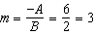. 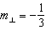.

REF: 011134ge

15 ANS:
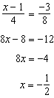

REF: 011534ge

