1 Line m and point P are shown in the graph below.
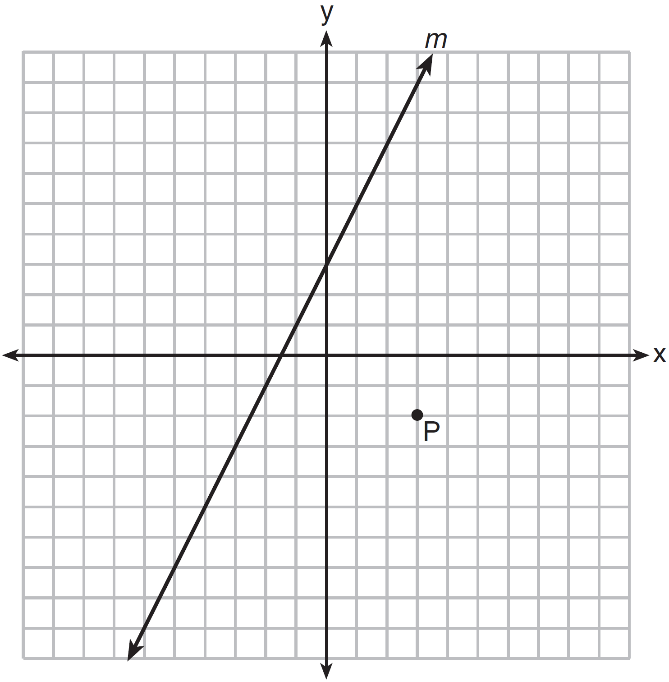
Which equation represents the line passing through P and parallel to line m?
1)
2)
3) | 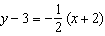
4) | 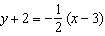

2 Given shown below, with and , what is an equation of the line that passes through point and is parallel to ?
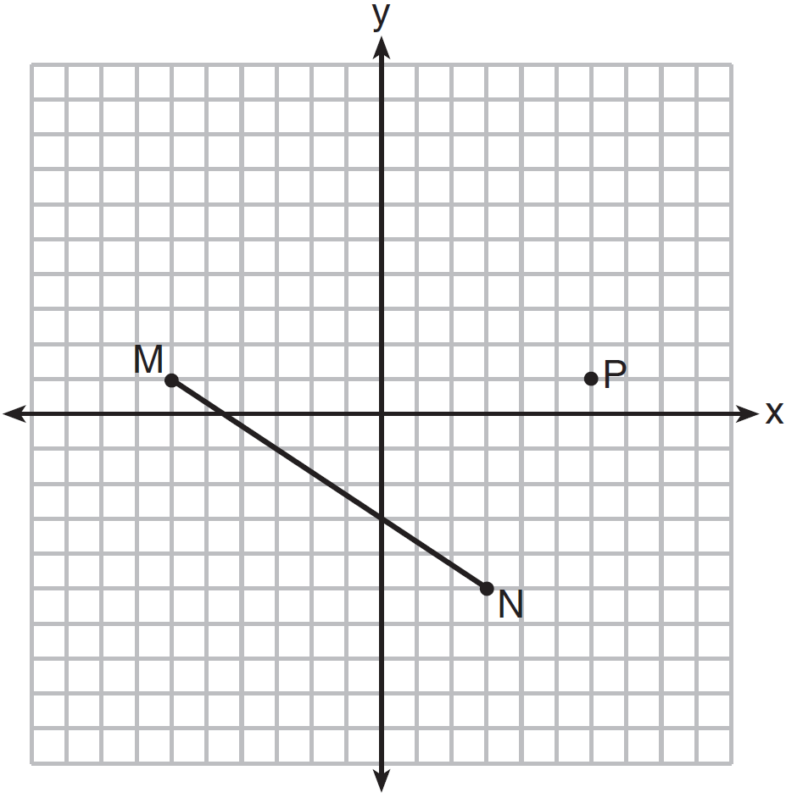
1) | 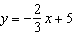
2) | 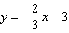
3) | 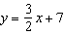
4) | 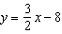

3 Which equation represents a line parallel to the line whose equation is and passes through the point ?
1) | 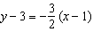
2) | 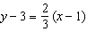
3) | 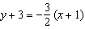
4) | 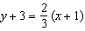

4 What is the equation of a line passing through and parallel to the line represented by the equation ?
1) | 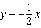
2) | 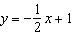
3)
4)

5 What is an equation of the line that passes through the point and is parallel to the line whose equation is 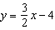?
1) | 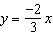
2) | 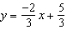
3) | 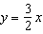
4) | 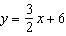

6 Which equation represents a line that is parallel to the line whose equation is 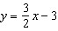 and passes through the point ?
1) | 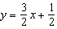
2) | 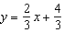
3) | 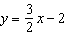
4) | 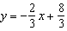

7 Which equation represents the line that passes through the point and is parallel to 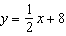?
1) | 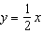
2)
3) | 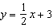
4)

8 What is an equation of the line that passes through the point and is parallel to the line whose equation is 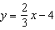?
1)
2)
3)
4)

9 What is an equation of the line that passes through the point and is parallel to the line whose equation is ?
1) | 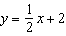
2) | 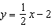
3)
4)

10 Line passes through the point and is parallel to line k whose equation is . An equation of line is
1) | 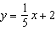
2)
3) | 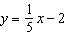
4)

11 Which line is parallel to the line whose equation is and also passes through the point ?
1)
2)
3)
4)

12 What is the equation of a line that passes through the point and is parallel to the line whose equation is ?
1)
2)
3) | 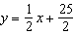
4) | 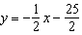

13 What is an equation of the line that passes through the point and is parallel to the line ?
1) | 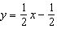
2) | 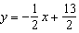
3)
4)

14 Which equation represents the line parallel to the line whose equation is and passing through the point ?
1)
2)
3)
4) | 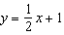

15 What is the equation of a line passing through the point and parallel to the line whose equation is ?
1)
2)
3)
4) | 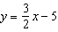

16 An equation of the line that passes through and is parallel to the line is
1)
2) | 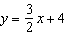
3) | 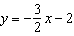
4) | 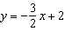

17 What is the equation of a line passing through the point and parallel to the line whose equation is ?
1) | 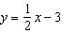
2) | 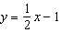
3)
4)

18 Which equation represents a line that passes through the point and is parallel to the line whose equation is ?
1)
2)
3)
4)

19 Write an equation of a line that is parallel to the line whose equation is and that passes through the point .

20 Find an equation of the line passing through the point and parallel to the line whose equation is .

21 Write an equation of the line that passes through the point and is parallel to the line whose equation is .

22 Write an equation of the line that is parallel to the line whose equation is and passes through the point .

1 ANS: 2 REF: 081420ge

2 ANS: 1
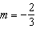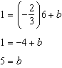

REF: 081510geo

3 ANS: 2
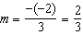

REF: 061916geo

4 ANS: 3
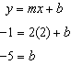

REF: 011224ge

5 ANS: 4
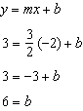

REF: 011114ge

6 ANS: 1
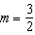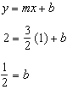

REF: 081217ge

7 ANS: 3
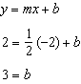

REF: 011701geo

8 ANS: 4
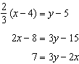

REF: 061528ge

9 ANS: 3
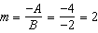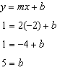

REF: 081509ge

10 ANS: 2
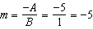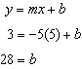

REF: 011410ge

11 ANS: 2
The slope of a line in standard form is , so the slope of this line is . A parallel line would also have a slope of . Since the answers are in standard form, use the point-slope formula. 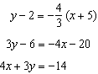

REF: 061123ge

12 ANS: 2
The slope of a line in standard form is , so the slope of this line is 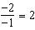. A parallel line would also have a slope of 2. Since the answers are in slope intercept form, find the y-intercept: 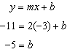

REF: fall0812ge

13 ANS: 4
The slope of a line in standard form is , so the slope of this line is 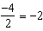. A parallel line would also have a slope of . Since the answers are in slope intercept form, find the y-intercept: 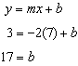

REF: 081010ge

14 ANS: 2
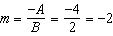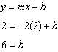

REF: 081112ge

15 ANS: 3
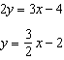. 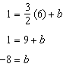

REF: 061316ge

16 ANS: 4
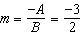. 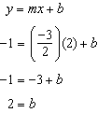

REF: 061226ge

17 ANS: 1
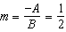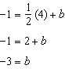

REF: 061420ge

18 ANS: 3
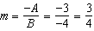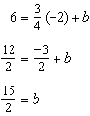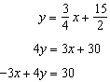

REF: 011620ge

19 ANS:
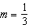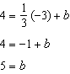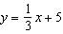

REF: 011532ge

20 ANS:
. The slope of is 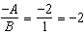. 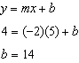.

REF: 060931ge

21 ANS:
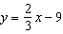. The slope of is 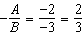. 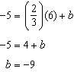

REF: 080931ge

22 ANS:
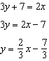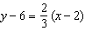

REF: 011925geo

