1 Which properties best describe the coordinate graph of two distinct parallel lines?
1) | same slopes and same intercepts
2) | same slopes and different intercepts
3) | different slopes and same intercepts
4) | different slopes and different intercepts

2 If two lines are parallel and the slope of one of the lines is m, what is the product of their slopes?
1) | 1
2)
3)
4) | 0

3 Segment RS is parallel to segment TU. If the slope of 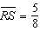 and the slope of 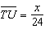, the value of x is
1) | 20
2) | 15
3) | 10
4) | 5

4 Which equation represents a line that is parallel to the line ?
1)
2) | 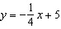
3) | 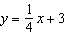
4)

5 Which equation represents a line parallel to the line ?
1)
2) | 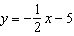
3)
4)

6 Which equation represents a line that is parallel to the line whose equation is ?
1)
2) | 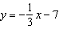
3) | 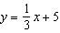
4)

7 Which equation represents a line that is parallel to the line whose equation is ?
1) | 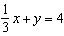
2) | 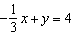
3)
4)

8 Which equation represents a line that is parallel to the line ?
1)
2)
3)
4)

9 What is the equation of a line that is parallel to the line whose equation is ?
1)
2)
3)
4)

10 Which equation represents a line parallel to the graph of ?
1) | 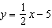
2) | 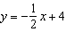
3)
4)

11 Which equation represents a line that is parallel to the line whose equation is ?
1) | 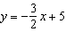
2) | 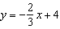
3) | 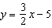
4) | 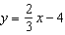

12 Which equation represents a line that is parallel to the line whose equation is ?
1)
2)
3) | 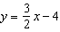
4) | 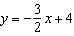

13 Which equation represents a line that is parallel to the line whose equation is ?
1)
2)
3)
4)

14 Which equation represents a line parallel to the line whose equation is ?
1)
2)
3)
4)

15 The graphs of the equations and are parallel when k equals
1)
2) | 2
3)
4) | 7

16 Two lines are represented by the equations 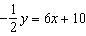 and . For which value of m will the lines be parallel?
1)
2)
3) | 3
4) | 12

17 Which pair of linear equations represents parallel lines?
1) | 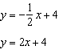
2) | 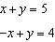
3) | 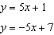
4) | 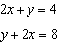

1 ANS: 2 REF: 060105a

2 ANS: 3
If two lines are parallel, they have equal slope. .

REF: 060210a

3 ANS: 2
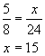

REF: 060801a

4 ANS: 1
The slope of both is .

REF: 060814ia

5 ANS: 1
The slope of both is 2.

REF: 080009a

6 ANS: 1

REF: 081307ia

7 ANS: 3
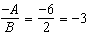

REF: 081427ia

8 ANS: 1
The slope of is . Using 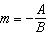, the slope of is 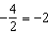.

REF: 010926ia

9 ANS: 3
The slope of is 1. The slope of is 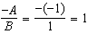.

REF: 080909ge

10 ANS: 1
The slope of is 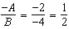

REF: 011026ia

11 ANS: 3
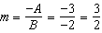

REF: 011324ge

12 ANS: 1
Using , the slope of is .

REF: 011322ia

13 ANS: 2
Using , the slope of both and is .

REF: 010522a

14 ANS: 3
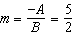. 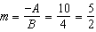

REF: 011014ge

15 ANS: 2
may be rewritten as

REF: 061015ia

16 ANS: 1
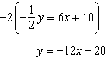

REF: 061027ge

17 ANS: 4
The slope of both is .

REF: 061611ia

