1 On the set of axes below, , altitude , and median are drawn.

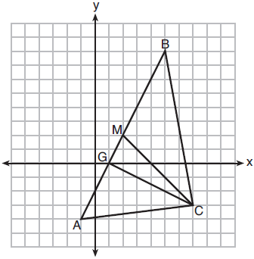

Which expression represents the area of ?
1) 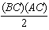 2) 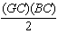 3) 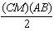 4) 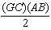

2 In the diagram below, has vertices , , and .

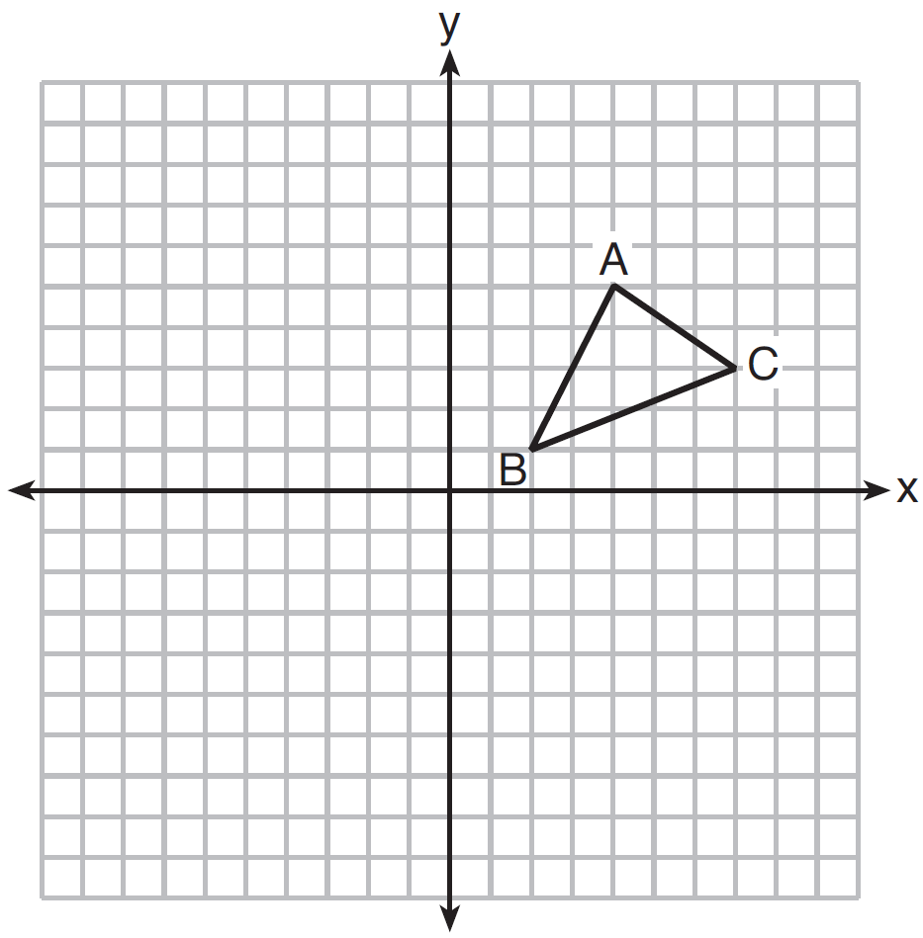

What is the slope of the altitude drawn from A to ?
1) 2) 3) 4)

3 The coordinates of the vertices of are , , and . Which type of triangle is ?
1) right 2) acute 3) obtuse 4) equiangular

4 Triangle ABC has vertices , , and . The triangle may be classified as
1) equilateral 2) isosceles 3) right 4) scalene

5 Which type of triangle can be drawn using the points , , and ?
1) scalene 2) isosceles 3) equilateral 4) no triangle can be drawn

6 If the vertices of are , , and , then is classified as
1) right 2) scalene 3) isosceles 4) equilateral

7 The vertices of are and Which conclusion can be made about the angles of ?
1) 2) 3) 4)

8 On the set of axes below, has vertices at the coordinates , , and , and point G has coordinates . Owen claims the median from point E must pass through point G. Is Owen correct? Explain why.

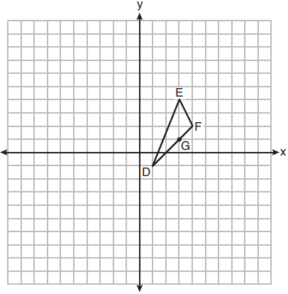

9 Triangle RST has vertices with coordinates , and . Determine and state an equation of the line parallel to that passes through point S. [The use of the set of axes below is optional.]

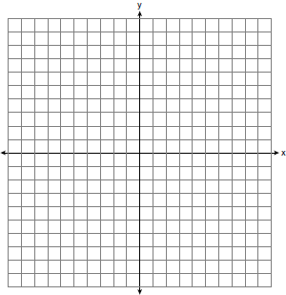

10 Given: Triangle RST has coordinates , , and
Prove: is a right triangle
[The use of the set of axes below is optional.]

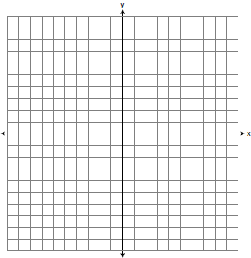

11 Triangle ABC has vertices with , , and . Determine and state a value of x that would make triangle a right triangle. Justify why is a right triangle. [The use of the set of axes below is optional.]

12 Given: , ,
Prove: is an isosceles right triangle.
[The use of the grid is optional.]



13 A triangle has vertices , , and . Prove that is an isosceles right triangle. [The use of the set of axes below is optional.]

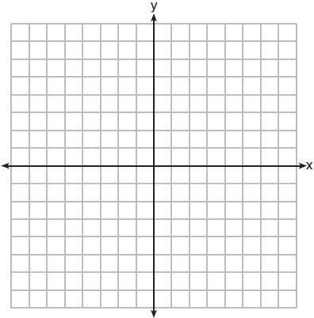

14 Triangle JOE has vertices whose coordinates are , , and . Prove that is isosceles. Point is on . Prove that is the perpendicular bisector of . [The use of the set of axes below is optional.]

15 Triangle ABC has vertices with coordinates , , and . Prove that is an isosceles triangle but not an equilateral triangle. [The use of the set of axes below is optional.]

16 Triangle PQR has vertices , , and , and points A and B are midpoints of and , respectively. Use coordinate geometry to prove that is parallel to and is half the length of . [The use of the set of axes below is optional.]

1 ANS: 4 REF: 011921geo

2 ANS: 4
The slope of is . Altitude is perpendicular, so its slope is .

REF: 061614geo

3 ANS: 1
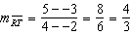 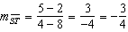 Slopes are opposite reciprocals, so lines form a right angle.

REF: 011618geo

4 ANS: 2 REF: 061115ge

5 ANS: 2 REF: 081226ge

6 ANS: 3
. .

REF: 011328ge

7 ANS: 1
Since , under the Isosceles Triangle Theorem.

REF: fall0809ge

8 ANS:
No. The midpoint of is 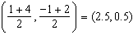. A median from point E must pass through the midpoint.

REF: 011930geo

9 ANS:
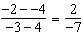; 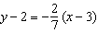

REF: 062331geo

10 ANS:
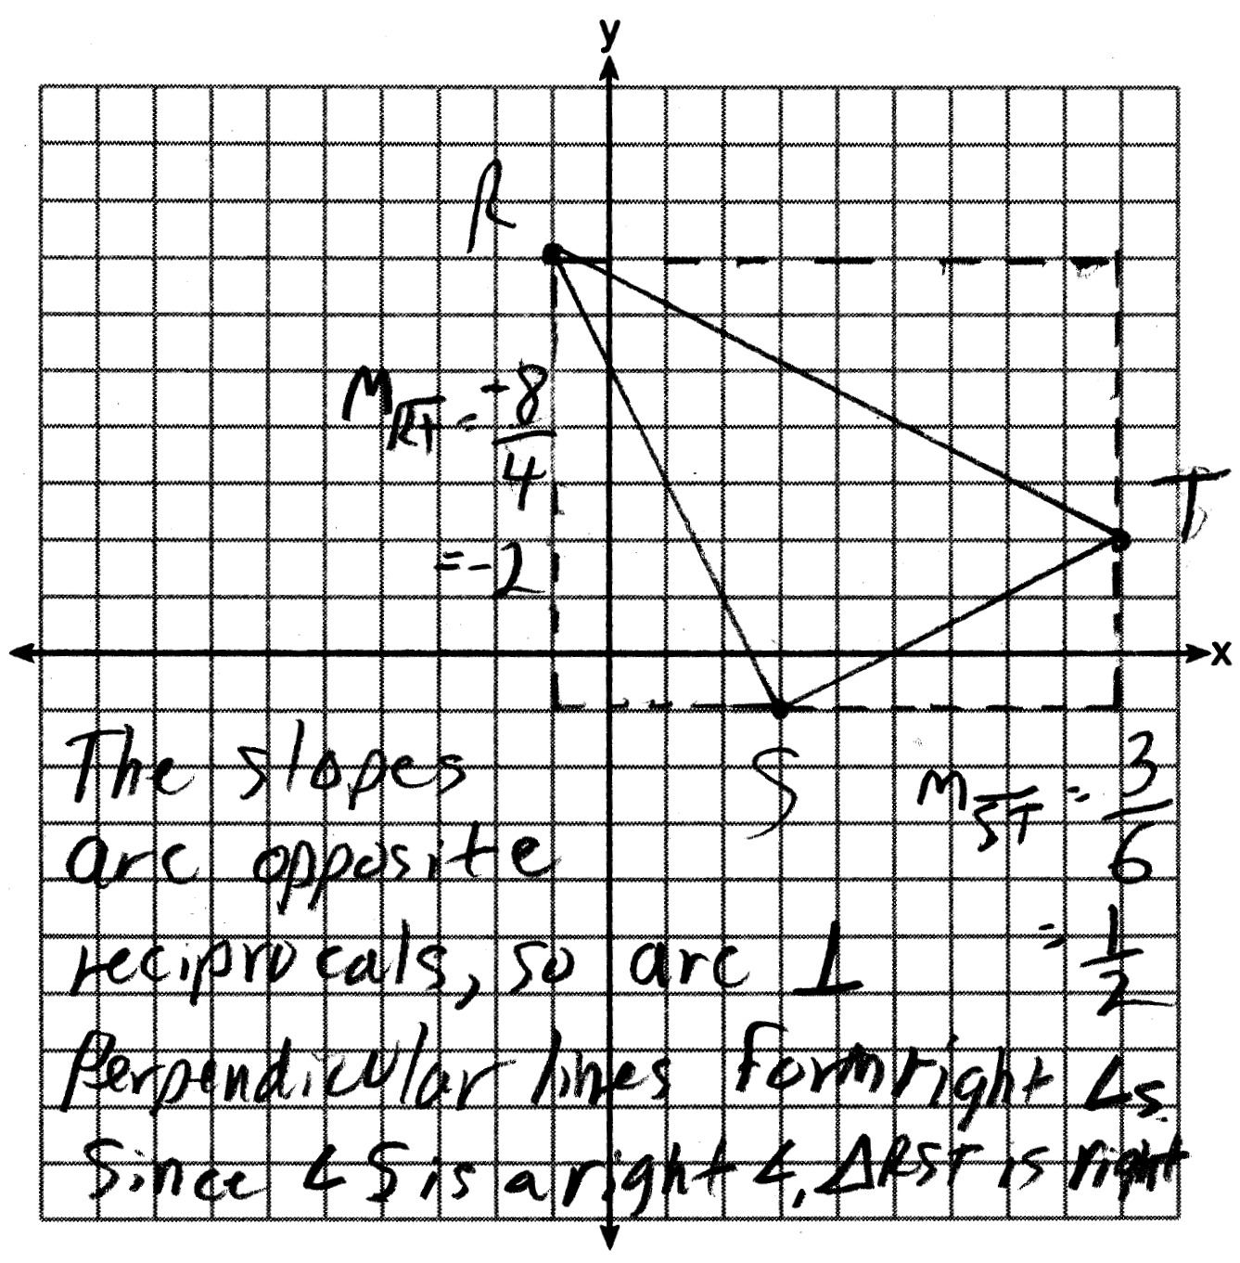

REF: 011637ge

11 ANS:
The slopes of perpendicular line are opposite reciprocals. Since the lines are perpendicular, they form right angles and a right triangle. 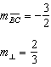 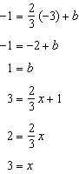 or 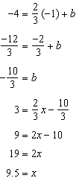 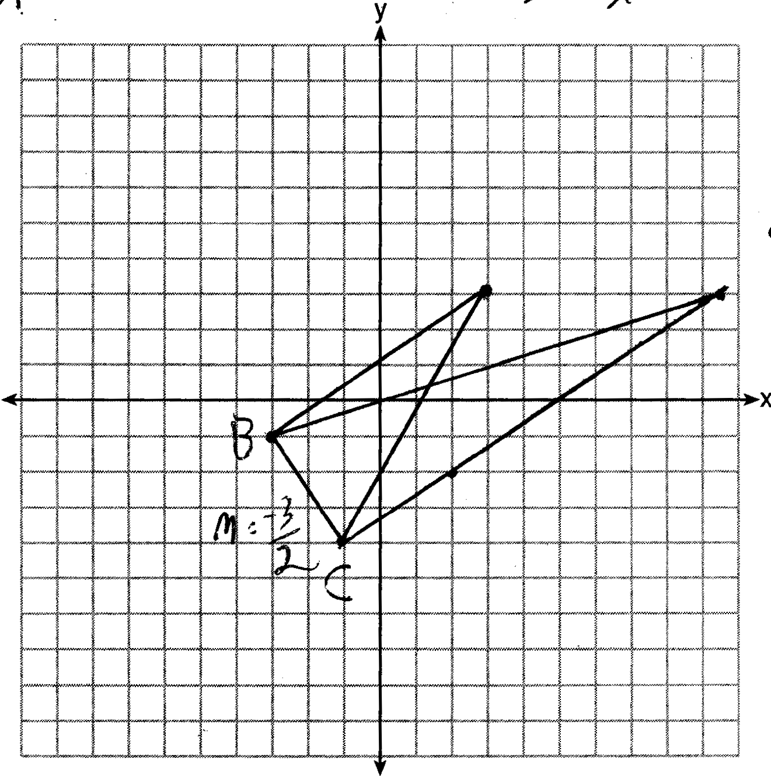

REF: 081533geo

12 ANS:
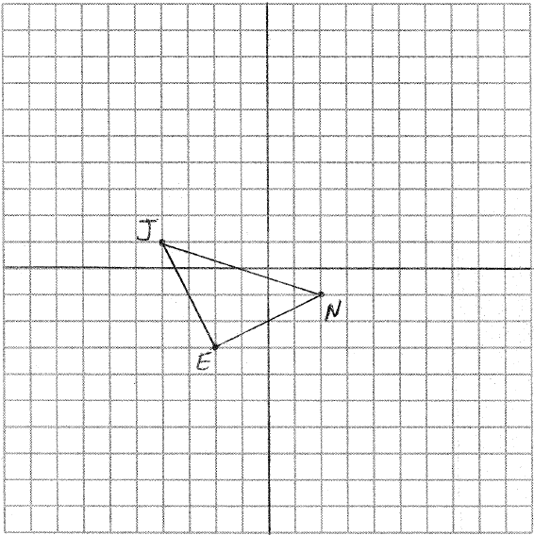 To prove that is a right triangle, prove that its legs are perpendicular by showing their slopes are opposite reciprocals: 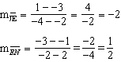
To prove that is an isosceles triangle, prove that it legs are congruent by using the distance formula: 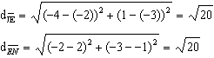

REF: 011029b

13 ANS:
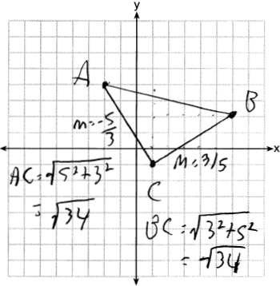Triangle with vertices , , and (given); 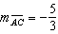, 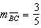, definition of slope; Because the slopes of the legs of the triangle are opposite reciprocals, the legs are perpendicular (definition of perpendicular); is a right angle (definition of right angle); is a right triangle (if a triangle has a right angle, it is a right triangle); (distance formula); is an isosceles triangle (an isosceles triangle has two congruent sides).

REF: 011932geo

14 ANS:
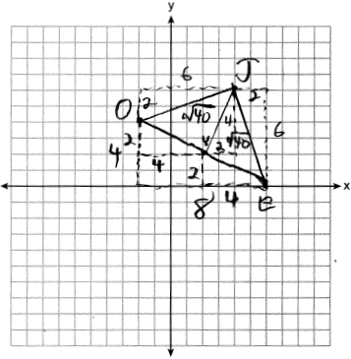 Since has two congruent sides, it is isosceles. Since , is a bisector of . 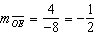 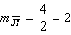 Since the slopes are opposite reciprocals, .

REF: 062435geo

15 ANS:
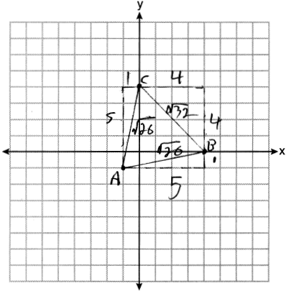Because , has two congruent sides and is isosceles. Because is not true, has sides that are not congruent and is not equilateral.

REF: 061832geo

16 ANS:
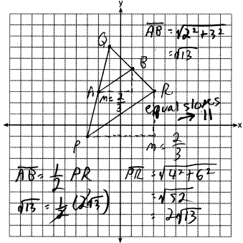

REF: 081732geo

