1 Quadrilateral ABCD is graphed on the set of axes below.

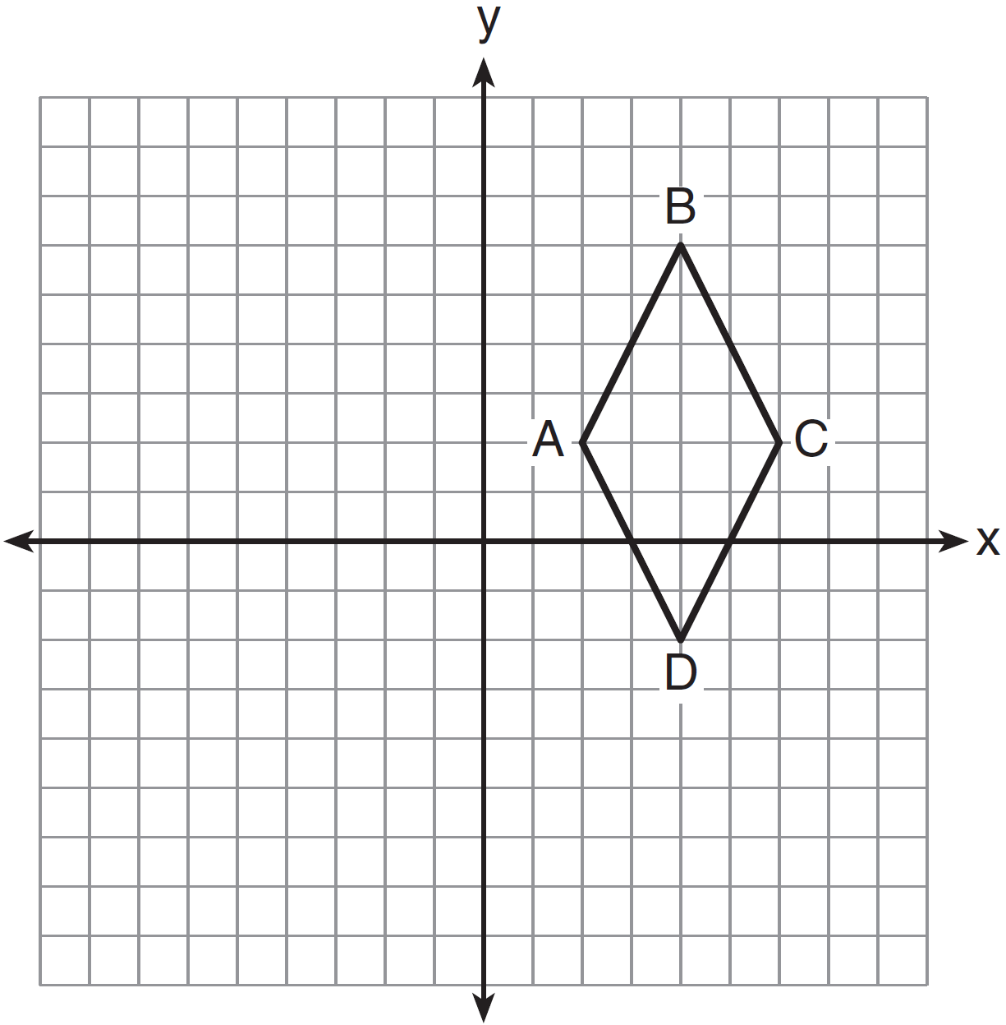

Which quadrilateral best classifies ABCD?
1) | trapezoid
2) | rectangle
3) | rhombus
4) | square

2 Square LMNO is shown in the diagram below.

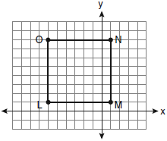

What are the coordinates of the midpoint of diagonal ?
1) | 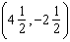
2) | 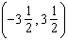
3) | 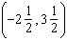
4) | 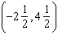

3 In the diagram below, quadrilateral ABCD has vertices , , , and .

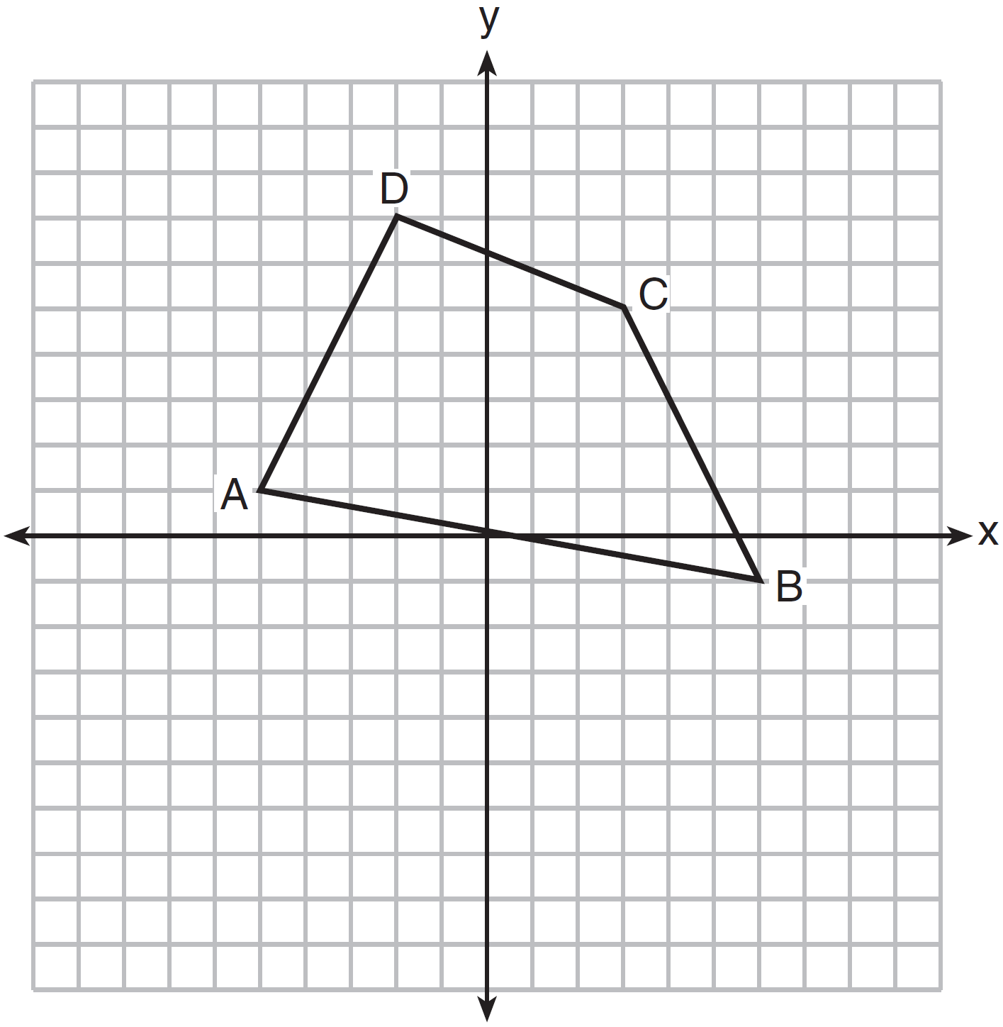

What are the coordinates of the midpoint of diagonal ?
1)
2)
3)
4)

4 In the diagram below, parallelogram ABCD has vertices , , , and . Diagonals and intersect at E.

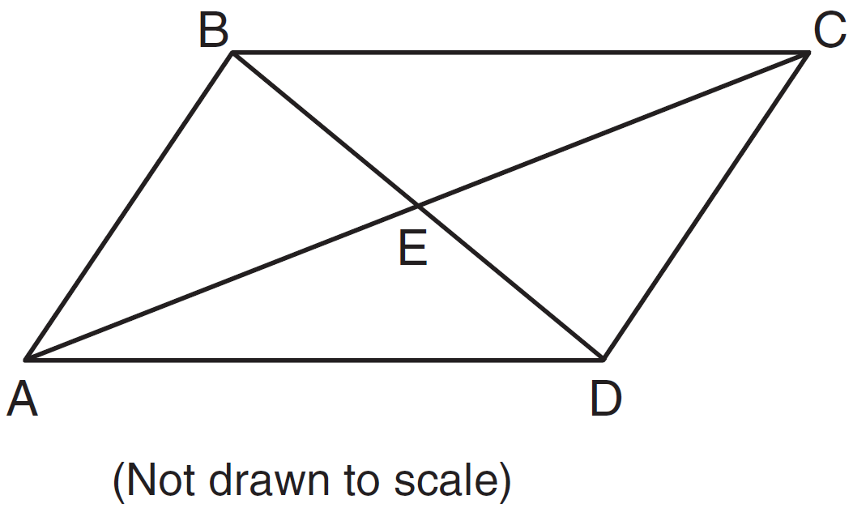

What are the coordinates of point E?
1)
2)
3)
4)

5 The coordinates of the vertices of parallelogram ABCD are , , , and . The slopes of which line segments could be calculated to show that ABCD is a rectangle?
1) | and
2) | and
3) | and
4) | and

6 Parallelogram ABCD has coordinates , , , and . What are the coordinates of E, the intersection of diagonals and ?
1)
2)
3)
4)

7 The coordinates of quadrilateral ABCD are , , , and . Using coordinate geometry, prove that quadrilateral ABCD is a rhombus. [The use of the grid is optional.]

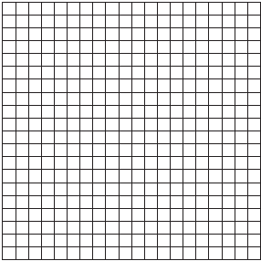

8 Given:
Prove: ABCD is a trapezoid. [The use of the accompanying grid is optional.]

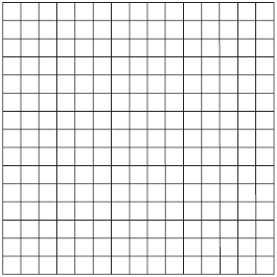

9 Ashanti is surveying for a new parking lot shaped like a parallelogram. She knows that three of the vertices of parallelogram ABCD are , , and . Find the coordinates of point D and sketch parallelogram ABCD on the accompanying set of axes. Justify mathematically that the figure you have drawn is a parallelogram.

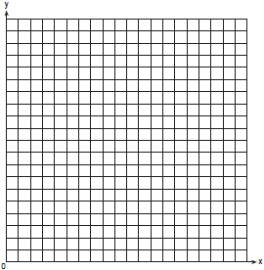

10 Quadrilateral ABCD has vertices , , , and . Prove that ABCD is a parallelogram but not a rhombus. [The use of the grid is optional.]

11 Given: , , ,
Prove: ABCD is a parallelogram but not a rectangle. [The use of the grid is optional.]

12 Quadrilateral MATH has coordinates , , , and . Prove that quadrilateral MATH is a rhombus and prove that it is not a square. [The use of the grid is optional.]

13 Jim is experimenting with a new drawing program on his computer. He created quadrilateral TEAM with coordinates , , , and . Jim believes that he has created a rhombus but not a square. Prove that Jim is correct. [The use of the grid is optional.]

14 The vertices of quadrilateral JKLM have coordinates , , , and . Prove that JKLM is a parallelogram. Prove that JKLM is not a rhombus. [The use of the set of axes below is optional.]

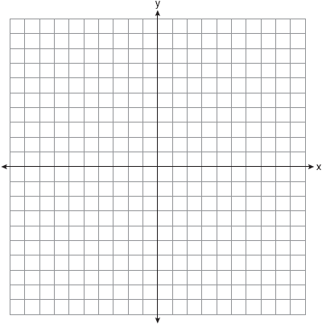

15 Quadrilateral KATE has vertices , , and .
a Prove that KATE is a trapezoid. [The use of the grid is optional.]
b Prove that KATE is not an isosceles trapezoid.

16 The coordinates of quadrilateral JKLM are , , , and . Prove that quadrilateral JKLM is a trapezoid but not an isosceles trapezoid. [The use of the grid is optional.]

17 Given: , , , and
Prove: TRAP is a trapezoid.
TRAP is not an isosceles trapezoid.
[The use of the grid is optional.]

18 Given: Quadrilateral ABCD has vertices , , , and .
Prove: Quadrilateral ABCD is a parallelogram but is neither a rhombus nor a rectangle. [The use of the grid below is optional.]



19 Quadrilateral ABCD with vertices , ,, and is graphed on the set of axes below. Quadrilateral MNPQ is formed by joining M, N, P, and Q, the midpoints of , , , and , respectively. Prove that quadrilateral MNPQ is a parallelogram. Prove that quadrilateral MNPQ is not a rhombus.

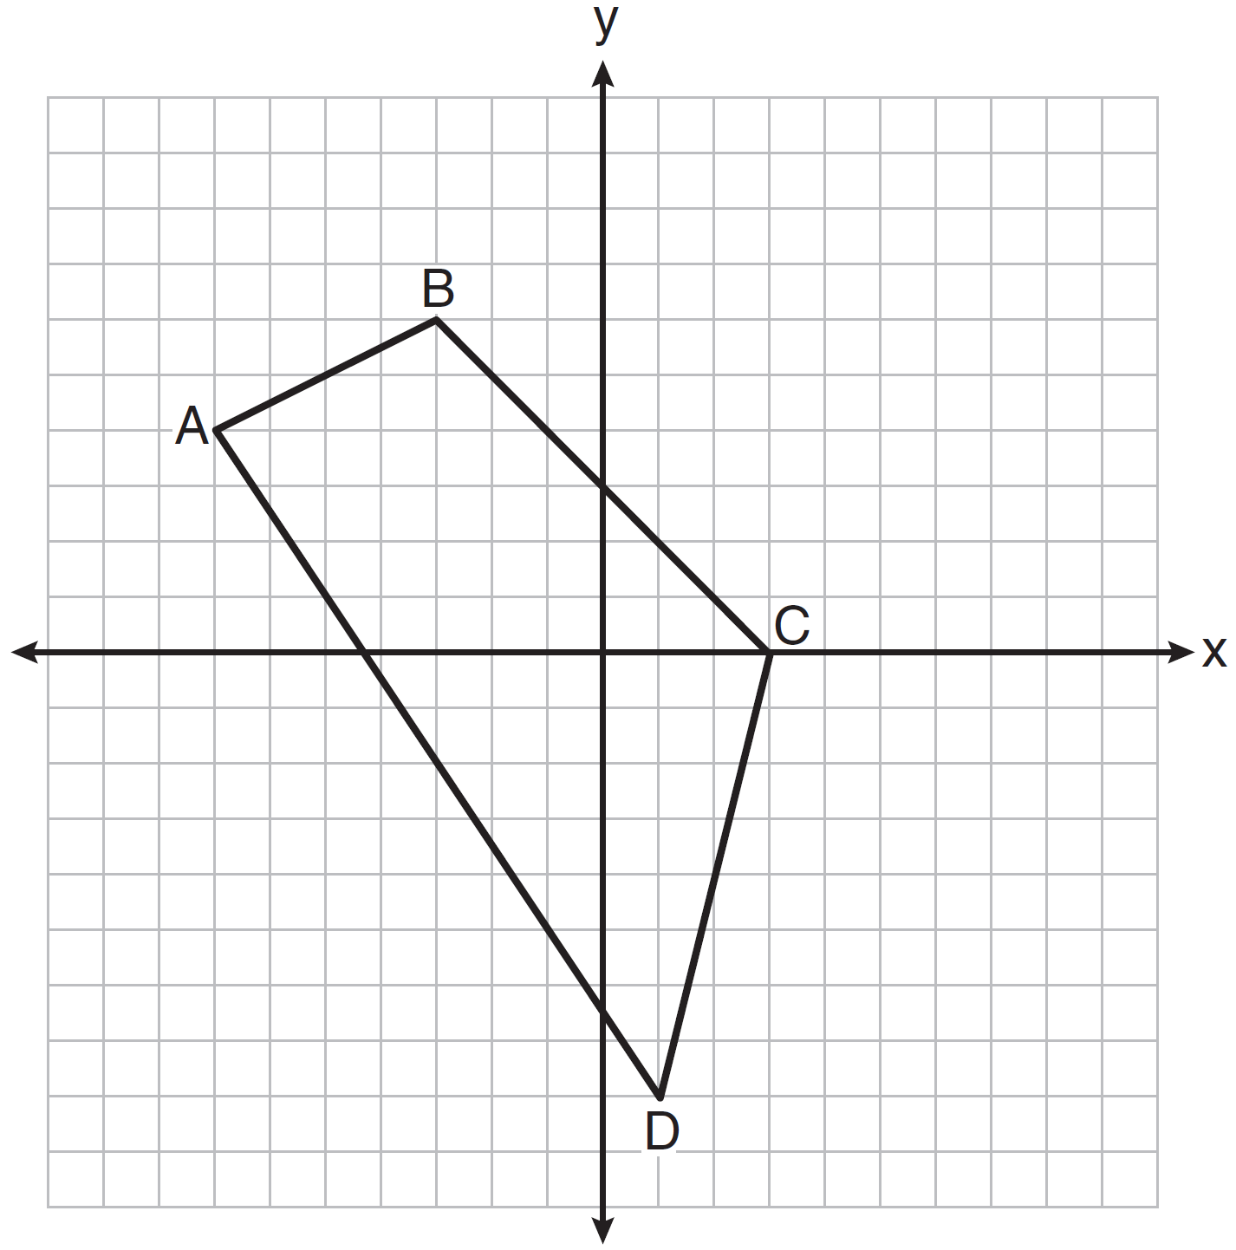

20 Given: with vertices , , and . has midpoint D, has midpoint E, and has midpoint F.
Prove: ADEF is a parallelogram
ADEF is not a rhombus
[The use of the grid is optional.]



21 In the accompanying diagram of ABCD, where , prove ABCD is an isosceles trapezoid.

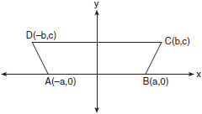

22 The coordinates of quadrilateral PRAT are , , , and . Prove that is parallel to .

23 The coordinates of two vertices of square ABCD are and . Determine the slope of side .

24 Rectangle KLMN has vertices , , , and . Determine and state the coordinates of the point of intersection of the diagonals.
1 ANS: 3
Both pairs of opposite sides are parallel, so not a trapezoid. None of the angles are right angles, so not a rectangle or square. All sides are congruent, so a rhombus.
REF: 081411ge

2 ANS: 4
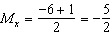. 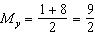.
REF: 060919ge

3 ANS: 1
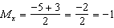. 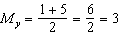.
REF: 061402ge

4 ANS: 3
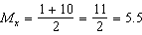 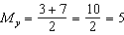.
REF: 081407ge

5 ANS: 2
Adjacent sides of a rectangle are perpendicular and have opposite and reciprocal slopes.
REF: 061028ge

6 ANS: 1
The diagonals of a parallelogram intersect at their midpoints. 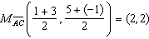
REF: 061209ge

7 ANS:
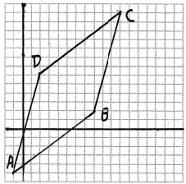. To prove that ABCD is a rhombus, show that all sides are congruent using the distance formula: 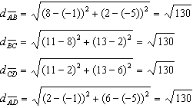.
REF: 060327b

8 ANS:
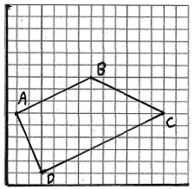. To prove that ABCD is a trapezoid, show that one pair of opposite sides of the figure is parallel by showing they have the same slope and that the other pair of opposite sides is not parallel by showing they do not have the same slope: 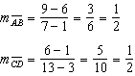 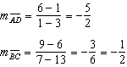

REF: 080134b

9 ANS:
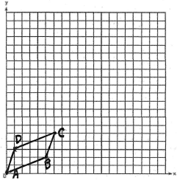 Both pairs of opposite sides of a parallelogram are parallel. Parallel lines have the same slope. The slope of side is 3. For side to have a slope of 3, the coordinates of point D must be . 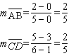 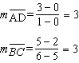
REF: 080032a

10 ANS:
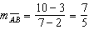, 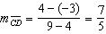, 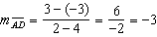, 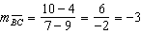 (Definition of slope). , (Parallel lines have equal slope). Quadrilateral ABCD is a parallelogram (Definition of parallelogram). , (Definition of distance). is not congruent to (Congruent lines have equal distance). ABCD is not a rhombus (A rhombus has four equal sides).
REF: 061031b

11 ANS:
To prove that ABCD is a parallelogram, show that both pairs of opposite sides of the parallelogram are parallel by showing the opposite sides have the same slope: 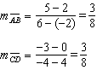 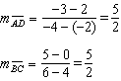
A rectangle has four right angles. If ABCD is a rectangle, then , , , and . Lines that are perpendicular have slopes that are the opposite and reciprocal of each other. Because and are not opposite reciprocals, the consecutive sides of ABCD are not perpendicular, and ABCD is not a rectangle. 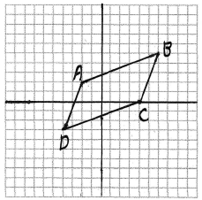
REF: 060633b

12 ANS:
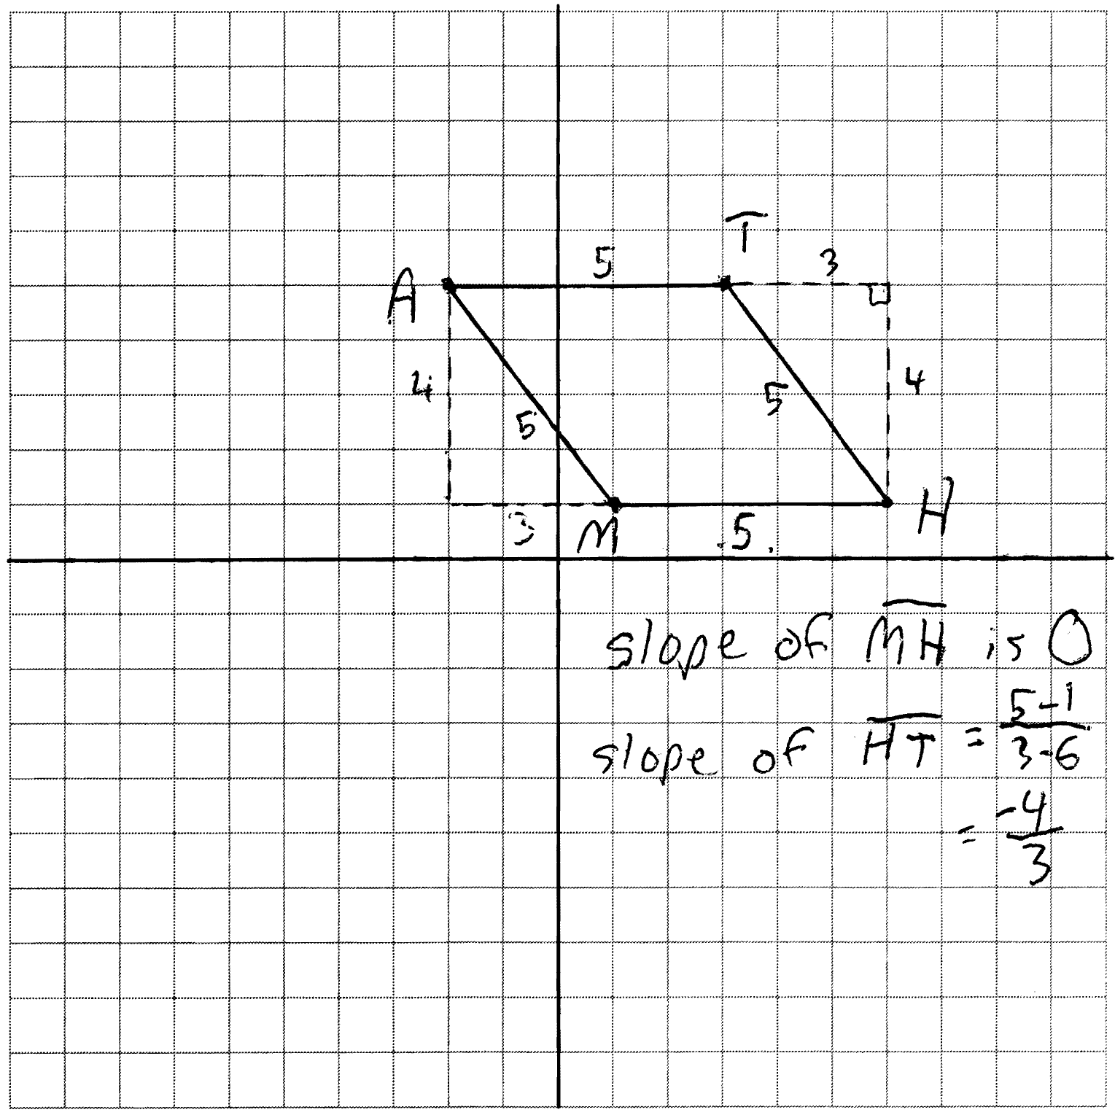 The length of each side of quadrilateral is 5. Since each side is congruent, quadrilateral MATH is a rhombus. The slope of is 0 and the slope of is . Since the slopes are not negative reciprocals, the sides are not perpendicular and do not form rights angles. Since adjacent sides are not perpendicular, quadrilateral MATH is not a square.
REF: 011138ge

13 ANS:
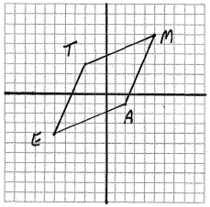. To prove that TEAM is a rhombus, show that all sides are congruent using the distance formula: 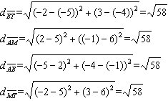. A square has four right angles. If TEAM is a square, then , , and . Lines that are perpendicular have slopes that are opposite reciprocals of each other. The slopes of sides of TEAM are: 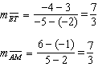 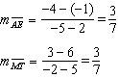 Because and are not opposite reciprocals, consecutive sides of TEAM are not perpendicular, and TEAM is not a square.
REF: 010533b

14 ANS:
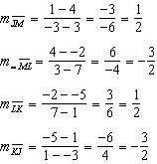 Since both opposite sides have equal slopes and are parallel, JKLM is a parallelogram. 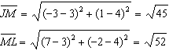. is not congruent to , so JKLM is not a rhombus since not all sides are congruent.
REF: 061438ge

15 ANS:
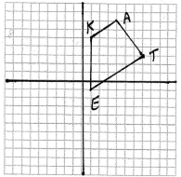. To prove that KATE is a trapezoid, show that one pair of opposite sides of the figure is parallel by showing they have the same slope and that the other pair of opposite sides is not parallel by showing they do not have the same slope: 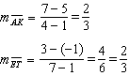 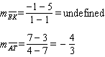
To prove that a trapezoid is not an isosceles trapezoid, show that the opposite sides that are not parallel are also not congruent using the distance formula: 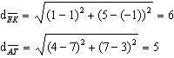
REF: 010333b

16 ANS:
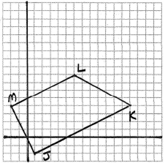. To prove that JKLM is a trapezoid, show that one pair of opposite sides of the figure is parallel by showing they have the same slope and that the other pair of opposite sides is not parallel by showing they do not have the same slope: 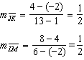 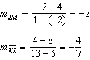
To prove that a trapezoid is not an isosceles trapezoid, show that the opposite sides that are not parallel are also not congruent using the distance formula: 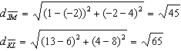
REF: 080434b

17 ANS:
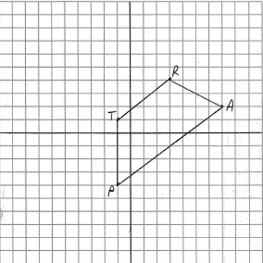. To prove that TRAP is a trapezoid, show that one pair of opposite sides of the figure is parallel by showing they have the same slope and that the other pair of opposite sides is not parallel by showing they do not have the same slope: 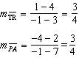 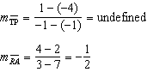
To prove that a trapezoid is not an isosceles trapezoid, show that the opposite sides that are not parallel are also not congruent using the distance formula: 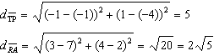
REF: 080933b

18 ANS:
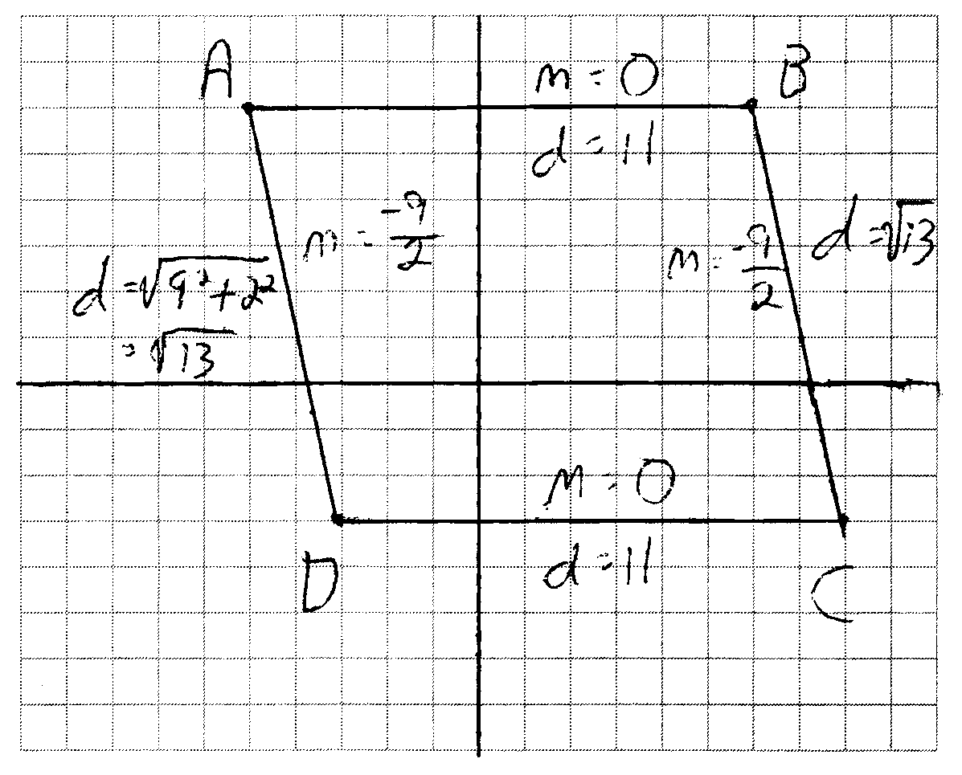 and because their slopes are equal. ABCD is a parallelogram because opposite side are parallel. ABCD is not a rhombus because all sides are not equal. because their slopes are not opposite reciprocals. ABCD is not a rectangle because is not a right angle.
REF: 081038ge

19 ANS:
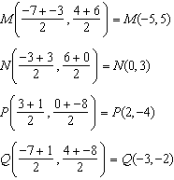. 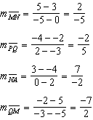. Since both opposite sides have equal slopes and are parallel, MNPQ is a parallelogram. 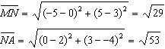. is not congruent to , so MNPQ is not a rhombus since not all sides are congruent. 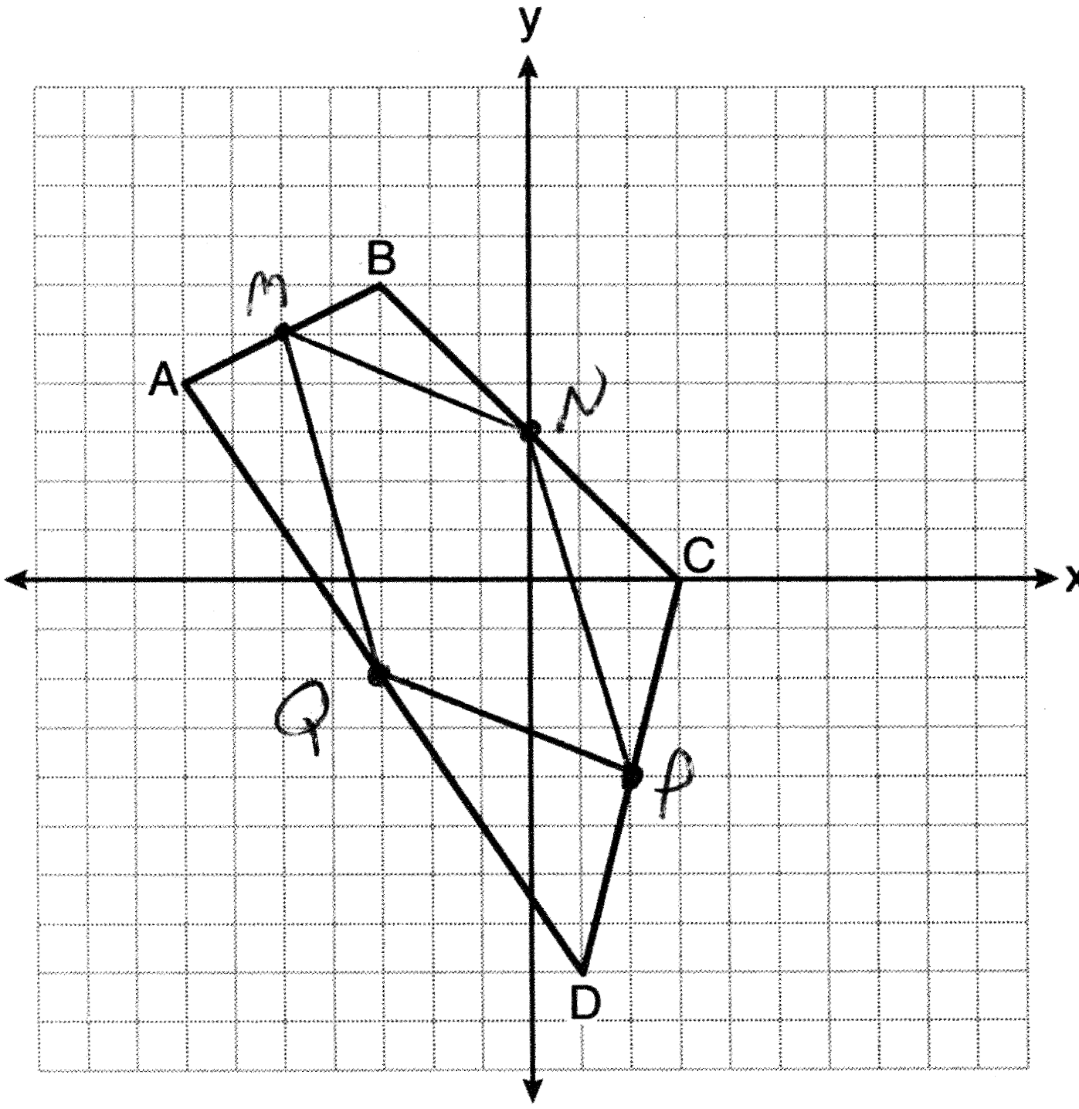
REF: 081338ge

20 ANS:
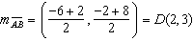 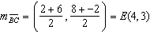 . To prove that ADEF is a parallelogram, show that both pairs of opposite sides of the parallelogram are parallel by showing the opposite sides have the same slope: 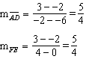 because all horizontal lines have the same slope. ADEF is not a rhombus because not all sides are congruent.
REF: 081138ge

21 ANS:
To prove that ABCD is a trapezoid, show that one pair of opposite sides of the figure is parallel by showing they have the same slope and that the other pair of opposite sides is not parallel by showing they do not have the same slope: 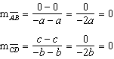 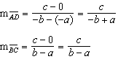 If and are parallel, then: 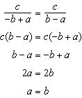 But the facts of the problem indicate , so and are not parallel.
To prove that a trapezoid is an isosceles trapezoid, show that the opposite sides that are not parallel are congruent using the distance formula: 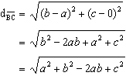 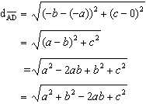
REF: 080534b

22 ANS:
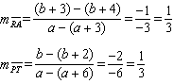. Because and have equal slopes, they are parallel.
REF: 060824b

23 ANS:
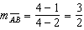. 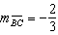
REF: 061334ge

24 ANS:
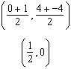
REF: 081534ge

