1 On the set of axes below, the coordinates of three vertices of trapezoid ABCD are , , and .

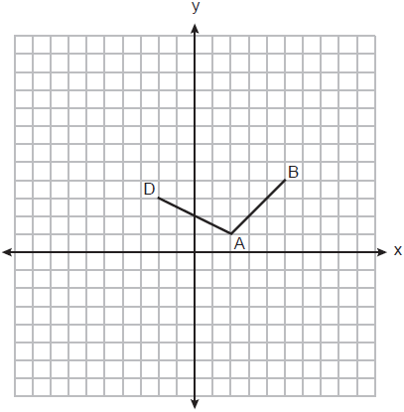

Which point could be vertex C?
1)
2)
3)
4)

2 A quadrilateral has vertices with coordinates , , , and . Which type of quadrilateral is this?
1) | rhombus
2) | rectangle
3) | square
4) | trapezoid

3 The coordinates of the vertices of parallelogram CDEH are , , , and . What are the coordinates of P, the point of intersection of diagonals and ?
1)
2)
3)
4)

4 Rectangle ABCD has two vertices at coordinates and . The slope of is
1)
2)
3)
4)

5 Parallelogram ABCD has coordinates and . Which statement would prove that ABCD is a rhombus?
1) | The midpoint of is .
2) | The length of is .
3) | The slope of is .
4) | The slope of is .

6 The diagonals of rhombus TEAM intersect at . If the equation of the line that contains diagonal is , what is the equation of a line that contains diagonal EM?
1)
2)
3)
4)

7 In square GEOM, the coordinates of G are and the coordinates of O are . Determine and state the coordinates of vertices E and M. [The use of the set of axes below is optional.]

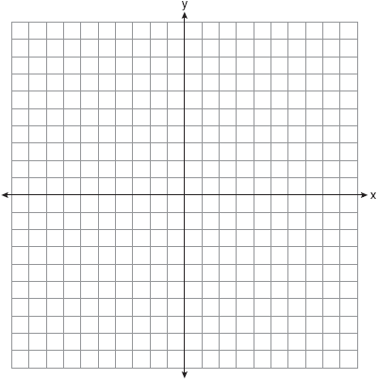

8 The coordinates of the vertices of quadrilateral HYPE are , , , and . Prove HYPE is a rectangle. [The use of the set of axes below is optional.]

9 Quadrilateral NATS has coordinates , , , and . Prove quadrilateral NATS is a rhombus. [The use of the set of axes below is optional.]

10 Parallelogram MATH has vertices , , , and . Prove that parallelogram MATH is a rhombus. [The use of the set of axes below is optional.] Determine and state the area of MATH.

11 Quadrilateral PQRS has vertices , , , and . Prove that PQRS is a rhombus. Prove that PQRS is not a square. [The use of the set of axes below is optional.]

12 The coordinates of the vertices of quadrilateral ABCD are , , , and . Prove that ABCD is a parallelogram, but not a rectangle. [The use of the set of axes below is optional.]

13 The vertices of quadrilateral MATH have coordinates , , , and . Prove that quadrilateral MATH is a parallelogram. Prove that quadrilateral MATH is a rectangle. [The use of the set of axes below is optional.]

14 Riley plotted , , , and to form a quadrilateral. Prove that Riley's quadrilateral ABCD is a trapezoid. [The use of the set of axes below is optional.] Riley defines an isosceles trapezoid as a trapezoid with congruent diagonals. Use Riley's definition to prove that ABCD is not an isosceles trapezoid.

15 Quadrilateral ABCD has vertices with coordinates , , , and . Joe defines an isosceles trapezoid as a trapezoid with congruent diagonals. Use Joe's definition to prove ABCD is an isosceles trapezoid. [The use of the set of axes below is optional.]

16 Quadrilateral MATH has vertices with coordinates , , , and ). Prove that quadrilateral MATH is a trapezoid. State the coordinates of point Y such that point A is the midpoint of . Prove that quadrilateral MYTH is a rectangle. [The use of the set of axes below is optional.]

17 In the coordinate plane, the vertices of are , , and . Prove that is a right triangle. State the coordinates of point P such that quadrilateral RSTP is a rectangle. Prove that your quadrilateral RSTP is a rectangle. [The use of the set of axes below is optional.]

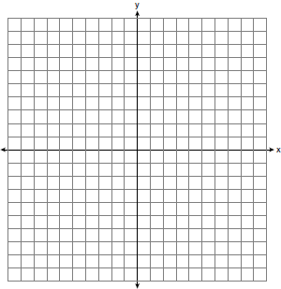

18 In the coordinate plane, the vertices of triangle PAT are , , and . Prove that is an isosceles triangle. State the coordinates of R so that quadrilateral PART is a parallelogram. Prove that quadrilateral PART is a parallelogram. [The use of the set of axes below is optional.]

19 The coordinates of the vertices of are , , and . Prove that is isosceles. State the coordinates of point D such that quadrilateral ABCD is a square. Prove that your quadrilateral ABCD is a square. [The use of the set of axes below is optional.]

20 The coordinates of the vertices of are , , and . Prove that is isosceles. State the coordinates of , the image of , after a translation 5 units to the right and 5 units down. Prove that quadrilateral AA'C'C is a rhombus. [The use of the set of axes below is optional.]

21 Given: Triangle DUC with coordinates , , and
Prove: is a right triangle
Point U is reflected over to locate its image point, U', forming quadrilateral DUCU'.
Prove quadrilateral DUCU' is a square.
[The use of the set of axes below is optional.]

22 In rhombus MATH, the coordinates of the endpoints of the diagonal are and . Write an equation of the line that contains diagonal . [Use of the set of axes below is optional.] Using the given information, explain how you know that your line contains diagonal .

1 ANS: 4
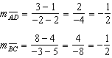 A pair of opposite sides is parallel.

REF: 082321geo

2 ANS: 4
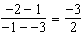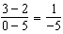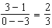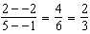

REF: 081522geo

3 ANS: 3
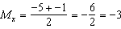 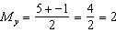.

REF: 081902geo

4 ANS: 1
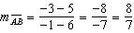

REF: 062315geo

5 ANS: 3
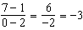 The diagonals of a rhombus are perpendicular.

REF: 011719geo

6 ANS: 1
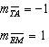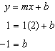

REF: 081614geo

7 ANS:
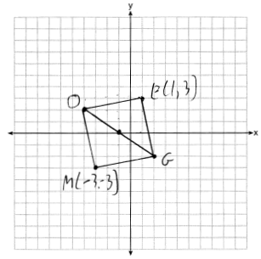

REF: 011731geo

8 ANS:
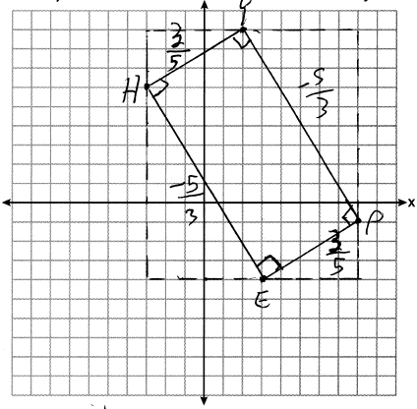 1) Quadrilateral HYPE with , , , and (Given); 2) Slope of and is , slope of and is (Slope determined graphically); 3) , , , (The slopes of perpendicular lines are opposite reciprocals); 4) , , , are right angles (Perpendicular lines form right angles); 5) HYPE is a rectangle (A rectangle has four right angles).

REF: 082233geo

9 ANS:
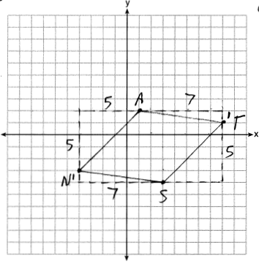 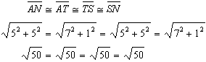 Quadrilateral NATS is a rhombus because all four sides are congruent.

REF: 012032geo

10 ANS:
A rhombus has four congruent sides. Since each side measures , all four sides of MATH are congruent, and MATH is a rhombus. 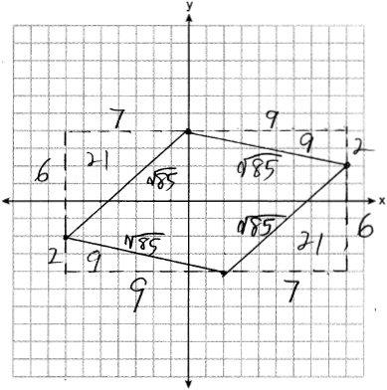

REF: 062334geo

11 ANS:
PQRS is a rhombus because all sides are congruent. 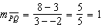 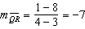 Because the slopes of adjacent sides are not opposite reciprocals, they are not perpendicular and do not form a right angle. Therefore PQRS is not a square. 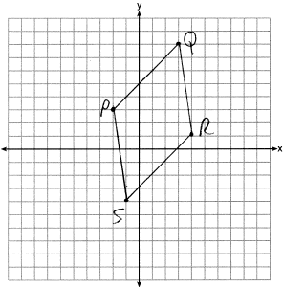

REF: 061735geo

12 ANS:
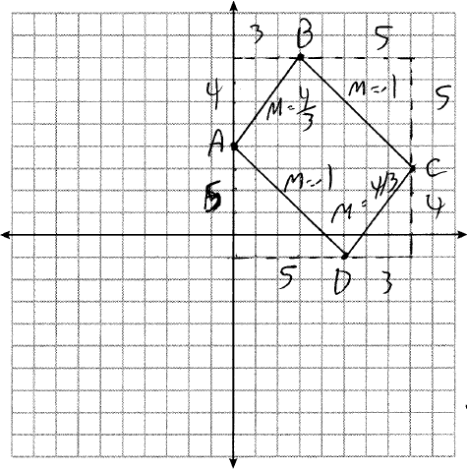 and have equal slope, so are parallel. and have equal slope, so are parallel. Since both pairs of opposite sides are parallel, ABCD is a parallelogram. The slope of and are not opposite reciprocals, so they are not perpendicular, and so is not a right angle. ABCD is not a rectangle since all four angles are not right angles.

REF: 082334geo

13 ANS:
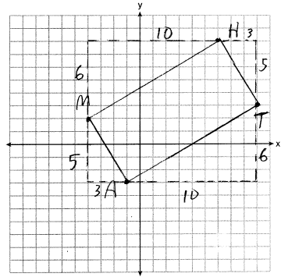 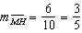, 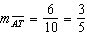, 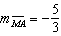, 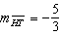; and . MATH is a parallelogram since both sides of opposite sides are parallel. , 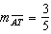. Since the slopes are negative reciprocals, and is a right angle. MATH is a rectangle because it is a parallelogram with a right angle.

REF: 081835geo

14 ANS:
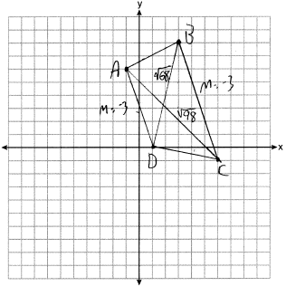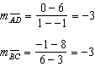 because their slopes are equal. ABCD is a trapezoid because it has a pair of parallel sides. 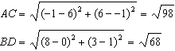 ABCD is not an isosceles trapezoid because its diagonals are not congruent.

REF: 061932geo

15 ANS:
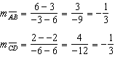 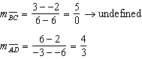 ABCD is a trapezoid because it has only one pair of parallel sides. 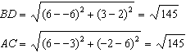 ABCD is isosceles because ABCD’s diagonals are congruent.

REF: 082433geo

16 ANS:
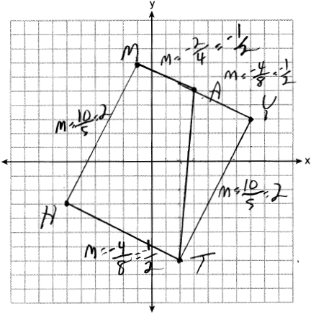The slope of and equals . Distinct lines with equal slope are parallel. MATH is a trapezoid because it has a pair of parallel lines. . The slope of and equals . The slope of and equals 2. The slopes of each side are opposite reciprocals and therefore perpendicular. Perpendicular sides form right angles, so MYTH has four right angles and is a rectangle.

REF: 012435geo

17 ANS:
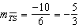 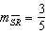 Since the slopes of and are opposite reciprocals, they are perpendicular and form a right angle. is a right triangle because is a right angle. 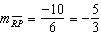 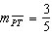 Since the slopes of all four adjacent sides ( and , and , and , and ) are opposite reciprocals, they are perpendicular and form right angles. Quadrilateral RSTP is a rectangle because it has four right angles.
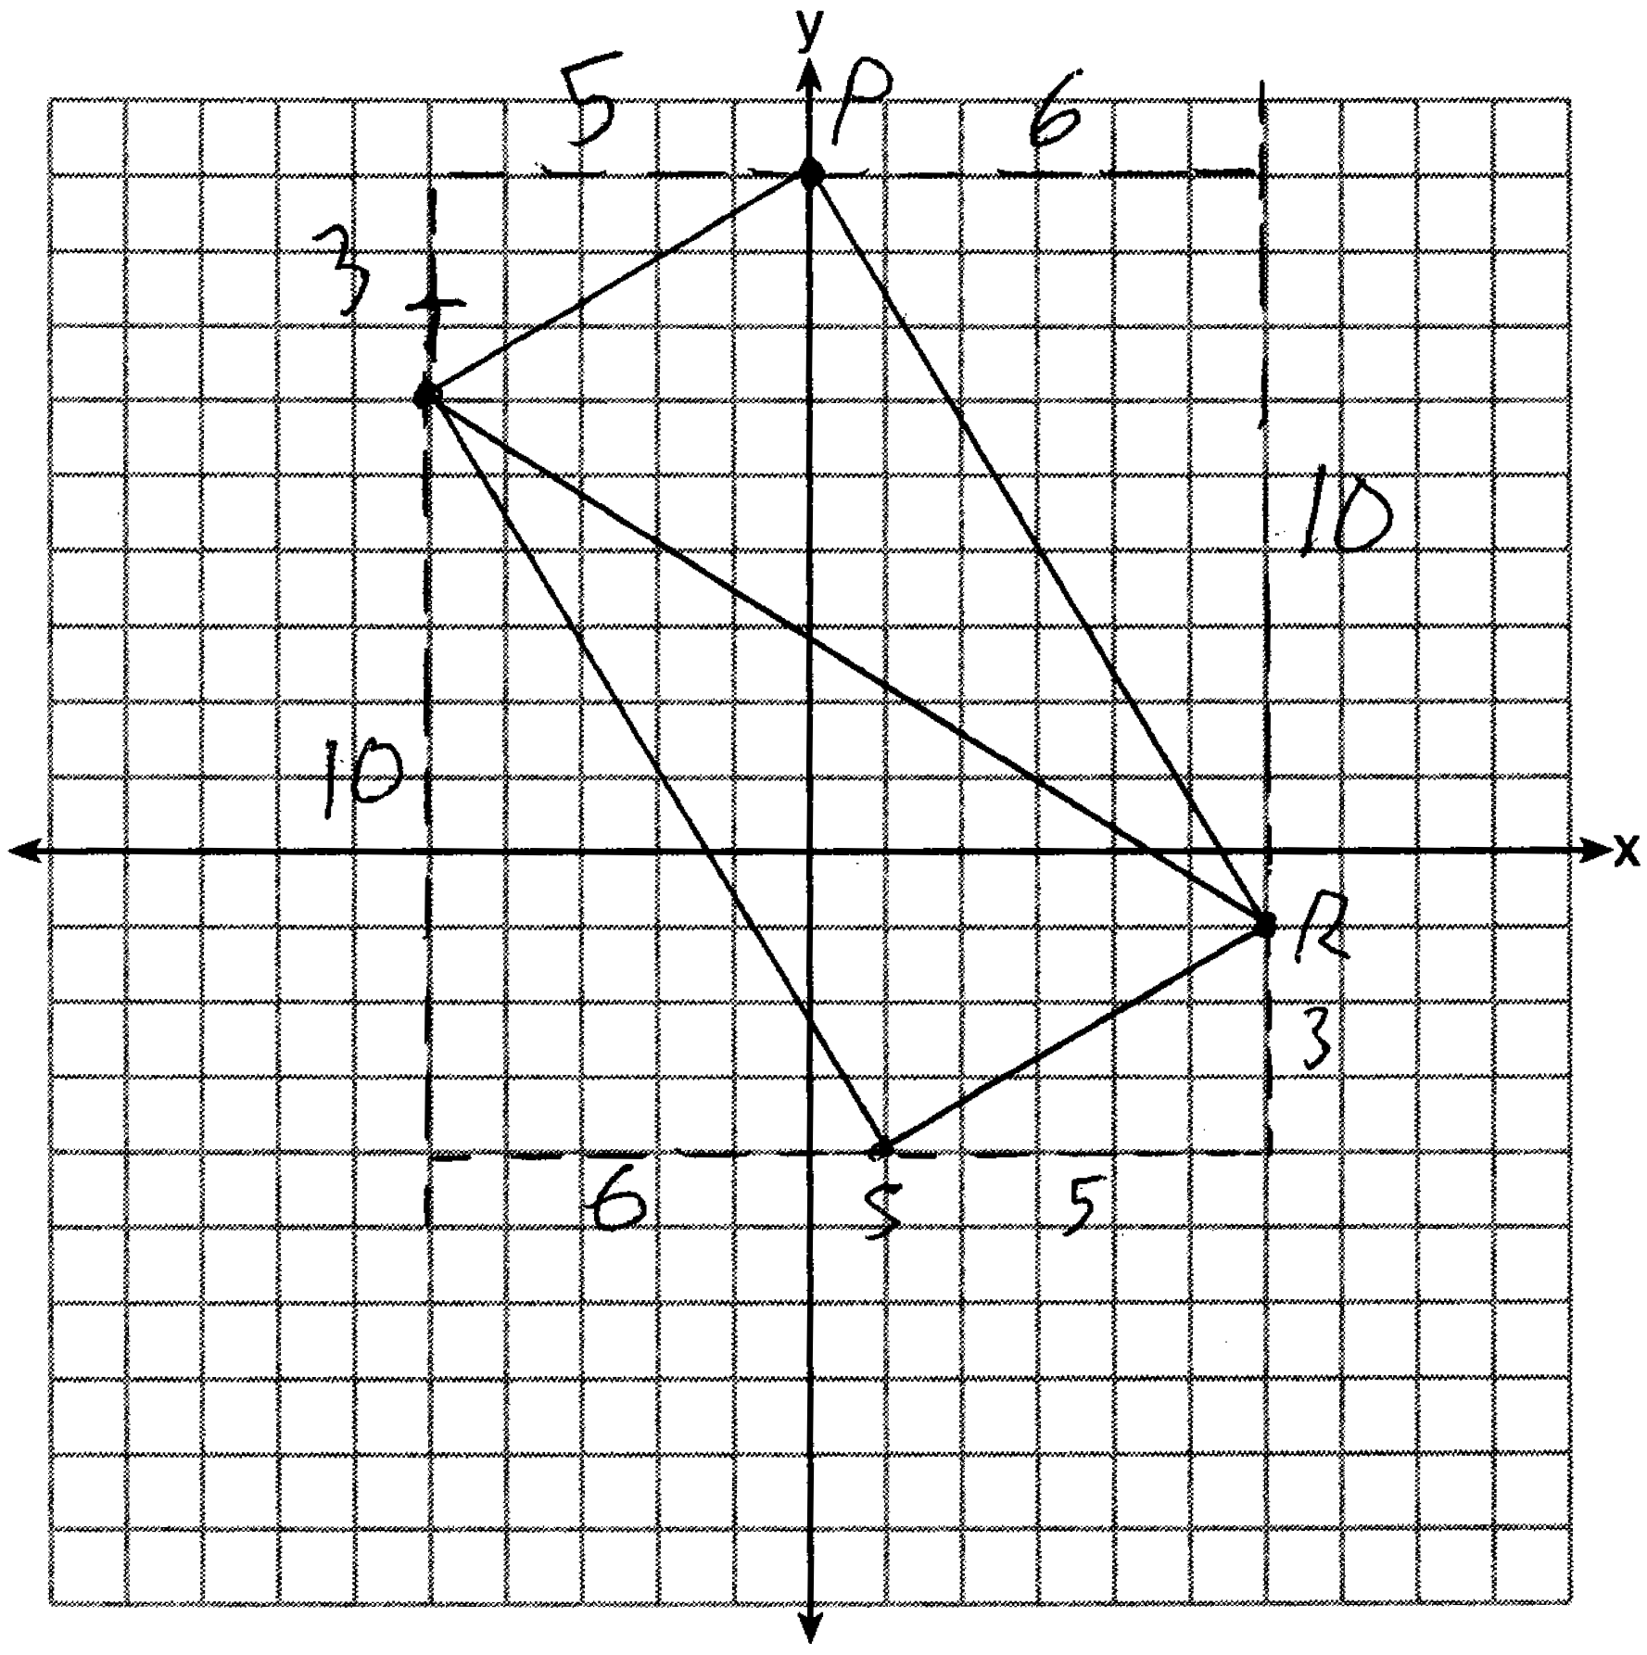

REF: 061536geo

18 ANS:
is an isosceles triangle because sides and are congruent (). . Quadrilateral PART is a parallelogram because the opposite sides are parallel since they have equal slopes 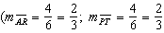; 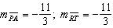) 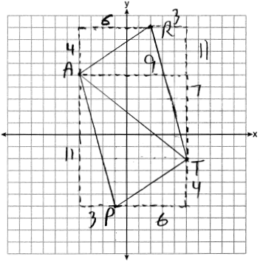

REF: 011835geo

19 ANS:
, (because , is isosceles). . , , 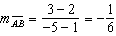, 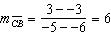 (ABCD is a square because all four sides are congruent, consecutive sides are perpendicular since slopes are opposite reciprocals and so is a right angle). 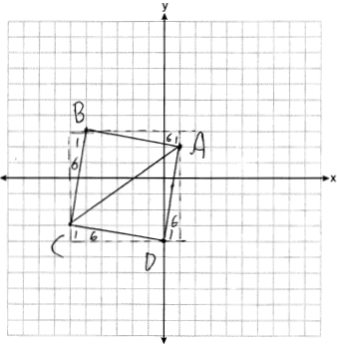

REF: 081935geo

20 ANS:
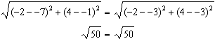 Since and are congruent, is isosceles. . 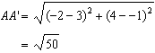, (translation preserves distance), 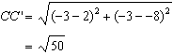 Since all four sides are congruent, AA'C'C is a rhombus. 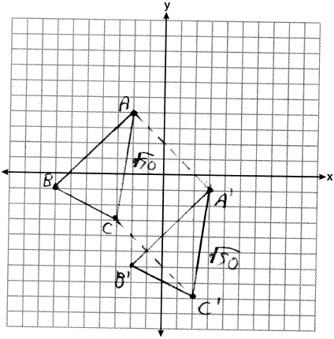

REF: 062235geo

21 ANS:
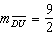 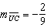 Since the slopes of and are opposite reciprocals, they are perpendicular and form a right angle. is a right triangle because is a right angle. Each side of quadrilateral DUCU' is . Quadrilateral DUCU' is a square because all four side are congruent and it has a right angle.
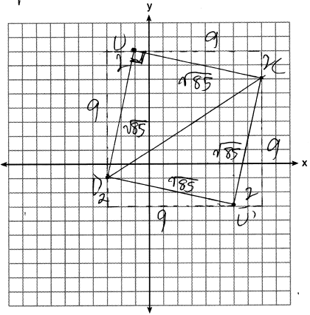

REF: 012335geo

22 ANS:
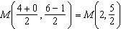 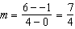 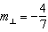 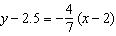 The diagonals, and , of rhombus MATH are perpendicular bisectors of each other.

REF: fall1411geo

