1 What are the coordinates of the center of a circle if the endpoints of its diameter are and ?
1)
2)
3)
4)

2 Segment AB is the diameter of circle M. The coordinates of A are . The coordinates of M are . What are the coordinates of B?
1)
2)
3)
4)

3 Line segment AB is a diameter of circle O whose center has coordinates . What are the coordinates of point B if the coordinates of point A are ?
1)
2)
3)
4)

4 The center of circle Q has coordinates . If circle Q passes through , what is the length of its diameter?
1) | 50
2) | 25
3) | 10
4) | 5

5 In circle O, a diameter has endpoints and . What is the length of the diameter?
1)
2)
3)
4)

6 In the coordinate plane, the points and are the endpoints of a diameter of a circle. What is the length of the radius of the circle?
1) | 5
2) | 6
3) | 7
4) | 10

7 A circle whose center is the origin passes through the point . Which point also lies on this circle?
1)
2)
3)
4)

8 A circle has a center at and radius of 4. Does the point lie on the circle? Justify your answer.

9 In circle O, diameter has endpoints and . Find the coordinates of point O, in terms of a and b. Express your answer in simplest form.

10 In the diagram below of circle C, is a diameter, and and are points on a coordinate plane. Find and state the coordinates of point R.

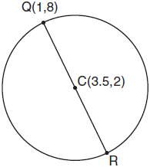

11 In a circle whose center is , one endpoint of a diameter is . Find the coordinates of the other endpoint of that diameter. [The use of the accompanying grid is optional.]

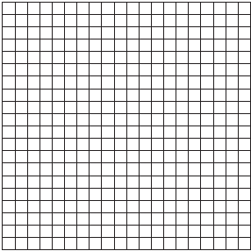

12 On the accompanying grid, graph a circle whose center is at (0,0) and whose radius is 5. Determine if the point (5,–2) lies on the circle.

1 ANS: 2
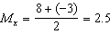. 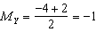.

REF: 061312ge

2 ANS: 1
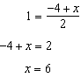. 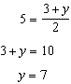.

REF: 081115ge

3 ANS: 3
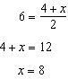. 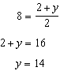.

REF: 011305ge

4 ANS: 3

REF: 061503geo

5 ANS: 4

REF: 011121ge

6 ANS: 1
Because the diameter is parallel to the y-axis, the length of the diameter may be calculated by subtracting the y values. If the diameter is , the radius is 5.

REF: 010426a

7 ANS: 3

REF: 011722geo

8 ANS:
Yes. 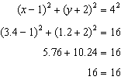

REF: 081630geo

9 ANS:
. 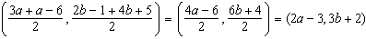

REF: 061134ge

10 ANS:
. 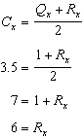. 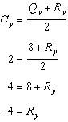.

REF: 011031ge

11 ANS:
. 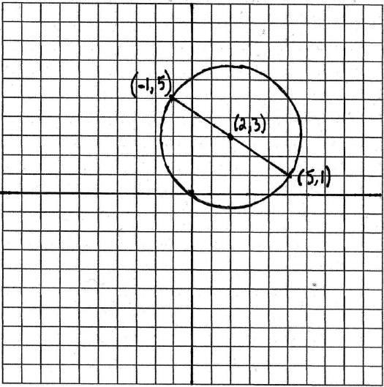. 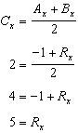. 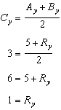.

REF: 010633a

12 ANS:
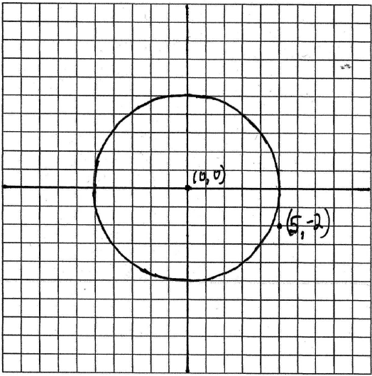 The point (5,–2) does not lie on the circle.

REF: 080230a

