1 Which ordered pair is in the solution set of the system of equations shown below?
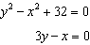
1)
2)
3)
4)

2 Which ordered pair is a solution to the system below?
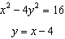
1)
2)
3)
4)

3 What is the total number of points of intersection of the graphs of the equations and ?
1) | 1
2) | 2
3) | 3
4) | 0

4 Solve the following system of equations algebraically: 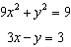

5 Solve 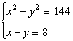

6 Solve the following systems of equations algebraically: 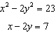

7 On the accompanying set of axes, graph the parabola whose equation is over the interval and graph the circle whose center is at and whose radius is 4. Using your graphs, determine how many points of intersection the two graphs have.

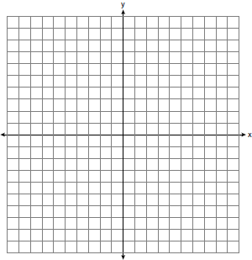

8 Two circles whose equations are and intersect in two points. What is the equation of the line passing through these two points? [The use of the accompanying grid is optional.]



9 On the accompanying grid, graph the following system of equations over the interval .
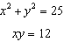
State the points of intersection.

1 ANS: 4
. 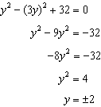.
REF: 061312a2

2 ANS: 2
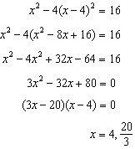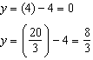
REF: 011704a2

3 ANS: 2
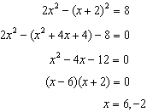
REF: 011609a2

4 ANS:
. . 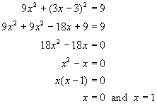. 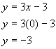. 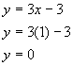
REF: 060627b

5 ANS:
REF: 010604al

6 ANS:
, . . 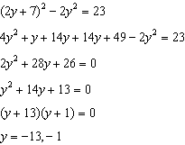. .
REF: 061032b

7 ANS:
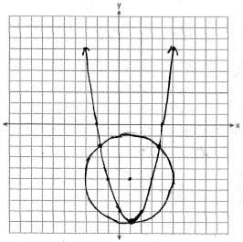 3
REF: 010839a

8 ANS:
. 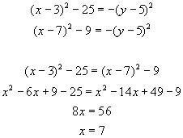 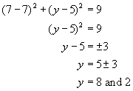. The line goes through the points of intersection, (7,2) and (7,8). 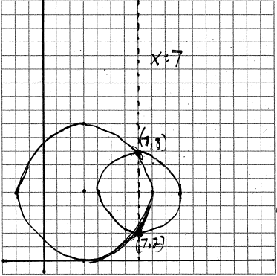
REF: 080732b

9 ANS:
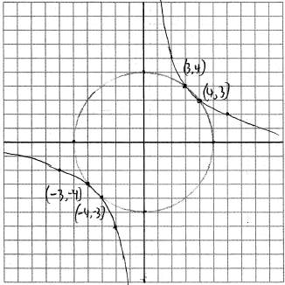
REF: 010932b

