1 What is the graph of the function ?
1) | a circle whose radius is 2 and whose center is at the origin
2) | a circle whose radius is 4 and whose center is at the origin
3) | the upper half of a circle whose radius is 2 and whose center is at the origin
4) | the upper half of a circle whose radius is 4 and whose center is at the origin

2 What is the axis of symmetry of the graph of the equation ?
1)
2)
3) | line
4) | line

3 The graph of the equation forms
1) | a circle
2) | a parabola
3) | a straight line
4) | two intersecting lines

4 The graph of the equation can be described as a
1) | line passing through points and
2) | parabola with its vertex at
3) | circle with its center at the origin and a radius of 2
4) | circle with its center at the origin and a radius of 4

5 When graphed on the coordinate plane, the equations and form
1) | a parabola and a straight line
2) | a parabola and a circle
3) | two parabolas
4) | two circles

6 The graph of the equation forms
1) | a circle
2) | an ellipse
3) | a hyperbola
4) | a parabola

7 An object orbiting a planet travels in a path represented by the equation . In which type of pattern does the object travel?
1) | hyperbola
2) | ellipse
3) | circle
4) | parabola

8 A commercial artist plans to include an ellipse in a design and wants the length of the horizontal axis to equal 10 and the length of the vertical axis to equal 6. Which equation could represent this ellipse?
1)
2)
3)
4)

9 Which equation, when graphed on a Cartesian coordinate plane, would best represent an elliptical racetrack?
1)
2)
3)
4)

10 A designer who is planning to install an elliptical mirror is laying out the design on a coordinate grid. Which equation could represent the elliptical mirror?
1)
2)
3)
4)

11 Which equation represents an ellipse?
1)
2)
3)
4)

12 Which graph represents the equation 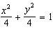?
1) | 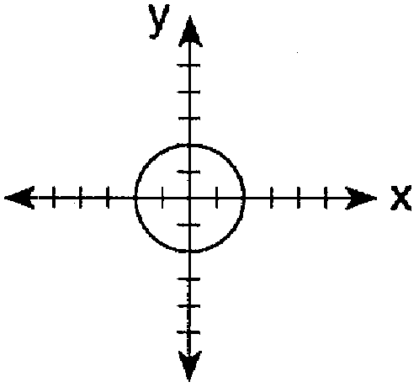
2) | 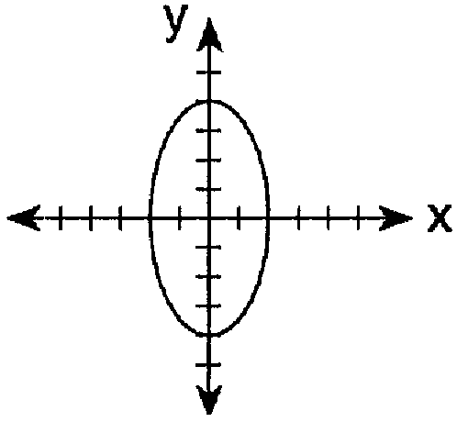
3) | 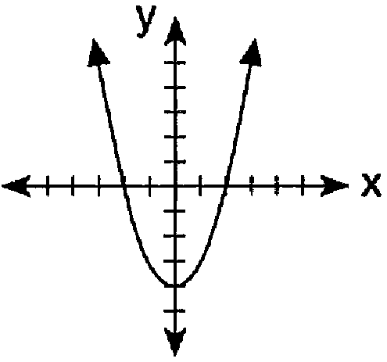
4) | 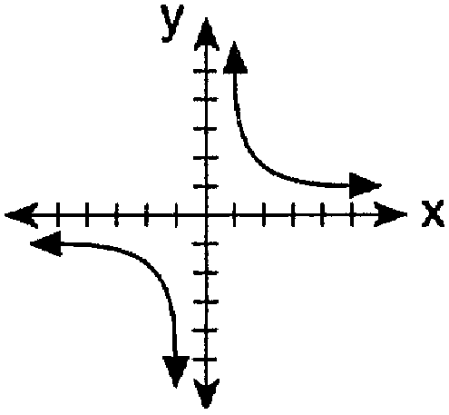

13 Which graph represents the equation ?
1) | 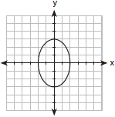
2) | 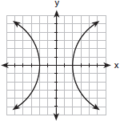
3) | 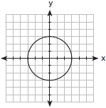
4) | 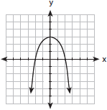

14 The accompanying diagram shows the elliptical orbit of a planet. The foci of the elliptical orbit are and .

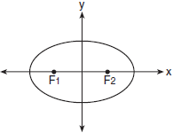

If a, b, and c are all positive and , which equation could represent the path of the planet?
1)
2)
3)
4)

15 The accompanying diagram represents the elliptical path of a ride at an amusement park.

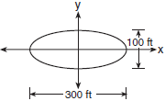

Which equation represents this path?
1)
2)
3) | 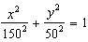
4) | 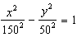

16 The accompanying diagram shows the construction of a model of an elliptical orbit of a planet traveling around a star. Point P and the center of the star represent the foci of the orbit.

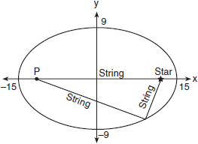

Which equation could represent the relation shown?
1) | 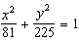
2) | 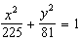
3) | 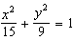
4) | 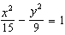

17 An architect is designing a building to include an arch in the shape of a semi-ellipse (half an ellipse), such that the width of the arch is 20 feet and the height of the arch is 8 feet, as shown in the accompanying diagram.

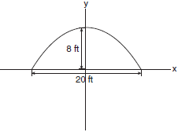

Which equation models this arch?
1) | 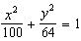
2) | 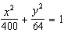
3) | 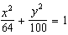
4) | 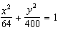

18 A landscape architect is working on the plans for a new horse farm. He is laying out the exercise ring and racetrack on the accompanying graph. The location of the circular exercise ring, with point R as its center, has already been plotted.

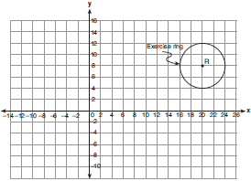

Write an equation that represents the outside edge of the exercise ring. The equation of the outside edge of the racetrack is 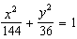. Sketch the outside edge of the racetrack on the graph.
1 ANS: 3 REF: 080804b

2 ANS: 1
If you take the square root of both sides of the equation, it becomes A square root function and its reflection are symmetric about the x-axis.

REF: 010419b

3 ANS: 1 REF: 010714a

4 ANS: 3 REF: 080528a

5 ANS: 2 REF: 080723a

6 ANS: 3 REF: 080920b

7 ANS: 2
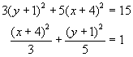

REF: 080517b

8 ANS: 1
The length of the semi-major axis is half of 10, or 5. So . The length of the semi-minor axis is half of 6, or 3. So . 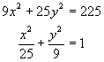

REF: 080318b

9 ANS: 1
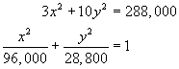

REF: 060512b

10 ANS: 3
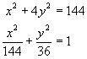

REF: 080609b

11 ANS: 1 REF: 061020b

12 ANS: 1 REF: 019724siii

13 ANS: 1 REF: 010917b

14 ANS: 2 REF: 010410b

15 ANS: 3
The length of the semi-major axis is half of 300, or 150. The length of the semi-minor axis is half of 100, or 50.

REF: 060311b

16 ANS: 2
The length of the semi-major axis is 15. So The length of the semi-minor axis is 9. So

REF: 010517b

17 ANS: 1
The length of the semi-major axis is half of 20, or 10. So . The length of the semi-minor axis is 8. So

REF: 080206b

18 ANS:
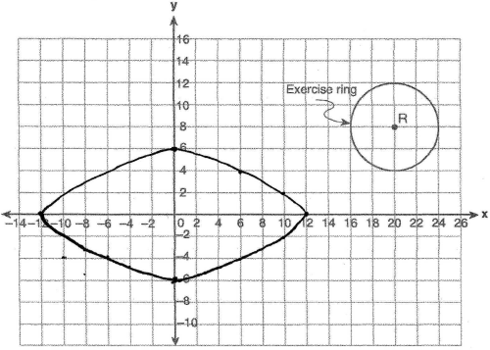. The center of the circle is (20,8) and the radius is 4. Since the length of the semi-major axis is 12. Since the length of the semi-minor axis is 6.

REF: 060730b

