1 In a coordinate plane, the locus of points 5 units from the x-axis is the
1) | lines and
2) | lines and
3) | line , only
4) | line , only

2 In a coordinate plane, how many points are both 5 units from the origin and 2 units from the x-axis?
1) | 1
2) | 2
3) | 3
4) | 4

3 How many points are both 4 units from the origin and also 2 units from the line ?
1) | 1
2) | 2
3) | 3
4) | 4

4 In the coordinate plane, what is the total number of points 5 units from the origin and equidistant from both the x- and y-axes?
1) | 1
2) | 2
3) | 0
4) | 4

5 How many points in the coordinate plane are 3 units from the origin and also equidistant from both the x-axis and the y-axis?
1) | 1
2) | 2
3) | 8
4) | 4

6 How many points are 3 units from the origin and also equidistant from both the x-axis and y-axis?
1) | 1
2) | 2
3) | 0
4) | 4

7 The graph below shows the locus of points equidistant from the x-axis and y-axis. On the same set of axes, graph the locus of points 3 units from the line . Label with an X all points that satisfy both conditions.

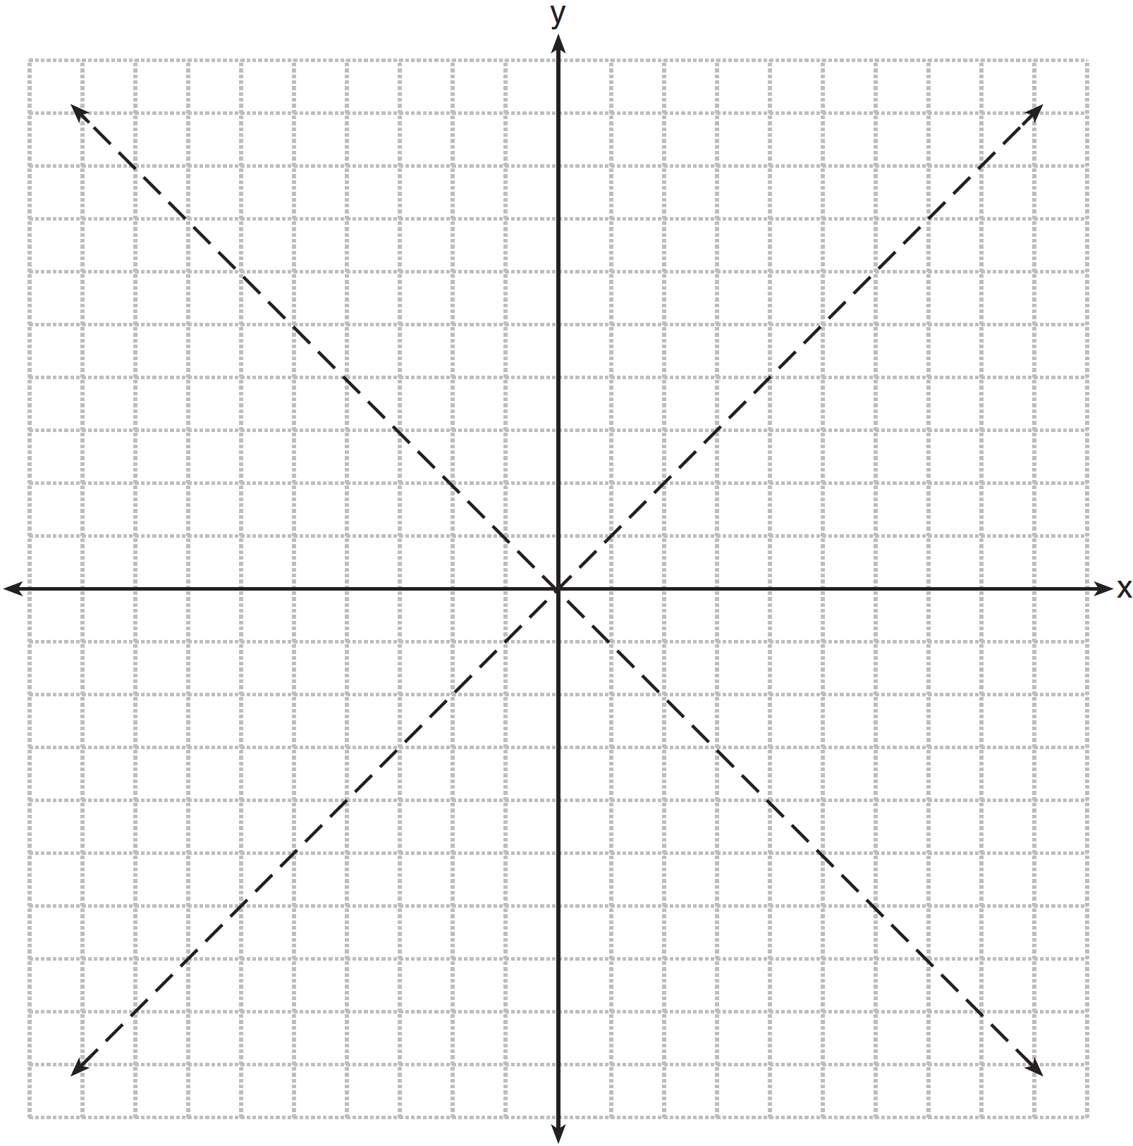

8 On the grid below, graph the points that are equidistant from both the x and y axes and the points that are 5 units from the origin. Label with an X all points that satisfy both conditions.

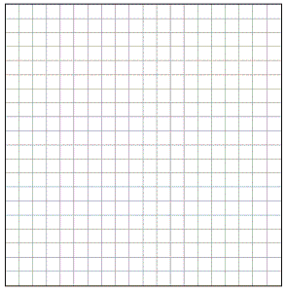

9 On the set of axes below, sketch the points that are 5 units from the origin and sketch the points that are 2 units from the line . Label with an X all points that satisfy both conditions.

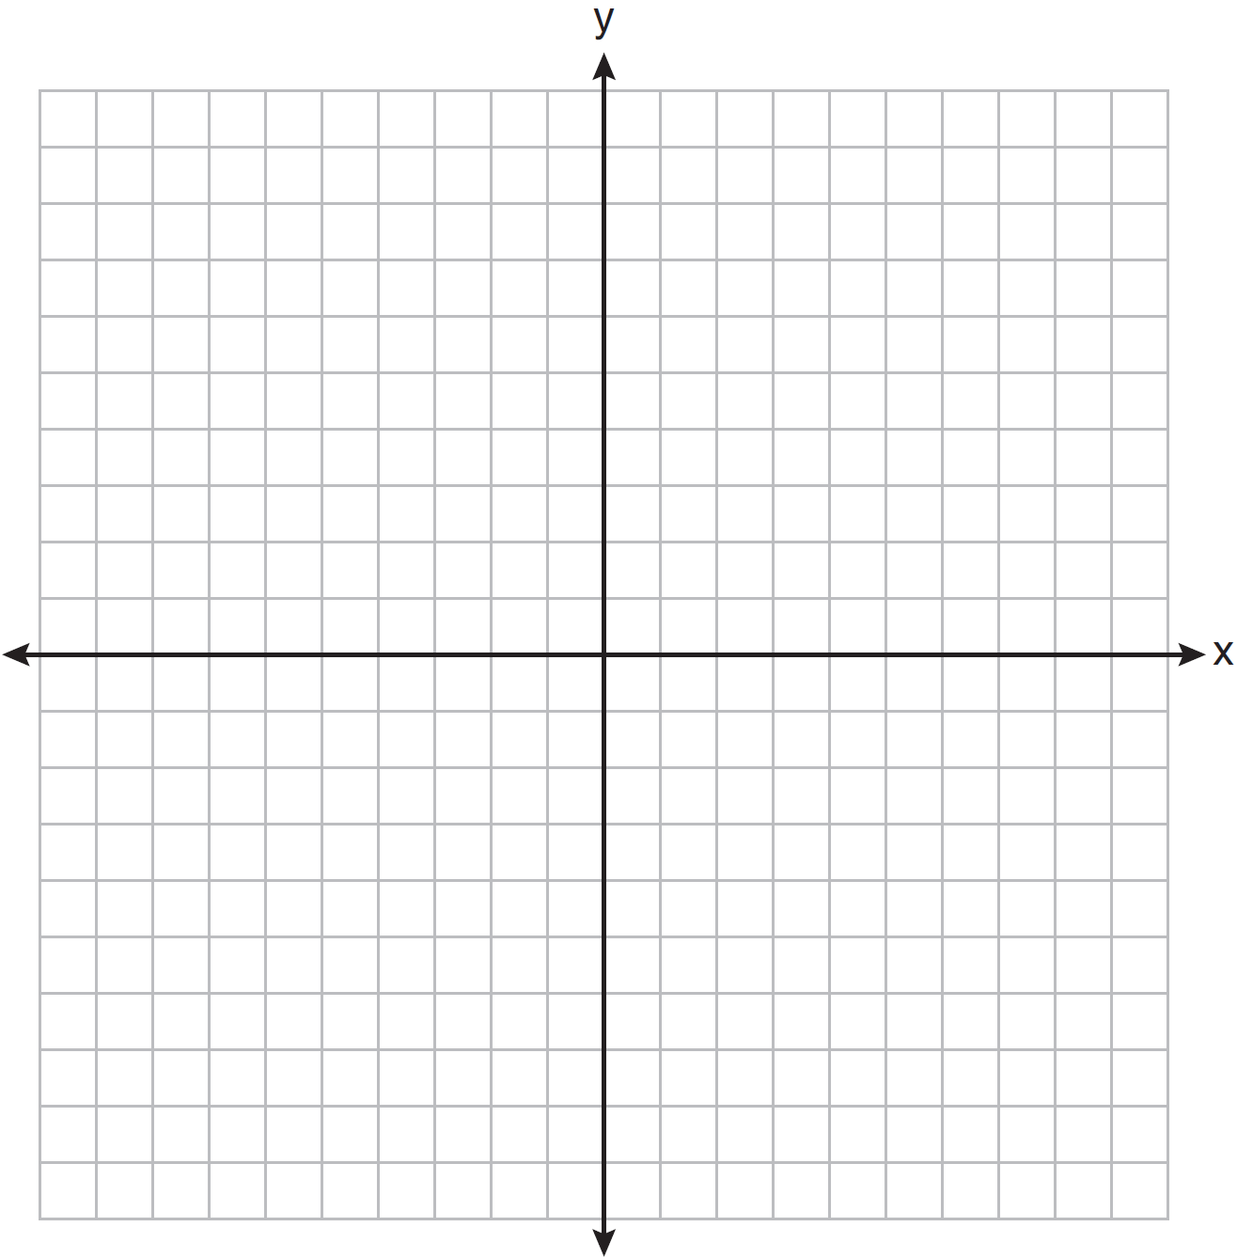

10 On the set of axes below, graph the locus of points that are four units from the point . On the same set of axes, graph the locus of points that are two units from the line . State the coordinates of all points that satisfy both conditions.

11 On the set of coordinate axes below, graph the locus of points that are equidistant from the lines and and also graph the locus of points that are 3 units from the y-axis. State the coordinates of all points that satisfy both conditions.

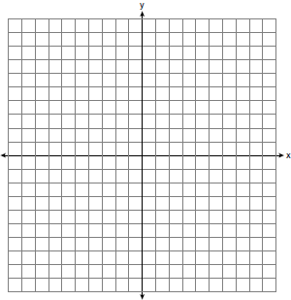

12 A city is planning to build a new park. The park must be equidistant from school A at and school B at . The park also must be exactly 5 miles from the center of town, which is located at the origin on the coordinate graph. Each unit on the graph represents 1 mile. On the set of axes below, sketch the compound loci and label with an X all possible locations for the new park.

13 On the set of axes below, graph the locus of points that are 4 units from the line and the locus of points that are 5 units from the point . Label with an X all points that satisfy both conditions.

14 On the set of axes below, graph the locus of points 4 units from and the locus of points 3 units from the origin. Label with an X any points that satisfy both conditions.

15 On the set of axes below, graph the locus of points 4 units from the x-axis and equidistant from the points whose coordinates are and . Mark with an X all points that satisfy both conditions.

16 On the set of axes below, sketch the locus of points 2 units from the x-axis and sketch the locus of points 6 units from the point . Label with an X all points that satisfy both conditions.

17 On the set of axes below, graph the locus of points 5 units from the point . On the same set of axes, graph the locus of points equidistant from the points and . State the coordinates of all points that satisfy both conditions.

18 On the set of axes below, graph two horizontal lines whose y-intercepts are and , respectively. Graph the locus of points equidistant from these horizontal lines. Graph the locus of points 3 units from the y-axis. State the coordinates of the points that satisfy both loci.

19 On the set of axes below, graph the locus of points 5 units from the point and the locus of points 2 units from the line whose equation is . State the coordinates of all points that satisfy both conditions.

1 ANS: 2 REF: 081316ge

2 ANS: 4 REF: 060912ge

3 ANS: 2 REF: 081117ge

4 ANS: 4 REF: 080003a

5 ANS: 4 REF: 011407ge

6 ANS: 4 REF: 011604ge

7 ANS:
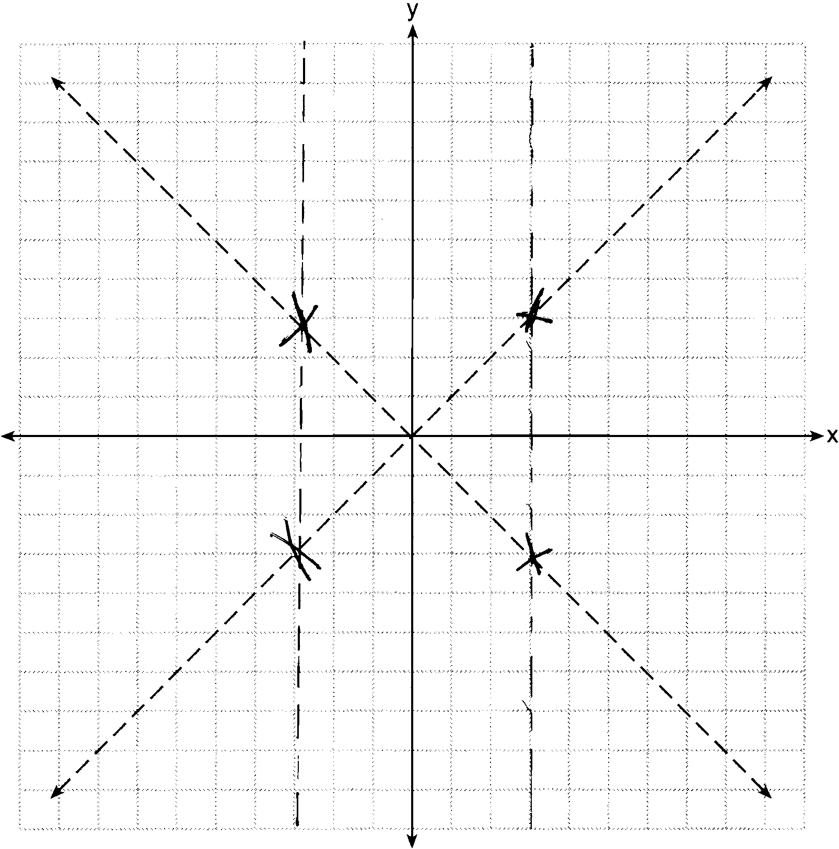

REF: 081234ge

8 ANS:
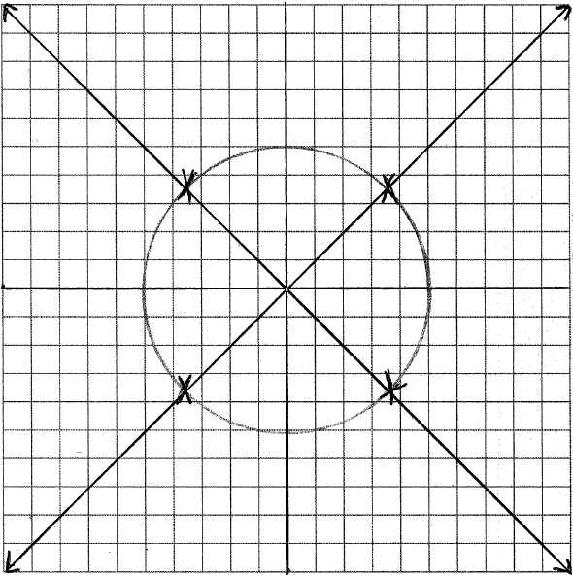

REF: 011037ge

9 ANS:
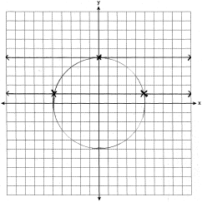

REF: 080936ge

10 ANS:
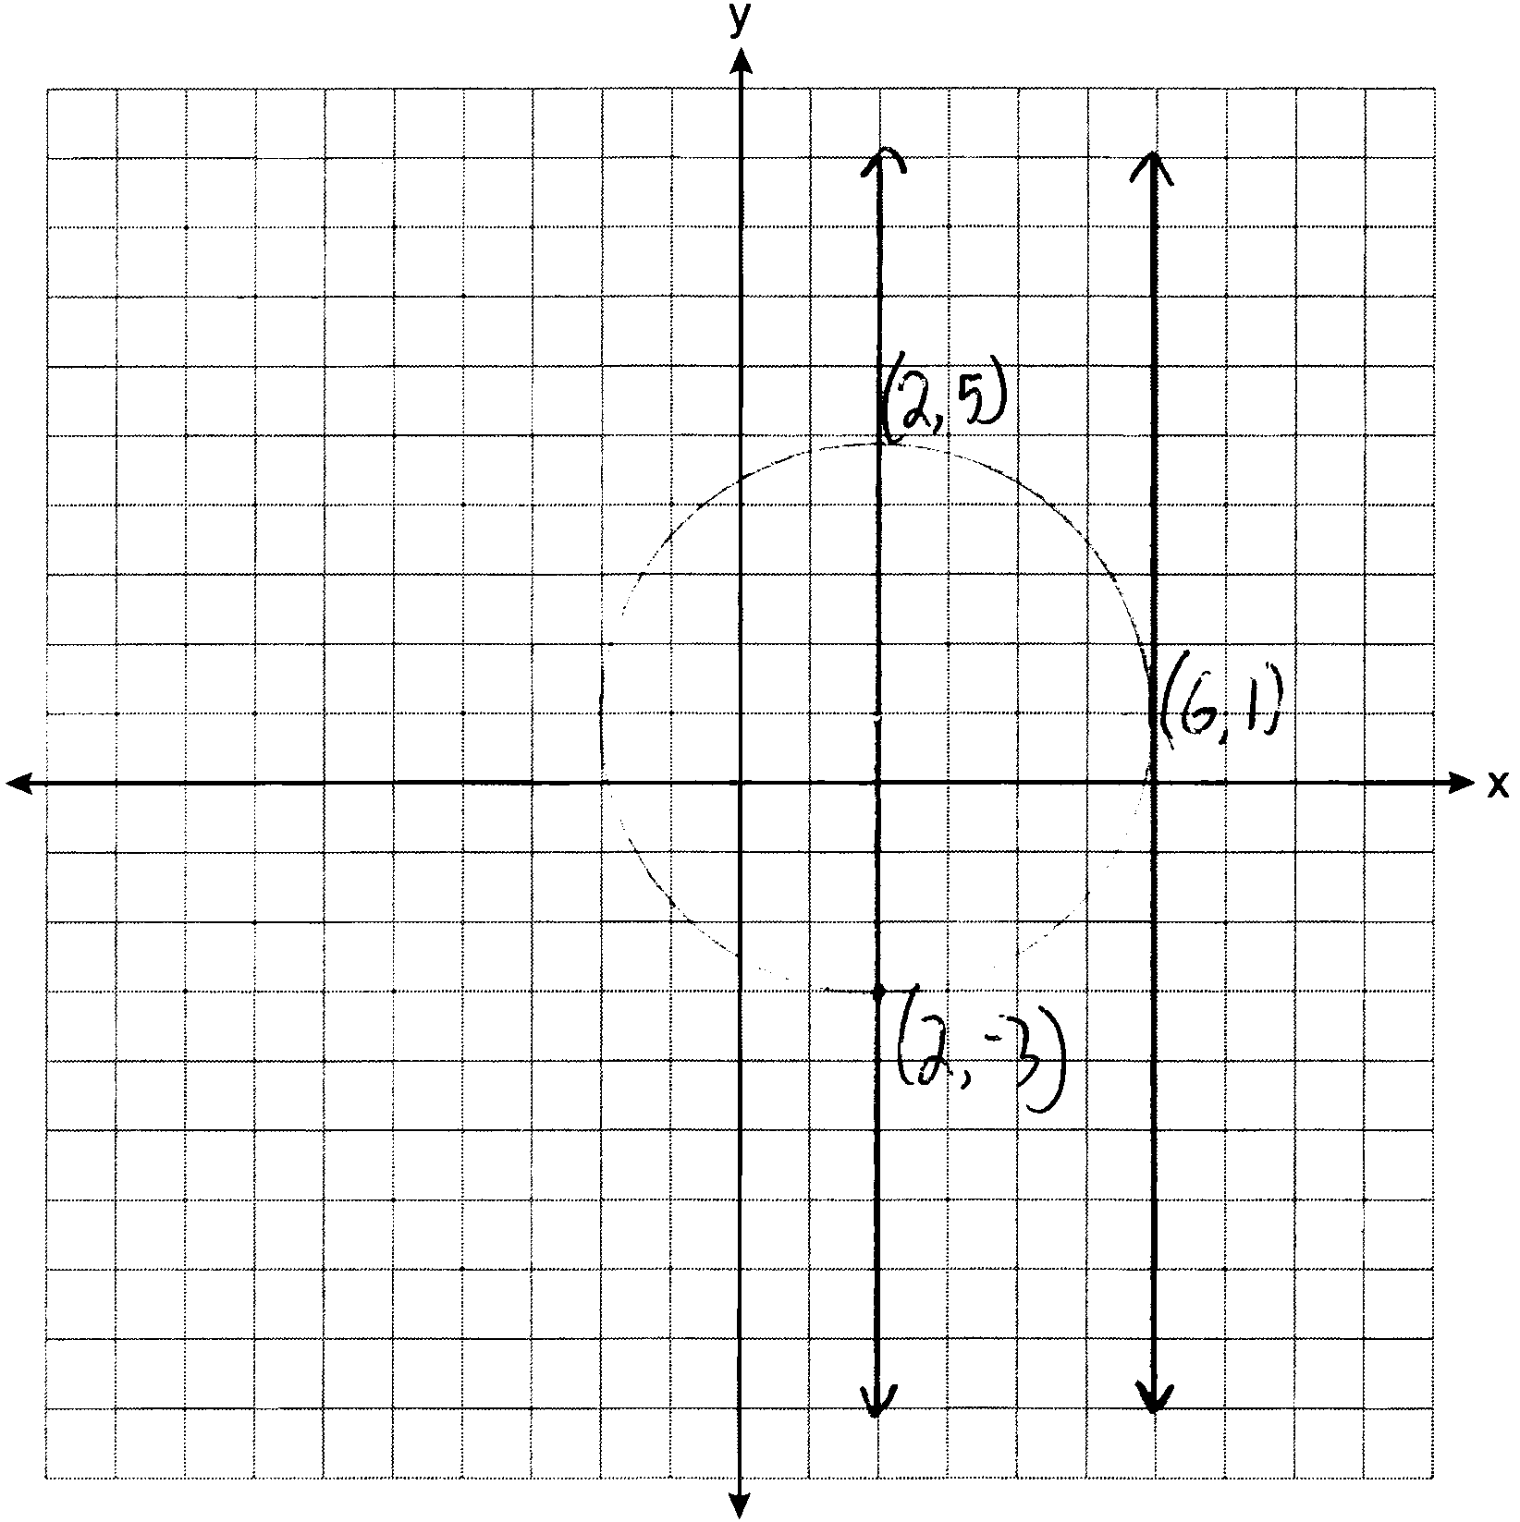

REF: 011135ge

11 ANS:
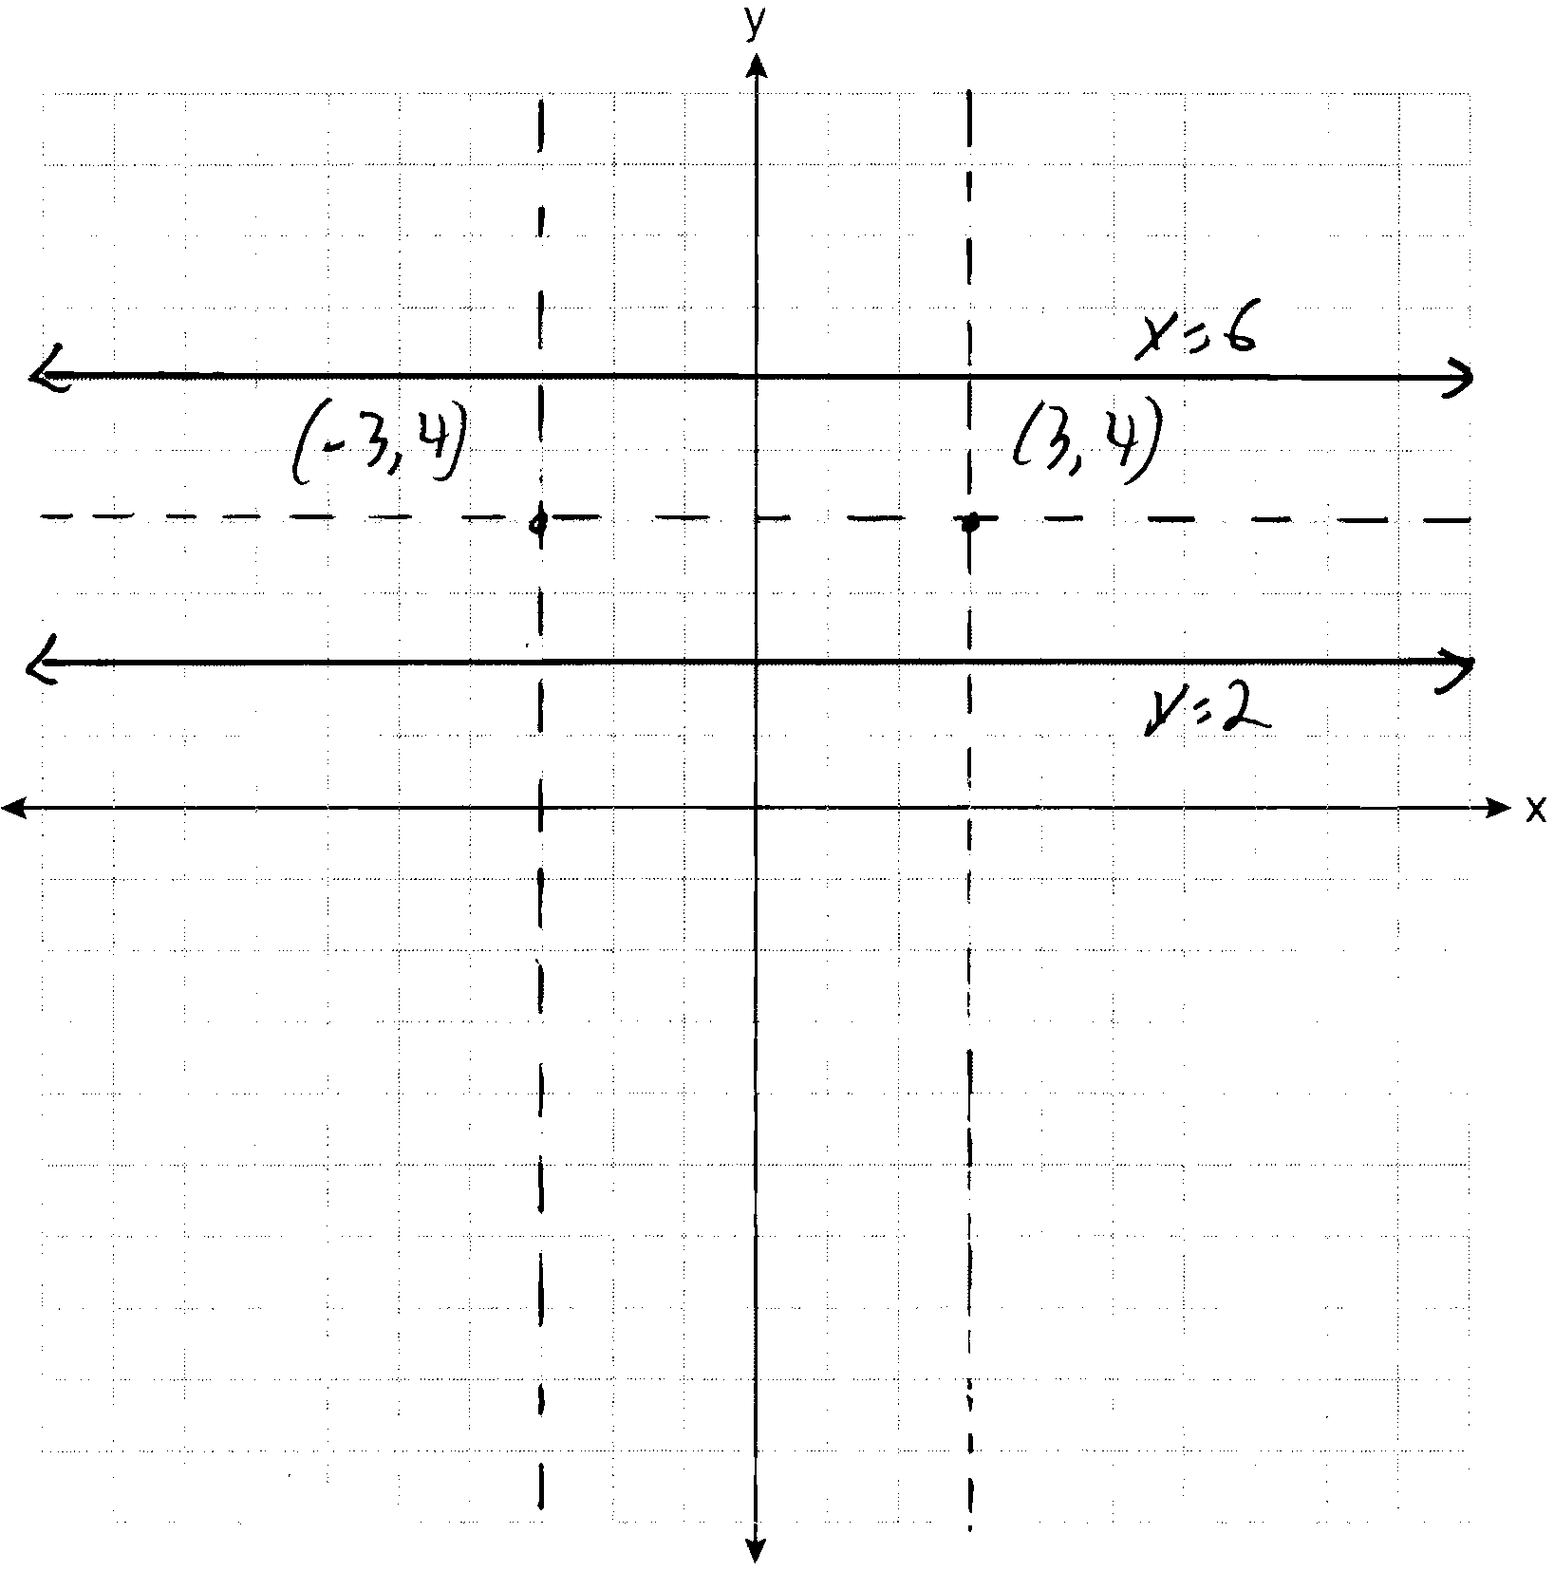

REF: 061135ge

12 ANS:
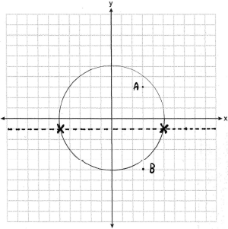

REF: fall0837ge

13 ANS:
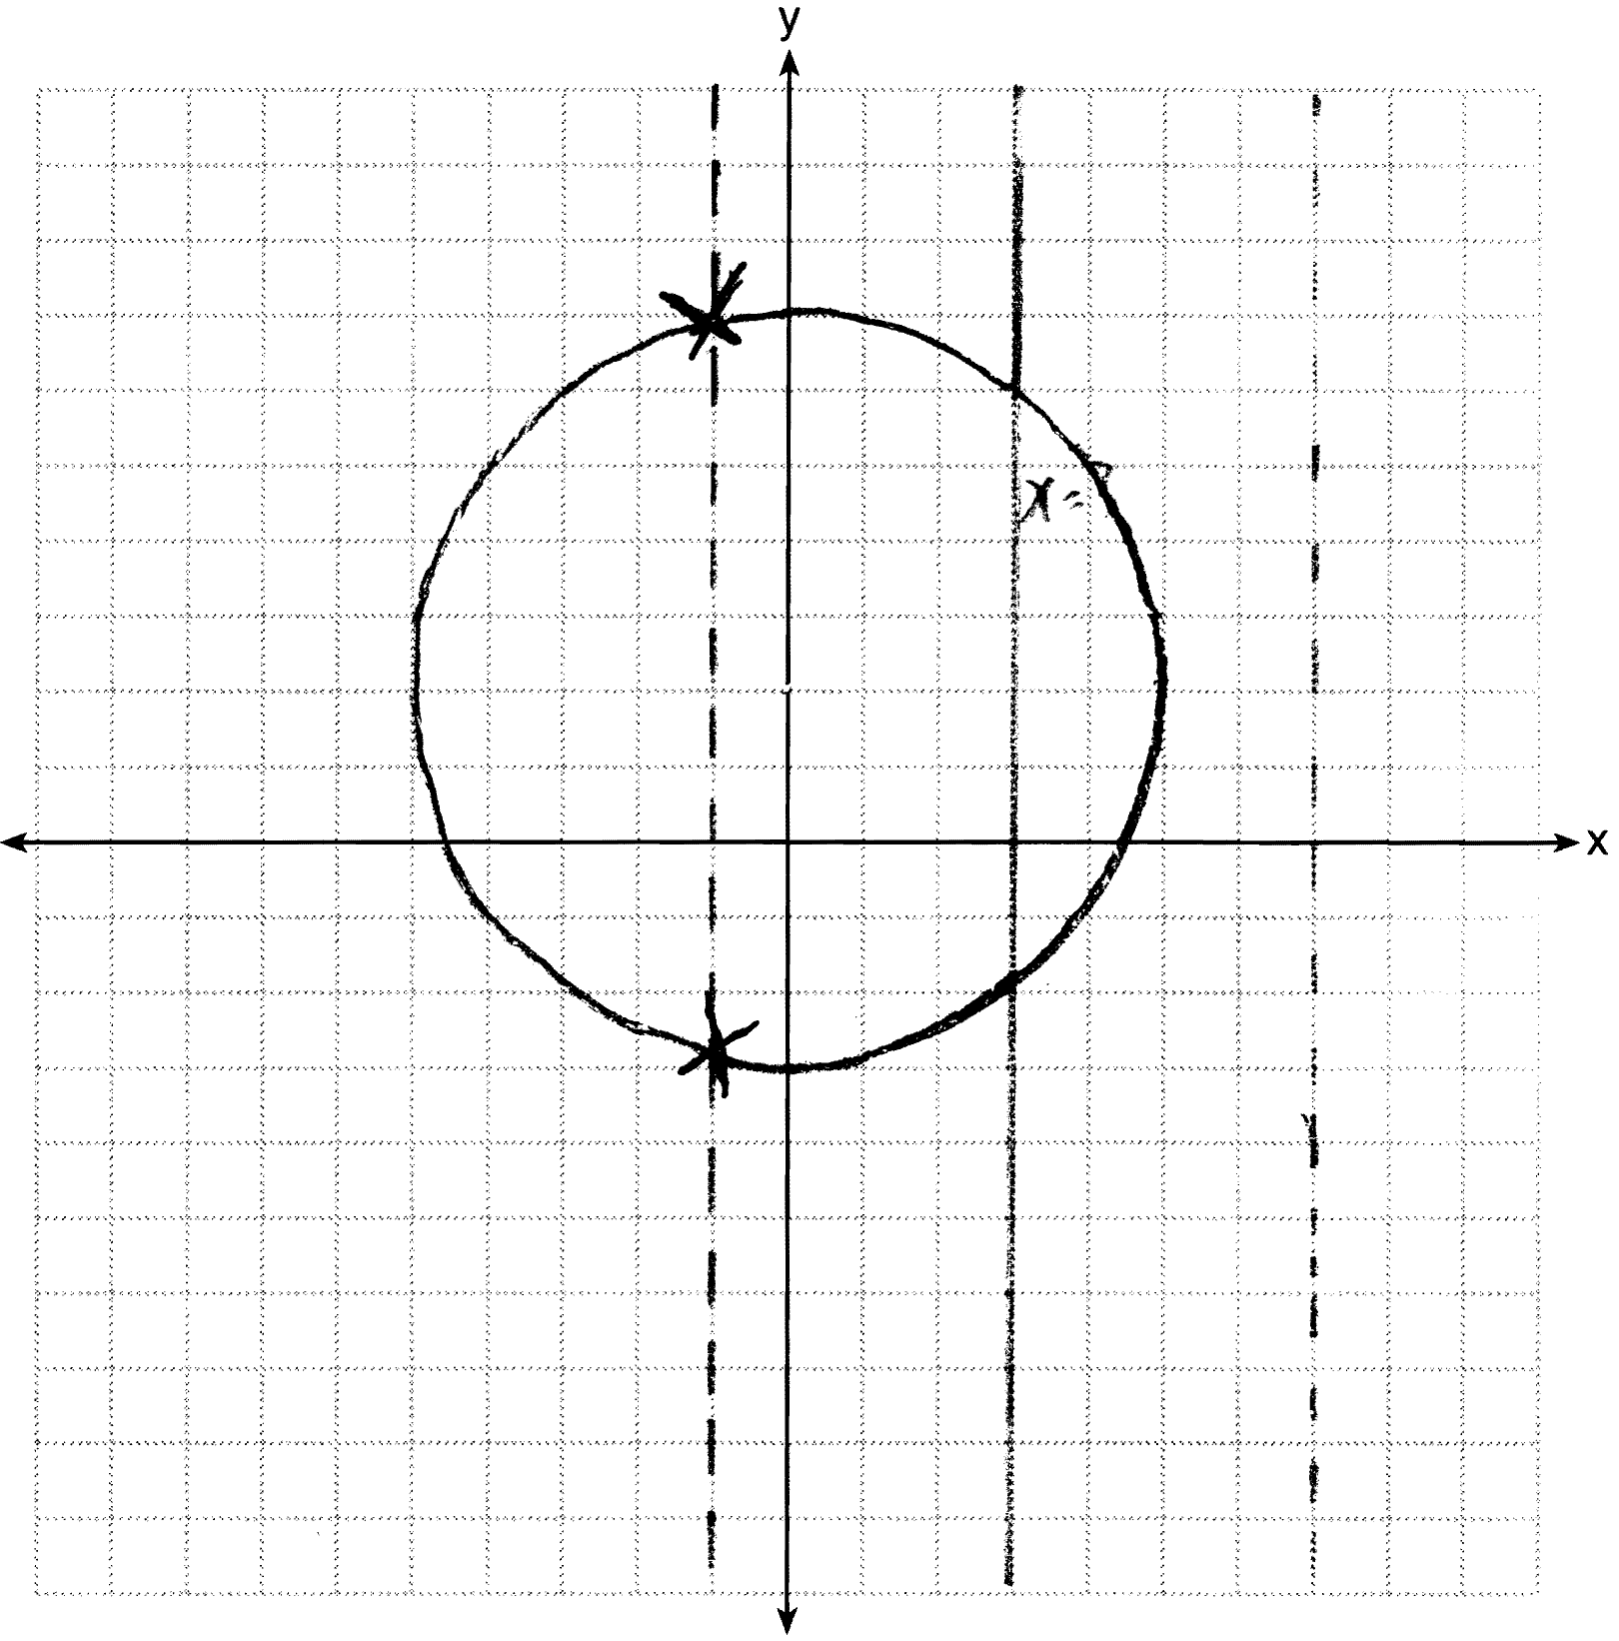

REF: 061234ge

14 ANS:
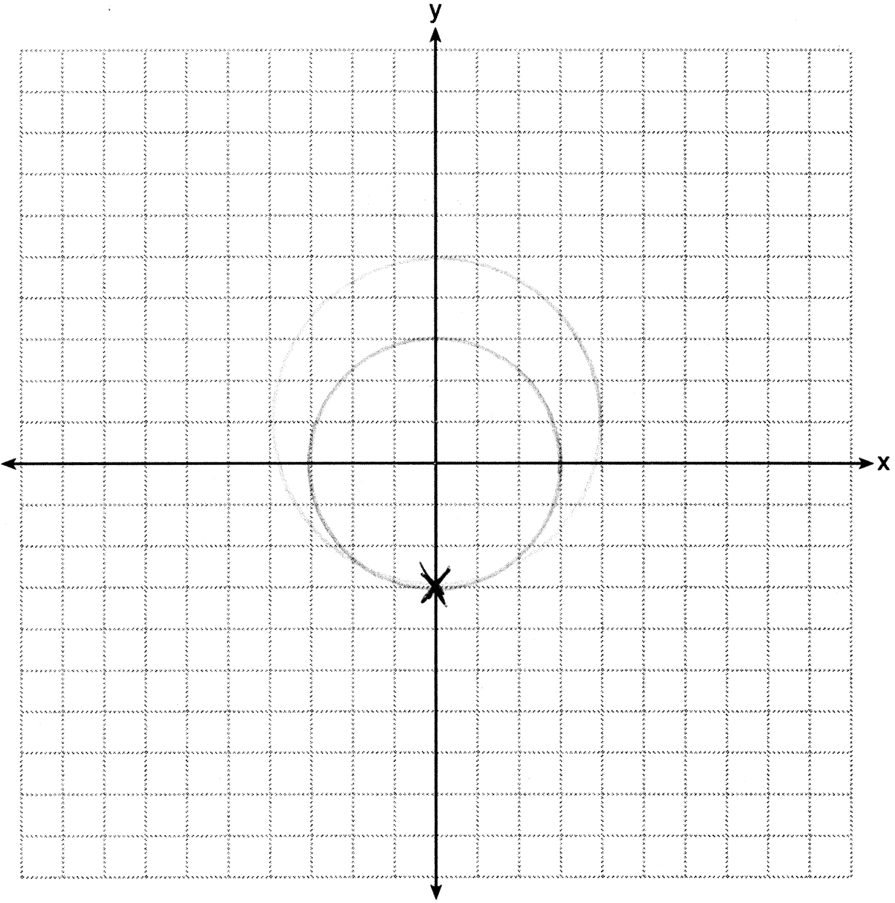

REF: 011331ge

15 ANS:
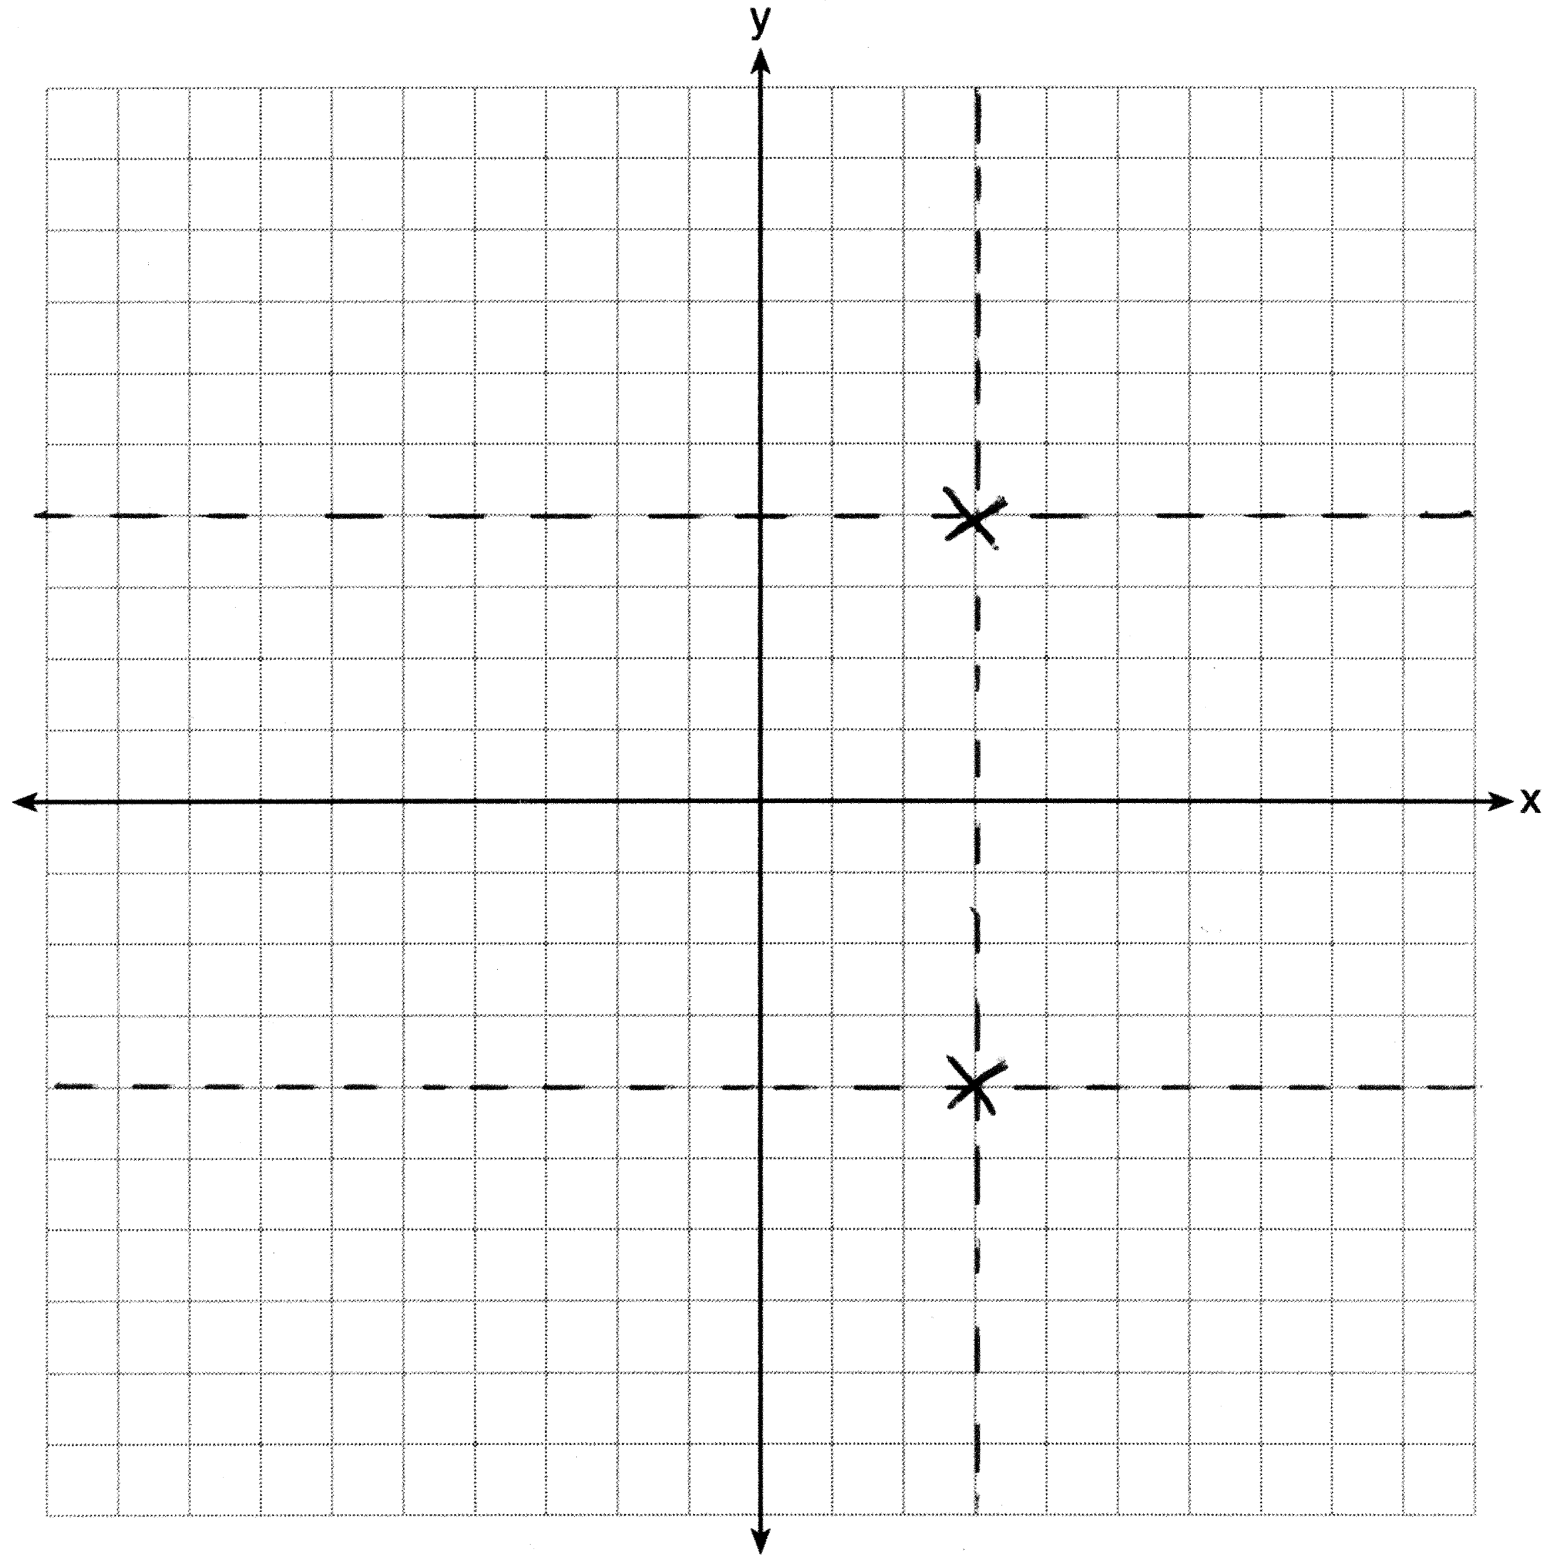

REF: 061333ge

16 ANS:
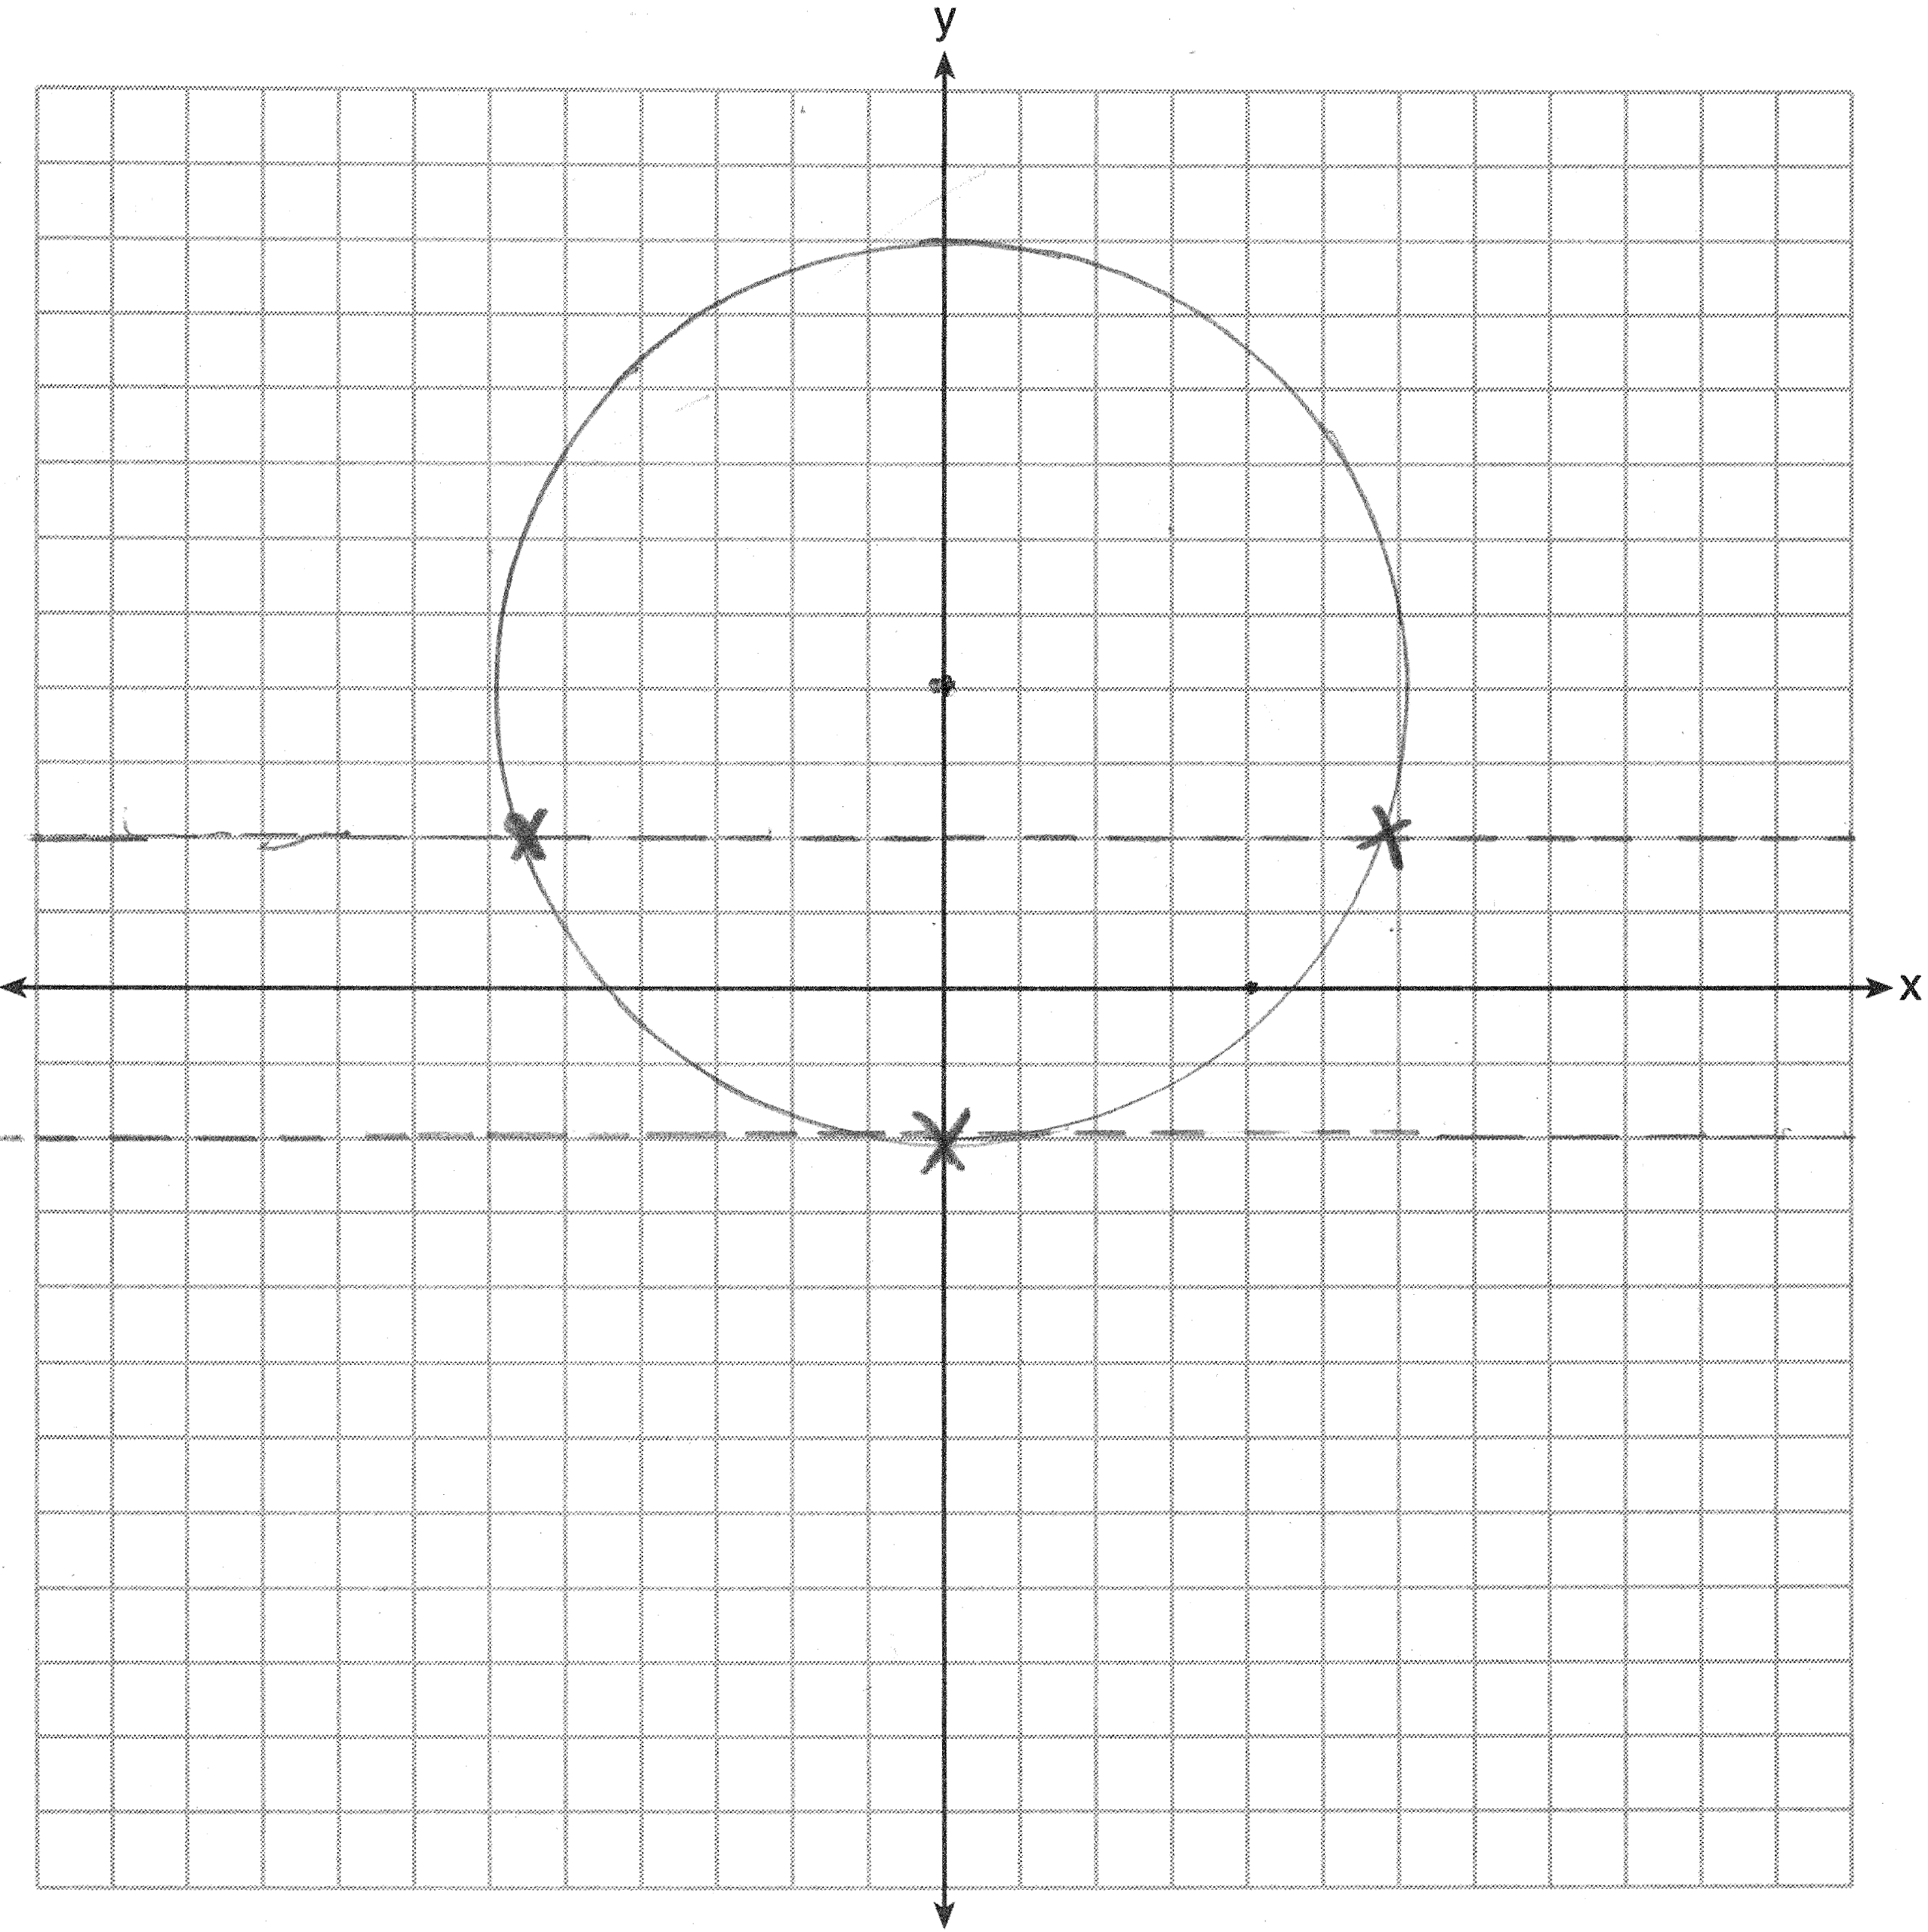
REF: 061436ge

17 ANS:
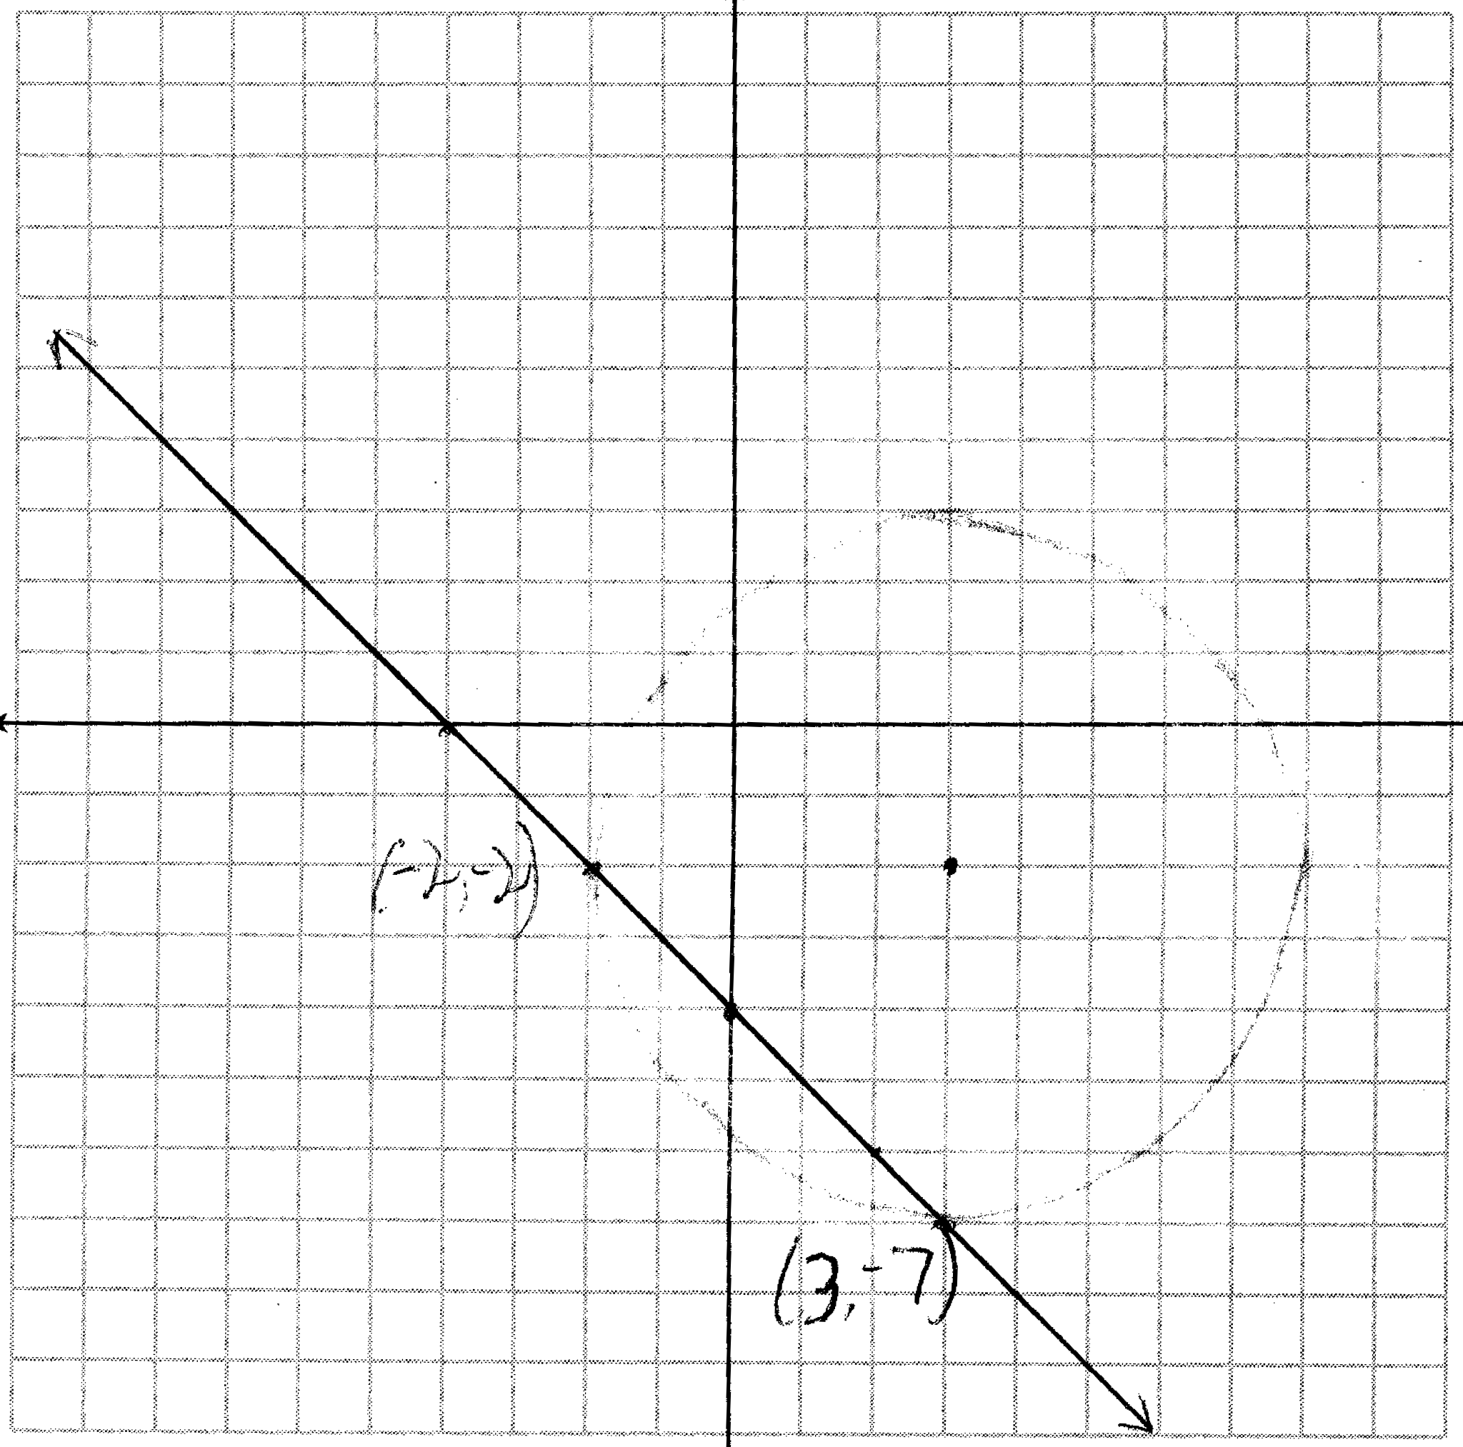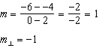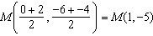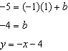
REF: 081438ge

18 ANS:
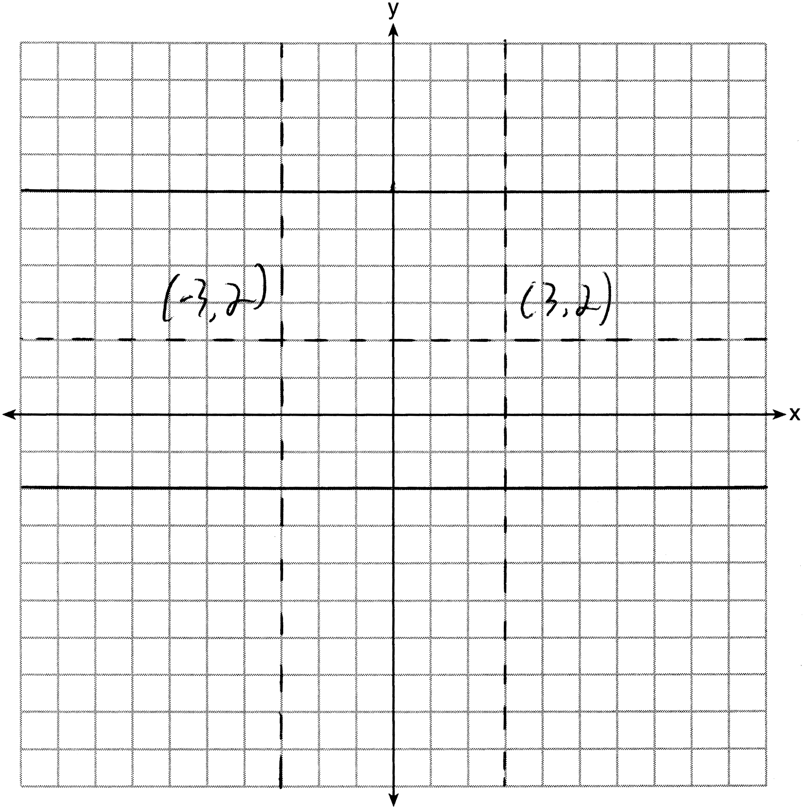
REF: 011536ge

19 ANS:
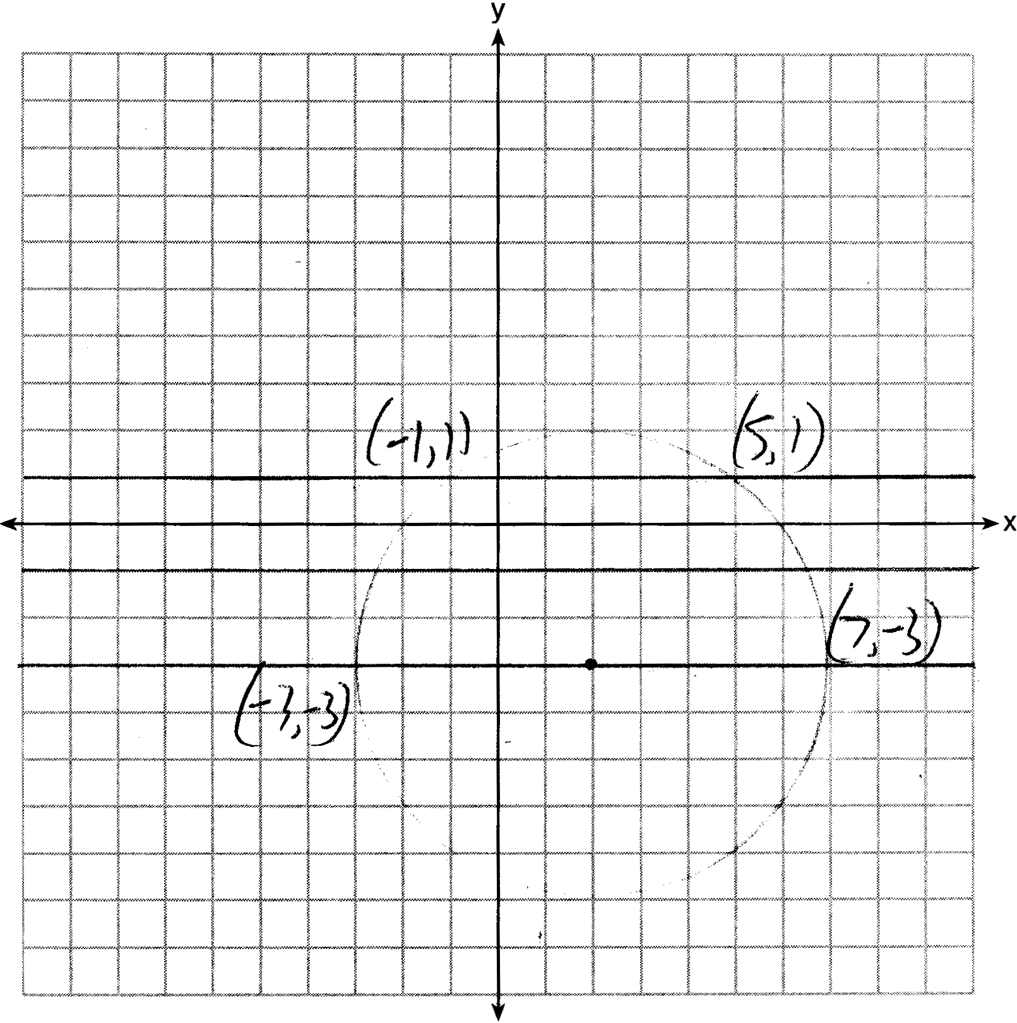
REF: 081535ge

