1 A man wants to place a new bird bath in his yard so that it is 30 feet from a fence, f, and also 10 feet from a light pole, P. As shown in the diagram below, the light pole is 35 feet away from the fence.

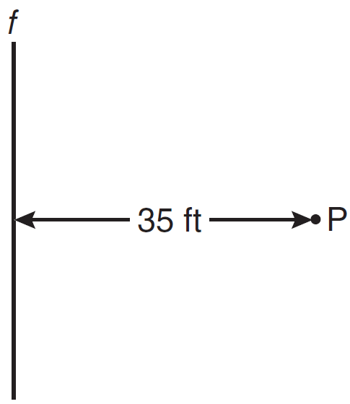

How many locations are possible for the bird bath?
1) | 1 | 3) | 3
2) | 2 | 4) | 0

2 Points A and B are on line , and line is parallel to line m, as shown in the diagram below.

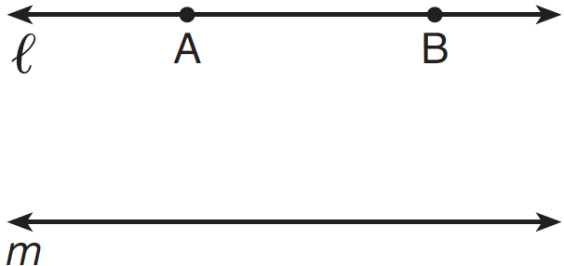

How many points are in the same plane as and m and equidistant from and m, and also equidistant from A and B?
1) | 1 | 3) | 3
2) | 2 | 4) | 0

3 How many points are 5 units from a line and also equidistant from two points on the line?
1) | 1 | 3) | 3
2) | 2 | 4) | 0

4 Points A and B are on line . How many points are 3 units from line and also equidistant from A and B?
1) | 1 | 3) | 3
2) | 2 | 4) | 4

5 Towns A and B are 16 miles apart. How many points are 10 miles from town A and 12 miles from town B?
1) | 1 | 3) | 3
2) | 2 | 4) | 0

6 In a park, two straight paths intersect. The city wants to install lampposts that are both equidistant from each path and also 15 feet from the intersection of the paths. How many lampposts are needed?
1) | 1 | 3) | 3
2) | 2 | 4) | 4

7 In the accompanying diagram, point P lies 3 centimeters from line .

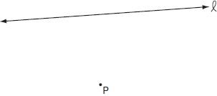

How many points are both 2 centimeters from line and 1 centimeter from point P?
1) | 1 | 3) | 0
2) | 2 | 4) | 4

8 The distance between points P and Q is eight (8) units. How many points are equidistant from P and Q and also three (3) units from P?
1) | 1 | 3) | 0
2) | 2 | 4) | 4

9 The distance between parallel lines and m is 12 units. Point A is on line . How many points are equidistant from lines and m and 8 units from point A.
1) | 1 | 3) | 3
2) | 2 | 4) | 4

10 What is the total number of points equidistant from two intersecting straight roads and also 300 feet from the traffic light at the center of the intersection?
1) | 1 | 3) | 3
2) | 2 | 4) | 4

11 How many points are equidistant from two parallel lines and also equidistant from two points on one of the lines?
1) | 1 | 3) | 3
2) | 2 | 4) | 4

12 Two lines, and , are parallel and 10 inches apart. Sketch the locus of all points that are equidistant from and and 7 inches from point R. Label with an X each point that satisfies both conditions.

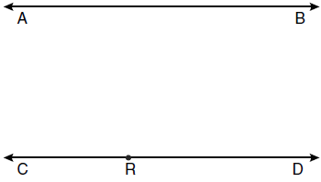

13 In the diagram below, car A is parked 7 miles from car B. Sketch the points that are 4 miles from car A and sketch the points that are 4 miles from car B. Label with an X all points that satisfy both conditions.



14 In the diagram below, point M is located on . Sketch the locus of points that are 1 unit from and the locus of points 2 units from point M. Label with an X all points that satisfy both conditions.

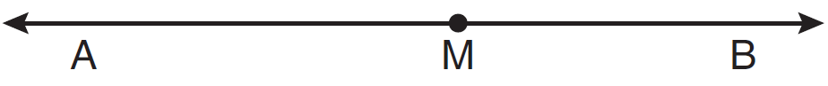

15 Two intersecting lines are shown in the diagram below. Sketch the locus of points that are equidistant from the two lines. Sketch the locus of points that are a given distance, d, from the point of intersection of the given lines. State the number of points that satisfy both conditions.

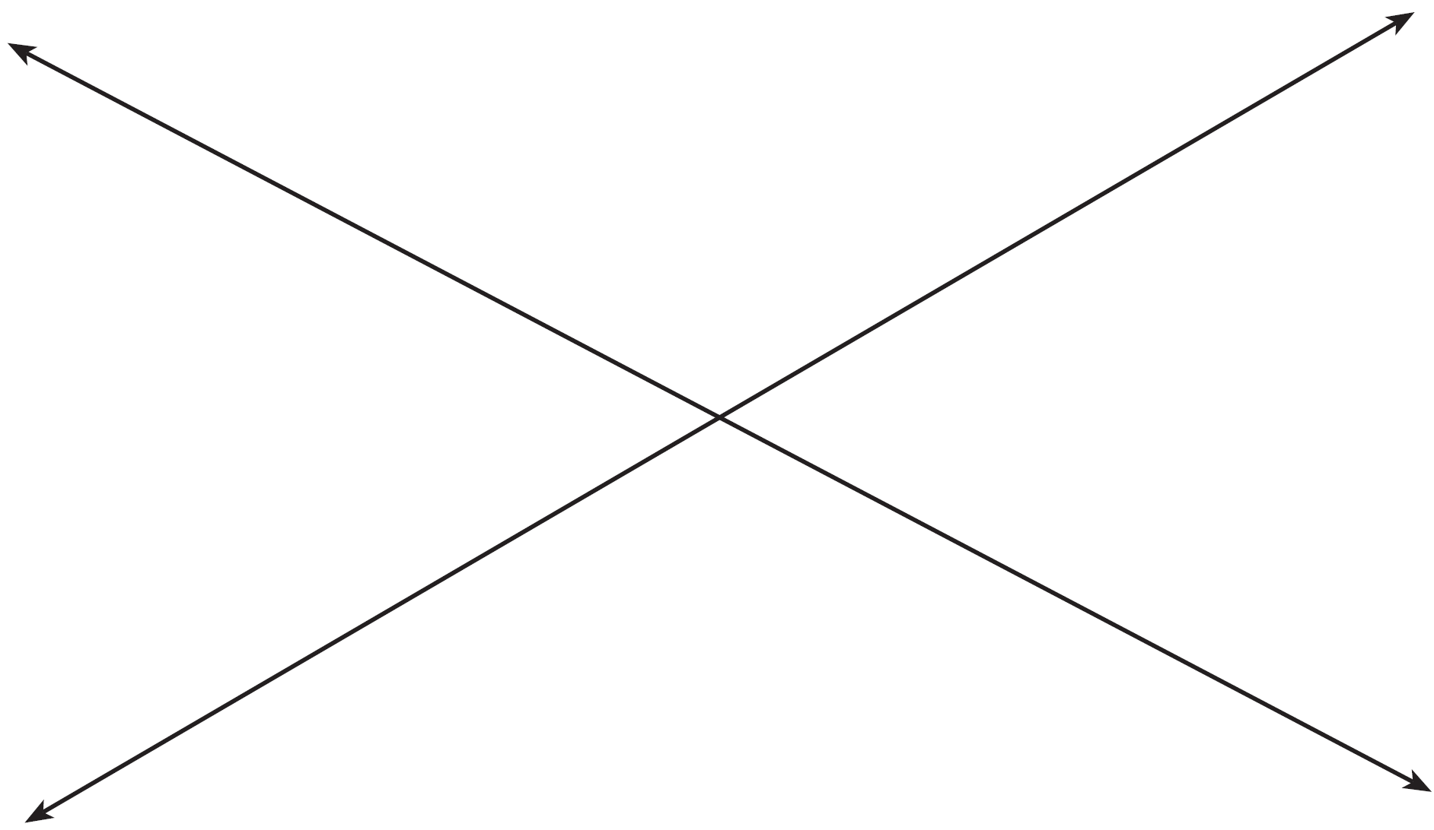

16 A tree, T, is 6 meters from a row of corn, c, as represented in the diagram below. A farmer wants to place a scarecrow 2 meters from the row of corn and also 5 meters from the tree. Sketch both loci. Indicate, with an X, all possible locations for the scarecrow.

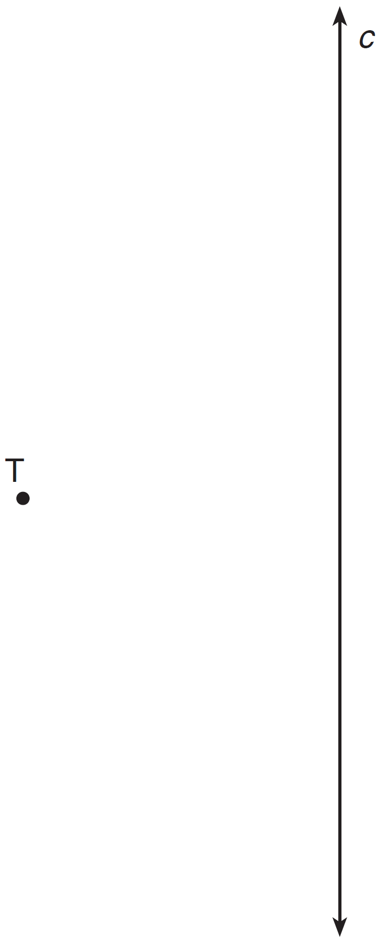

17 Point P is 5 units from line j. Sketch the locus of points that are 3 units from line j and also sketch the locus of points that are 8 units from P. Label with an X all points that satisfy both conditions.
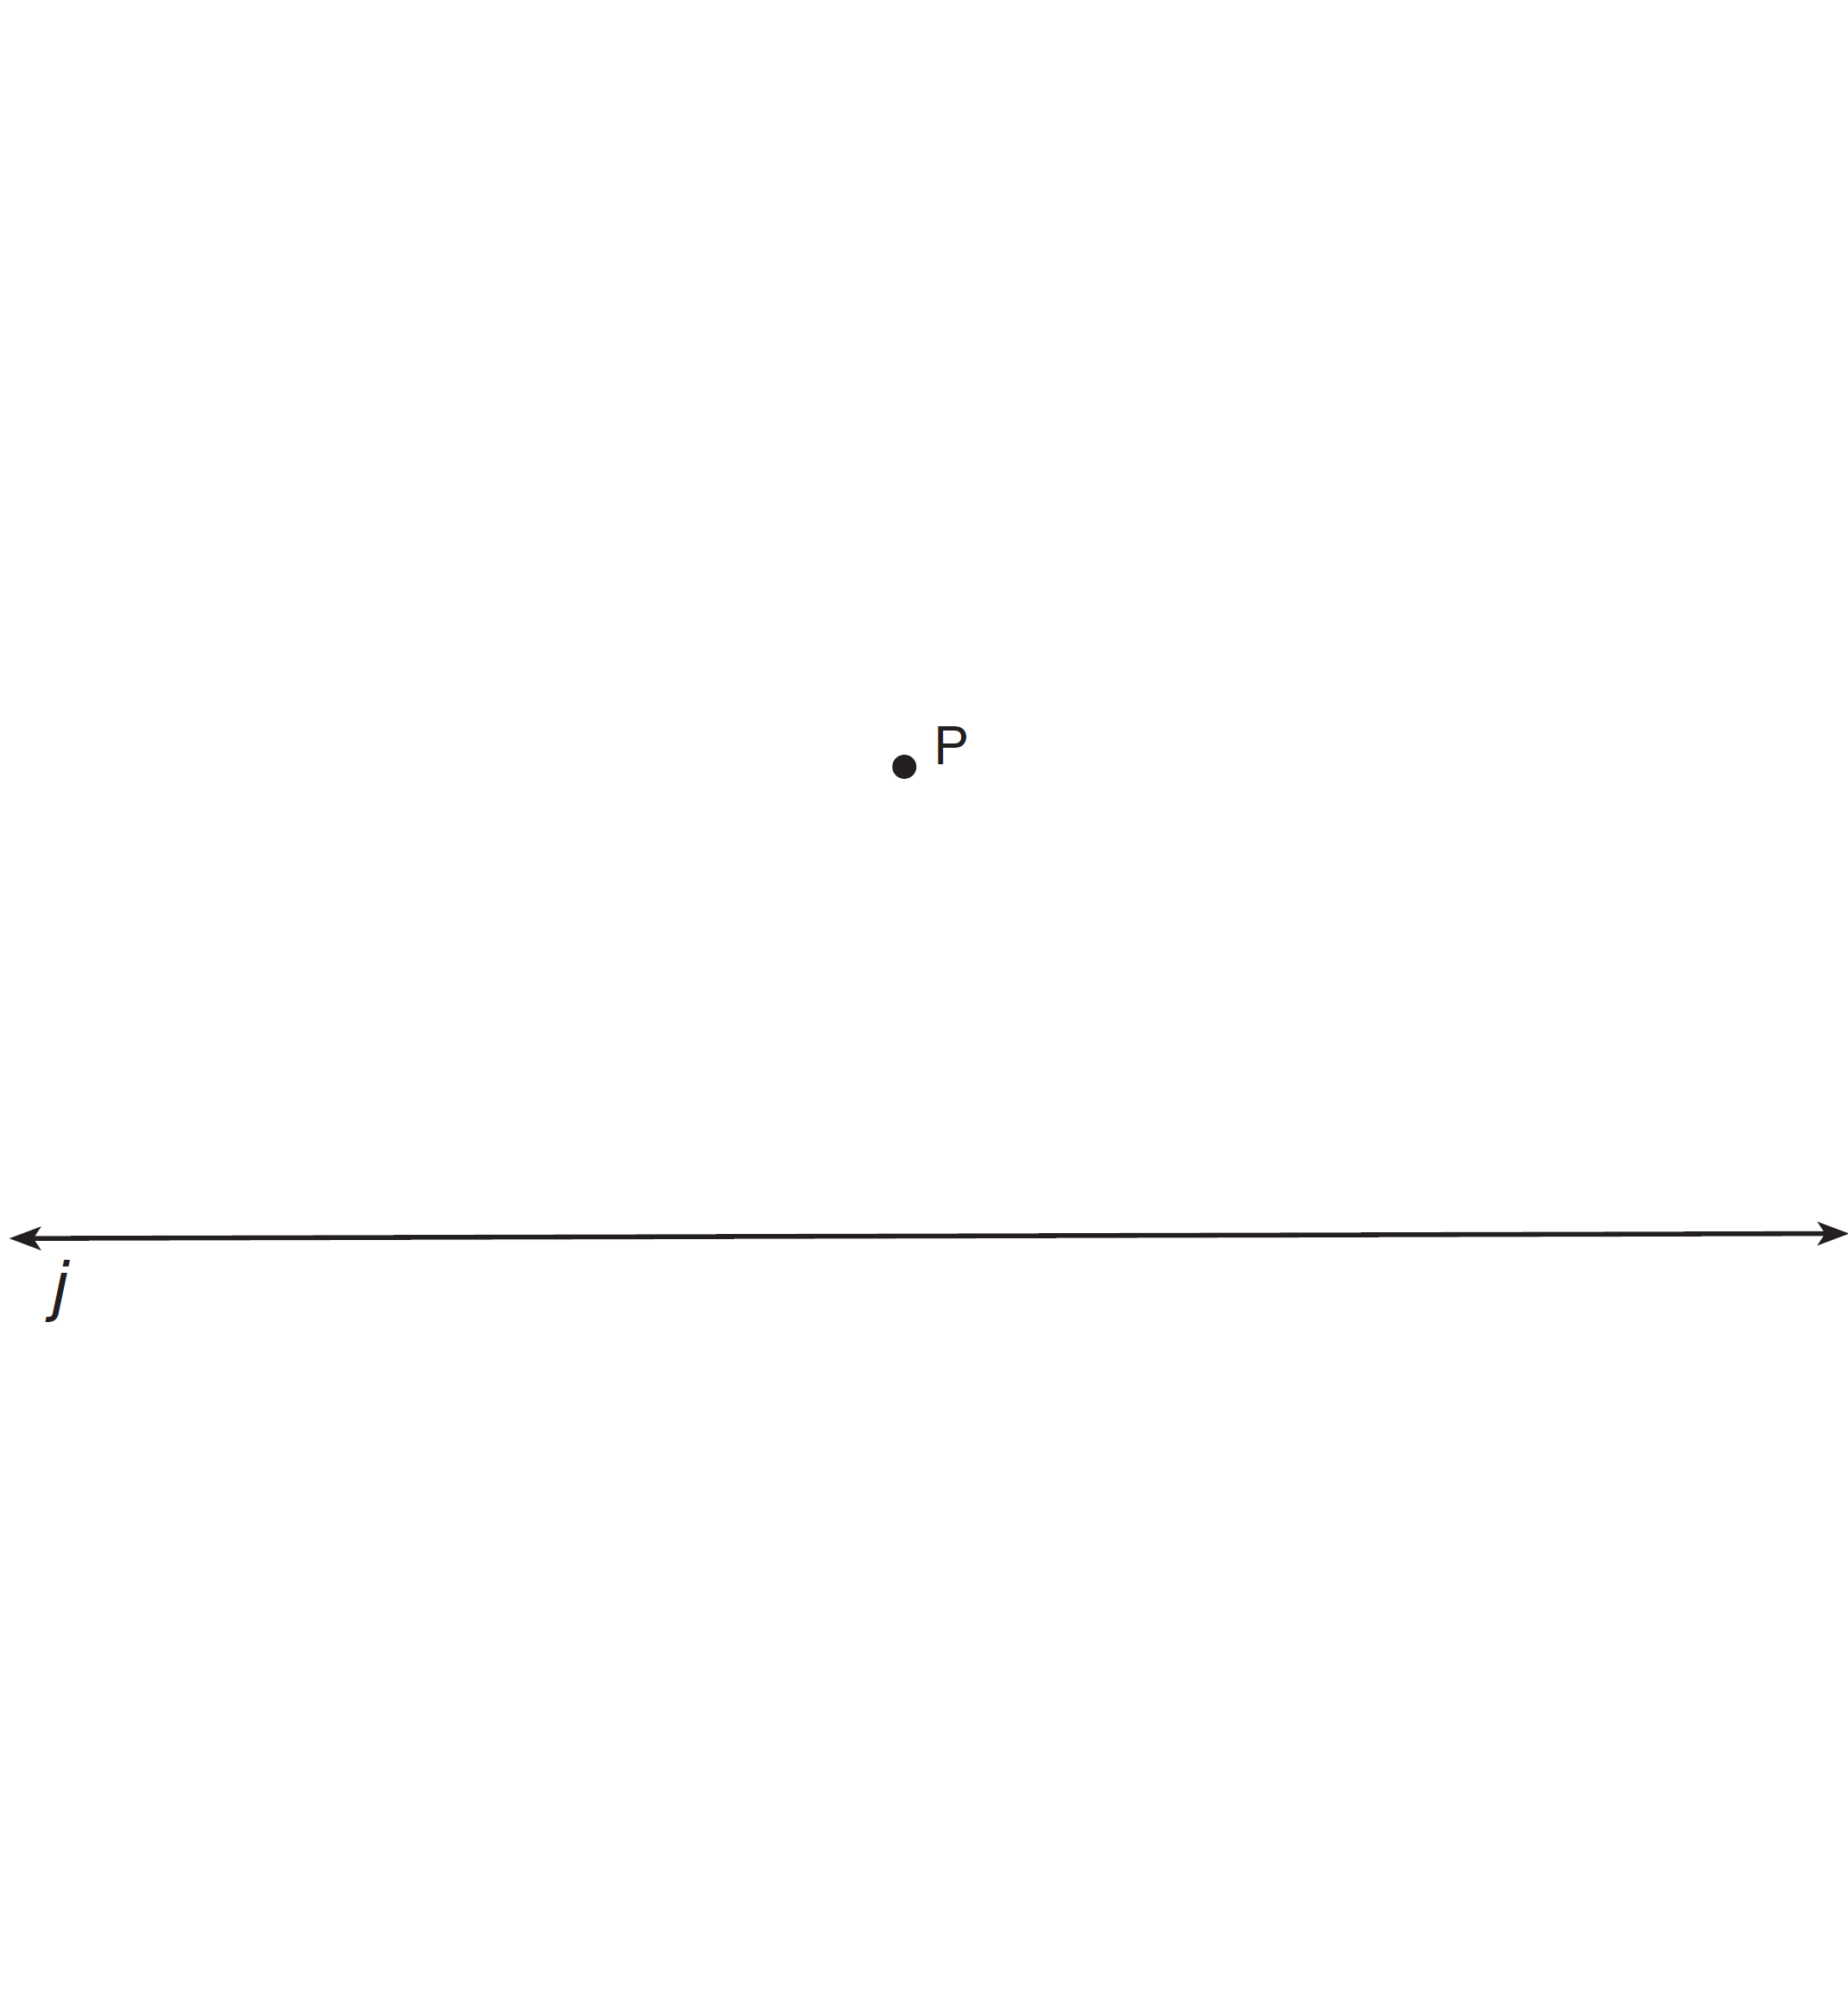

18 The length of is 3 inches. On the diagram below, sketch the points that are equidistant from A and B and sketch the points that are 2 inches from A. Label with an X all points that satisfy both conditions.

19 Steve has a treasure map, represented in the accompanying diagram, that shows two trees 8 feet apart and a straight fence connecting them. The map states that treasure is buried 3 feet from the fence and equidistant from the two trees.

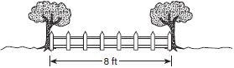

a Sketch a diagram to show all the places where the treasure could be buried. Clearly indicate in your diagram where the treasure could be buried.
b What is the distance between the treasure and one of the trees?

20 A triangular park is formed by the intersection of three streets, Bridge Street, Harbor Place, and College Avenue, as shown in the accompanying diagram. A walkway parallel to Harbor Place goes through the park. A time capsule has been buried in the park in a location that is equidistant from Bridge Street and College Avenue and 5 yards from the walkway. Indicate on the diagram with an X each possible location where the time capsule could be buried.

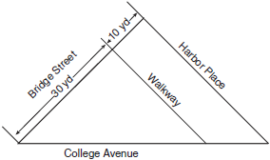
21 In the diagram below, town C lies on straight road p. Sketch the points that are 6 miles from town C. Then sketch the points that are 3 miles from road p. How many points satisfy both conditions?

22 Point P is located on .
a Describe the locus of points that are
3 units from
5 units from point P
b How many points satisfy both conditions in part a?

23 A treasure map shows a treasure hidden in a park near a tree and a statue. The map indicates that the tree and the statue are 10 feet apart. The treasure is buried 7 feet from the base of the tree and also 5 feet from the base of the statue. How many places are possible locations for the treasure to be buried? Draw a diagram of the treasure map, and indicate with an X each possible location of the treasure.
1 ANS: 2 REF: 061121ge

2 ANS: 1 REF: 081522ge

3 ANS: 2 REF: 011317ge

4 ANS: 2 REF: 011609ge

5 ANS: 2 REF: 011011ge

6 ANS: 4 REF: 061303ge

7 ANS: 1 REF: 010623a

8 ANS: 3 REF: spring9817a

9 ANS: 2 REF: 010020a

10 ANS: 4 REF: 080203a

11 ANS: 1 REF: 010527a

12 ANS:
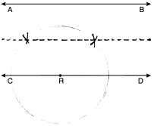
REF: 061033ge

13 ANS:
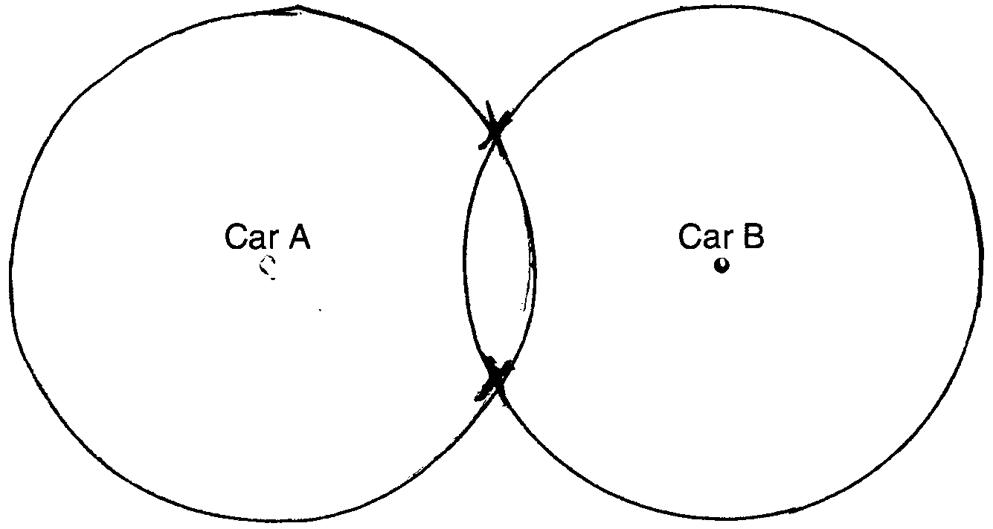
REF: 081033ge

14 ANS:
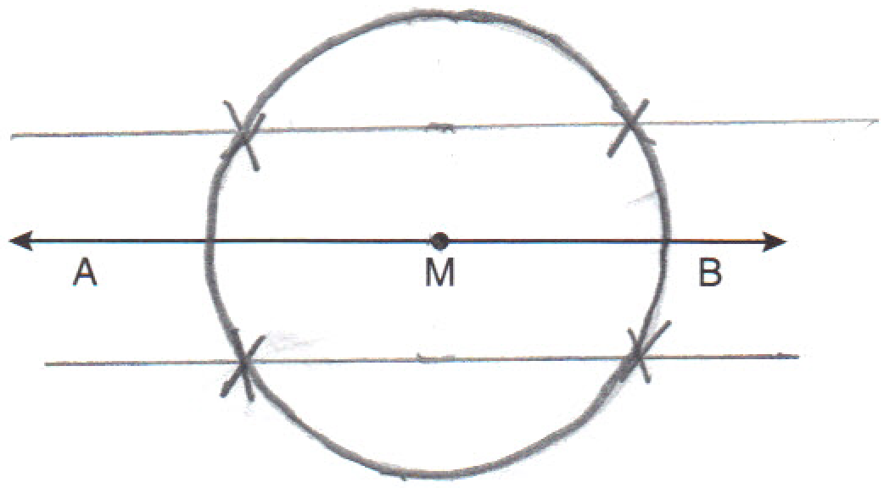
REF: 011230ge

15 ANS:
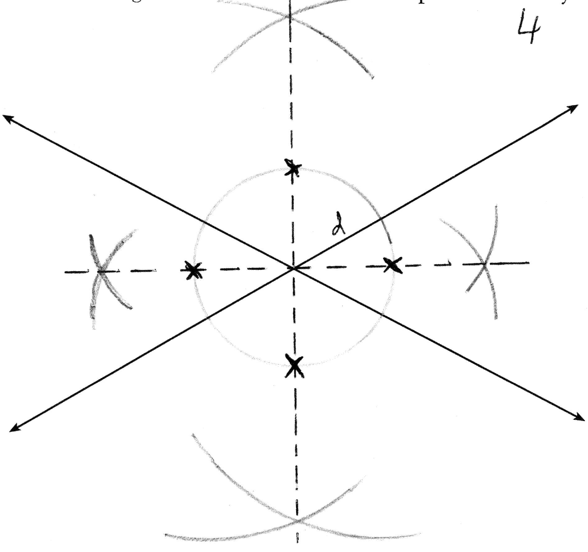
REF: 081334ge

16 ANS:
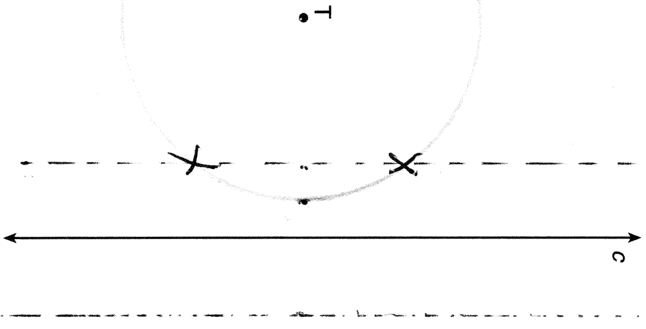
REF: 011434ge

17 ANS:
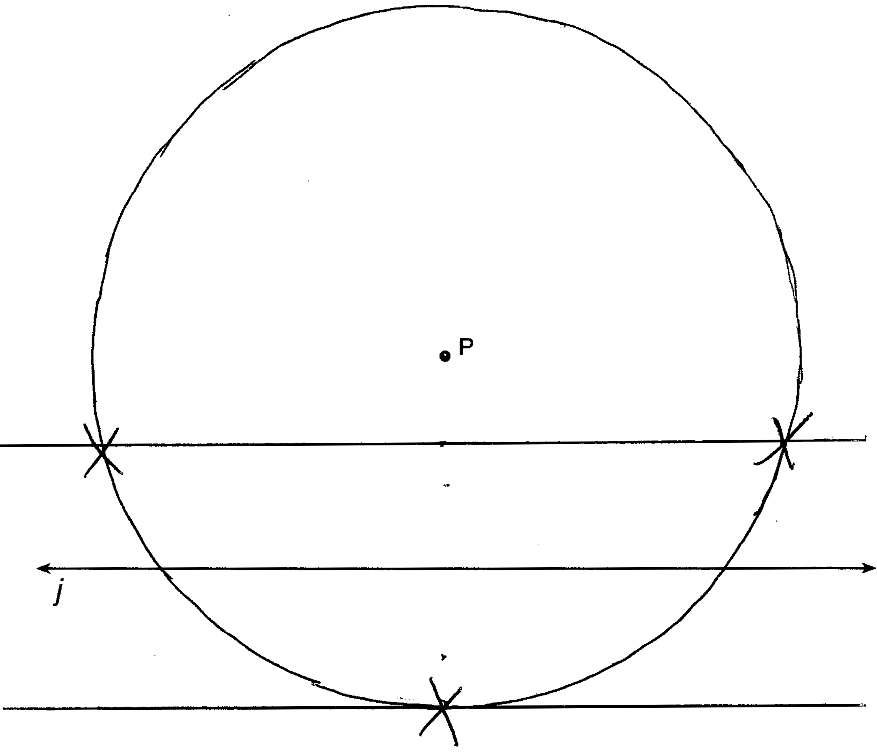
REF: 061537ge

18 ANS:
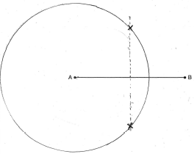
REF: 060932ge

19 ANS:
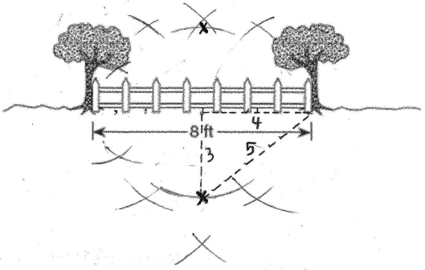. 5 feet. Bisecting the 8 ft segment creates two 4 ft segments. Bisecting one of the 4 ft segments creates two 2 ft segments. Bisecting one of the 2 ft segments creates two 1 ft segments, which can be used to construct a 3 ft segment.
REF: 010127a

20 ANS:
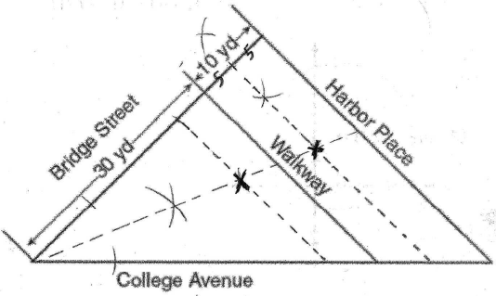. Bisect the angle created by Bridge Street and College Avenue to mark the locus of points equidistant from Bridge Street and College Avenue. Bisect the 10 yd segment to construct a 5 yd segment. Use this distance to mark the two loci of points 5 yards from the walkway.
REF: 060332a

21 ANS:
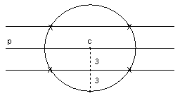 4
REF: 080737a

22 ANS:
The locus of points that are 3 units from are two lines parallel to , one 3 units above and the other 3 units below . The locus of points that are 5 units from point P is a circle with radius of 5. 4 points satisfy both conditions.
REF: 080131a

23 ANS:
2 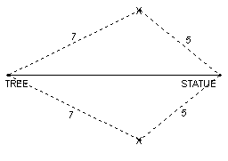
REF: 060032a

