1 If point P lies on line , which diagram represents the locus of points 3 centimeters from point P?
1) | 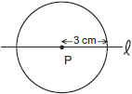
2) | 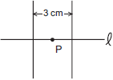
3) | 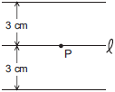
4) | 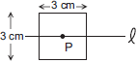

2 In the accompanying diagram, line is parallel to line .

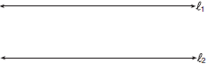

Which term describes the locus of all points that are equidistant from line and line ?
1) | line
2) | circle
3) | point
4) | rectangle

3 The locus of points equidistant from two sides of an acute scalene triangle is
1) | an angle bisector
2) | an altitude
3) | a median
4) | the third side

4 Chantrice is pulling a wagon along a smooth, horizontal street. The path of the center of one of the wagon wheels is best described as
1) | a circle
2) | a line perpendicular to the road
3) | a line parallel to the road
4) | two parallel lines

5 Which equation represents the locus of points 4 units from the origin?
1)
2)
3)
4)

6 Which equation represents the locus of all points 5 units below the x-axis?
1)
2)
3)
4)

7 The locus of points equidistant from the points and is the line whose equation is
1)
2)
3)
4)

8 Maria’s backyard has two trees that are 40 feet apart, as shown in the accompanying diagram. She wants to place lampposts so that the posts are 30 feet from both of the trees. Draw a sketch to show where the lampposts could be placed in relation to the trees. How many locations for the lampposts are possible?

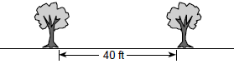

9 Dan is sketching a map of the location of his house and his friend Matthew's house on a set of coordinate axes. Dan locates his house at point and locates Matthews house, which is 6 miles east of Dan's house, at point . On the accompanying set of coordinate axes, graph the locus of points equidistant from the two houses. Then write the equation of the locus.

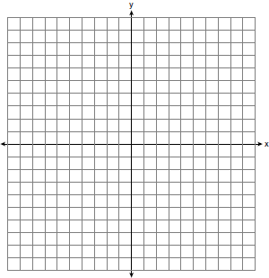
1 ANS: 1 REF: 060212a

2 ANS: 1 REF: 010409a

3 ANS: 1 REF: 010317a

4 ANS: 3 REF: 060619a

5 ANS: 4 REF: 080426a

6 ANS: 3 REF: 080512a

7 ANS: 1
The midpoint of (4,-5) and (4,7) is (4,1).

REF: 010830a

8 ANS:
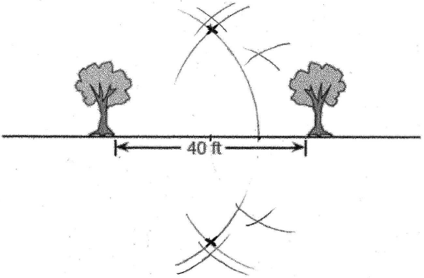. 2. Bisecting the 40 ft segment creates two 20 ft segments. Bisecting one of the 20 ft segments creates two 10 ft segments, which can be used to construct a 30 ft segment.

REF: 089925a

9 ANS:
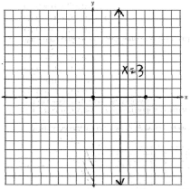

REF: 080634a

