1 Which graph represents a circle with the equation ?
1) | 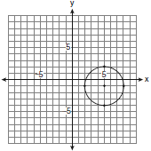
2) | 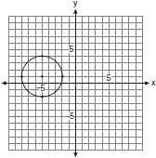
3) | 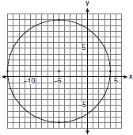
4) | 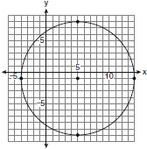

2 Which graph represents a circle with the equation ?
1) | 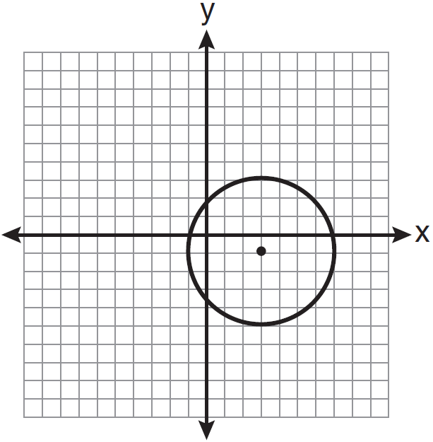
2) | 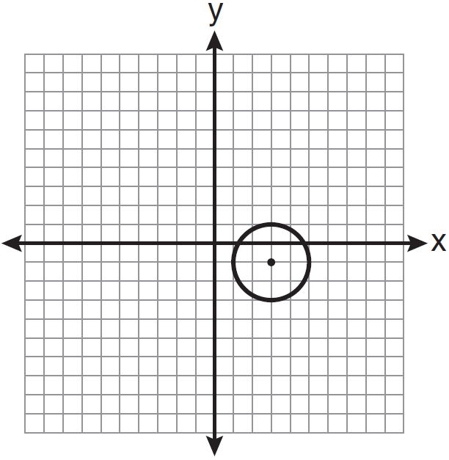
3) | 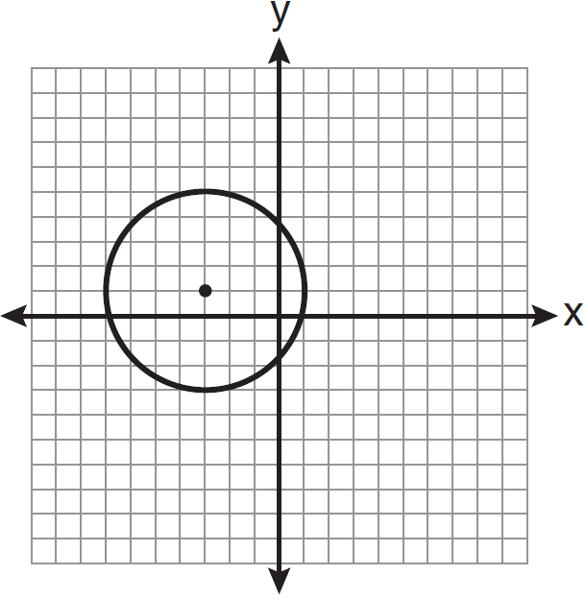
4) | 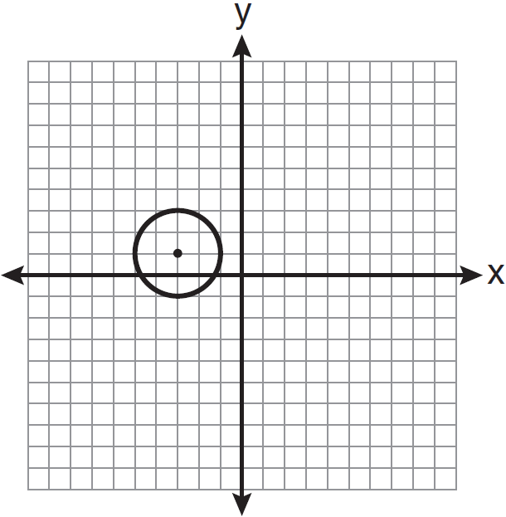

3 The equation of a circle is . Which diagram is the graph of the circle?
1) | 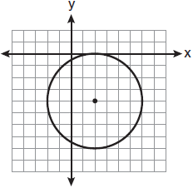
2) | 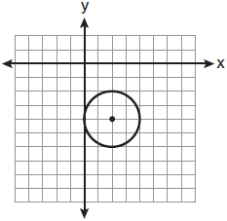
3) | 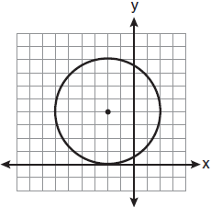
4) | 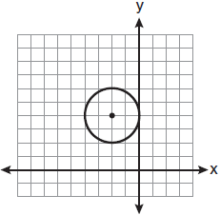

4 Which graph represents a circle whose equation is ?
1) | 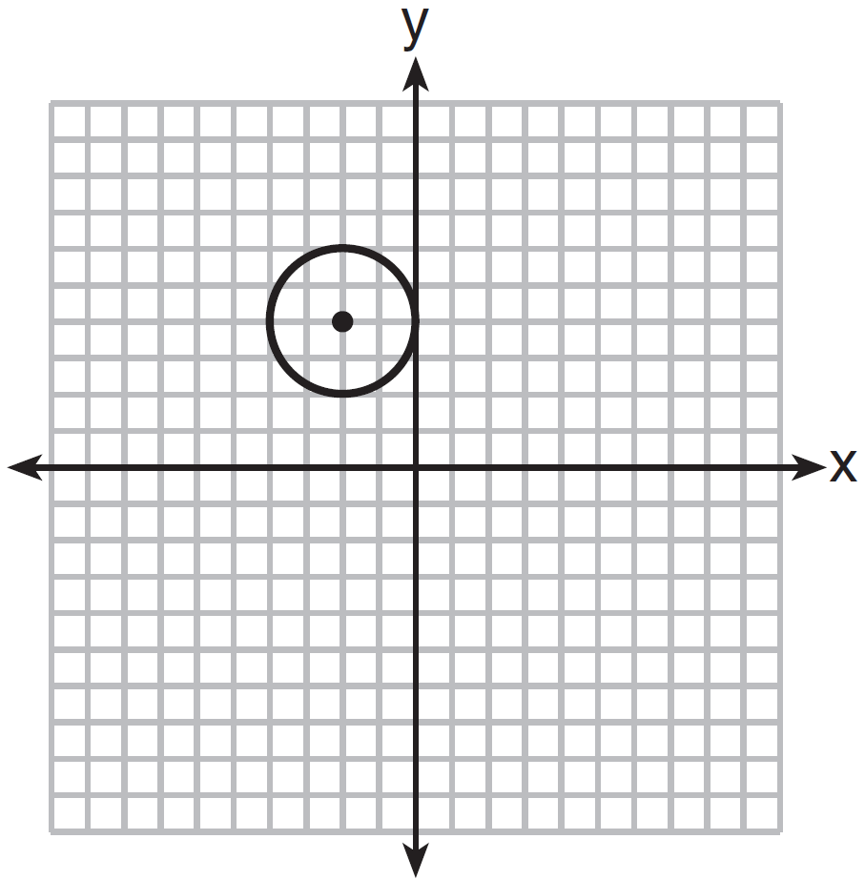
2) | 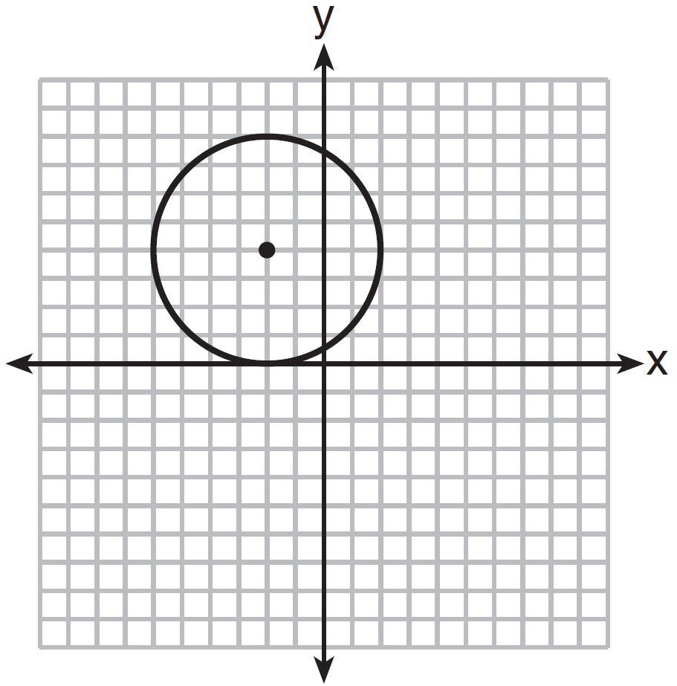
3) | 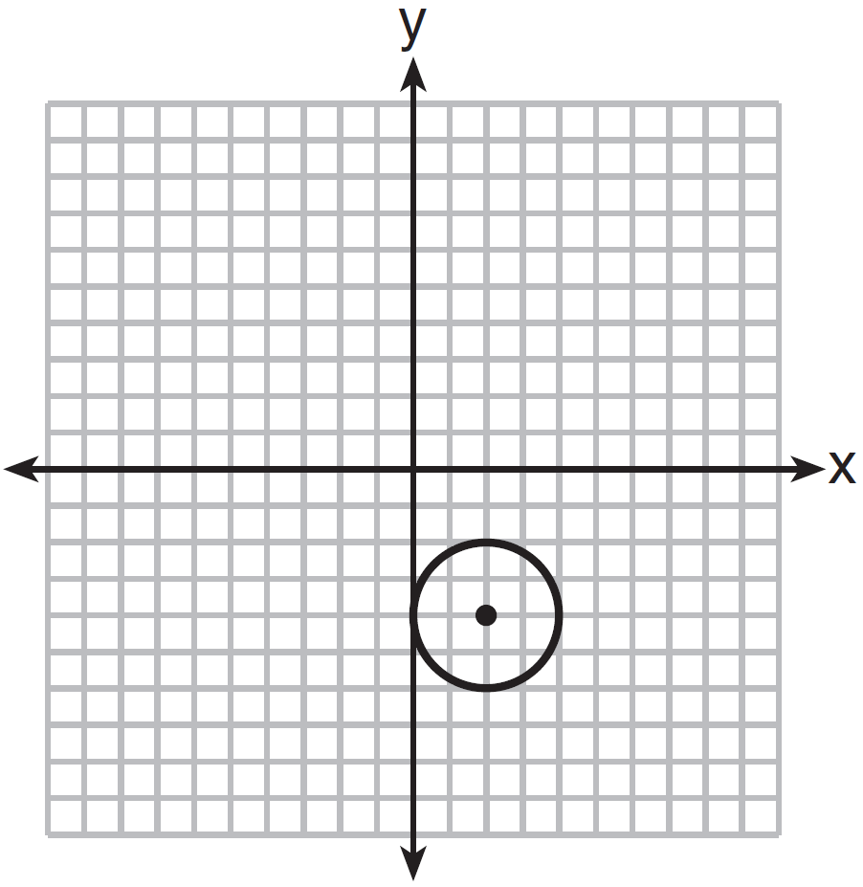
4) | 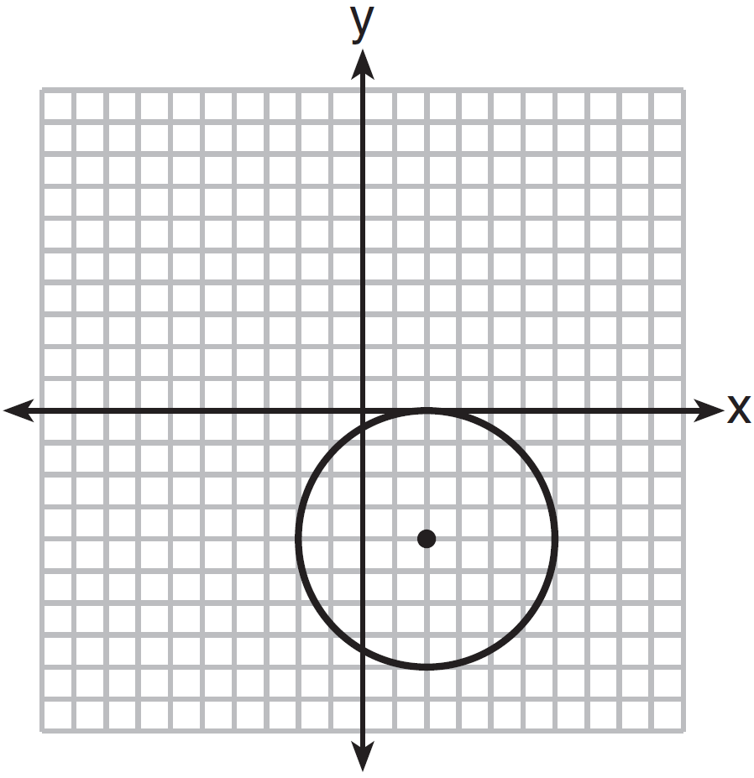

5 Which graph represents a circle whose equation is ?
1) | 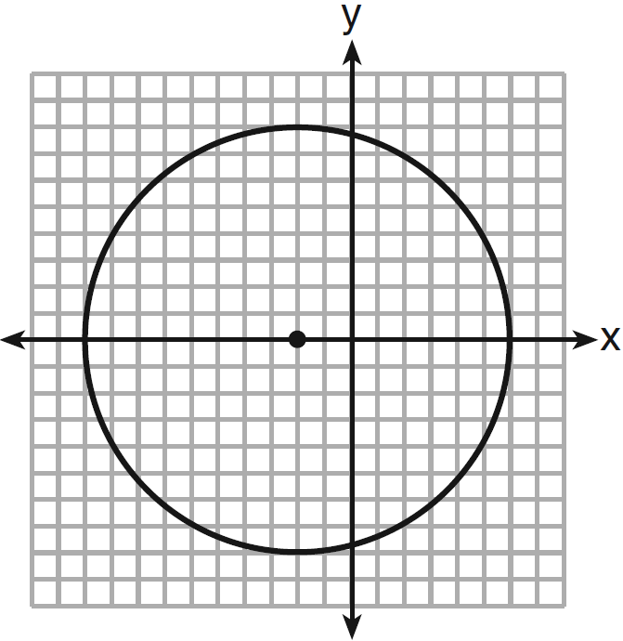
2) | 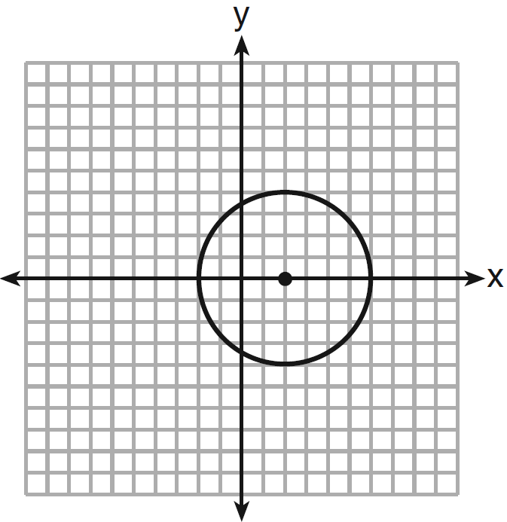
3) | 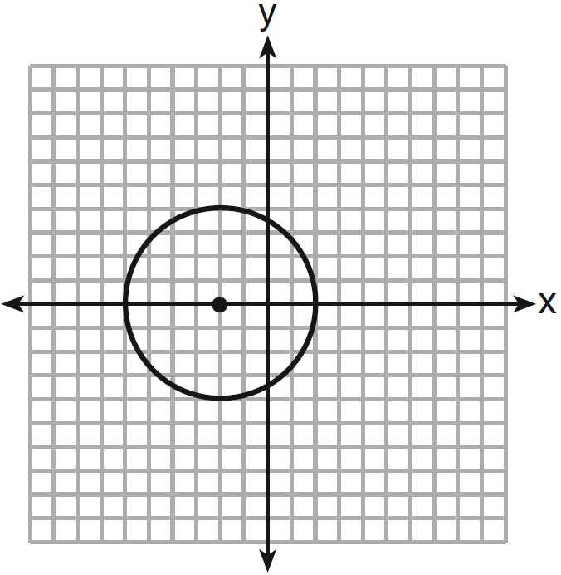
4) | 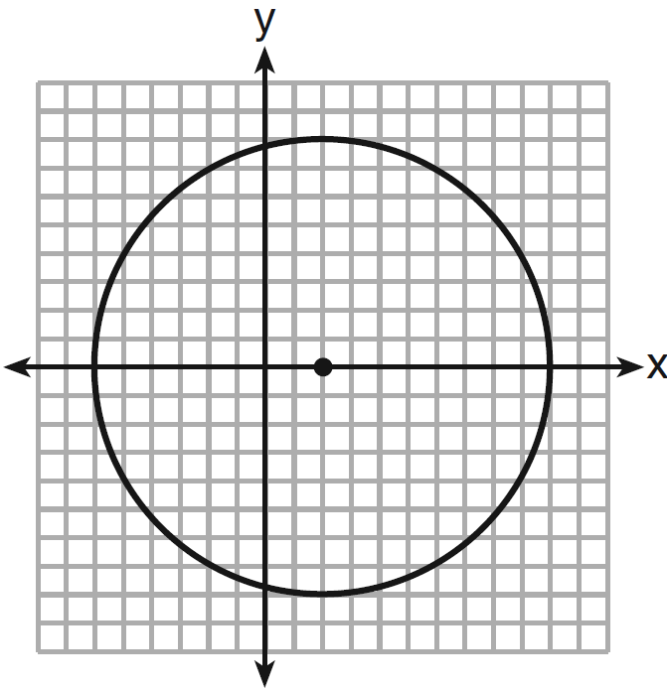

6 Which graph represents a circle whose equation is ?
1) | 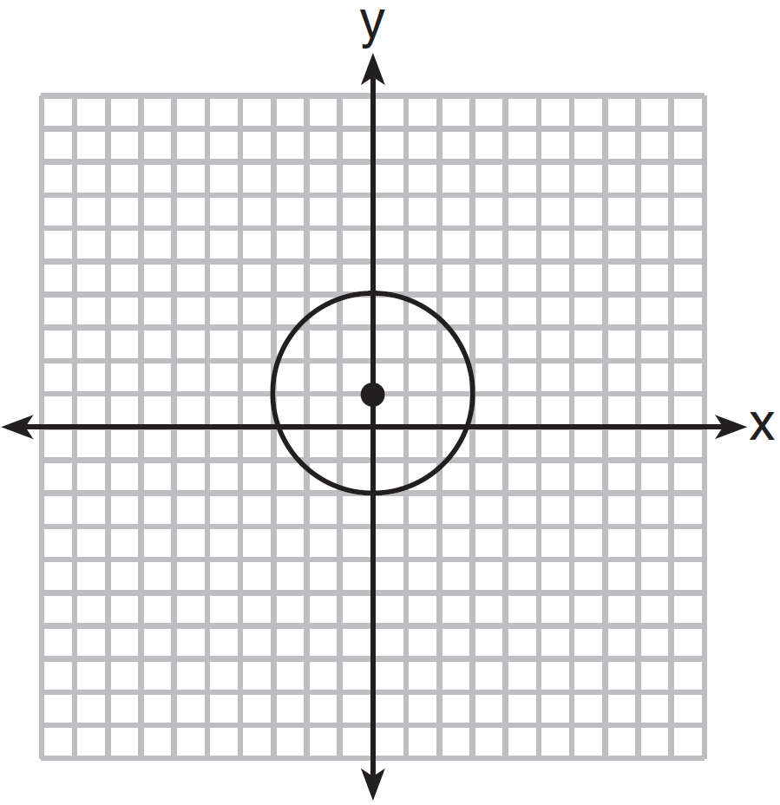
2) | 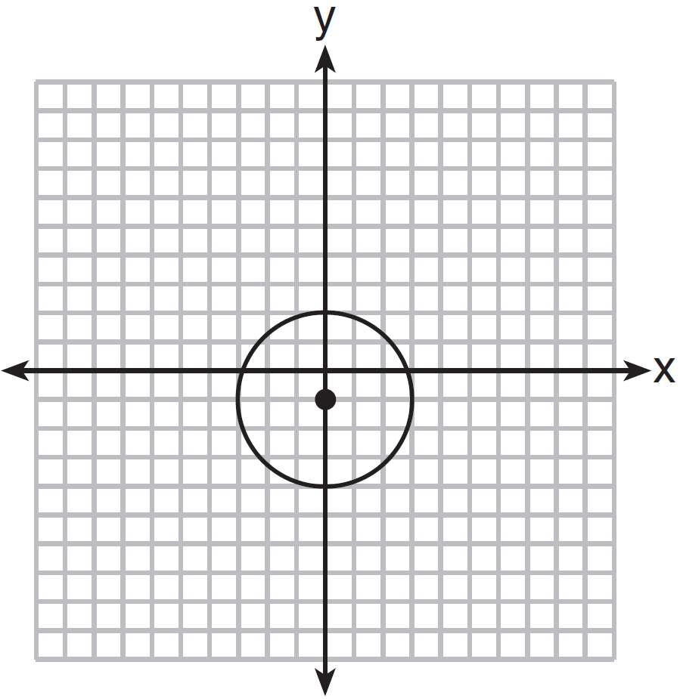
3) | 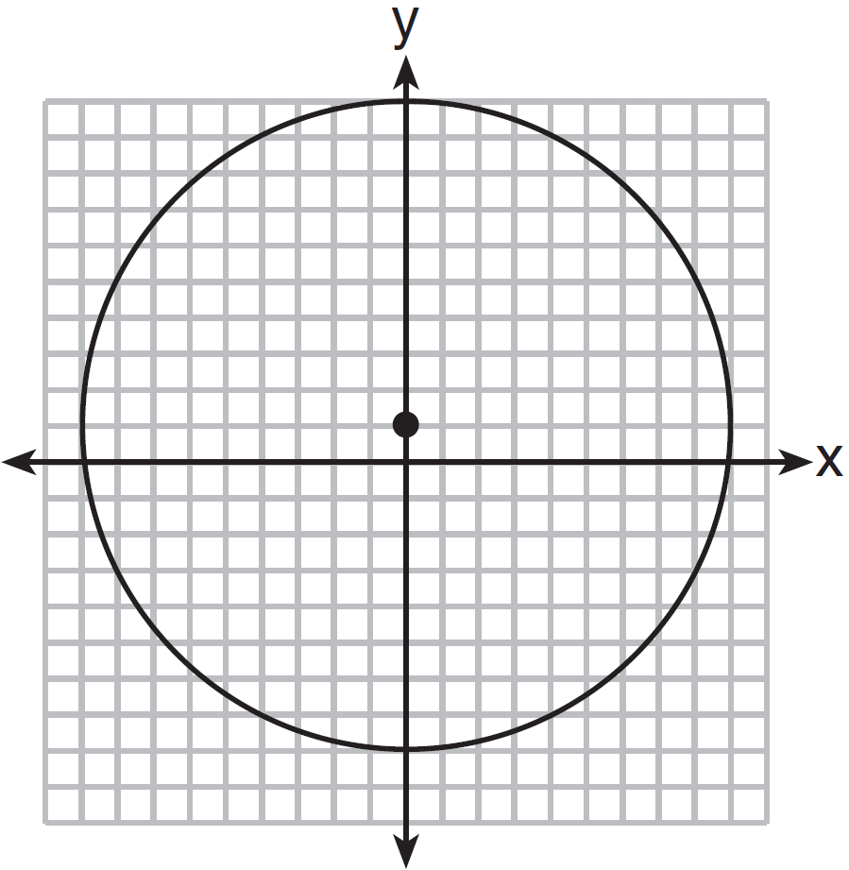
4) | 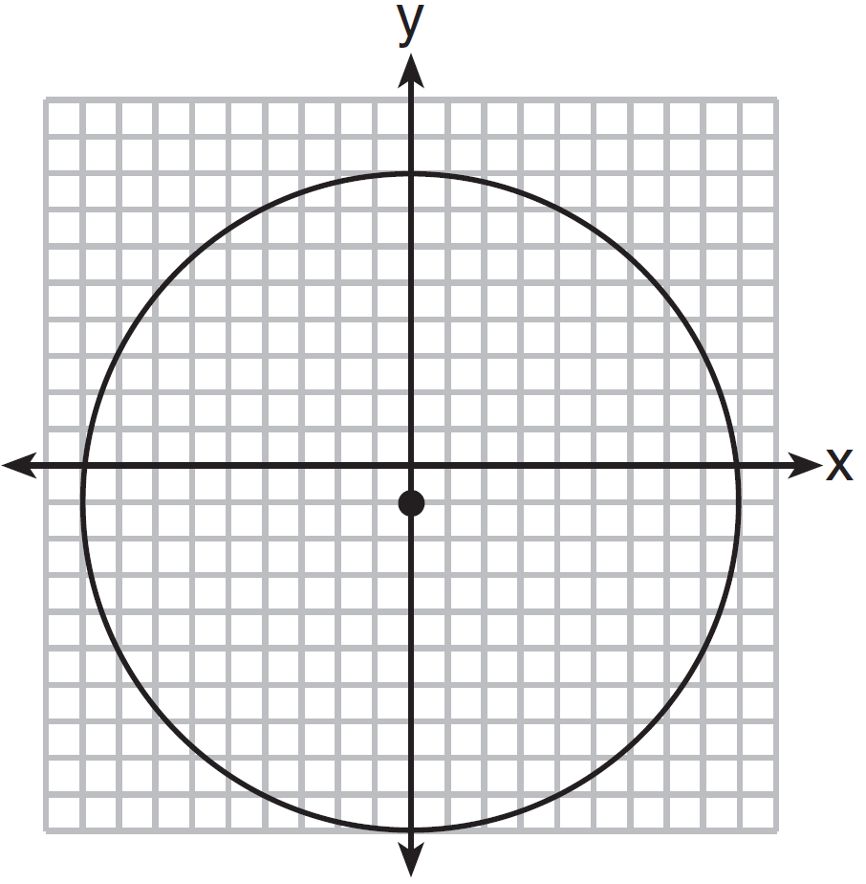

7 Which graph represents a circle whose equation is ?
1) | 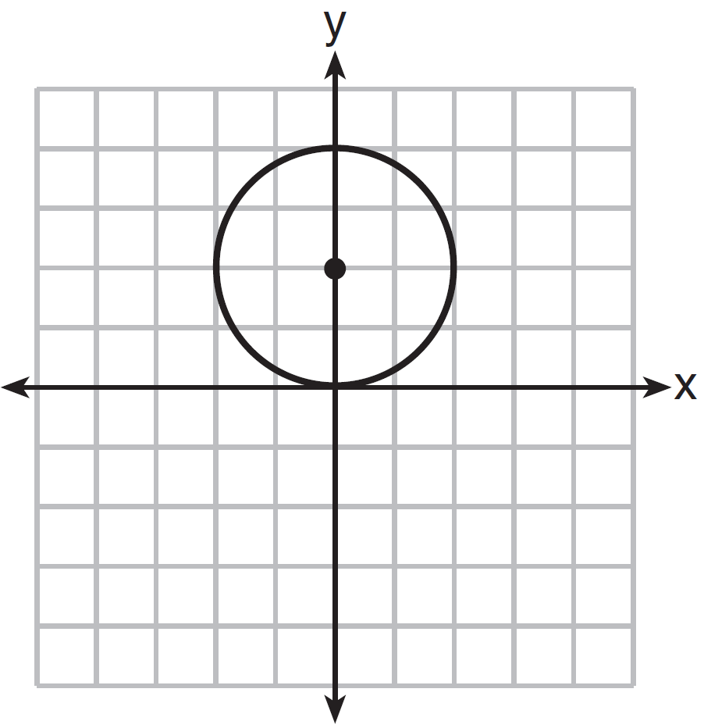
2) | 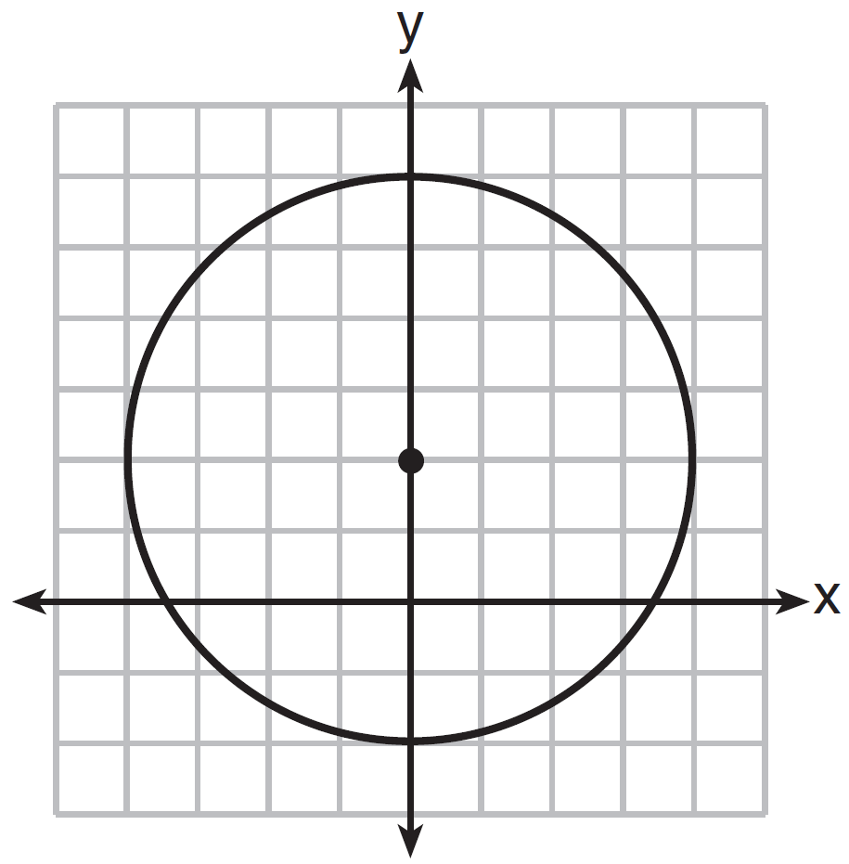
3) | 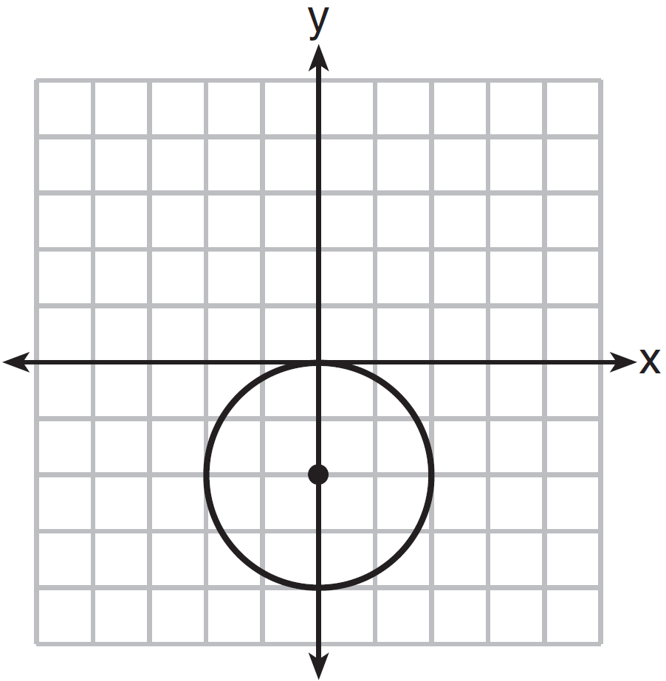
4) | 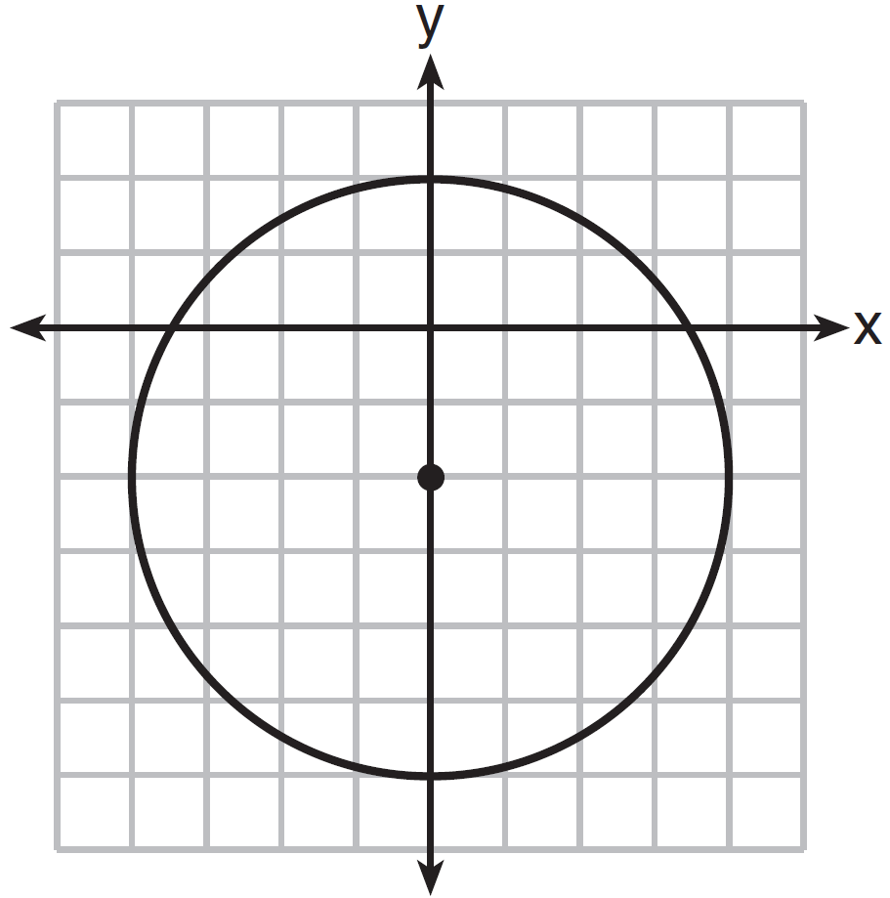

8 Which graph represents the graph of the equation ?
1) | 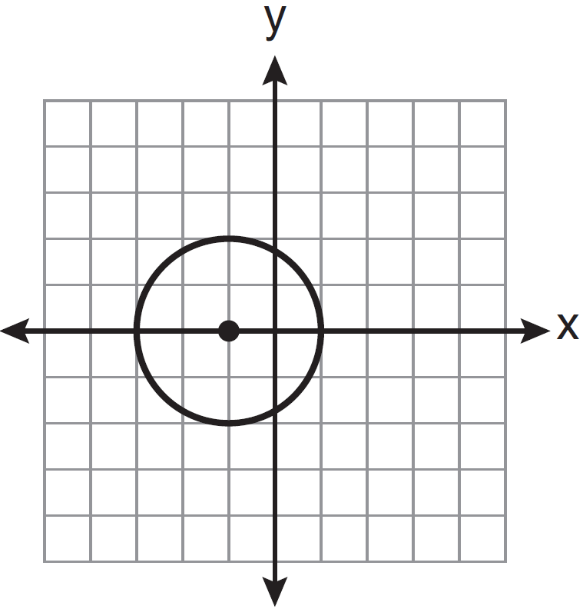
2) | 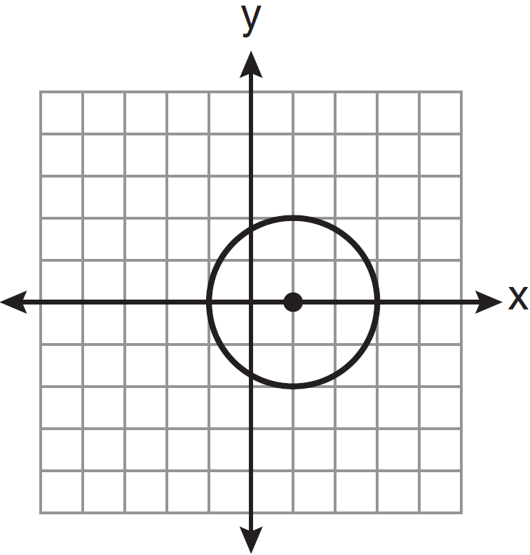
3) | 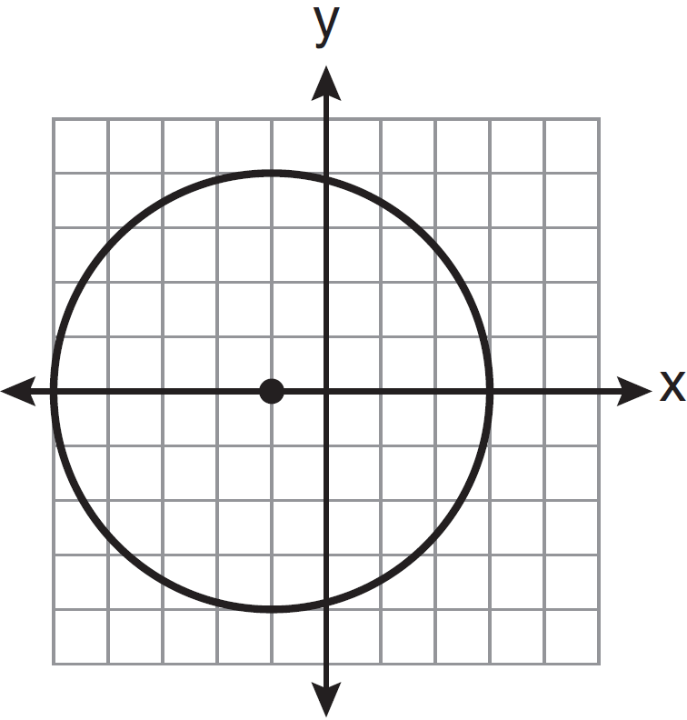
4) | 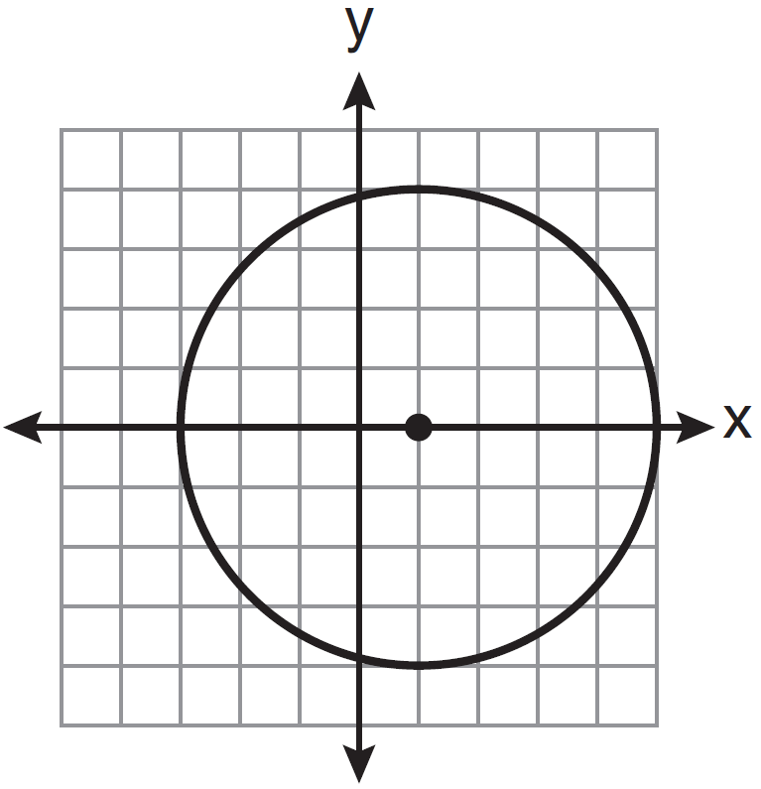

9 Which graph represents a circle whose equation is ?
1) | 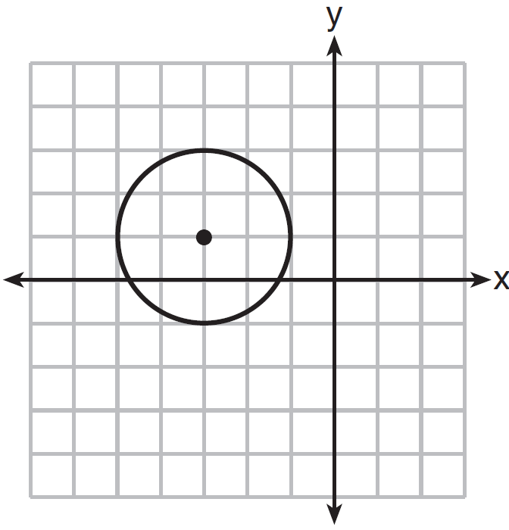
2) | 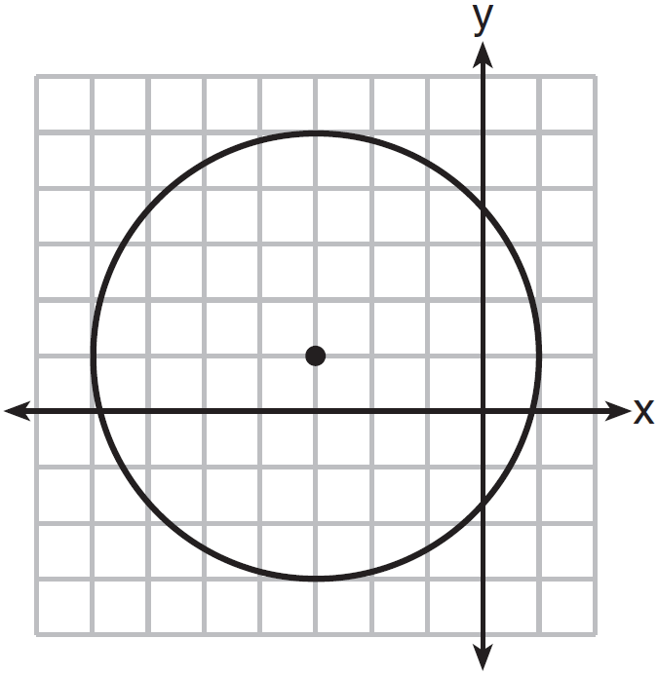
3) | 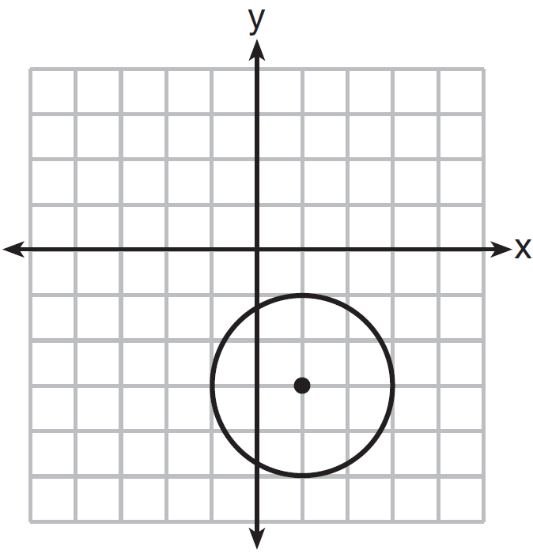
4) | 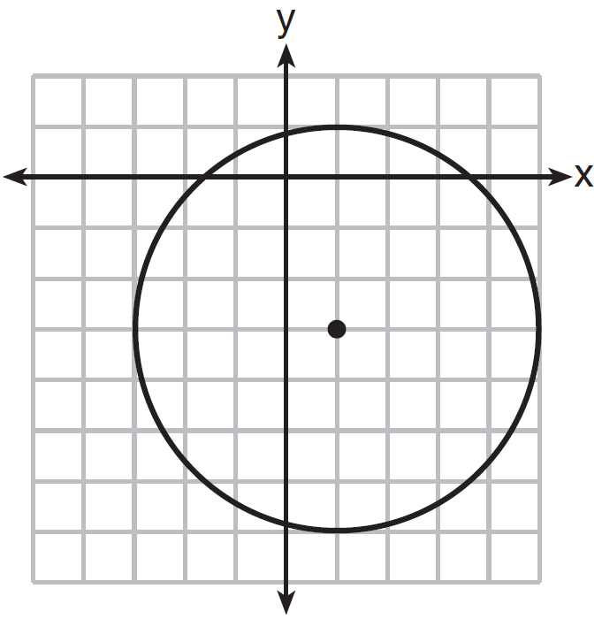

10 John uses the equation to represent the shape of a garden on graph paper.
a Graph on the accompanying grid.

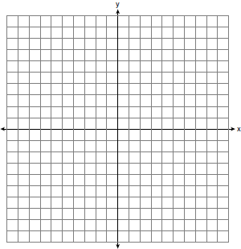

b What is the area of the garden to the nearest square unit?

11 On the set of axes below, graph and label circle A whose equation is and circle B whose equation is . Determine, in simplest radical form, the length of the line segment with endpoints at the centers of circles A and B.

12 For a carnival game, John is painting two circles, V and M, on a square dartboard.
a On the accompanying grid, draw and label circle V, represented by the equation , and circle M, represented by the equation .

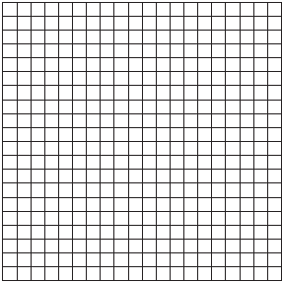

b A point, , is randomly selected such that and . What is the probability that point lies outside both circle V and circle M?

1 ANS: 1 REF: 060920ge

2 ANS: 2 REF: 011125ge

3 ANS: 2 REF: 011020ge

4 ANS: 3 REF: 011518ge

5 ANS: 3 REF: 061220ge

6 ANS: 1 REF: 061325ge

7 ANS: 1 REF: 081324ge

8 ANS: 2 REF: 081425ge

9 ANS: 1 REF: 011614ge

10 ANS:
a) 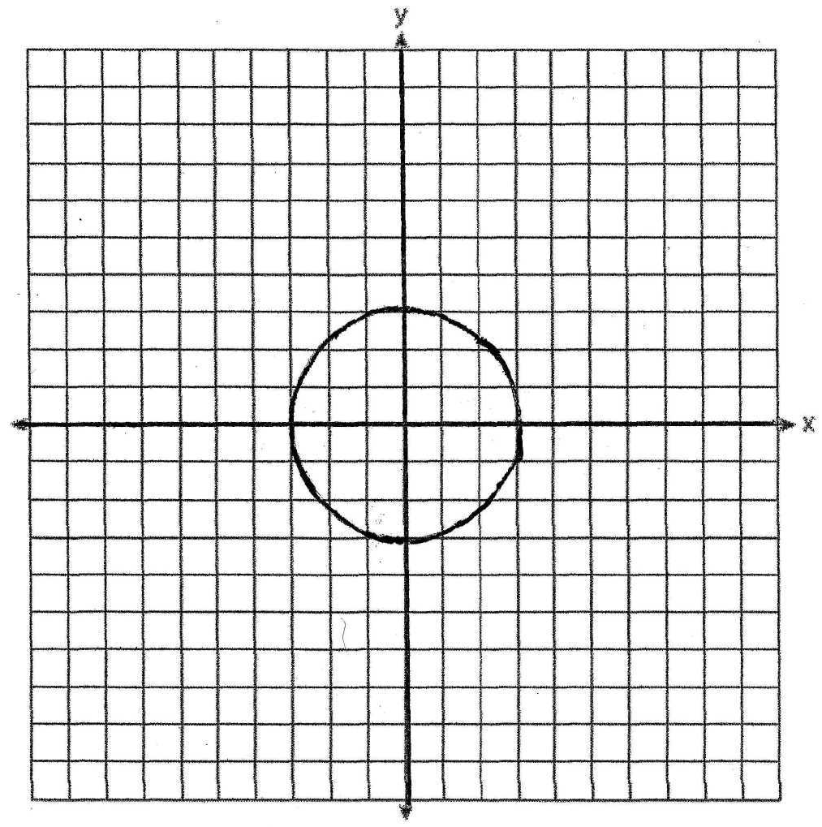; b) 28

REF: 010133a

11 ANS:
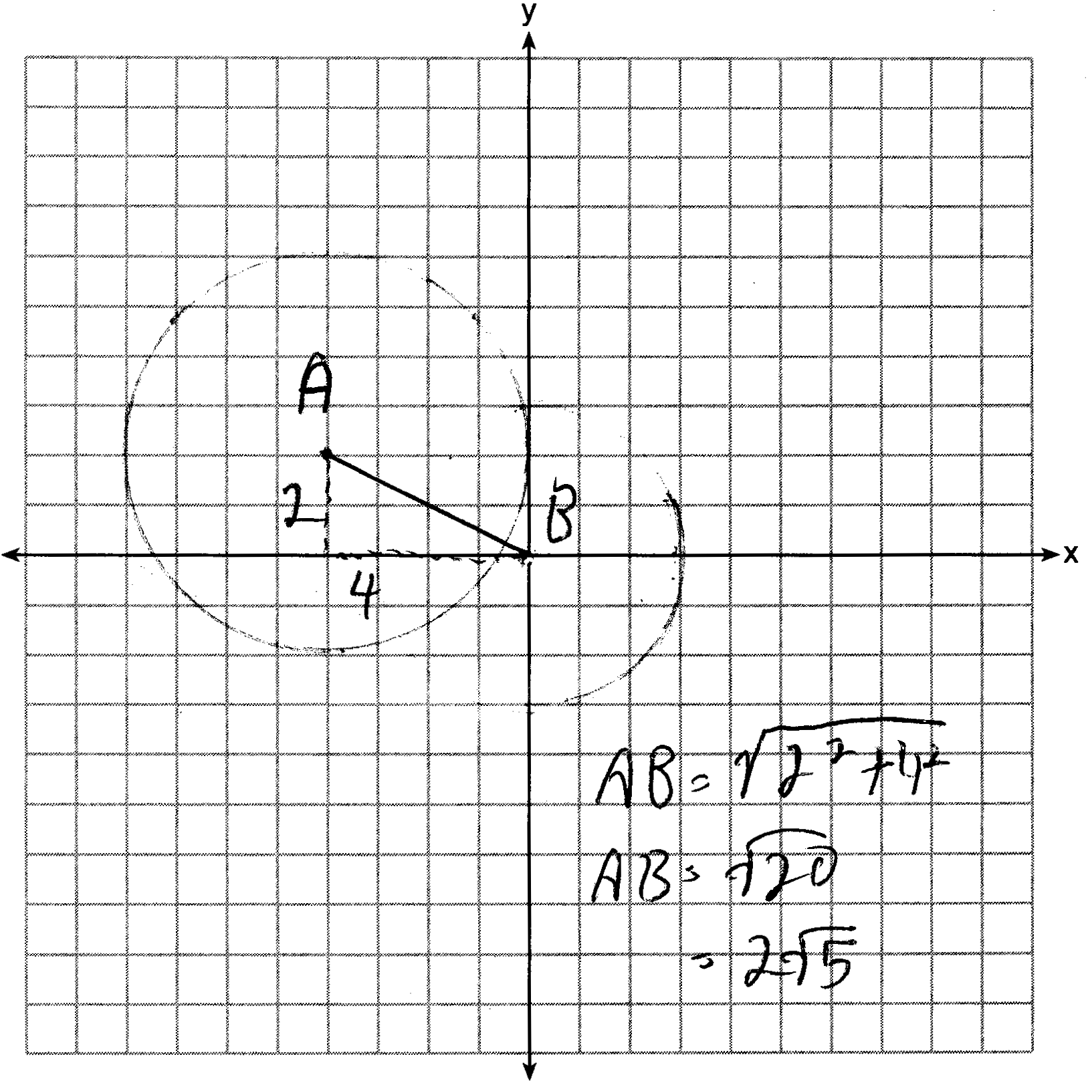

REF: 081537ge

12 ANS:
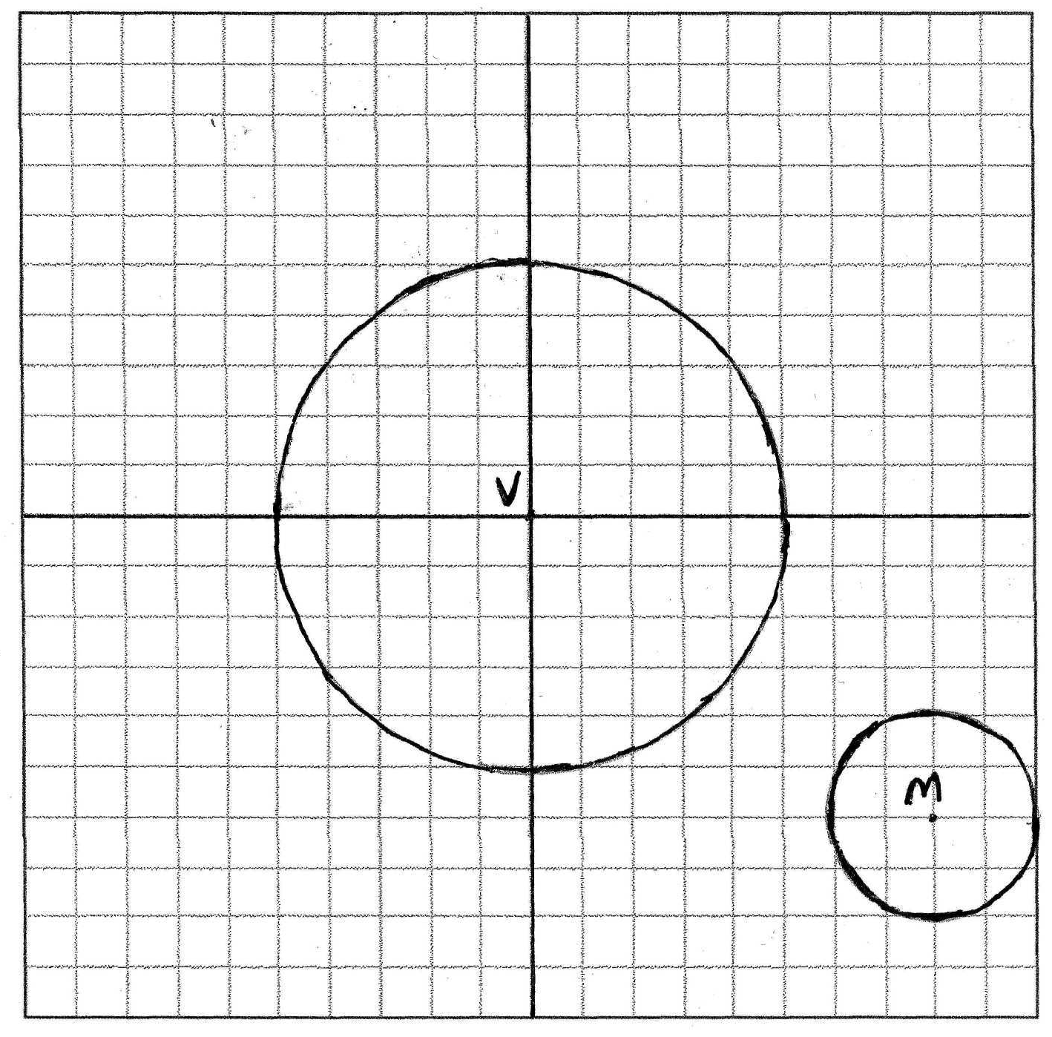. 0.77. The dartboard is 20 x 20, with area of 400. , so the area of circle V is 25π and of circle M is 4π. The percentage of the area of the dartboard outside both circles is 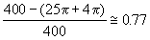

REF: 060334b

