1 Which point is on the circle whose equation is ?
1)
2)
3)
4)

2 Which equation represents a circle whose center is the origin and that passes through the point ?
1)
2)
3)
4)

3 A circle whose center has coordinates passes through the origin. What is the equation of the circle?
1)
2)
3)
4)

4 What is the equation of the circle with its center at and that passes through the point ?
1)
2)
3)
4)

5 What is the equation of the circle passing through the point and centered at ?
1)
2)
3)
4)

6 Which equation represents a circle with its center at and that passes through the point ?
1)
2)
3)
4)

7 What is the equation of a circle with its center at and passing through the point ?
1)
2)
3)
4)

8 What is the equation of the circle passing through the point whose center is at ?
1)
2)
3)
4)

9 Which equation represents the circle whose center is and that passes through the point ?
1)
2)
3)
4)

10 What is an equation of a circle whose center is at and is tangent to the line ?
1)
2)
3)
4)

11 The coordinates of the endpoints of the diameter of a circle are and . What is the equation of the circle?
1)
2)
3)
4)

12 The diameter of a circle has endpoints at and . What is an equation of the circle?
1)
2)
3)
4)

13 Write an equation of the circle whose diameter has endpoints and . [The use of the grid below is optional.]

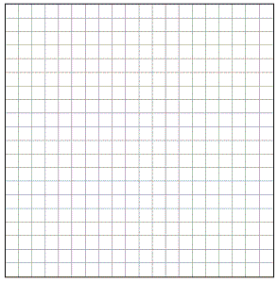

14 The graph below shows , which is a chord of circle O. The coordinates of the endpoints of are and . The distance from the midpoint of to the center of circle O is 2 units.

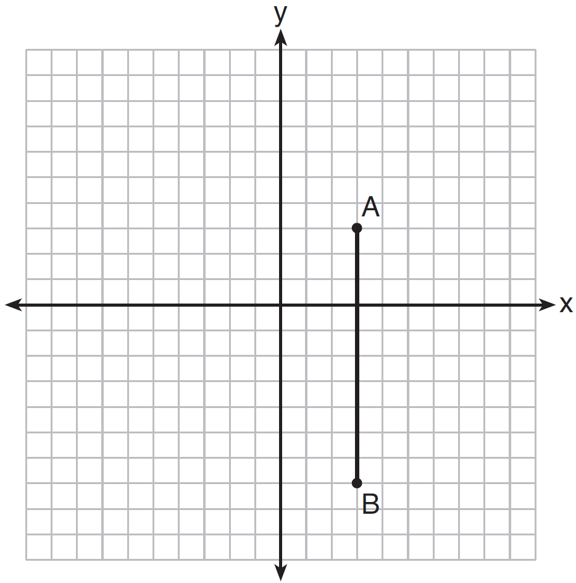

What could be a correct equation for circle O?
1)
2)
3)
4)

1 ANS: 4
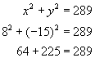

REF: 010625a

2 ANS: 2 REF: 061524ge

3 ANS: 2 REF: 011511ge

4 ANS: 1 REF: 011423ge

5 ANS: 4

REF: 061415a2

6 ANS: 3

REF: 081516a2

7 ANS: 3

REF: 011624a2

8 ANS: 3

REF: 061620a2

9 ANS: 3 REF: 061306ge

10 ANS: 2
The line will be tangent to the circle at . A segment connecting this point and is a radius of the circle with length 4.

REF: 012020geo

11 ANS: 1
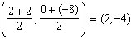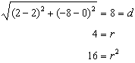

REF: 061428ge

12 ANS: 1
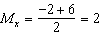. 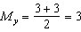. The center is . . If the diameter is 8, the radius is 4 and .

REF: fall0820ge

13 ANS:
Midpoint: 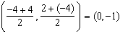. Distance: 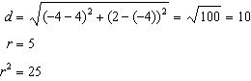

REF: 061037ge

14 ANS: 1
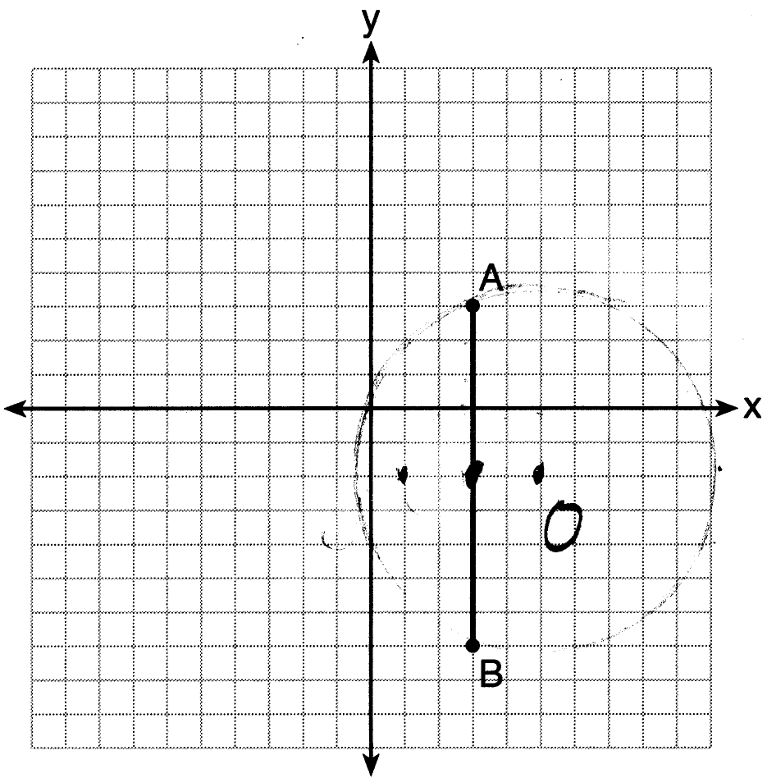 Since the midpoint of is , the center must be either or .

REF: 061623geo

