1 In the accompanying diagram, the center of circle O is , and the coordinates of point P are . If is a radius, what is the equation of the circle?

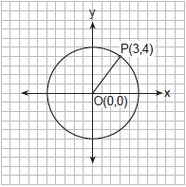
1)
2)
3)
4)

2 What is an equation for the circle shown in the graph below?

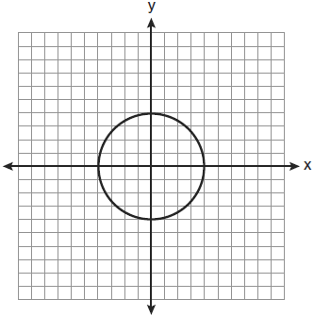
1)
2)
3)
4)

3 Circle P with center at and passing through is graphed on the set of axes below.

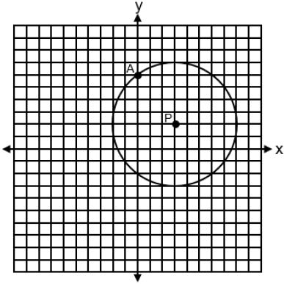
An equation of circle P is
1)
2)
3)
4)

4 What is an equation of circle O shown in the graph below?

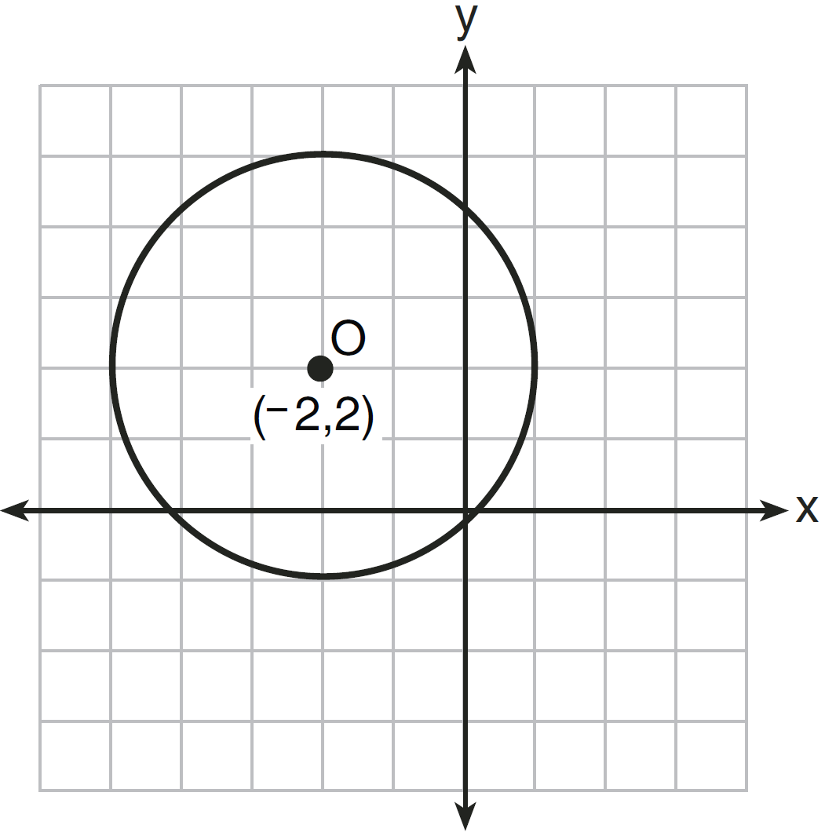
1)
2)
3)
4)

5 Which equation represents circle A shown in the diagram below?

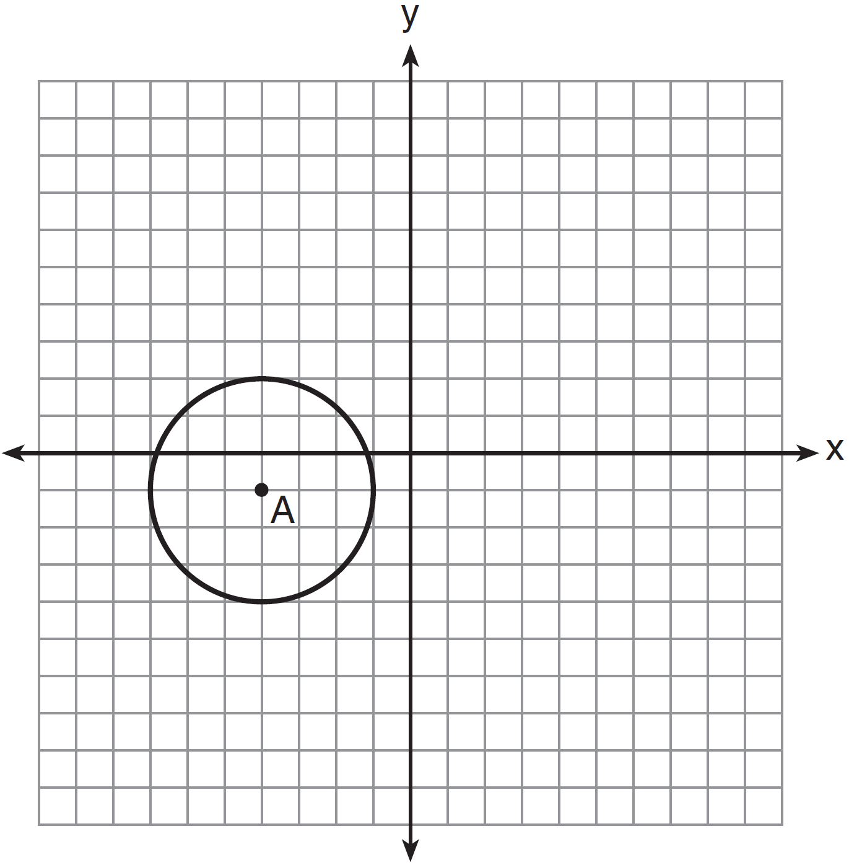
1)
2)
3)
4)

6 What is an equation of circle O shown in the graph below?

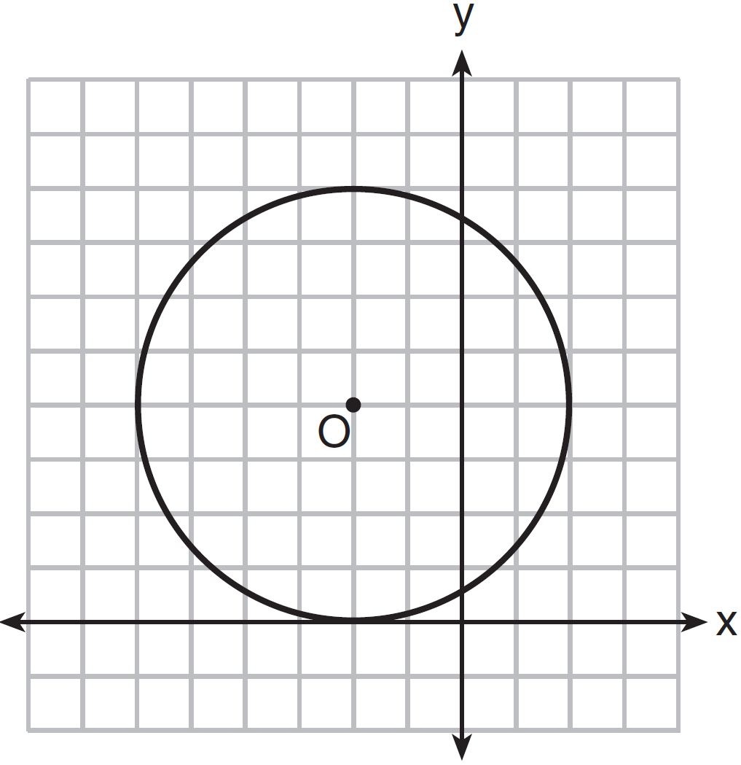
1)
2)
3)
4)

7 Which equation represents circle K shown in the graph below?

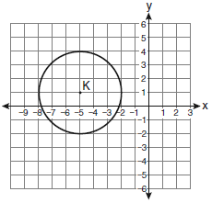
1)
2)
3)
4)

8 Which equation represents the circle shown in the accompanying graph?

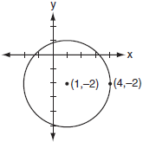
1)
2)
3)
4)

9 What is an equation of circle O shown in the graph below?

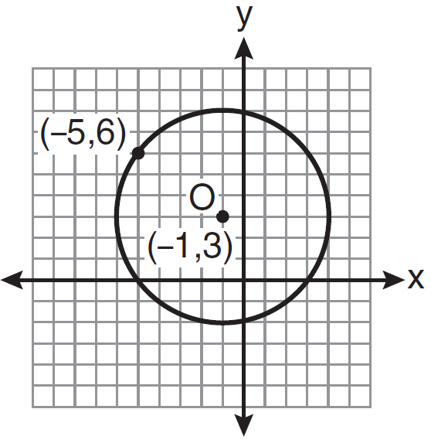
1)
2)
3)
4)

10 Circle O is graphed on the set of axes below. Which equation represents circle O?

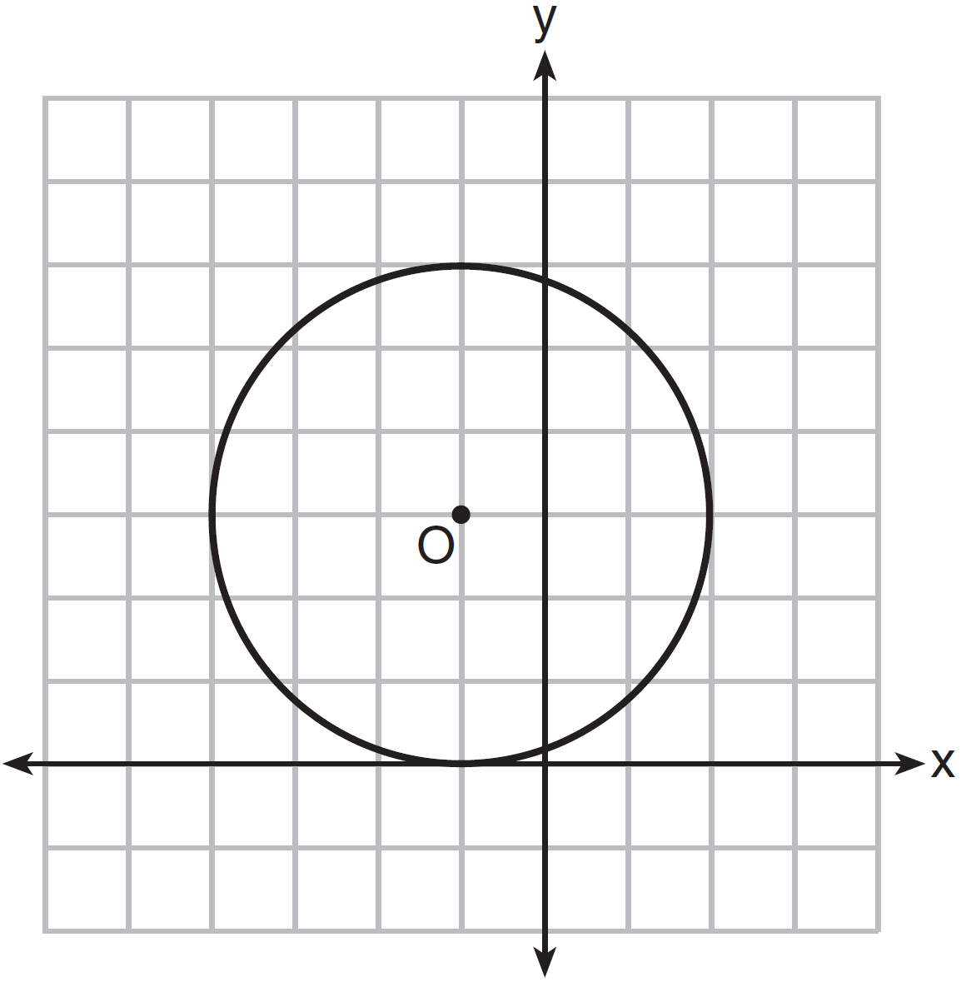
1)
2)
3)
4)

11 What is an equation of the circle shown in the graph below?

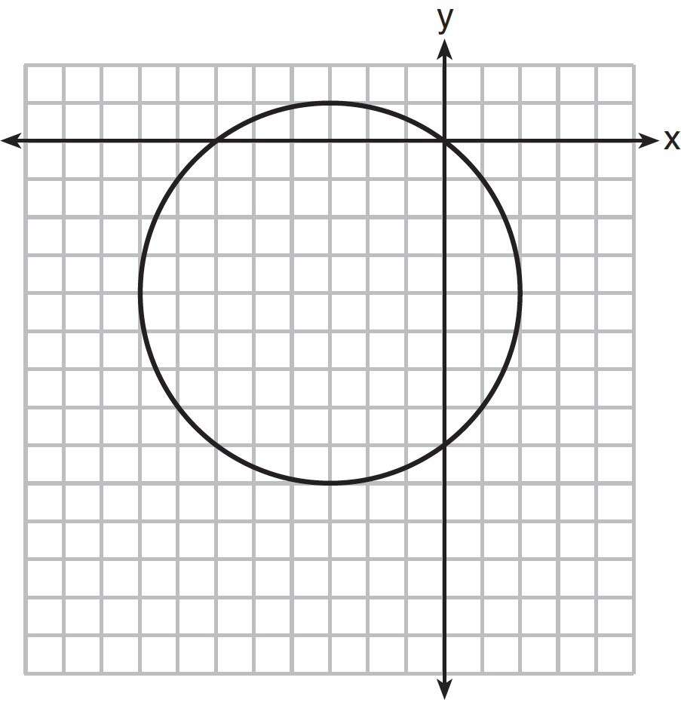
1)
2)
3)
4)

12 What is the equation for circle O shown in the graph below?

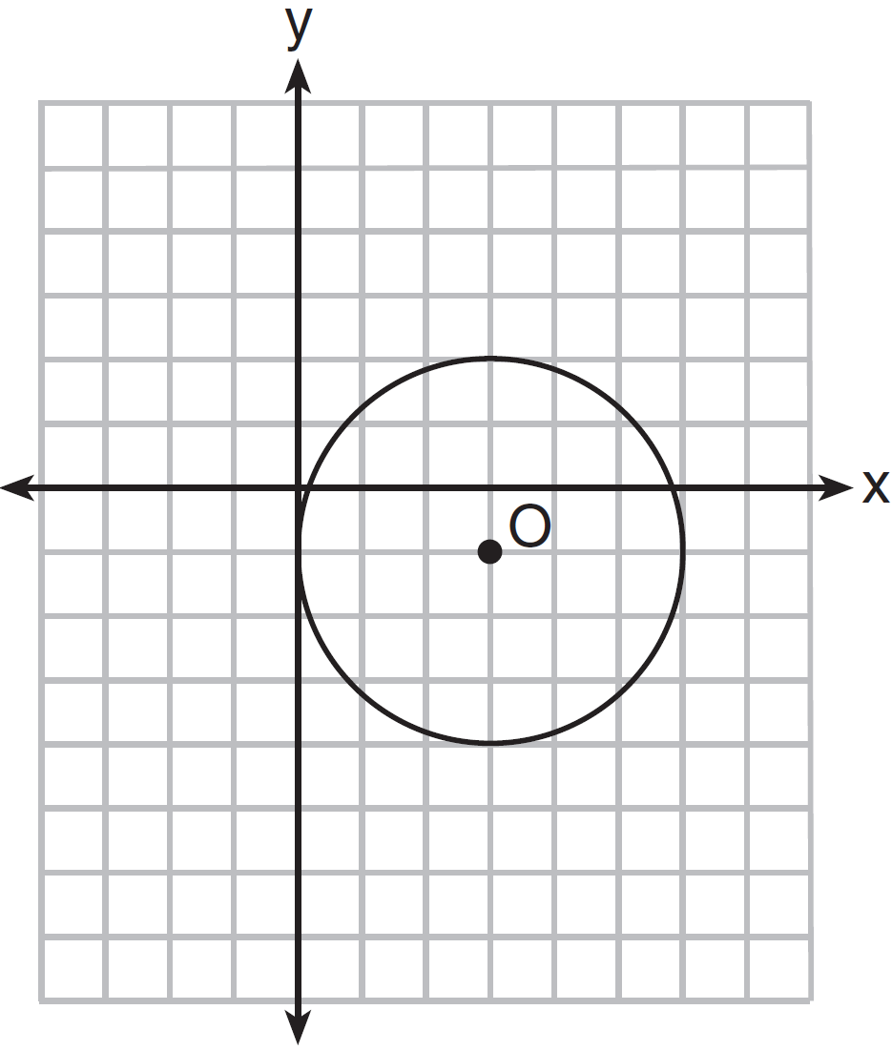
1)
2)
3)
4)

13 What is the equation of circle O shown in the diagram below?

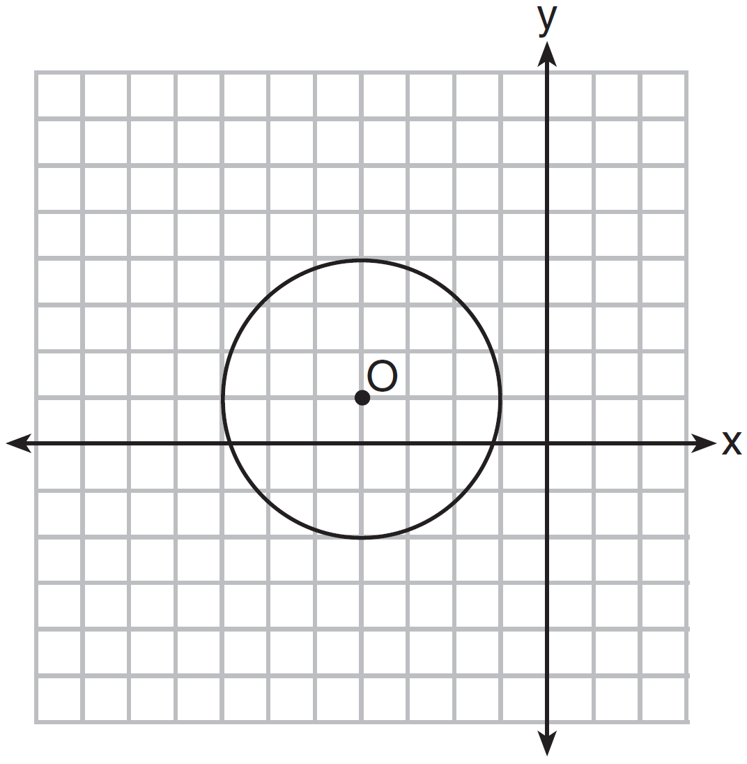
1)
2)
3)
4)

14 The diagram below is a graph of circle O.

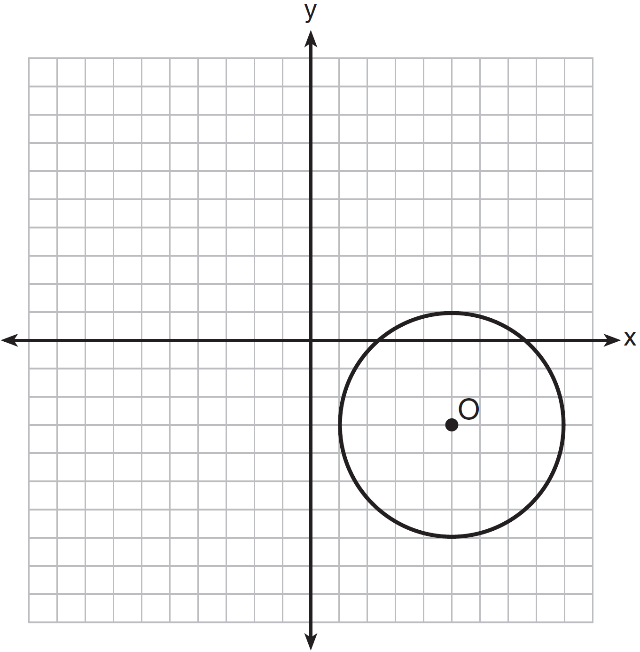
Which equation represents circle O?
1)
2)
3)
4)

15 Which equation represents circle O shown in the graph below?

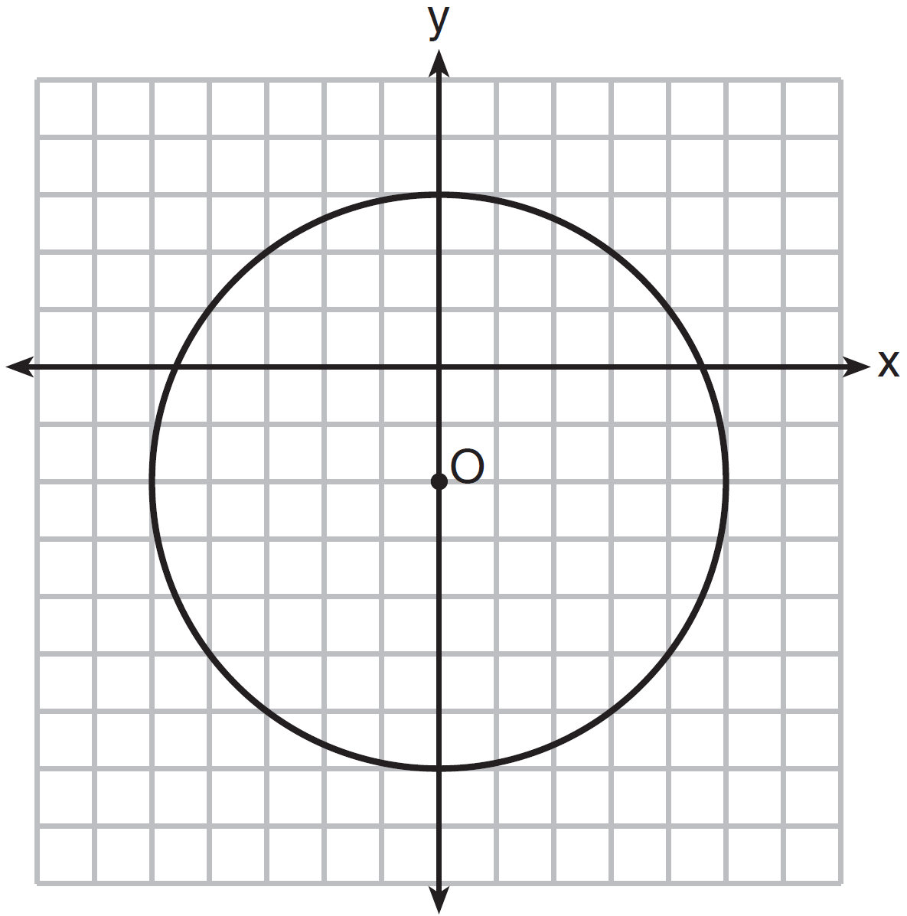
1)
2)
3)
4)

16 Which equation represents the circle shown in the graph below?

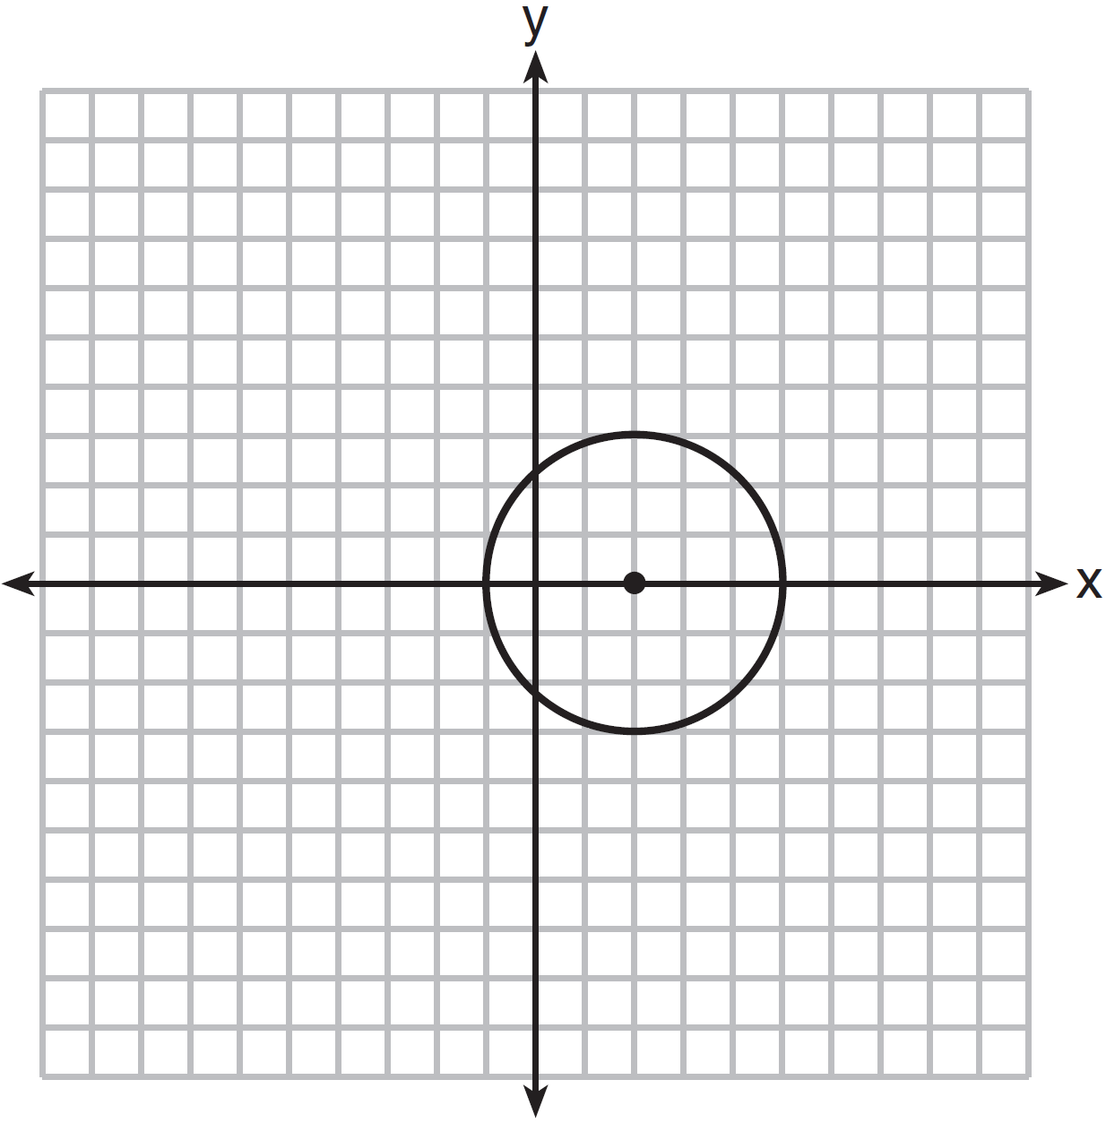
1)
2)
3)
4)

17 Which equation represents the circle shown in the graph below?

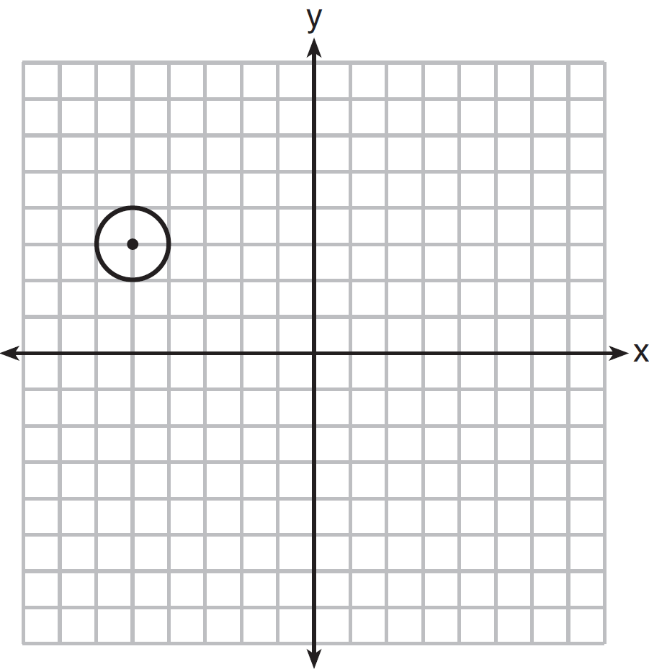
1)
2)
3)
4)

18 Which equation represents the circle shown in the graph below that passes through the point ?

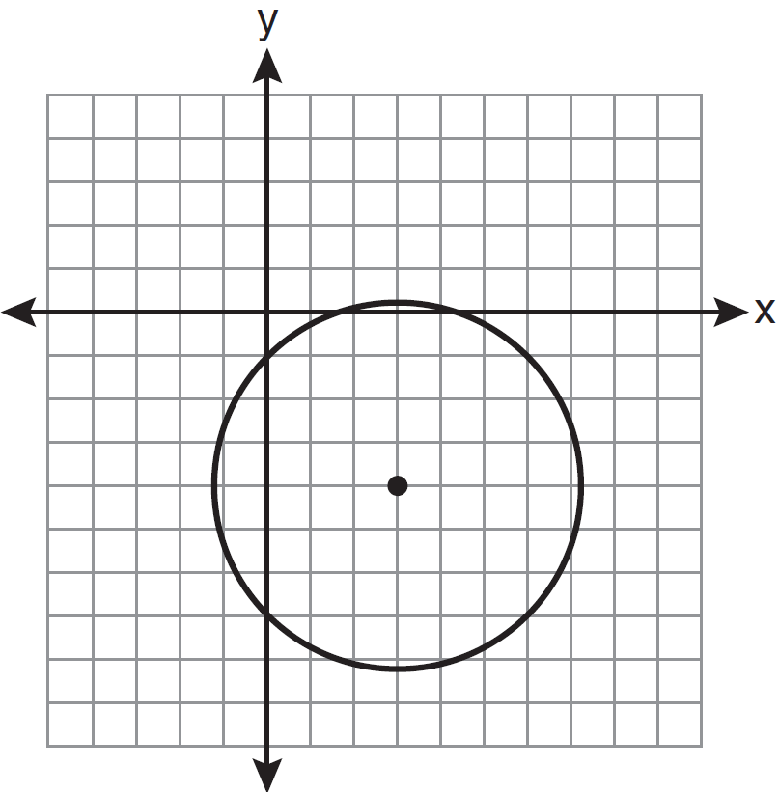
1)
2)
3)
4)

19 A circle with center O and passing through the origin is graphed below.

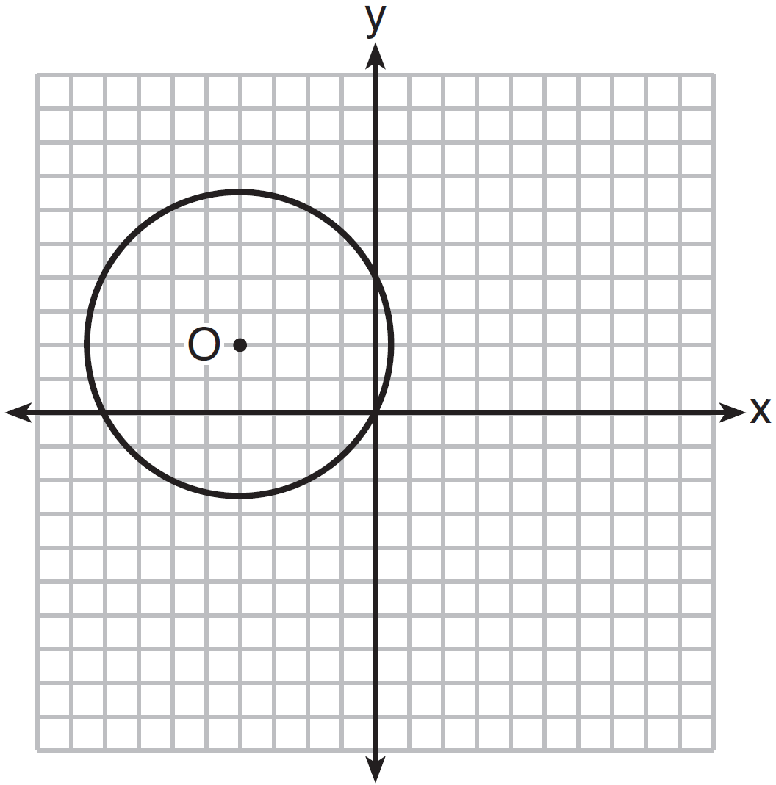

What is the equation of circle O?
1)
2)
3)
4)

20 Which equation is represented by the graph below?

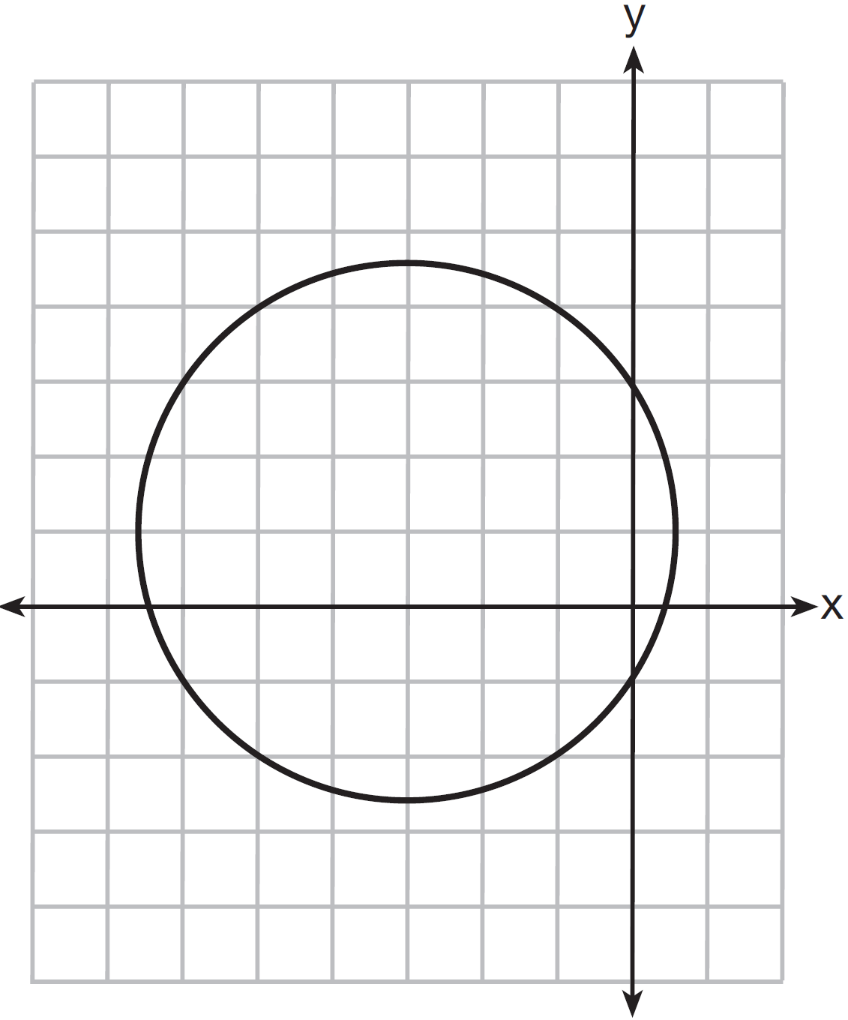
1)
2)
3)
4)

21 What is an equation of circle O shown in the graph below?

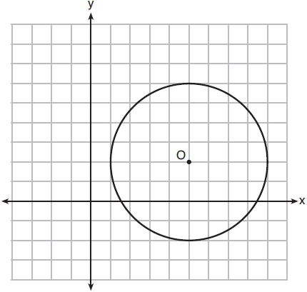
1)
2)
3)
4)

22 Write an equation of the circle graphed in the diagram below.

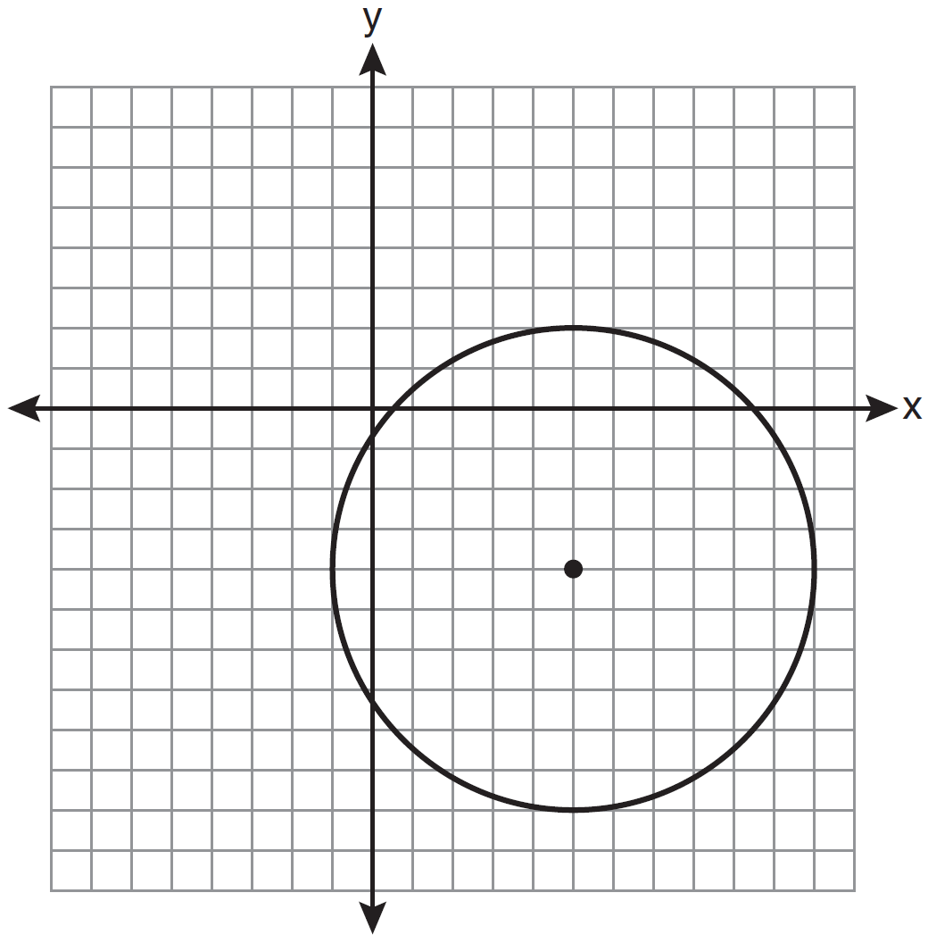

23 Write an equation for circle O shown on the graph below.

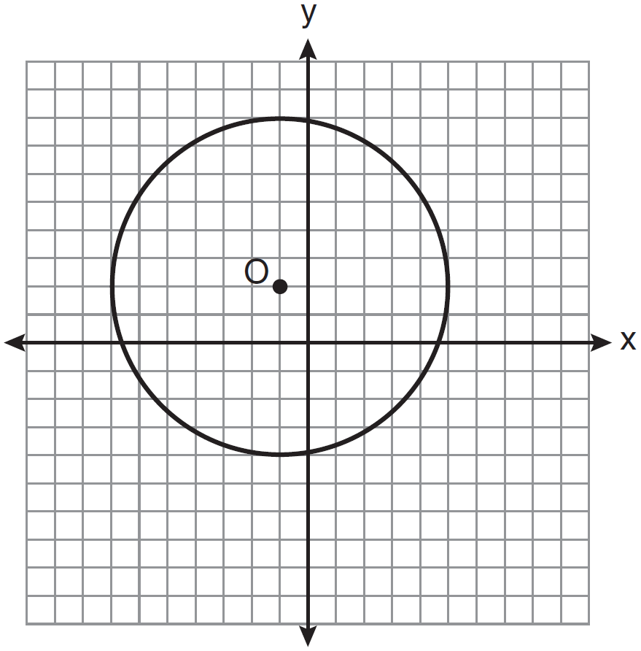

24 Write an equation of the circle shown in the diagram below.

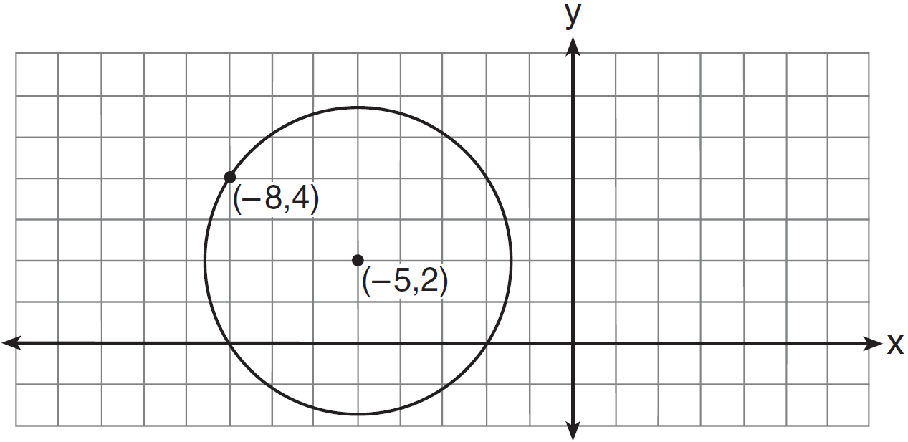

25 A circle shown in the diagram below has a center of and passes through point .

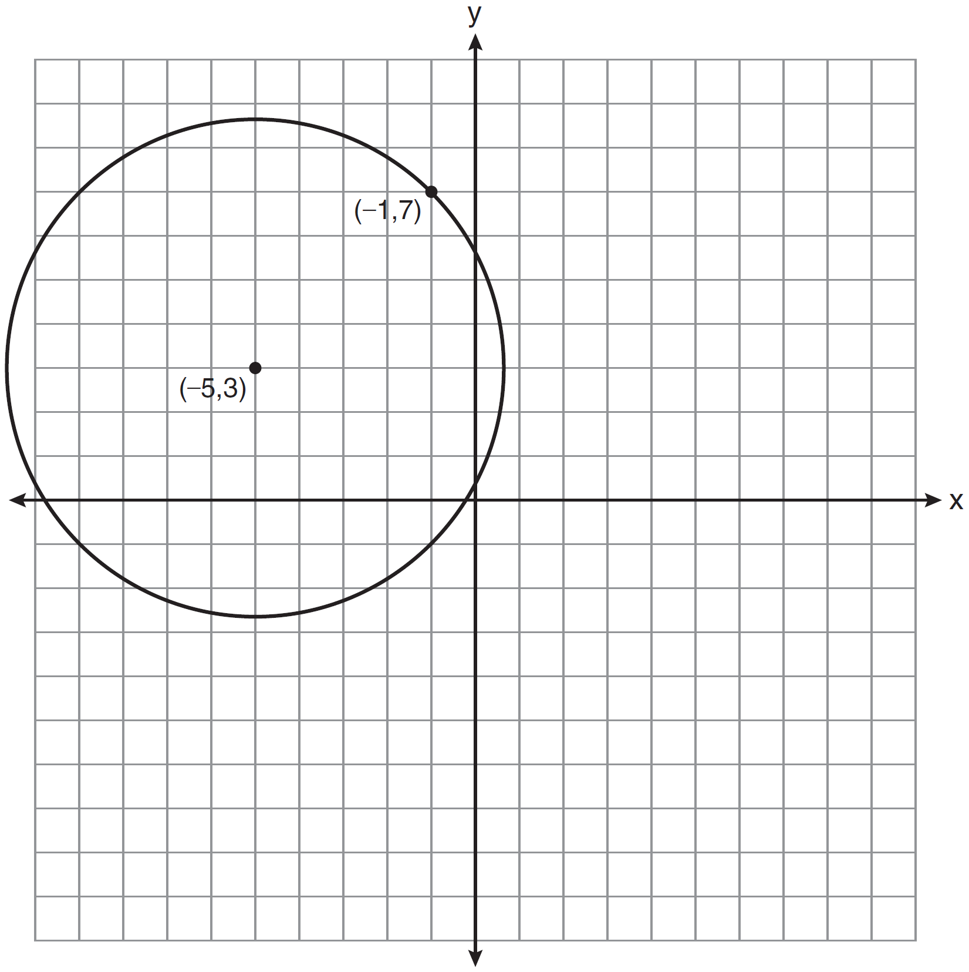

Write an equation that represents the circle.

26 Write an equation of the circle shown in the graph below.

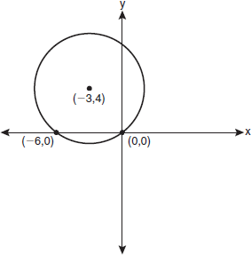
1 ANS: 4 REF: 080823a

2 ANS: 4
The radius is 4. .

REF: 061014ge

3 ANS: 4 REF: spr2404geo

4 ANS: 1 REF: 011220ge

5 ANS: 4 REF: 011323ge

6 ANS: 4 REF: 081409ge

7 ANS: 2 REF: 080921ge

8 ANS: 2 REF: 010716b

9 ANS: 1 REF: 061110ge

10 ANS: 1 REF: 061408ge

11 ANS: 2 REF: 081212ge

12 ANS: 3 REF: 061309ge

13 ANS: 3 REF: 081312ge

14 ANS: 3 REF: 011514ge

15 ANS: 4 REF: 011415ge

16 ANS: 1 REF: 061510ge

17 ANS: 2 REF: 081520ge

18 ANS: 2 REF: 011126a2

19 ANS: 4 REF: 011513a2

20 ANS: 4 REF: 061318a2

21 ANS: 2
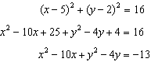

REF: 061820geo

22 ANS:

REF: 081132ge

23 ANS:
REF: 081034ge

24 ANS:
.
REF: 011234a2

25 ANS:
REF: 081033a2

26 ANS:
REF: fall0929a2

