1 A plane intersects a cylinder perpendicular to its bases.

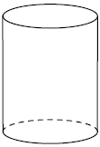

This cross section can be described as a
1) | rectangle
2) | parabola
3) | triangle
4) | circle

2 The right prism with a triangular base shown below is cut by a plane perpendicular to its bases.

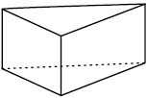

The two-dimensional shape of the cross section is always a
1) | triangle
2) | rhombus
3) | pentagon
4) | rectangle

3 A right hexagonal prism is shown below. A two-dimensional cross section that is perpendicular to the base is taken from the prism.

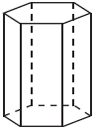

Which figure describes the two-dimensional cross section?
1) | triangle
2) | rectangle
3) | pentagon
4) | hexagon

4 In the diagram below, a plane intersects a square pyramid parallel to its base.
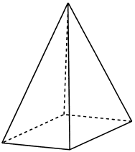

Which two-dimensional shape describes this cross section?
1) | circle
2) | square
3) | triangle
4) | pentagon

5 A square pyramid is intersected by a plane passing through the vertex and perpendicular to the base.
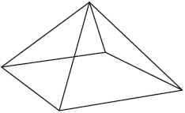

Which two-dimensional shape describes this cross section?
1) | square
2) | triangle
3) | pentagon
4) | rectangle

6 A right cylinder is cut perpendicular to its base. The shape of the cross section is a
1) | circle
2) | cylinder
3) | rectangle
4) | triangular prism

7 A right cylinder is cut parallel to its base. The shape of this cross section is a
1) | cone
2) | circle
3) | triangle
4) | rectangle

8 The cross section of a regular pyramid contains the altitude of the pyramid. The shape of this cross section is a
1) | circle
2) | square
3) | triangle
4) | rectangle

9 A plane intersects a hexagonal prism. The plane is perpendicular to the base of the prism. Which two-dimensional figure is the cross section of the plane intersecting the prism?
1) | triangle
2) | trapezoid
3) | hexagon
4) | rectangle

10 A plane intersects a sphere. Which two-dimensional shape is formed by this cross section?
1) | rectangle
2) | triangle
3) | square
4) | circle

11 A two-dimensional cross section is taken of a three-dimensional object. If this cross section is a triangle, what can not be the three-dimensional object?
1) | cone
2) | cylinder
3) | pyramid
4) | rectangular prism

12 Which figure(s) below can have a triangle as a two-dimensional cross section?
I. cone
II. cylinder
III. cube
IV. square pyramid
1) | I, only
2) | IV, only
3) | I, II, and IV, only
4) | I, III, and IV, only

13 Which figure can have the same cross section as a sphere?
1) | 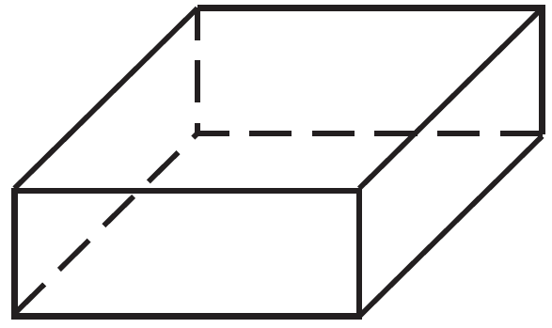
2) | 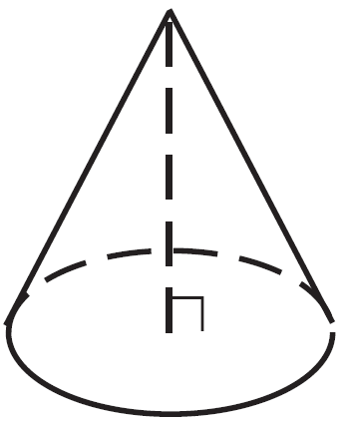
3) | 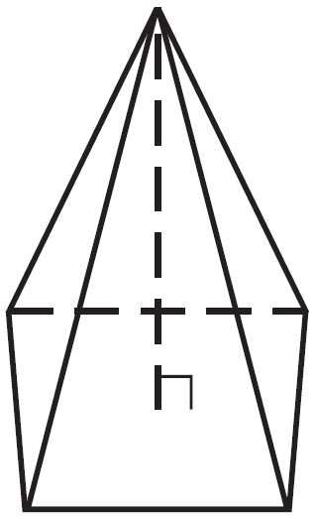
4) | 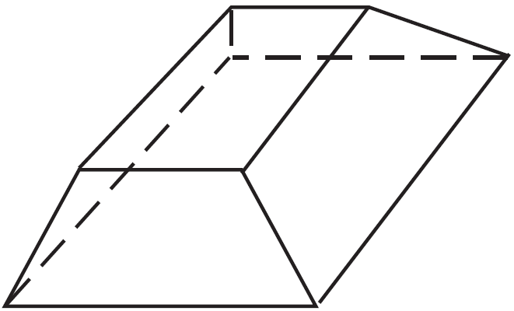

14 A right circular cylinder has a diameter of 8 inches and a height of 12 inches. Which two-dimensional figure shows a cross section that is perpendicular to the base and passes through the center of the base?
1) | 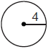
2) | 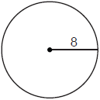
3) | 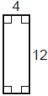
4) | 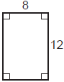

15 William is drawing pictures of cross sections of the right circular cone below.

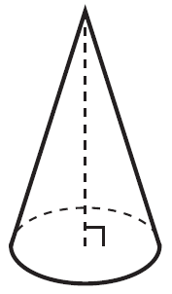

Which drawing can not be a cross section of a cone?
1) | 
2) | 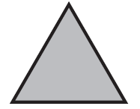
3) | 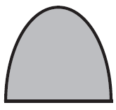
4) | 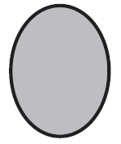

1 ANS: 1 REF: 082211geo

2 ANS: 4 REF: 082422geo

3 ANS: 2 REF: 011805geo

4 ANS: 2 REF: 062202geo

5 ANS: 2 REF: 062301geo

6 ANS: 3 REF: 081805geo

7 ANS: 2 REF: 062402geo

8 ANS: 3 REF: 081613geo

9 ANS: 4 REF: 011723geo

10 ANS: 4 REF: 082301geo

11 ANS: 2 REF: 081701geo

12 ANS: 4 REF: 012019geo

13 ANS: 2 REF: 061506geo

14 ANS: 4 REF: 012415geo

15 ANS: 1 REF: 011601geo

