1 The volume, in cubic centimeters, of a sphere whose diameter is 6 centimeters is
1)
2)
3)
4)

2 The diameter of a sphere is 12 inches. What is the volume of the sphere to the nearest cubic inch?
1) | 288
2) | 452
3) | 905
4) | 7,238

3 The diameter of a sphere is 15 inches. What is the volume of the sphere, to the nearest tenth of a cubic inch?
1) | 706.9
2) | 1767.1
3) | 2827.4
4) | 14,137.2

4 What is the volume of a hemisphere that has a diameter of 12.6 cm, to the nearest tenth of a cubic centimeter?
1) | 523.7
2) | 1047.4
3) | 4189.6
4) | 8379.2

5 In the diagram below, a sphere is inscribed inside a cube. The cube has edge lengths of 18.

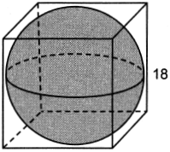

What is the volume of the sphere, in terms of ?
1)
2)
3)
4)

6 A sphere is inscribed inside a cube with edges of 6 cm. In cubic centimeters, what is the volume of the sphere, in terms of ?
1)
2)
3)
4)

7 The diameter of a basketball is approximately 9.5 inches and the diameter of a tennis ball is approximately 2.5 inches. The volume of the basketball is about how many times greater than the volume of the tennis ball?
1) | 3591
2) | 65
3) | 55
4) | 4

8 If the circumference of a standard lacrosse ball is 19.9 cm, what is the volume of this ball, to the nearest cubic centimeter?
1) | 42
2) | 133
3) | 415
4) | 1065

9 The volume of a sphere is approximately 44.6022 cubic centimeters. What is the radius of the sphere, to the nearest tenth of a centimeter?
1) | 2.2
2) | 3.3
3) | 4.4
4) | 4.7

10 If the surface area of a sphere is represented by , what is the volume in terms of ?
1)
2)
3)
4)

11 Which diagram represents the figure with the greatest volume?
1) | 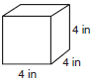
2) | 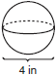
3) | 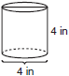
4) | 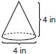

12 A sphere has a diameter of 18 meters. Find the volume of the sphere, in cubic meters, in terms of .

13 Randy's basketball is in the shape of a sphere with a maximum circumference of 29.5 inches. Determine and state the volume of the basketball, to the nearest cubic inch.

14 A large snowman is made of three spherical snowballs with radii of 1 foot, 2 feet, and 3 feet, respectively. Determine and state the amount of snow, in cubic feet, that is used to make the snowman. [Leave your answer in terms of .]

15 When volleyballs are purchased, they are not fully inflated. A partially inflated volleyball can be modeled by a sphere whose volume is approximately 180 in³. After being fully inflated, its volume is approximately 294 in³. To the nearest tenth of an inch, how much does the radius increase when the volleyball is fully inflated?

16 Tamika has a hard rubber ball whose circumference measures 13 inches. She wants to box it for a gift but can only find cube shaped boxes of sides 3 inches, 4 inches, 5 inches, or 6 inches. What is the smallest box that the ball will fit into with the top on?

17 Izzy is making homemade clay pendants in the shape of a solid hemisphere, as modeled below. Each pendant has a radius of 2.8 cm.

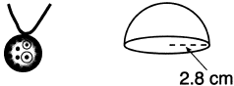

How much clay, to the nearest cubic centimeter, does Izzy need to make 100 pendants?
1 ANS: 2
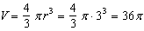

REF: 061112ge

2 ANS: 3
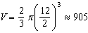

REF: 061502ge

3 ANS: 2
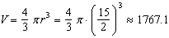

REF: 061207ge

4 ANS: 1
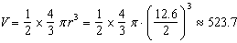

REF: 061910geo

5 ANS: 3
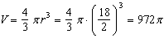

REF: 062404geo

6 ANS: 2
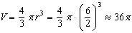

REF: 081215ge

7 ANS: 3
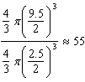

REF: 011614geo

8 ANS: 2
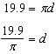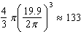

REF: 012310geo

9 ANS: 1
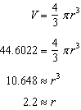

REF: 061317ge

10 ANS: 4
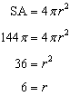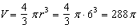

REF: 081020ge

11 ANS: 1
(1) cube:
(2) sphere: 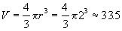
(3) cylinder:
(4) cone: 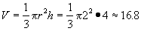

REF: 080403a

12 ANS:
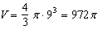

REF: 081131ge

13 ANS:
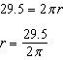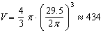

REF: 061831geo

14 ANS:
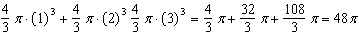

REF: 062329geo

15 ANS:
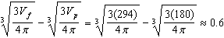

REF: 061728geo

16 ANS:
5-inch. The great circle of a sphere has the same circumference as the sphere. 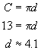

REF: 060028a

17 ANS:
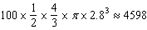

REF: 062229geo

