1 In the diagram below, a right circular cone has a diameter of 8 inches and a height of 12 inches.

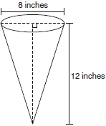

What is the volume of the cone to the nearest cubic inch?
1) | 201
2) | 481
3) | 603
4) | 804

2 What is the volume of a right circular cone that has a height of 7.2 centimeters and a radius of 2.5 centimeters, to the nearest tenth of a cubic centimeter?
1) | 37.7
2) | 47.1
3) | 113.1
4) | 141.4

3 In the diagram below, a cone has a diameter of 16 inches and a slant height of 17 inches.

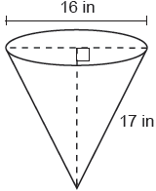

What is the volume of the cone, in cubic inches?
1)
2)
3)
4)

4 As shown in the diagram below, the radius of a cone is 2.5 cm and its slant height is 6.5 cm.
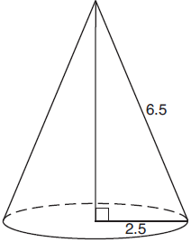

How many cubic centimeters are in the volume of the cone?
1)
2)
3)
4)

5 The funnel shown below can be used to decorate cookies with melted chocolate. The funnel can be modeled by a cone whose radius is 6 cm and height is 13 cm.
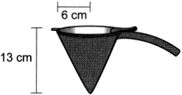

The baker uses 2 cubic centimeters of chocolate to decorate each cookie. When the funnel is completely filled, what is the maximum number of cookies that can be decorated with the melted chocolate?
1) | 78
2) | 245
3) | 490
4) | 735

6 A right circular cone has a diameter of and a height of 12. What is the volume of the cone in terms of π?
1)
2)
3)
4)

7 A water cup in the shape of a cone has a height of 4 inches and a maximum diameter of 3 inches. What is the volume of the water in the cup, to the nearest tenth of a cubic inch, when the cup is filled to half its height?
1) | 1.2
2) | 3.5
3) | 4.7
4) | 14.1

8 The area of the base of a cone is square inches. The volume of the cone is cubic inches. What is the height of the cone in inches?
1) | 12
2) | 8
3) | 3
4) | 4

9 A cone has a volume of and a base diameter of 12. What is the height of the cone?
1) | 27
2) | 9
3) | 3
4) | 4

10 An ice cream waffle cone can be modeled by a right circular cone with a base diameter of 6.6 centimeters and a volume of cubic centimeters. What is the number of centimeters in the height of the waffle cone?
1)
2) | 5
3) | 15
4)

11 Jaden is comparing two cones. The radius of the base of cone A is twice as large as the radius of the base of cone B. The height of cone B is twice the height of cone A. The volume of cone A is
1) | twice the volume of cone B
2) | four times the volume of cone B
3) | equal to the volume of cone B
4) | equal to half the volume of cone B

12 In the diagram below, a right circular cone has a diameter of 10 and a slant height of 13.

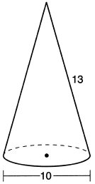

Determine and state the volume of the cone, in terms of .

13 A candle maker uses a mold to make candles like the one shown below.

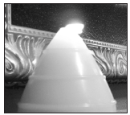

The height of the candle is 13 cm and the circumference of the candle at its widest measure is 31.416 cm. Use modeling to approximate how much wax, to the nearest cubic centimeter, is needed to make this candle. Justify your answer.

14 A paper container in the shape of a right circular cone has a radius of 3 inches and a height of 8 inches. Determine and state the number of cubic inches in the volume of the cone, in terms of .

15 In the diagram below, a right circular cone with a radius of 3 inches has a slant height of 5 inches, and a right cylinder with a radius of 4 inches has a height of 6 inches.
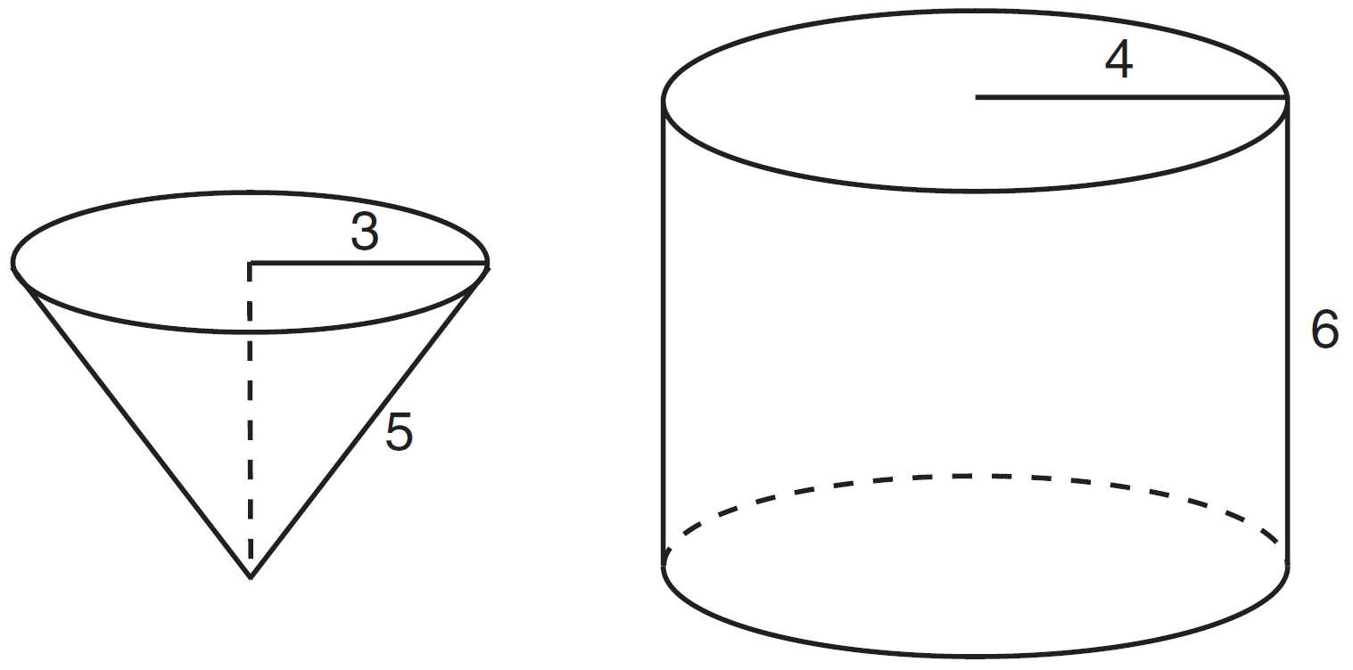
Determine and state the number of full cones of water needed to completely fill the cylinder with water.

16 Sally and Mary both get ice cream from an ice cream truck. Sally's ice cream is served as a cylinder with a diameter of 4 cm and a total height of 8 cm. Mary's ice cream is served as a cone with a diameter of 7 cm and a total height of 12.5 cm. Assume that ice cream fills Sally's cylinder and Mary's cone.
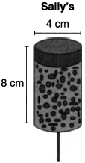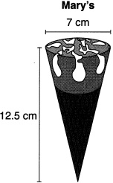
Who was served more ice cream, Sally or Mary? Justify your answer. Determine and state how much more is served in the larger ice cream than the smaller ice cream, to the nearest cubic centimeter.

17 A water glass can be modeled by a truncated right cone (a cone which is cut parallel to its base) as shown below.

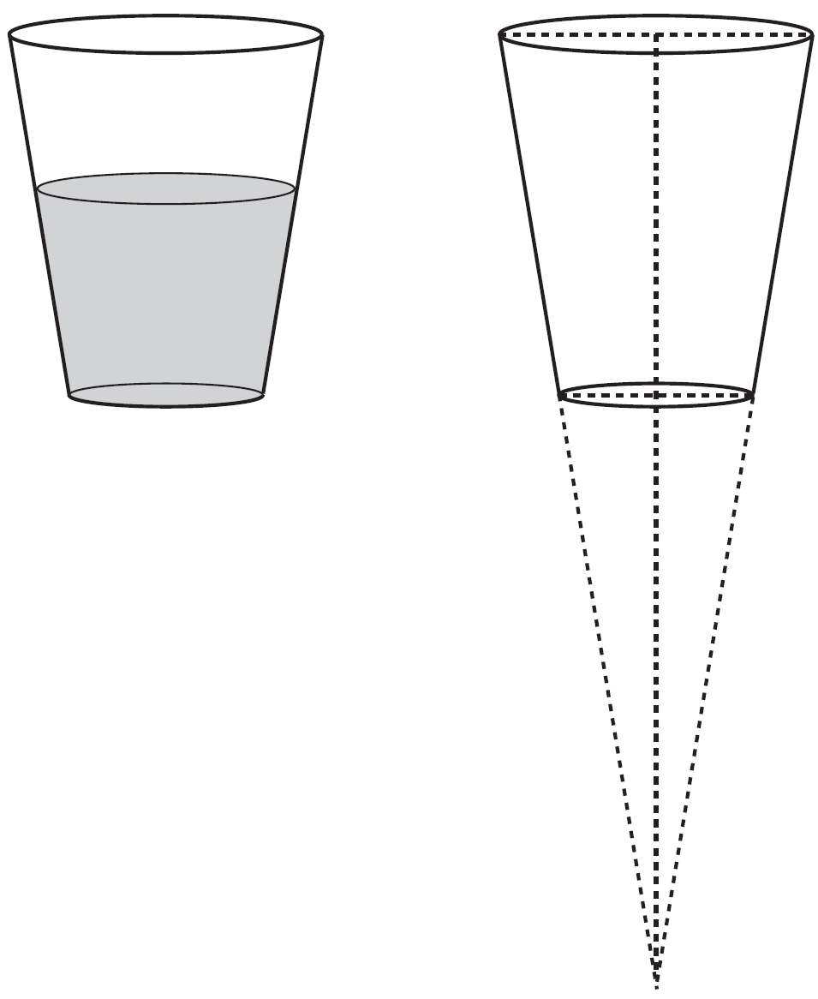

The diameter of the top of the glass is 3 inches, the diameter at the bottom of the glass is 2 inches, and the height of the glass is 5 inches. The base with a diameter of 2 inches must be parallel to the base with a diameter of 3 inches in order to find the height of the cone. Explain why. Determine and state, in inches, the height of the larger cone. Determine and state, to the nearest tenth of a cubic inch, the volume of the water glass.
1 ANS: 1
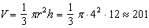

REF: 060921ge

2 ANS: 2
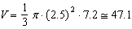

REF: 062303geo

3 ANS: 1
, forming an 8-15-17 triple. 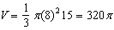

REF: 082318geo

4 ANS: 1
, 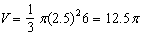

REF: 011923geo

5 ANS: 2
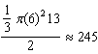

REF: 062408geo

6 ANS: 1
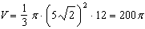

REF: 011623ge

7 ANS: 1
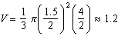

REF: 011724geo

8 ANS: 1
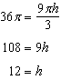

REF: 082411geo

9 ANS: 2
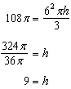

REF: 012002geo

10 ANS: 3
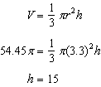

REF: 011807geo

11 ANS: 1
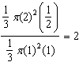

REF: 012010geo

12 ANS:
If 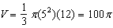

REF: 062227geo

13 ANS:
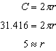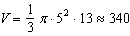

REF: 011734geo

14 ANS:
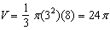

REF: 081530ge

15 ANS:
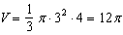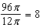

REF: 011537ge

16 ANS:
Mary. Sally: Mary: 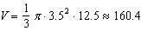

REF: 012332geo

17 ANS:
Similar triangles are required to model and solve a proportion. 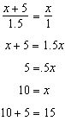 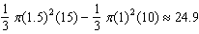

REF: 061636geo

