1 Which expression represents the volume, in cubic centimeters, of the cylinder represented in the diagram below?

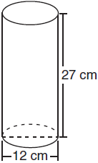
1)
2)
3)
4)

2 A cylindrical container has a diameter of 12 inches and a height of 15 inches, as illustrated in the diagram below.

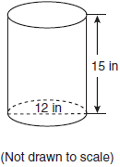

What is the volume of this container to the nearest tenth of a cubic inch?
1) | 6,785.8
2) | 4,241.2
3) | 2,160.0
4) | 1,696.5

3 Darnell models a cup with the cylinder below. He measured the diameter of the cup to be 10 cm and the height to be 9 cm.
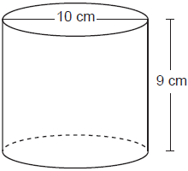
If Darnell fills the cup with water to a height of 8 cm, what is the volume of the water in the cup, to the nearest cubic centimeter?
1) | 628
2) | 707
3) | 2513
4) | 2827

4 What is the volume, in cubic centimeters, of a cylinder that has a height of 15 cm and a diameter of 12 cm?
1)
2)
3)
4)

5 A cylinder has a diameter of 10 inches and a height of 2.3 inches. What is the volume of this cylinder, to the nearest tenth of a cubic inch?
1) | 72.3
2) | 83.1
3) | 180.6
4) | 722.6

6 A cylinder has a circular base with a radius of 3 units and a height of 7 units. What is the volume of the cylinder in cubic units?
1)
2)
3)
4)

7 Tennis balls are sold in cylindrical cans with the balls stacked one on top of the other. A tennis ball has a diameter of 6.7 cm. To the nearest cubic centimeter, what is the minimum volume of the can that holds a stack of 4 tennis balls?
1) | 236
2) | 282
3) | 564
4) | 945

8 A cylindrical pool has a diameter of 16 feet and height of 4 feet. The pool is filled to foot below the top. How much water does the pool contain, to the nearest gallon? [1 ft³ = 7.48 gallons]
1) | 704
2) | 804
3) | 5264
4) | 6016

9 The volume of a cylindrical can in cubic inches. If the height of the can is 2 inches, what is its radius, in inches?
1) | 8
2) | 2
3) | 16
4) | 4

10 A right circular cylinder has a volume of 1,000 cubic inches and a height of 8 inches. What is the radius of the cylinder to the nearest tenth of an inch?
1) | 6.3
2) | 11.2
3) | 19.8
4) | 39.8

11 A peanut butter manufacturer would like to use a cylindrical jar with a volume of 1180 cm³. The jar has a height of 10 cm. What is the diameter of the jar, to the nearest tenth of a centimeter?
1) | 3.8
2) | 6.1
3) | 10.9
4) | 12.3

12 A small town is installing a water storage tank in the shape of a cylinder. The tank must be able to hold at least 100,000 gallons of water. The tank must have a height of exactly 30 feet. [1 cubic foot holds 7.48 gallons of water] What should the minimum diameter of the tank be, to the nearest foot?
1) | 12
2) | 24
3) | 65
4) | 75

13 Oatmeal is packaged in a cylindrical container, as shown in the diagram below.

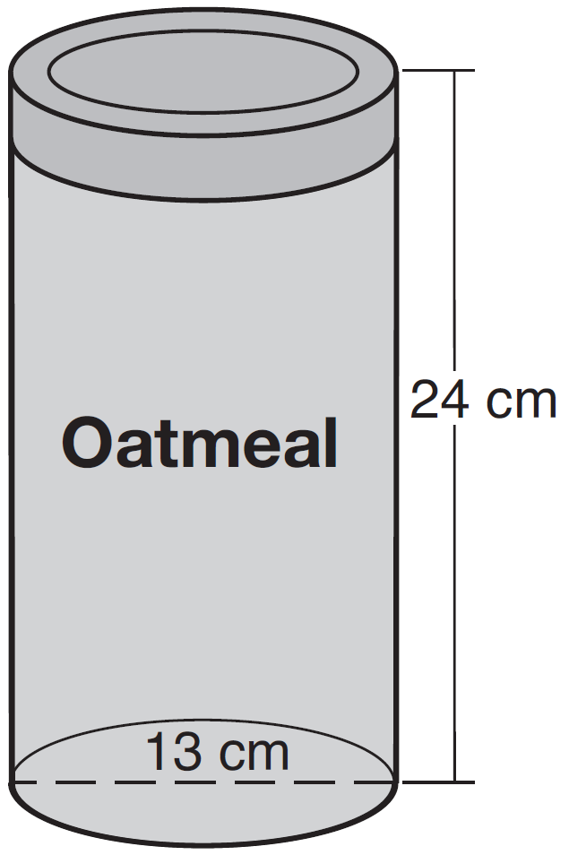

The diameter of the container is 13 centimeters and its height is 24 centimeters. Determine, in terms of , the volume of the cylinder, in cubic centimeters.

14 A concrete footing is a cylinder that is placed in the ground to support a building structure. The cylinder is 4 feet tall and 12 inches in diameter. A contractor is installing 10 footings.

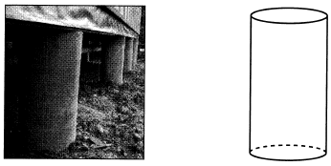

If a bag of concrete mix makes of a cubic foot of concrete, determine and state the minimum number of bags of concrete mix needed to make all 10 footings.

15 A cylinder has a height of 7 cm and a base with a diameter of 10 cm. Determine the volume, in cubic centimeters, of the cylinder in terms of .

16 A thermos in the shape of a cylinder is filled to 1 inch from the top of the cylinder with coffee. The height of the cylinder is 12 inches and its radius is 2.5 inches. State, to the nearest hundredth of a cubic inch, the volume of coffee in the thermos.

17 A barrel of fuel oil is a right circular cylinder where the inside measurements of the barrel are a diameter of 22.5 inches and a height of 33.5 inches. There are 231 cubic inches in a liquid gallon. Determine and state, to the nearest tenth, the gallons of fuel that are in a barrel of fuel oil.

18 The volume of a cylinder is 12,566.4 cm³. The height of the cylinder is 8 cm. Find the radius of the cylinder to the nearest tenth of a centimeter.

19 A large water basin is in the shape of a right cylinder. The inside of the basin has a diameter of feet and a height of 3 feet. Determine and state, to the nearest cubic foot, the number of cubic feet of water that it will take to fill the basin to a level of foot from the top.

20 A child-sized swimming pool can be modeled by a cylinder. The pool has a diameter of feet and a height of 12 inches. The pool is filled with water to of its height. Determine and state the volume of the water in the pool, to the nearest cubic foot. One cubic foot equals 7.48 gallons of water. Determine and state, to the nearest gallon, the number of gallons of water in the pool.

21 A soup can is in the shape of a cylinder. The can has a volume of and a diameter of 6 cm. Express the height of the can in terms of π. Determine the maximum number of soup cans that can be stacked on their base between two shelves if the distance between the shelves is exactly 36 cm. Explain your answer.

22 A small can of soup is a right circular cylinder with a base diameter of 7 cm and a height of 9 cm. A large container is also a right circular cylinder with a base diameter of 9 cm and a height of 13cm. Determine and state the volume of the small can and the volume of the large container to the nearest cubic centimeter. What is the minimum number of small cans that must be opened to fill the large container? Justify your answer.

23 In the accompanying diagram, a rectangular container with the dimensions 10 inches by 15 inches by 20 inches is to be filled with water, using a cylindrical cup whose radius is 2 inches and whose height is 5 inches. What is the maximum number of full cups of water that can be placed into the container without the water overflowing the container?

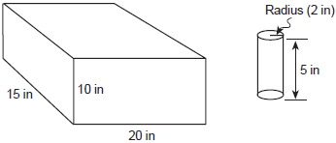

24 A manufacturer is designing a new container for their chocolate-covered almonds. Their original container was a cylinder with a height of 18 cm and a diameter of 14 cm. The new container can be modeled by a rectangular prism with a square base and will contain the same amount of chocolate-covered almonds.

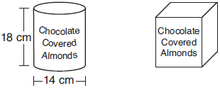

If the new container's height is 16 cm, determine and state, to the nearest tenth of a centimeter, the side length of the new container if both containers contain the same amount of almonds. A store owner who sells the chocolate-covered almonds displays them on a shelf whose dimensions are 80 cm long and 60 cm wide. The shelf can only hold one layer of new containers when each new container sits on its square base. Determine and state the maximum number of new containers the store owner can fit on the shelf.

25 Mike buys his ice cream packed in a rectangular prism-shaped carton, while Carol buys hers in a cylindrical-shaped carton. The dimensions of the prism are 5 inches by 3.5 inches by 7 inches. The cylinder has a diameter of 5 inches and a height of 7 inches. Which container holds more ice cream? Justify your answer. Determine, to the nearest tenth of a cubic inch, how much more ice cream the larger container holds.

26 Theresa has a rectangular pool 30 ft long, 15 ft wide, and 4 ft deep. Theresa fills her pool using city water at a rate of $3.95 per 100 gallons of water. Nancy has a circular pool with a diameter of 24 ft and a depth of 4 ft. Nancy fills her pool with a water delivery service at a rate of $200 per 6000 gallons. If Theresa and Nancy both fill their pools 6 inches from the top of the pool, determine and state who paid more to fill her pool.

27 A gas station has a cylindrical fueling tank that holds the gasoline for its pumps, as modeled below. The tank holds a maximum of 20,000 gallons of gasoline and has a length of 34.5 feet.

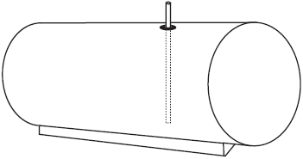

A metal pole is used to measure how much gas is in the tank. To the nearest tenth of a foot, how long does the pole need to be in order to reach the bottom of the tank and still extend one foot outside the tank? Justify your answer. [1 ft³=7.48 gallons]
1 ANS: 3

REF: 011027ge

2 ANS: 4

REF: fall0712ia

3 ANS: 1

REF: 082304geo

4 ANS: 2

REF: 011117ge

5 ANS: 3

REF: 081105ia

6 ANS: 3

REF: 011505ia

7 ANS: 4
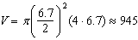

REF: 081620geo

8 ANS: 3

REF: 012320geo

9 ANS: 4
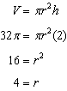

REF: 081224ia

10 ANS: 1
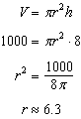

REF: 080926ge

11 ANS: 4
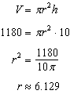

REF: 062413geo

12 ANS: 2
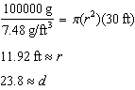

REF: 012424geo

13 ANS:

REF: 061332ia

14 ANS:
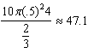 48 bags

REF: 062234geo

15 ANS:

REF: 081231ge

16 ANS:

REF: 081433ia

17 ANS:
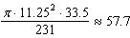

REF: 061632geo

18 ANS:
22.4. 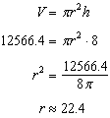

REF: fall0833ge

19 ANS:
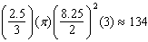

REF: 081931geo

20 ANS:
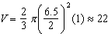

REF: 061933geo

21 ANS:
, 2. 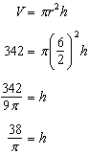. 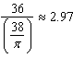. Three cans will not fit. The maximum number is 2.

REF: 010936ia

22 ANS:
; ; 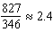; 3 cans

REF: 062333geo

23 ANS:
47. 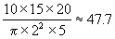. The question asks how many full cups of water can be placed into the container without the water overflowing, so do not round up to 48. The answer is 47.

REF: 010227a

24 ANS:
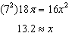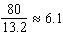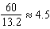

REF: 012034geo

25 ANS:
Carol’s, by 14.9. . .

REF: 061237ia

26 ANS:
Theresa. 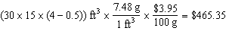, 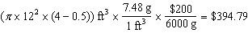

REF: 011933geo

27 ANS:
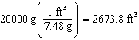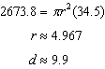

REF: 061734geo

