1 A packing carton in the shape of a triangular prism is shown in the diagram below.

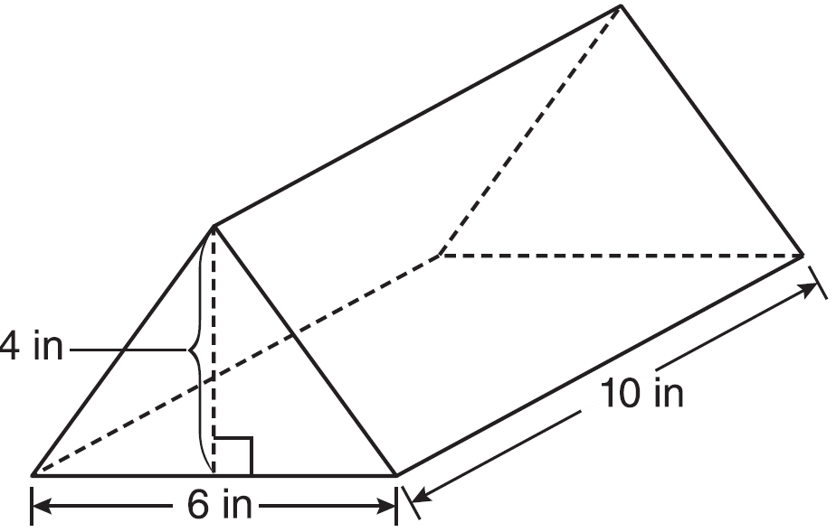

What is the volume, in cubic inches, of this carton?
1) | 20
2) | 60
3) | 120
4) | 240

2 A sandbox in the shape of a rectangular prism has a length of 43 inches and a width of 30 inches. Jack uses bags of sand to fill the sandbox to a depth of 9 inches. Each bag of sand has a volume of 0.5 cubic foot. What is the minimum number of bags of sand that must be purchased to fill the sandbox?
1) | 14
2) | 13
3) | 7
4) | 4

3 A gardener wants to buy enough mulch to cover a rectangular garden that is 3 feet by 10 feet. One bag contains 2 cubic feet of mulch and costs $3.66. How much will the minimum number of bags cost to cover the garden with mulch 3 inches deep?
1) | $3.66
2) | $10.98
3) | $14.64
4) | $29.28

4 A fish tank in the shape of a rectangular prism has dimensions of 14 inches, 16 inches, and 10 inches. The tank contains 1680 cubic inches of water. What percent of the fish tank is empty?
1) | 10
2) | 25
3) | 50
4) | 75

5 The volume of a rectangular prism is 144 cubic inches. The height of the prism is 8 inches. Which measurements, in inches, could be the dimensions of the base?
1) | 3.3 by 5.5
2) | 2.5 by 7.2
3) | 12 by 8
4) | 9 by 9

6 A rectangular prism has a volume of . Its base has a length of and a width of 3. Which expression represents the height of the prism?
1)
2)
3) | 3
4)

7 A right prism has a square base with an area of 12 square meters. The volume of the prism is 84 cubic meters. Determine and state the height of the prism, in meters.

8 The Parkside Packing Company needs a rectangular shipping box. The box must have a length of 11 inches and a width of 8 inches. Find, to the nearest tenth of an inch, the minimum height of the box such that the volume is at least 800 cubic inches.

9 The base of a right pentagonal prism has an area of 20 square inches. If the prism has an altitude of 8 inches, determine and state the volume of the prism, in cubic inches.

10 A carpenter made a storage container in the shape of a rectangular prism. It is 5 feet high and has a volume of 720 cubic feet. He wants to make a second container with the same height and volume as the first one, but in the shape of a triangular prism. What will be the number of square feet in the area of the base of the new container?
1) | 36
2) | 72
3) | 144
4) | 288

11 A rectangular prism has a base with a length of 25, a width of 9, and a height of 12. A second prism has a square base with a side of 15. If the volumes of the two prisms are equal, what is the height of the second prism?
1) | 6
2) | 8
3) | 12
4) | 15

12 Two prisms have equal heights and equal volumes. The base of one is a pentagon and the base of the other is a square. If the area of the pentagonal base is 36 square inches, how many inches are in the length of each side of the square base?
1) | 6
2) | 9
3) | 24
4) | 36

13 Tim has a rectangular prism with a length of 10 centimeters, a width of 2 centimeters, and an unknown height. He needs to build another rectangular prism with a length of 5 centimeters and the same height as the original prism. The volume of the two prisms will be the same. Find the width, in centimeters, of the new prism.

14 Two prisms with equal altitudes have equal volumes. The base of one prism is a square with a side length of 5 inches. The base of the second prism is a rectangle with a side length of 10 inches. Determine and state, in inches, the measure of the width of the rectangle.

15 Ian needs to replace two concrete sections in his sidewalk, as modeled below. Each section is 36 inches by 36 inches and 4 inches deep. He can mix his own concrete for $3.25 per cubic foot.

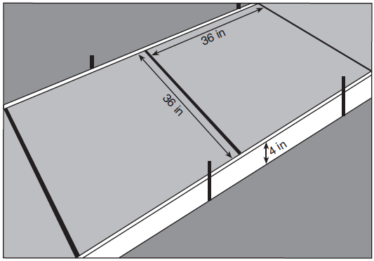

How much money will it cost Ian to replace the two concrete sections?

16 The volume of a triangular prism is 70 in³. The base of the prism is a right triangle with one leg whose measure is 5 inches. If the height of the prism is 4 inches, determine and state the length, in inches, of the other leg of the triangle.
1 ANS: 3 REF: 081123ge

2 ANS: 1
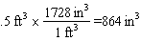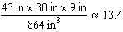

REF: 012419geo

3 ANS: 3
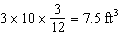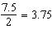

REF: 062311geo

4 ANS: 2
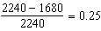

REF: 011604geo

5 ANS: 2 REF: 011215ge

6 ANS: 1
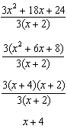

REF: fall0815ge

7 ANS:
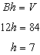

REF: 011432ge

8 ANS:
9.1. 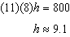

REF: 061131ge

9 ANS:

REF: 011633ge

10 ANS: 3
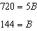

REF: 081523ge

11 ANS: 3
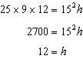

REF: 061323ge

12 ANS: 1
If two prisms have equal heights and volume, the area of their bases is equal.

REF: 081321ge

13 ANS:
4. 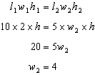

REF: 011030ge

14 ANS:
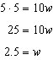

REF: 061432ge

15 ANS:
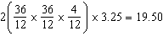

REF: 081831geo

16 ANS:
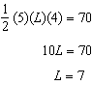

REF: 012330geo

