1 Sue believes that the two cylinders shown in the diagram below have equal volumes.

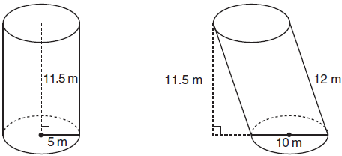

Is Sue correct? Explain why.

2 Two stacks of 23 quarters each are shown below. One stack forms a cylinder but the other stack does not form a cylinder.

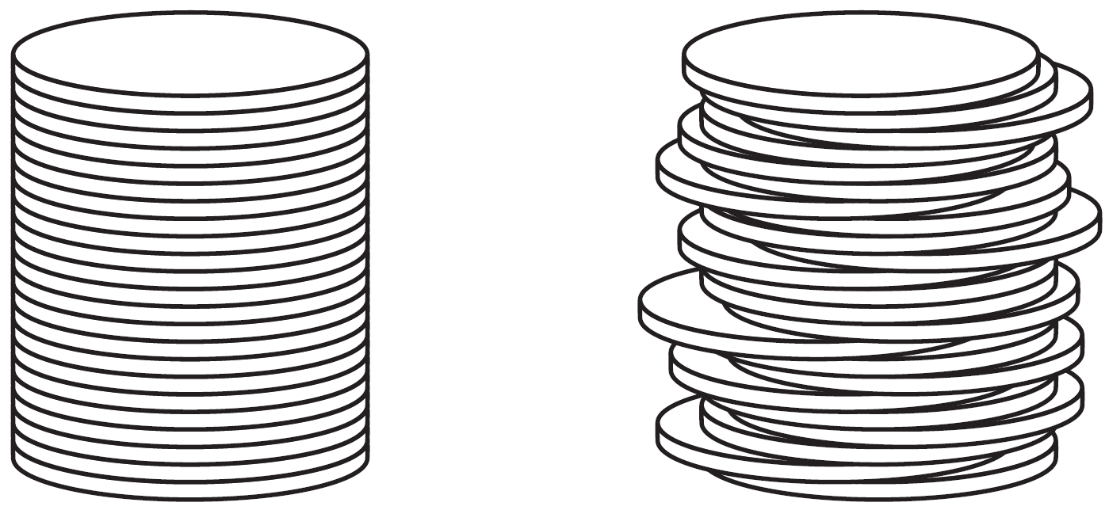

Use Cavelieri’s principle to explain why the volumes of these two stacks of quarters are equal.

3 The diagram below shows two figures. Figure A is a right triangular prism and figure B is an oblique triangular prism. The base of figure A has a height of 5 and a length of 8 and the height of prism A is 14. The base of figure B has a height of 8 and a length of 5 and the height of prism B is 14.

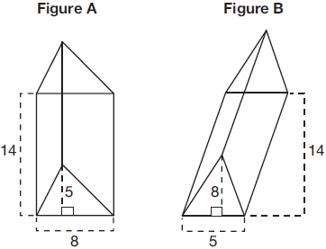

Use Cavalieri's Principle to explain why the volumes of these two triangular prisms are equal.
1 ANS:
Yes. The bases of the cylinders have the same area and the cylinders have the same height.

REF: 081725geo

2 ANS:
Each quarter in both stacks has the same base area. Therefore, each corresponding cross-section of the stacks will have the same area. Since the two stacks of quarters have the same height of 23 quarters, the two volumes must be the same.

REF: spr1405geo

3 ANS:
Each triangular prism has the same base area. Therefore, each corresponding cross-section of the prisms will have the same area. Since the two prisms have the same height of 14, the two volumes must be the same.

REF: 061727geo

