1 Virginia has a circular rug on her square living room floor, as represented in the accompanying diagram. If her entire living room floor measures 100 square feet, what is the area of the part of the floor covered by the rug?

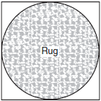

2 If the circumference of a circle is inches, what is the area, in square inches, of the circle?
1)
2)
3)
4)

3 The circumference of a circle measures units. Find the number of square units in the area of the circle. Express your answer in terms of .

4 A dog is tied with a rope to a stake in the ground. The length of the rope is 5 yards. What is the area, in square yards, in which the dog can roam?
1)
2)
3) | 25
4) | 20

5 A circular garden has a diameter of 12 feet. How many bags of topsoil must Linda buy to cover the garden if one bag covers an area of 3 square feet?
1) | 13
2) | 38
3) | 40
4) | 151

6 The circumference of a circular plot of land is increased by 10%. What is the best estimate of the total percentage that the area of the plot increased?
1) | 10%
2) | 21%
3) | 25%
4) | 31%

7 If an arc of 60° on circle A has the same length as an arc of 45° on circle B, what is the ratio of the area of circle B to the area of circle A?
1 ANS:
. If Virginia’s entire square living room floor measures 100 square feet, each wall is 10 feet long. Therefore the diameter of the rug is 10 and its radius is 5. The area of the floor covered by the rug is
REF: 060129a

2 ANS: 2
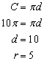. 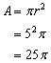
REF: 010012a

3 ANS:
. 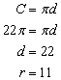. 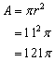
REF: 010831a

4 ANS: 1
REF: 010617a

5 ANS: 2
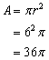. 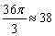
REF: 010717a

6 ANS: 2
If the circumference is increased by 10%, radius is also increased by 10%.
REF: 060106b

7 ANS:
. 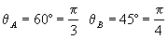. 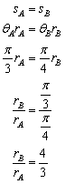. If the ratio of the radii of circle A and B is the ratio of their areas is
REF: fall9932b

