1 Given circle O with radius , use a compass and straightedge to construct an equilateral triangle inscribed in circle O. [Leave all construction marks.]

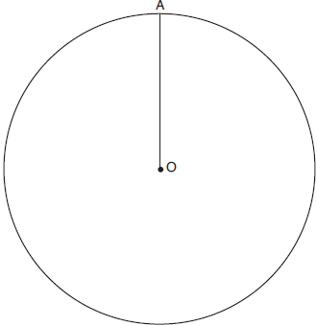

2 Construct an equilateral triangle inscribed in circle T shown below. [Leave all construction marks.]

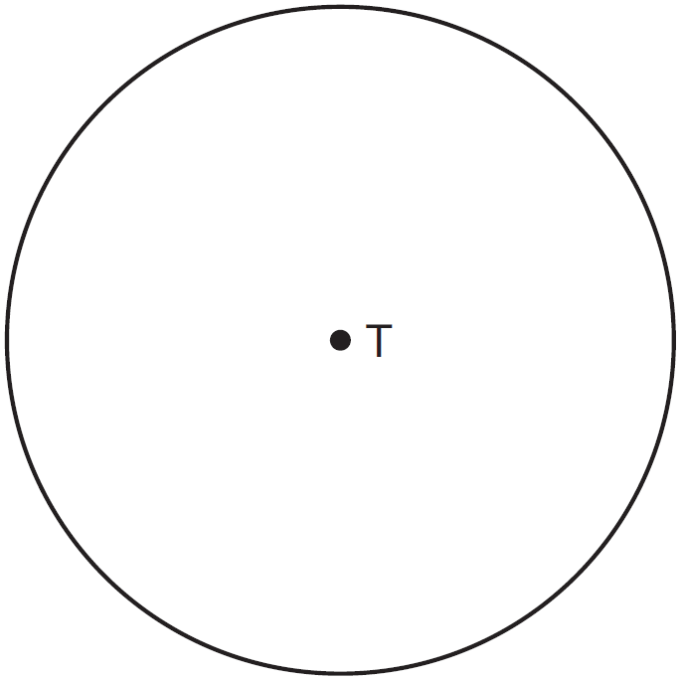

3 Use a compass and straightedge to construct an equilateral triangle inscribed in circle A below. [Leave all construction marks.]

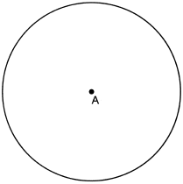

4 Use a compass and straightedge to construct an inscribed square in circle T shown below. [Leave all construction marks.]

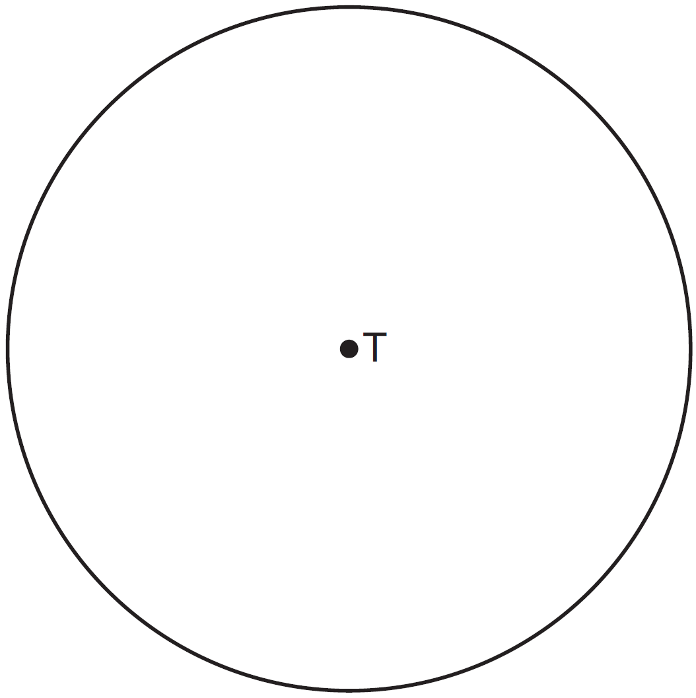

5 The diagram below shows circle O with diameter . Using a compass and straightedge, construct a square that is inscribed in circle O. [Leave all construction marks.]

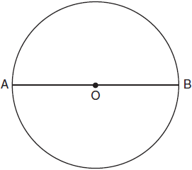

6 Using a straightedge and compass, construct a square inscribed in circle O below. [Leave all construction marks.]

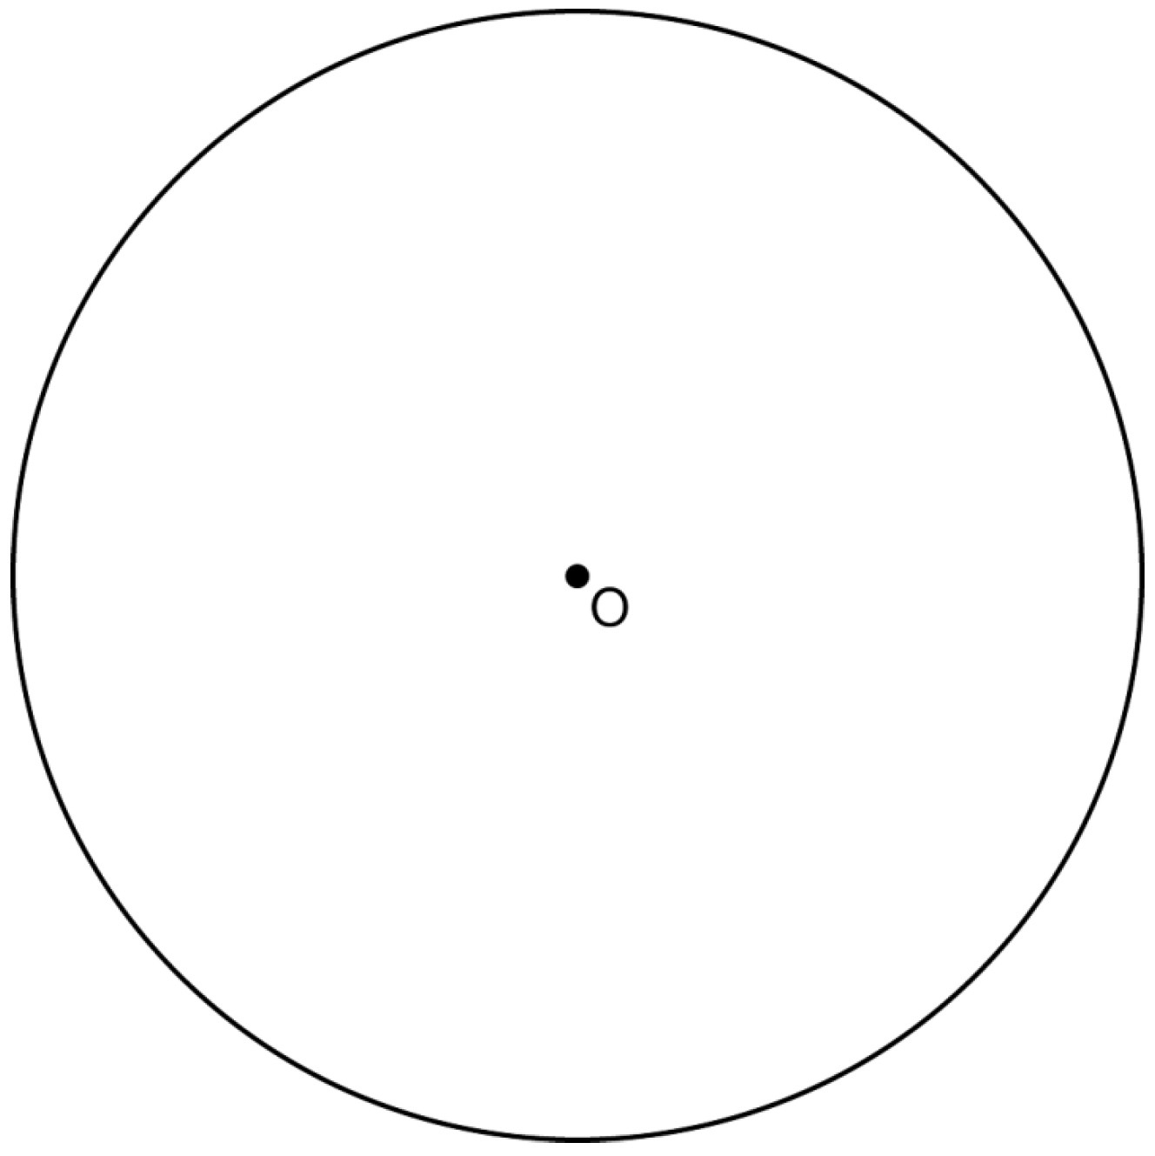

Determine the measure of the arc intercepted by two adjacent sides of the constructed square. Explain your reasoning.

7 Using a compass and straightedge, construct a regular hexagon inscribed in circle O. [Leave all construction marks.]

8 Using a compass and straightedge, construct a regular hexagon inscribed in circle O below. Label it ABCDEF. [Leave all construction marks.]

If chords and are drawn, which type of triangle, according to its angles, would be? Explain your answer.
1 ANS:
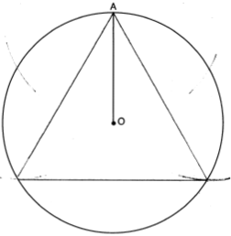

REF: 061931geo

2 ANS:
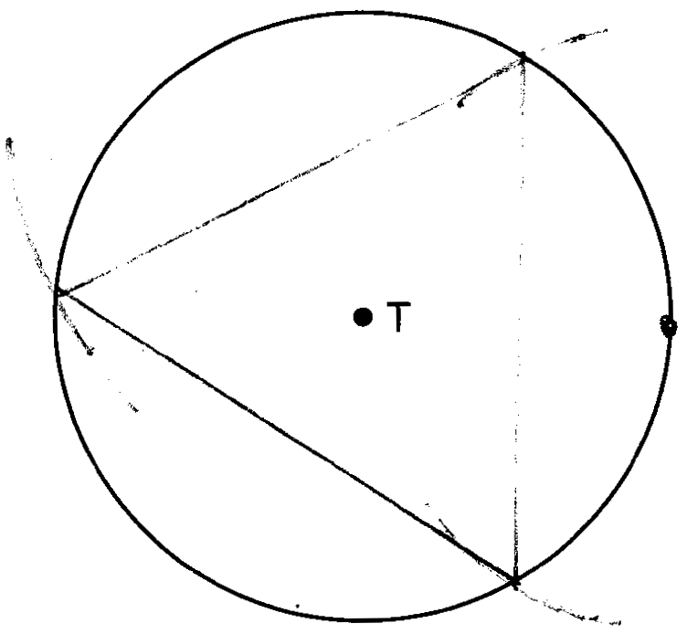

REF: 081526geo

3 ANS:
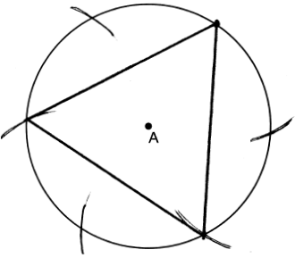

REF: 062426geo

4 ANS:
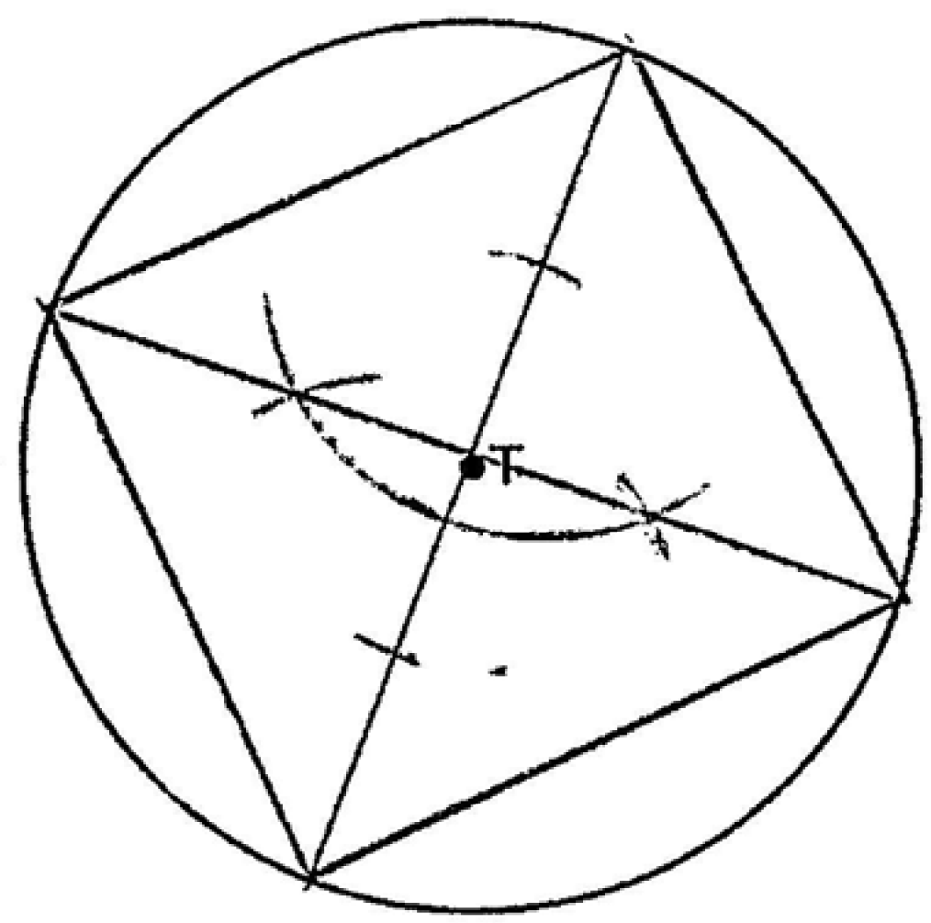

REF: 061525geo

5 ANS:
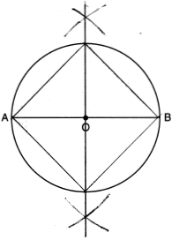

REF: 011826geo

6 ANS:
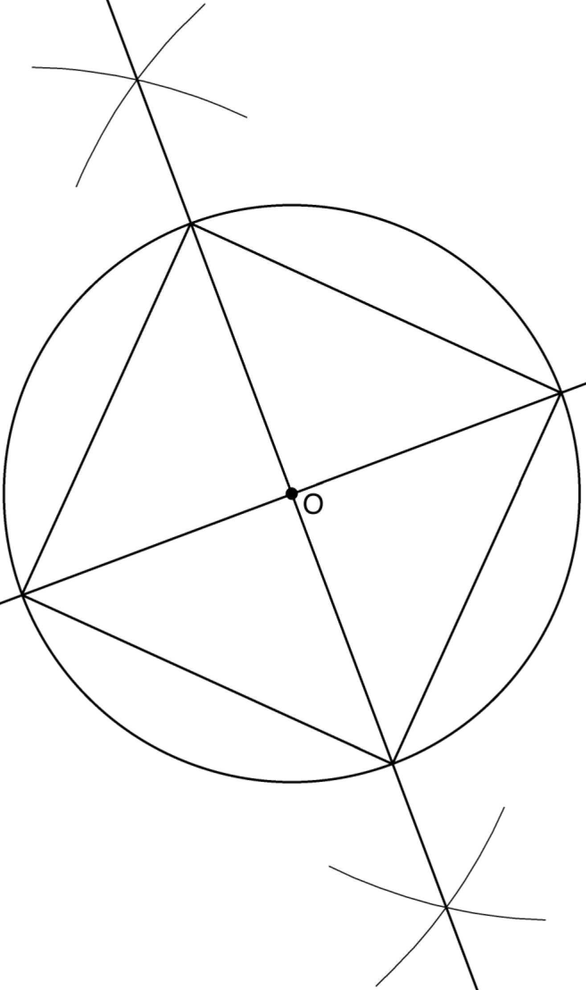 Since the square is inscribed, each vertex of the square is on the circle and the diagonals of the square are diameters of the circle. Therefore, each angle of the square is an inscribed angle in the circle that intercepts the circle at the endpoints of the diameters. Each angle of the square, which is an inscribed angle, measures 90 degrees. Therefore, the measure of the arc intercepted by two adjacent sides of the square is 180 degrees because it is twice the measure of its inscribed angle.

REF: fall1412geo

7 ANS:
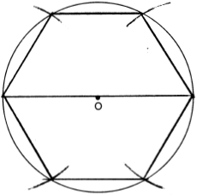
REF: 081728geo

8 ANS:
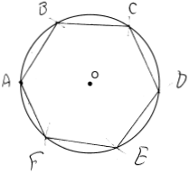 Right triangle because is inscribed in a semi-circle.
REF: 011733geo

