1 In the diagram below, is equilateral.

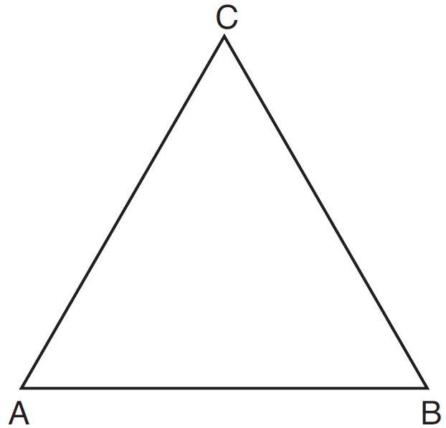

Using a compass and straightedge, construct a new equilateral triangle congruent to in the space below. [Leave all construction marks.]

2 Triangle XYZ is shown below. Using a compass and straightedge, on the line below, construct and label , such that . [Leave all construction marks.] Based on your construction, state the theorem that justifies why is congruent to .

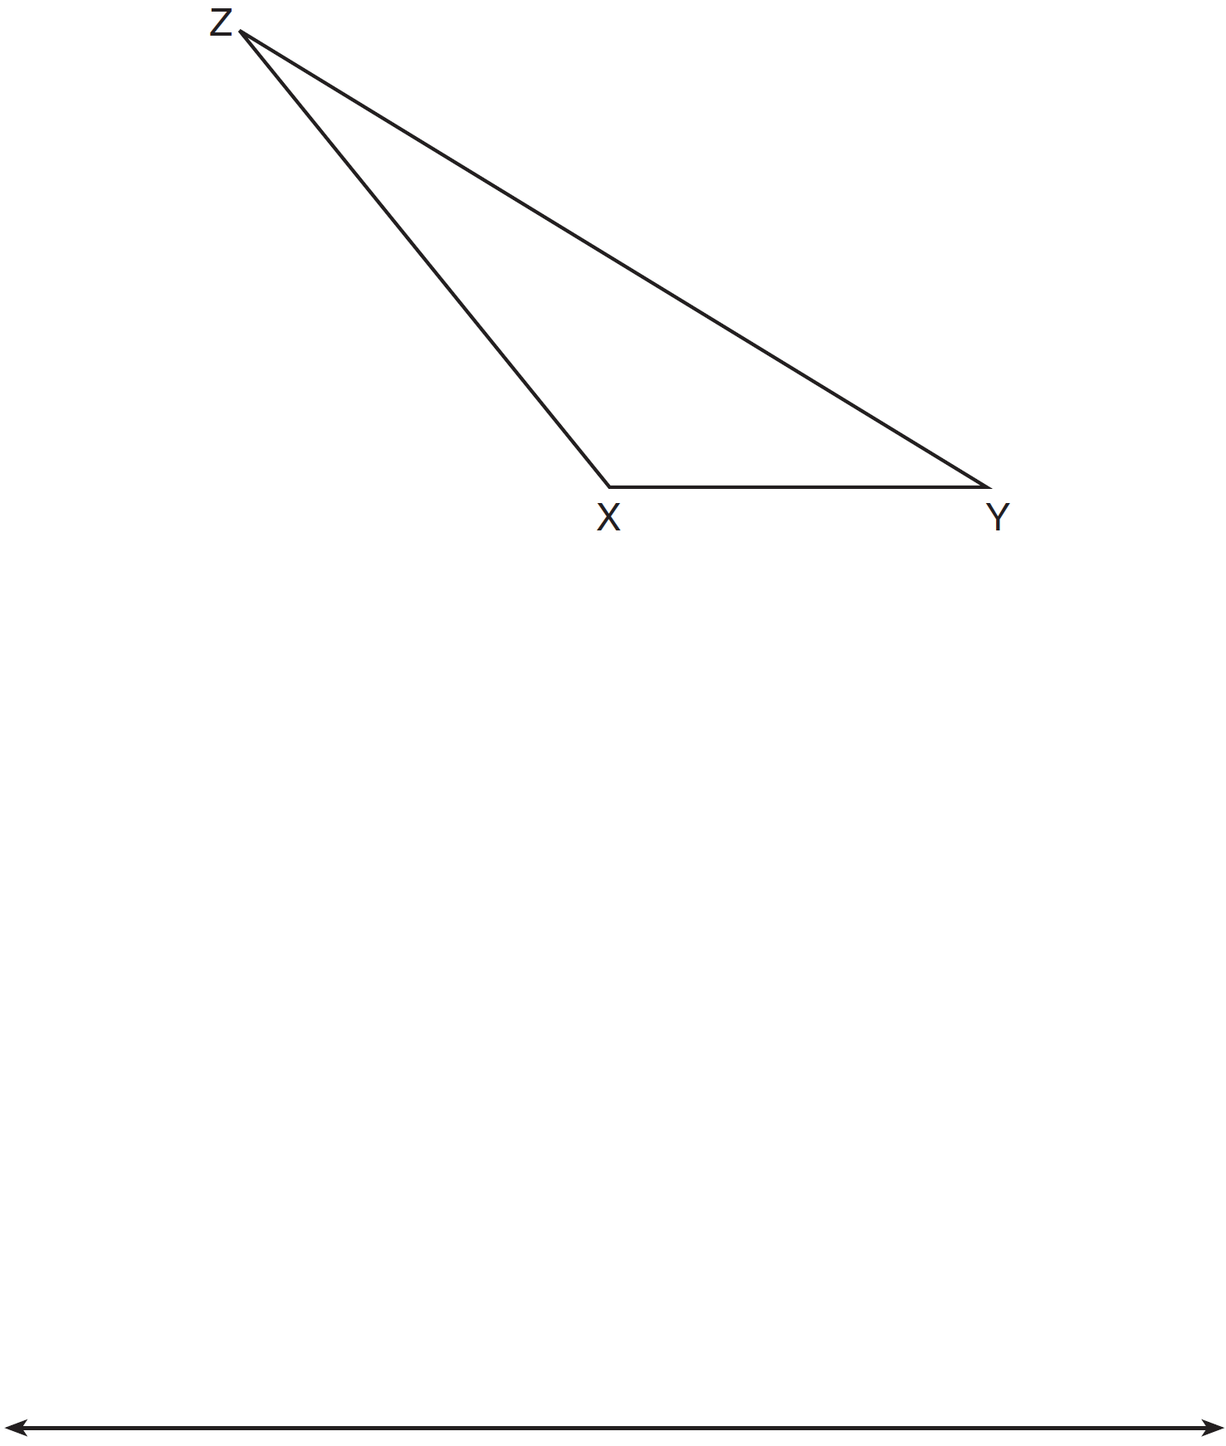

3 Using a compass and straightedge, dilate triangle ABC by a scale factor of 2 centered at C. [Leave all construction marks.]

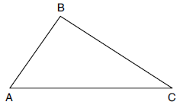

4 Using a compass and straightedge, construct and label , the image of after a dilation with a scale factor of 2 and centered at B. [Leave all construction marks.] Describe the relationship between the lengths of and .

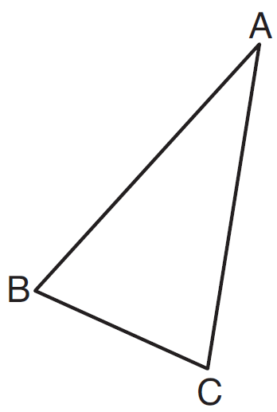

5 Triangle ABC is shown below. Using a compass and straightedge, construct the dilation of centered at B with a scale factor of 2. [Leave all construction marks.]

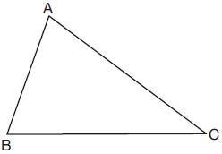

Is the image of similar to the original triangle? Explain why.
1 ANS:
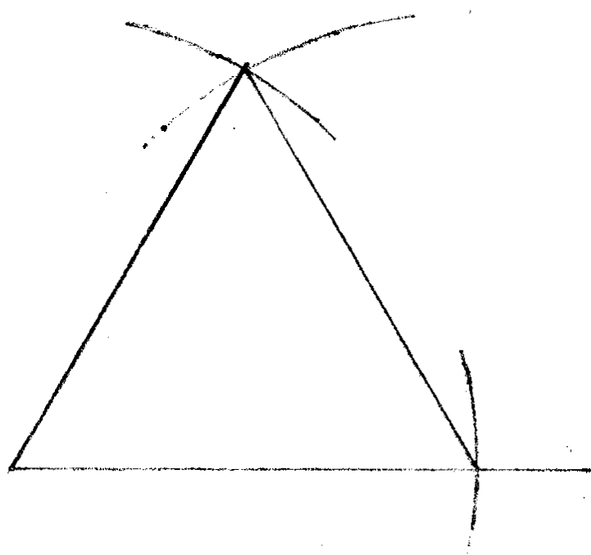

REF: 081532ge

2 ANS:
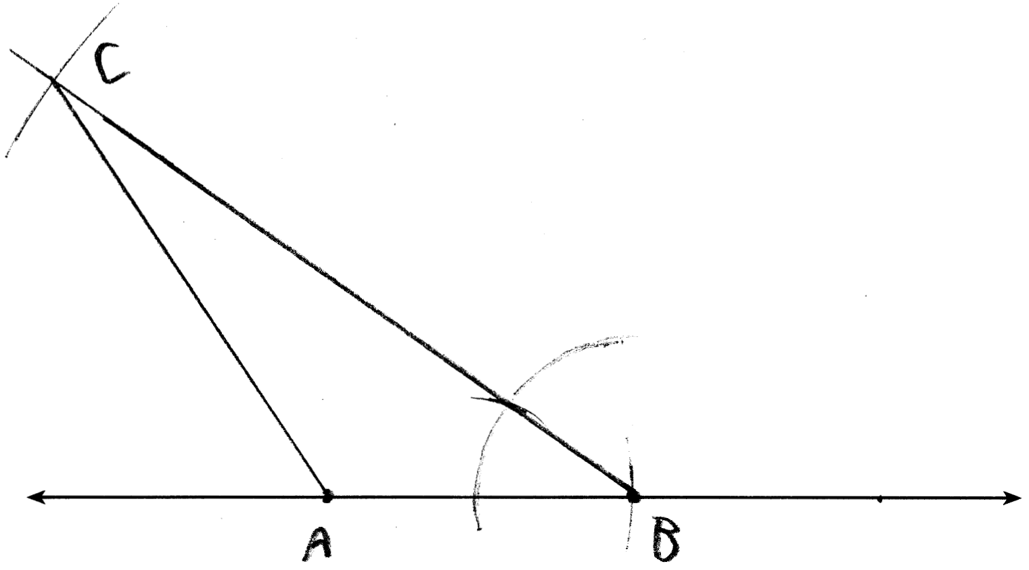

REF: 011634geo

3 ANS:
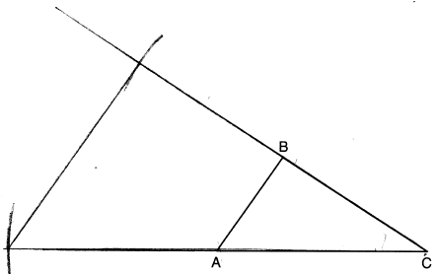

REF: 082227geo

4 ANS:
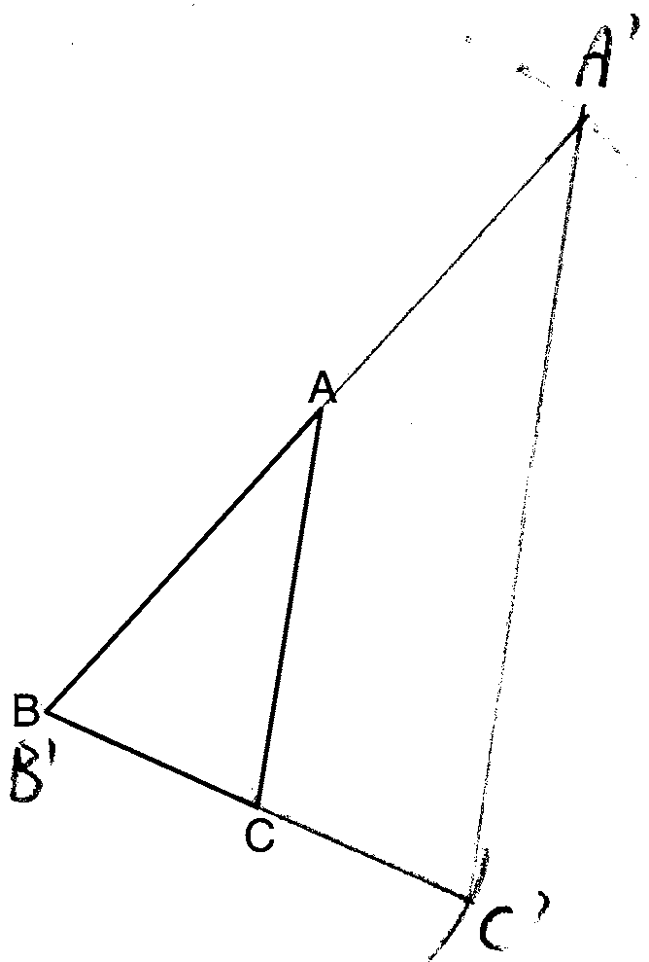 The length of is twice .

REF: 081632geo

5 ANS:
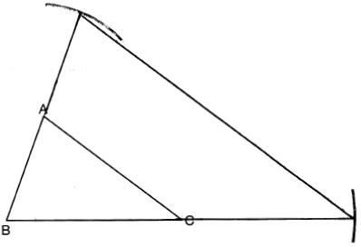Yes, because a dilation preserves angle measure.

REF: 081932geo

