1 Which diagram shows the construction of an equilateral triangle?
1) | 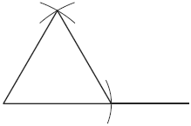
2) | 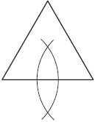
3) | 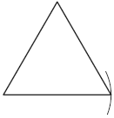
4) | 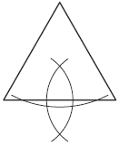

2 Which diagram represents a correct construction of equilateral , given side ?
1) | 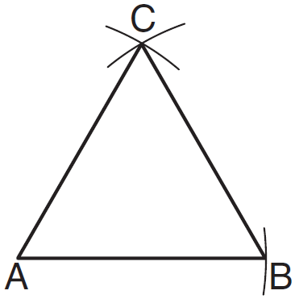
2) | 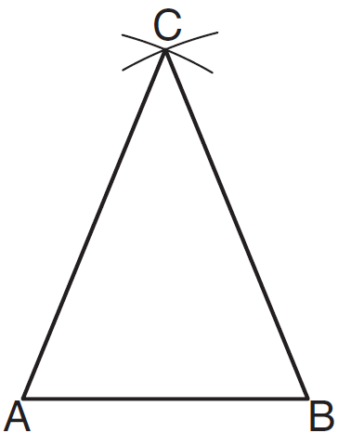
3) | 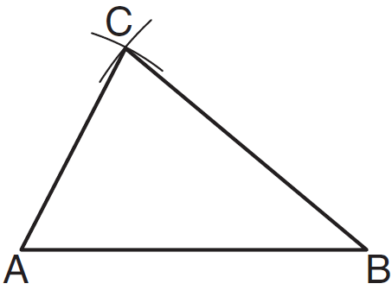
4) | 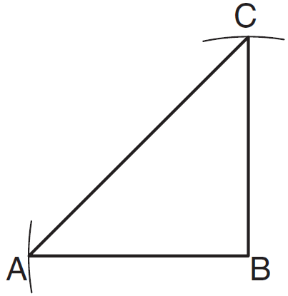

3 The diagram below shows the construction of an equilateral triangle.

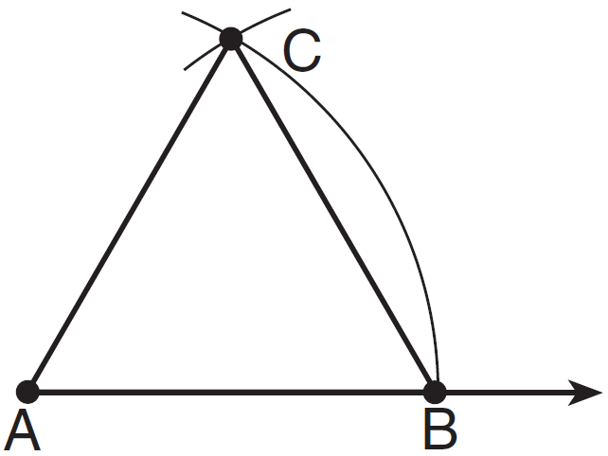

Which statement justifies this construction?
1)
2)
3)
4)

4 Using the construction below, state the degree measure of . Explain why.

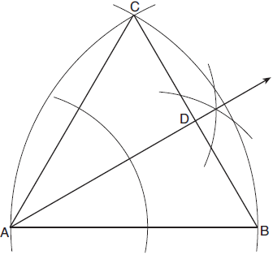

5 Using a compass and straightedge, and below, construct an equilateral triangle with all sides congruent to . [Leave all construction marks.]

6 On the line segment below, use a compass and straightedge to construct equilateral triangle ABC. [Leave all construction marks.]

7 Using a compass and straightedge, on the diagram below of , construct an equilateral triangle with as one side. [Leave all construction marks.]

8 Construct a triangle with sides of lengths a, b, and c, as shown below. Be sure the longest side of your triangle lies on and that point P is one of the triangle’s vertices. [Show all arcs necessary for a valid construction.]

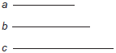

9 Segment CA is drawn below. Using a compass and straightedge, construct isosceles right triangle CAT where and . [Leave all construction marks.]

10 On the ray drawn below, using a compass and straightedge, construct an equilateral triangle with a vertex at R. The length of a side of the triangle must be equal to a length of the diagonal of rectangle ABCD.

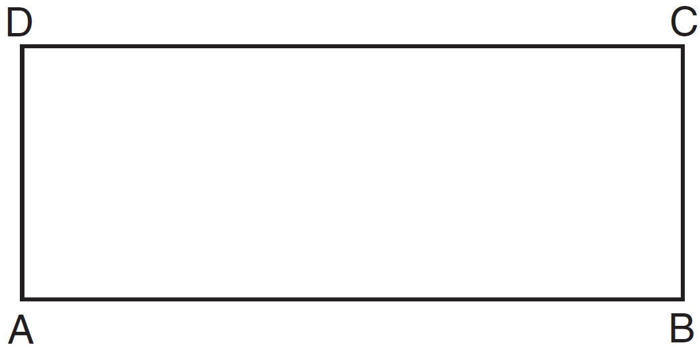

11 Given points A, B, and C, use a compass and straightedge to construct point D so that ABCD is a parallelogram. [Leave all construction marks.]

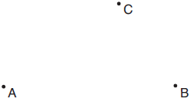
1 ANS: 1 REF: 061012ge

2 ANS: 1 REF: 011207ge

3 ANS: 3 REF: 011309ge

4 ANS:
30° is an equilateral triangle, so . Since is an angle bisector, .

REF: 081929geo

5 ANS:
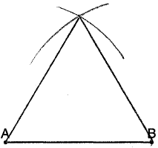

REF: 011032ge

6 ANS:
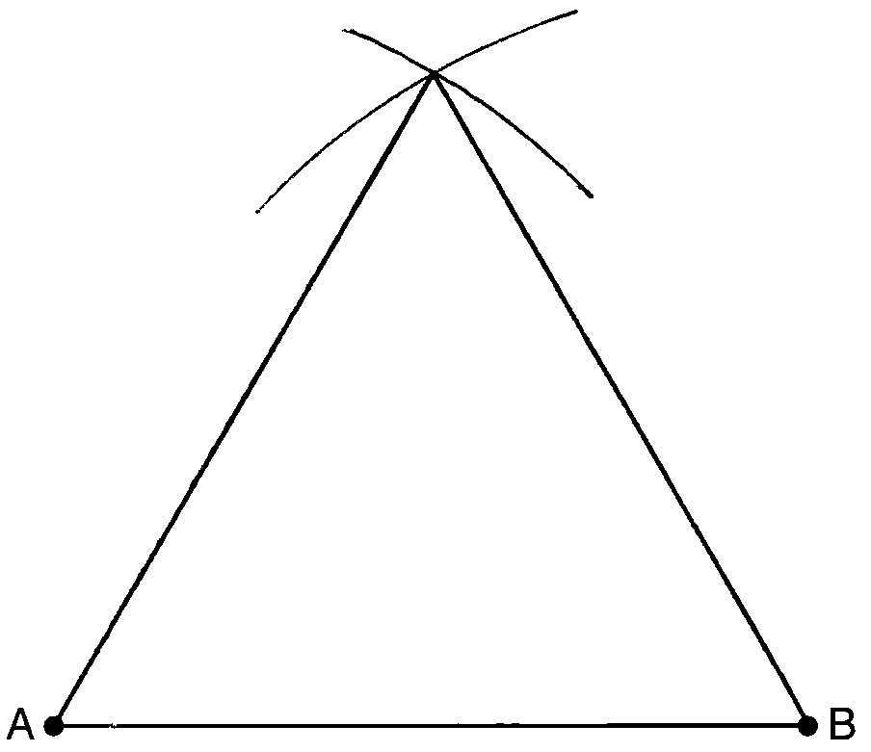

REF: 081032ge

7 ANS:
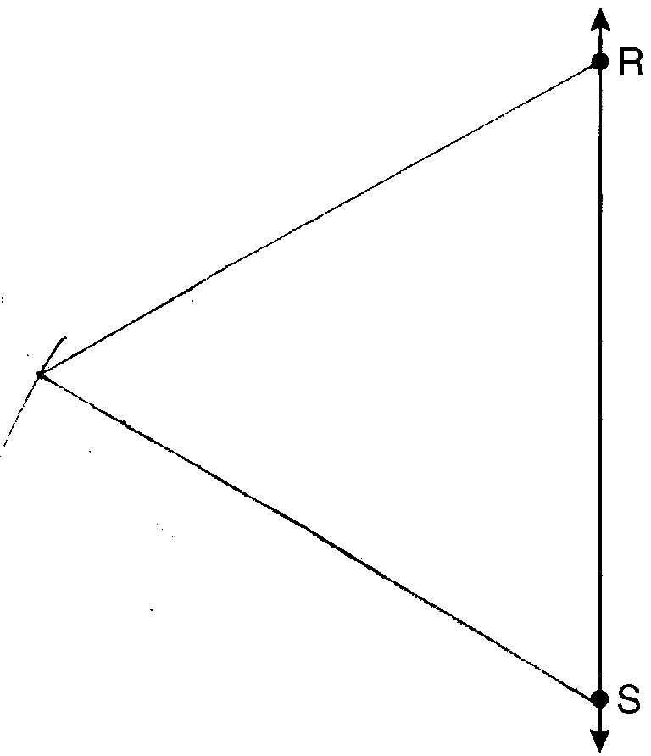

REF: 061130ge

8 ANS:
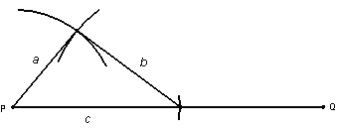

REF: 010225a

9 ANS:
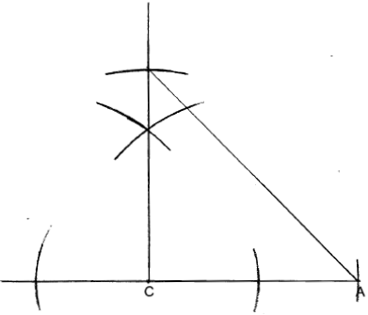

REF: 012427geo

10 ANS:
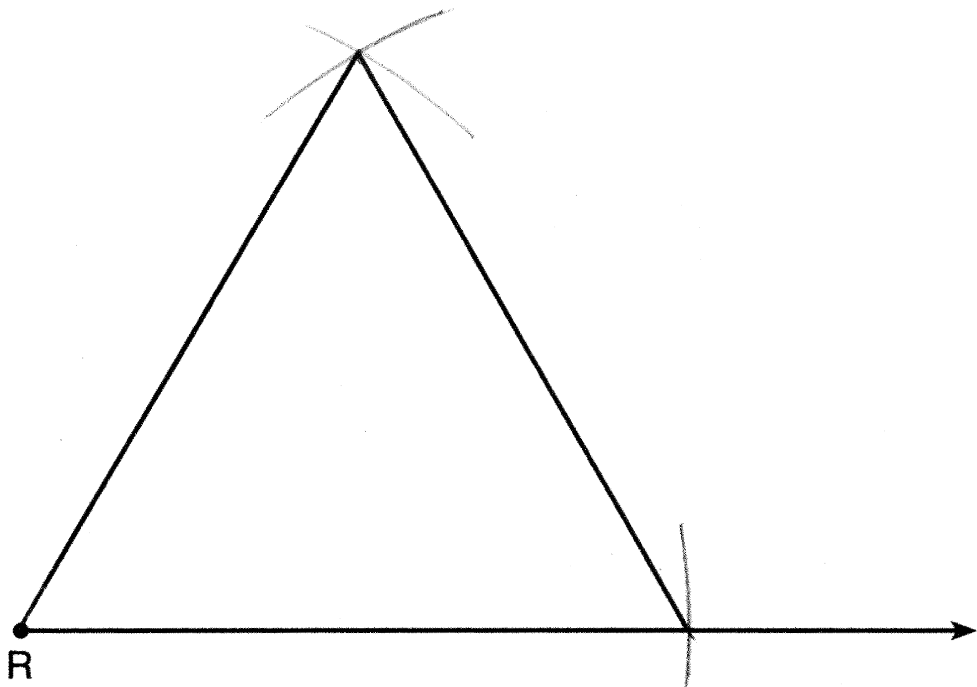

REF: 061332ge

11 ANS:
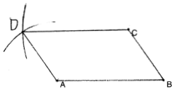

REF: 011929geo

