1 The diagram below shows the construction of the bisector of .

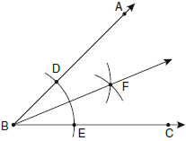

Which statement is not true?
1) | 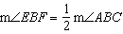
2) | 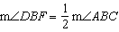
3)
4)

2 A student used a compass and a straightedge to construct in as shown below.

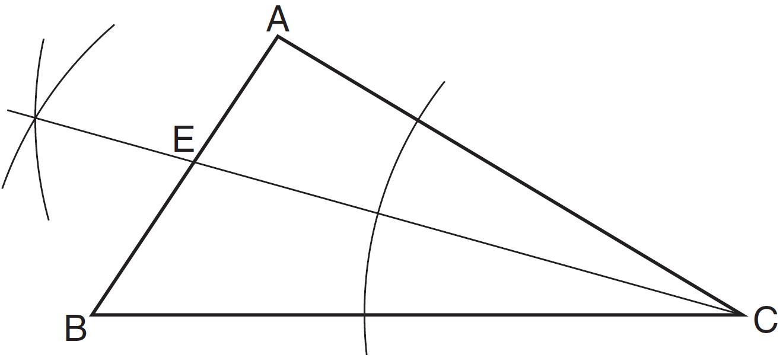

Which statement must always be true for this construction?
1)
2)
3)
4)

3 Based on the construction below, which statement must be true?

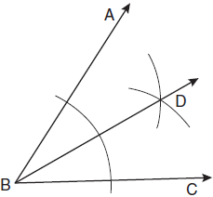
1) | 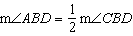
2)
3)
4) | 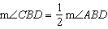

4 A straightedge and compass were used to create the construction below. Arc EF was drawn from point B, and arcs with equal radii were drawn from E and F.

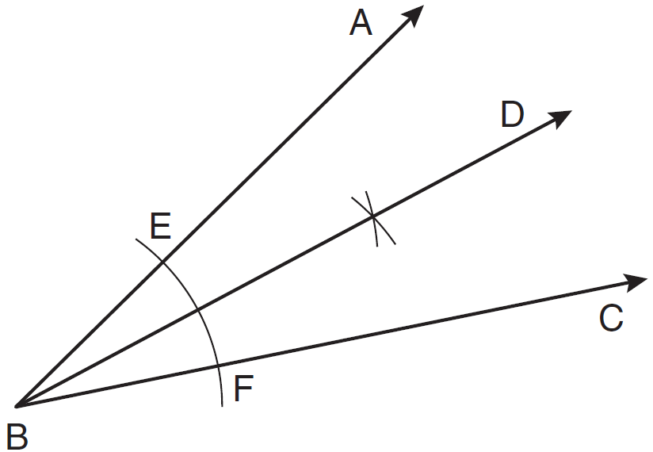

Which statement is false?
1)
2) | 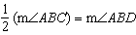
3)
4)

5 As shown in the diagram below of , a compass is used to find points D and E, equidistant from point A. Next, the compass is used to find point F, equidistant from points D and E. Finally, a straightedge is used to draw . Then, point G, the intersection of and side of , is labeled.

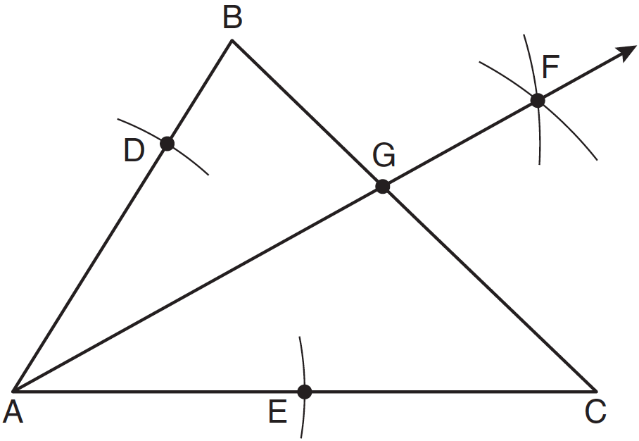

Which statement must be true?
1) | bisects side
2) | bisects
3)
4)

6 Which diagram shows the construction of a 45° angle?
1) | 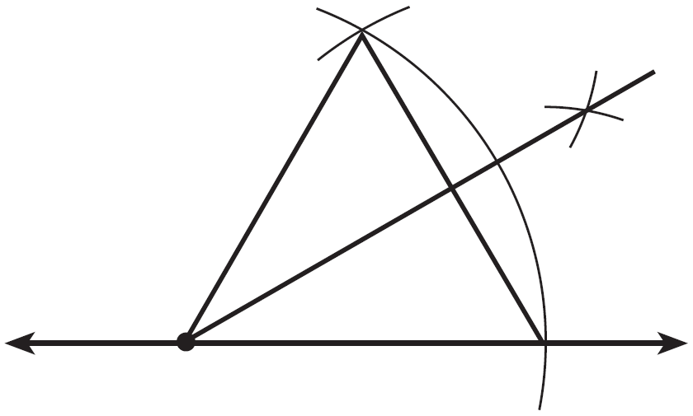
2) | 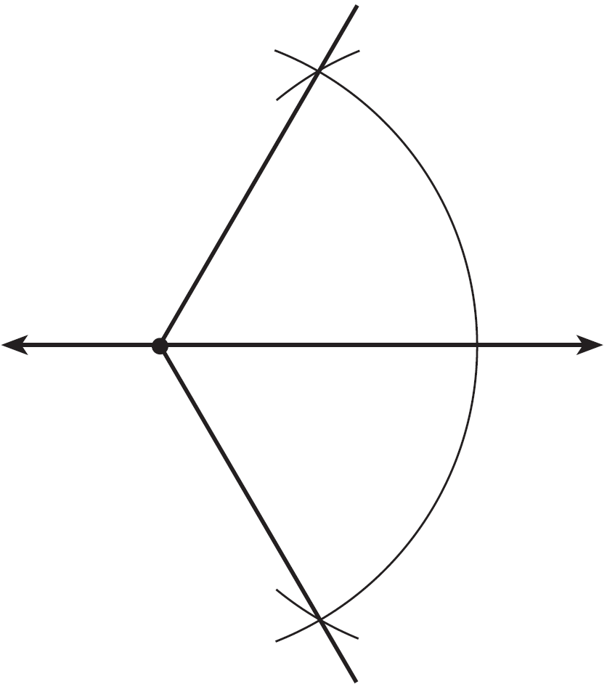
3) | 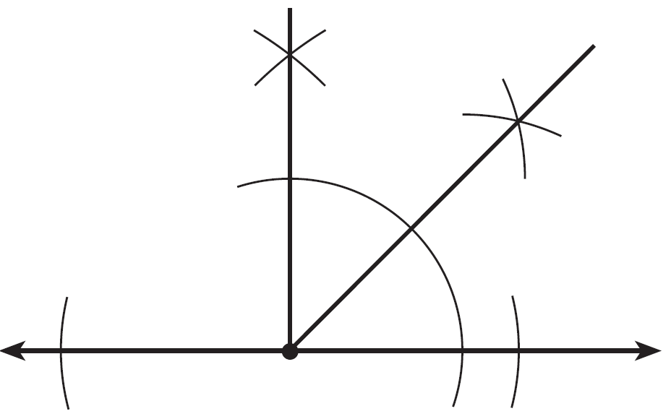
4) | 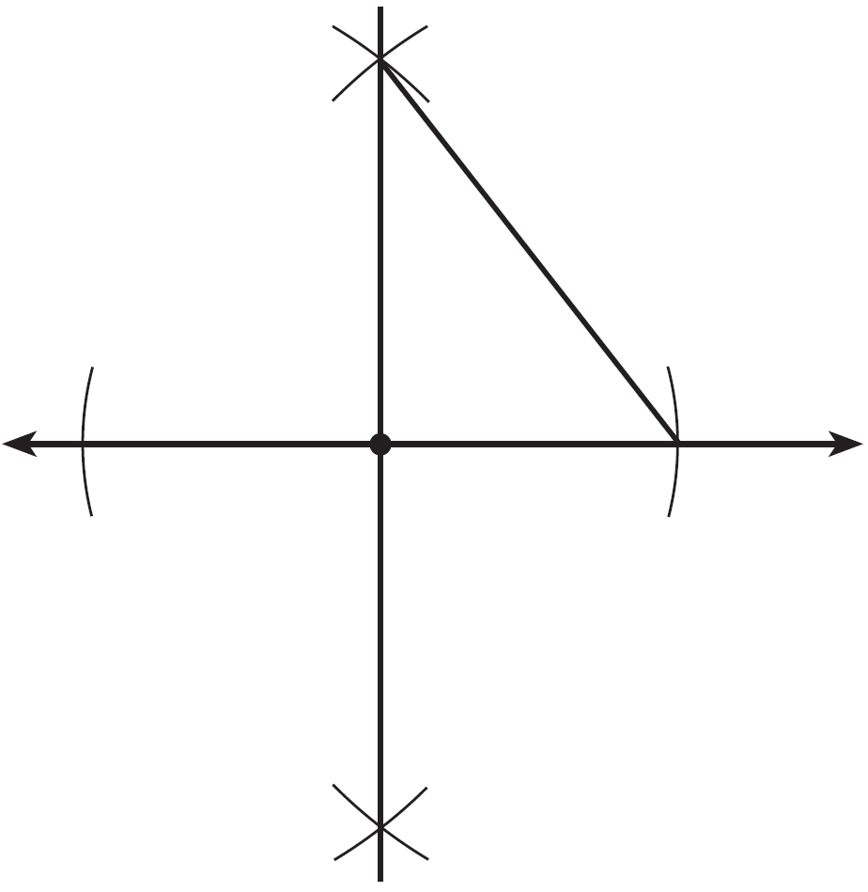

7 Which illustration shows the correct construction of an angle bisector?
1) | 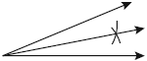
2) | 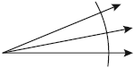
3) | 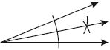
4) | 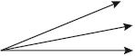

8 Using only a ruler and compass, construct the bisector of angle BAC in the accompanying diagram.
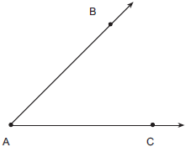

9 Using a compass and straightedge, construct the bisector of the angle shown below. [Leave all construction marks.]
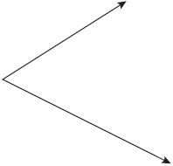

10 Using a compass and straightedge, construct the angle bisector of shown below. [Leave all construction marks.]
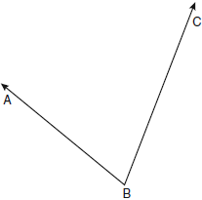

11 On the diagram below, use a compass and straightedge to construct the bisector of . [Leave all construction marks.]

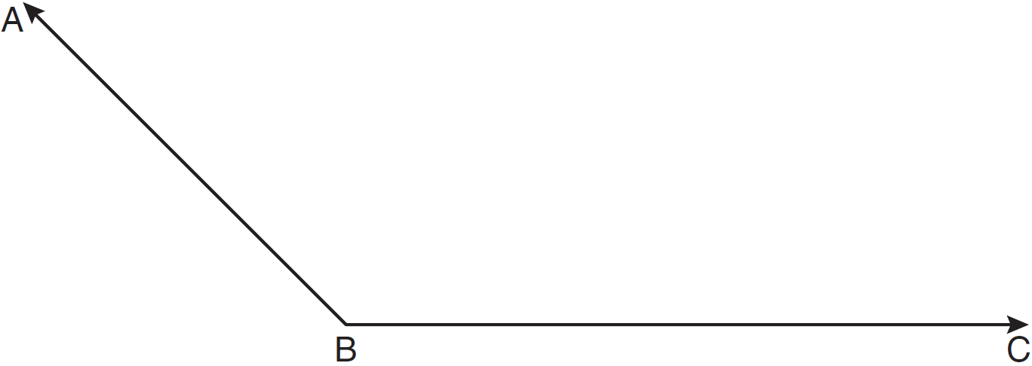

12 On the diagram below, use a compass and straightedge to construct the bisector of . [Leave all construction marks.]
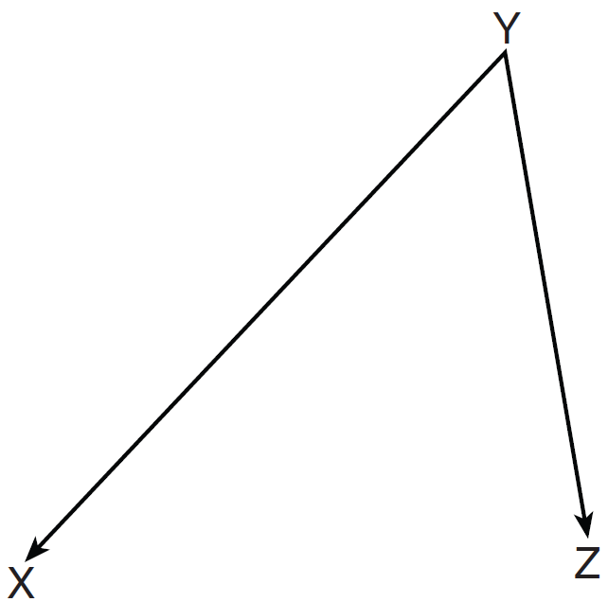

13 Using a compass and straightedge, construct the bisector of . [Leave all construction marks.]

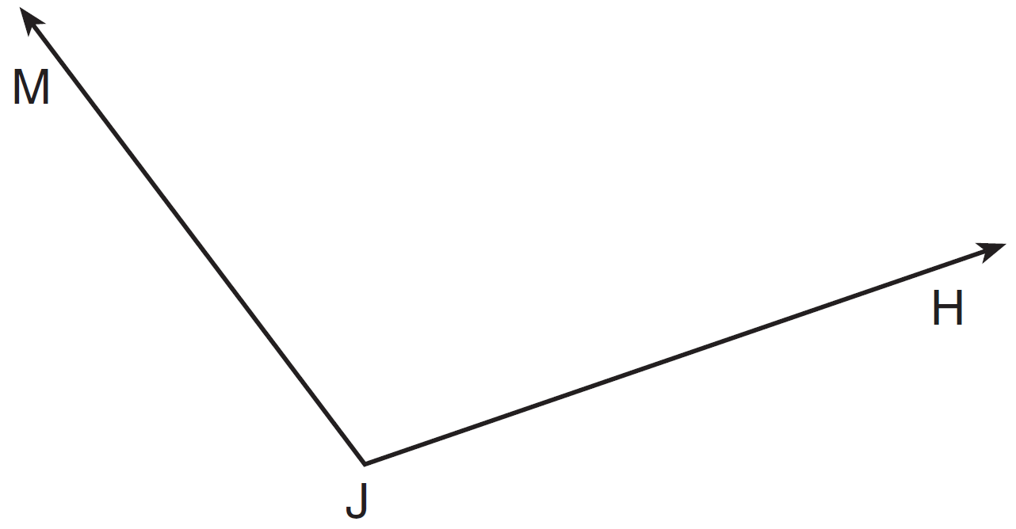

14 Using a compass and a straightedge, construct the bisector of . [Leave all construction marks.]
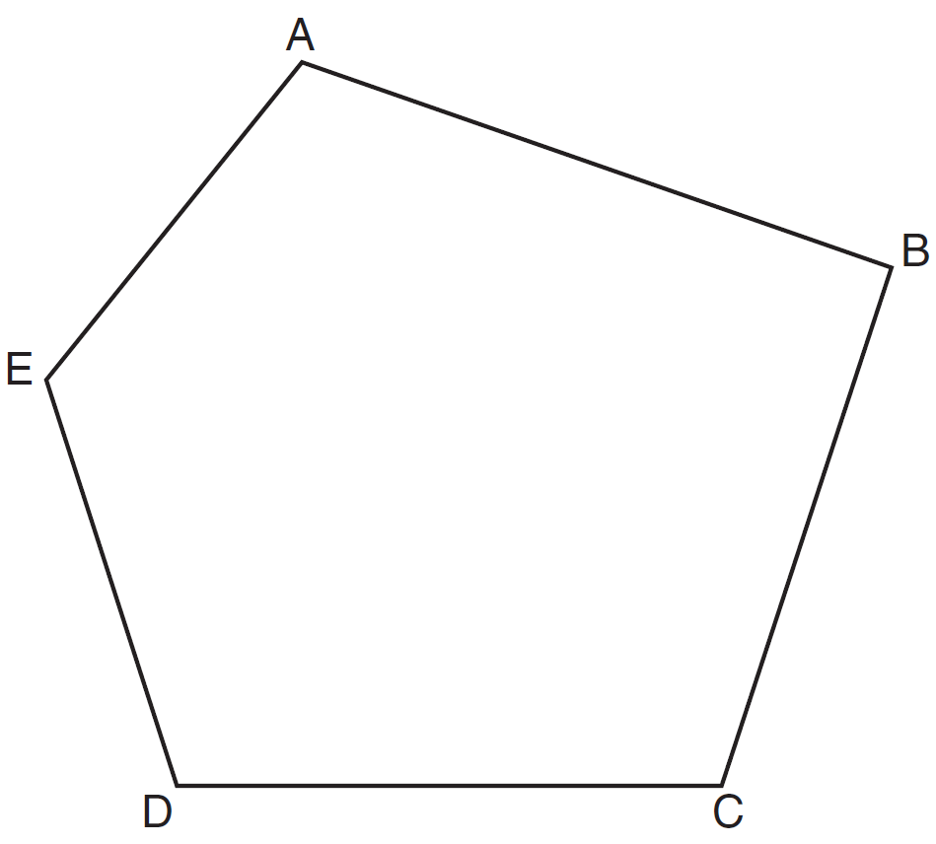

15 Using a compass and straightedge, construct the bisector of . [Leave all construction marks.]
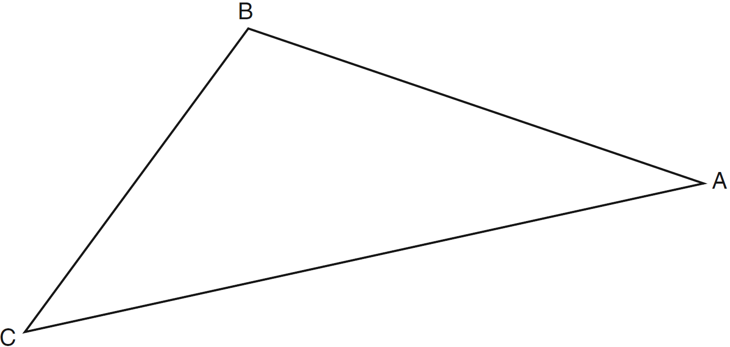

16 Using a compass and straightedge, construct the angle bisector of . [Leave all construction marks.]

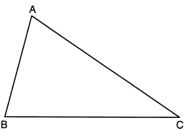

17 Using a compass and straightedge, construct an equilateral triangle with as a side. Using this triangle, construct a 30° angle with its vertex at A. [Leave all construction marks.]

1 ANS: 3 REF: 080902ge

2 ANS: 2 REF: 011509ge

3 ANS: 2 REF: 011004ge

4 ANS: 4 REF: 081106ge

5 ANS: 2 REF: 081205ge

6 ANS: 3 REF: 011402ge

7 ANS: 3 REF: 060925ge

8 ANS:
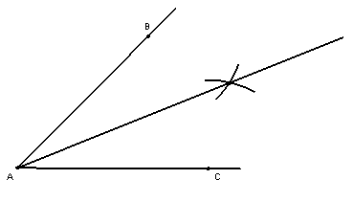

REF: 060022a

9 ANS:
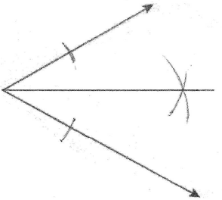

REF: fall0832ge

10 ANS:
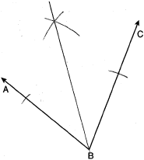

REF: 080932ge

11 ANS:
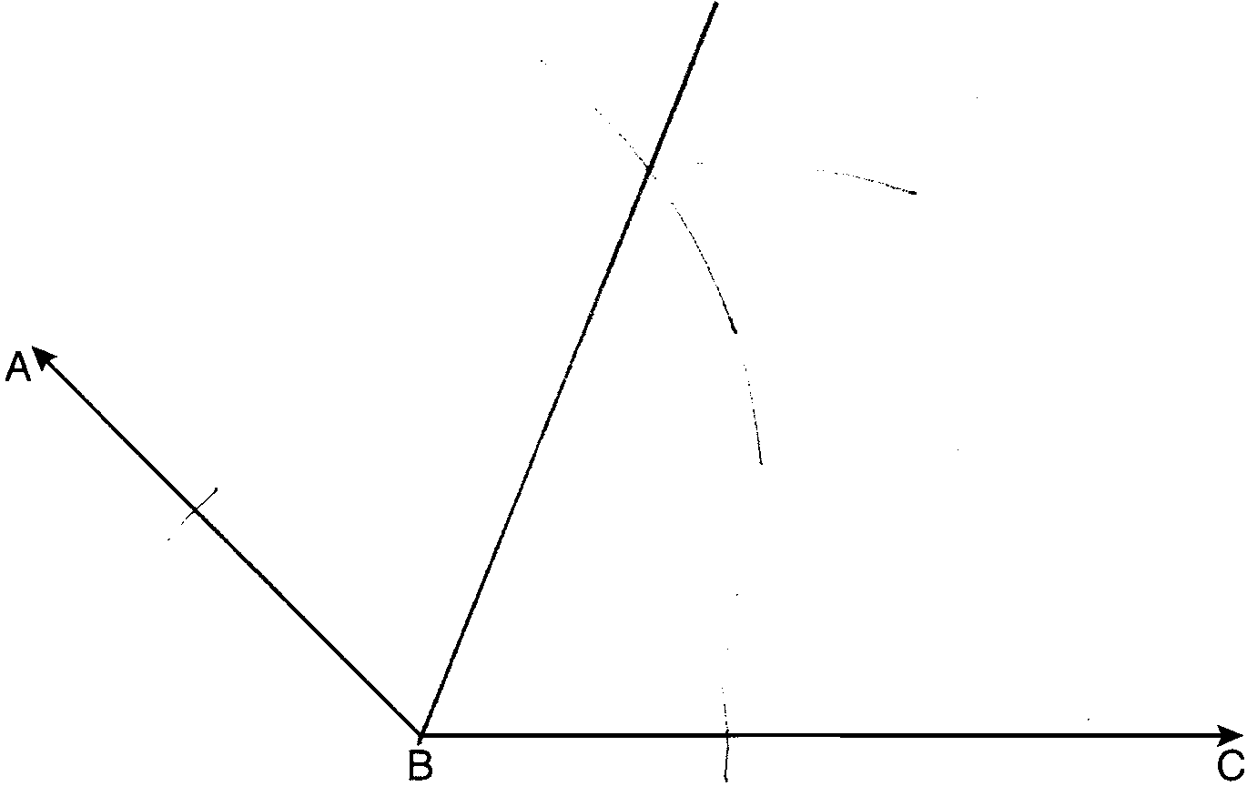

REF: 011133ge

12 ANS:
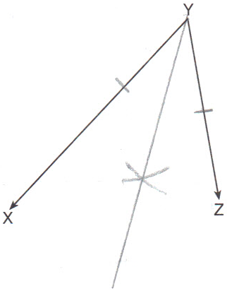

REF: 011233ge

13 ANS:
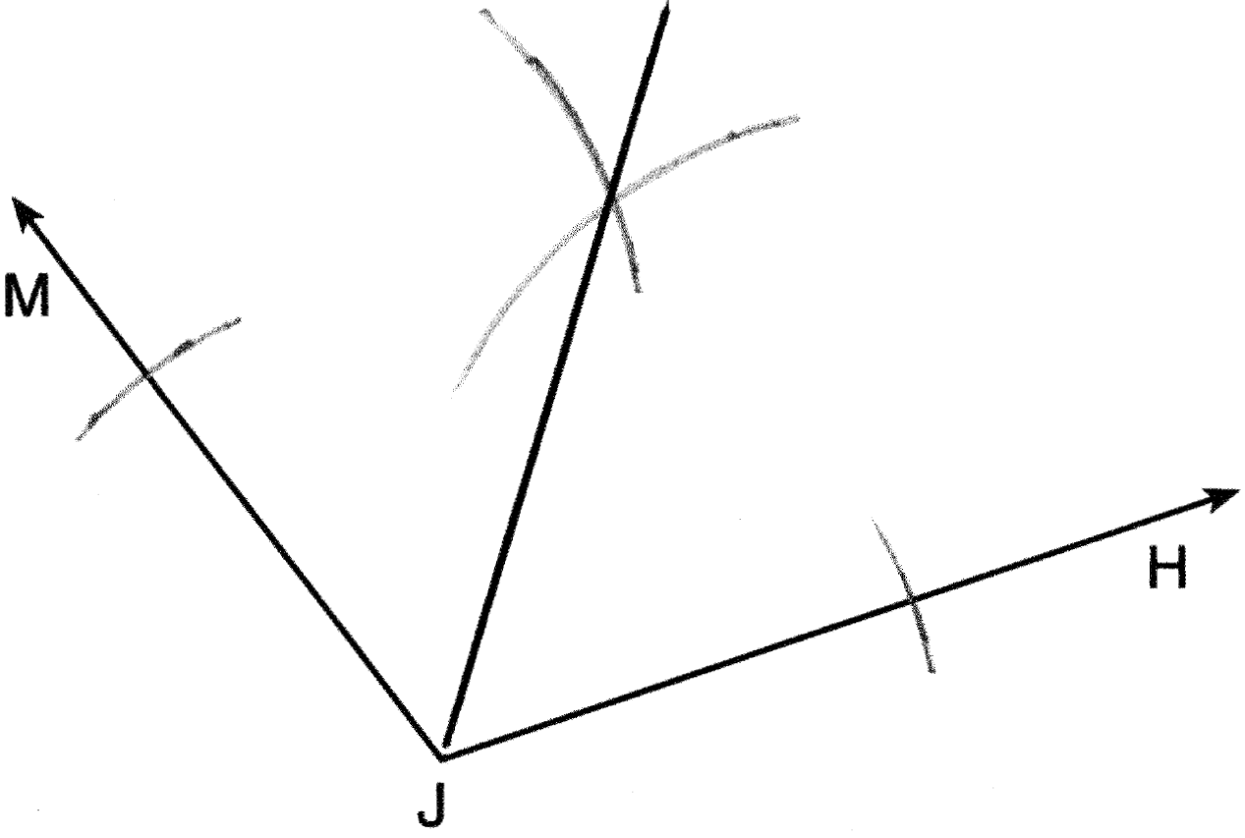

REF: 081330ge

14 ANS:
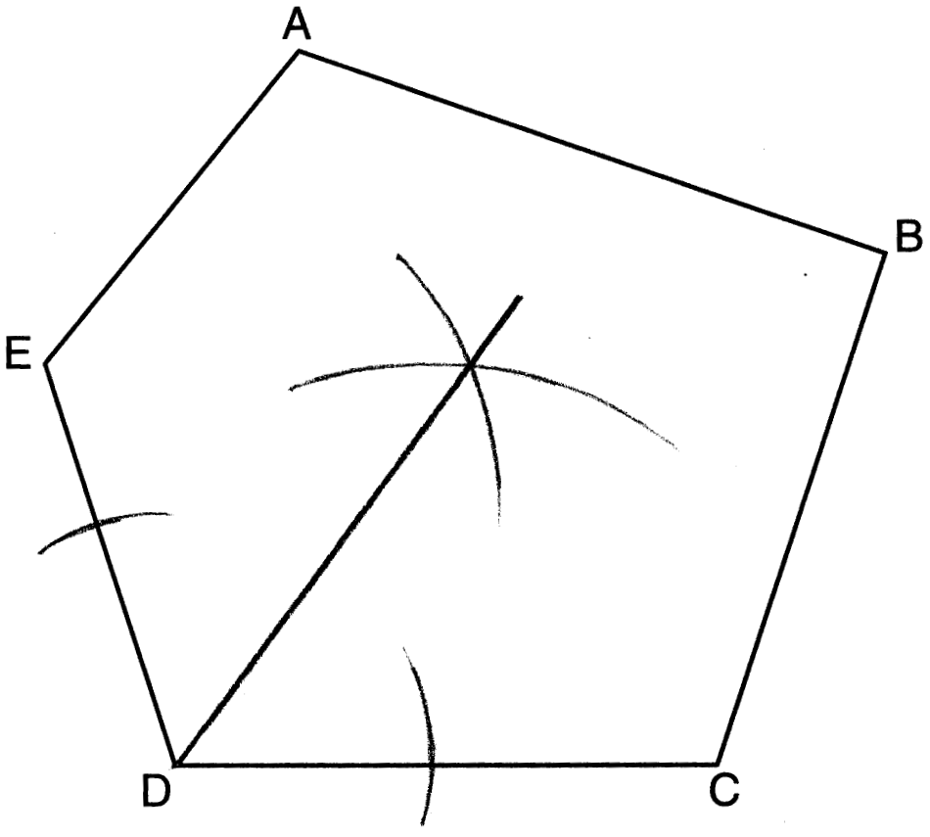

REF: 011634ge

15 ANS:
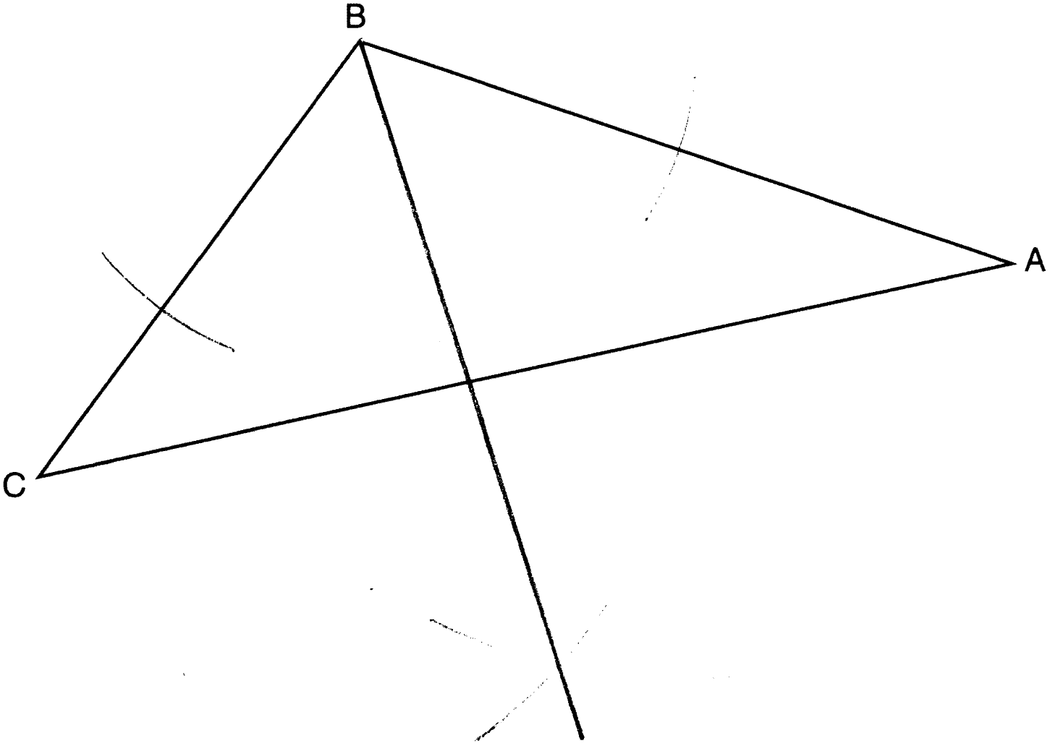

REF: 061232ge

16 ANS:
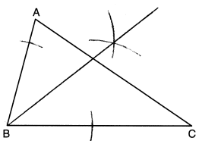

REF: 012325geo

17 ANS:
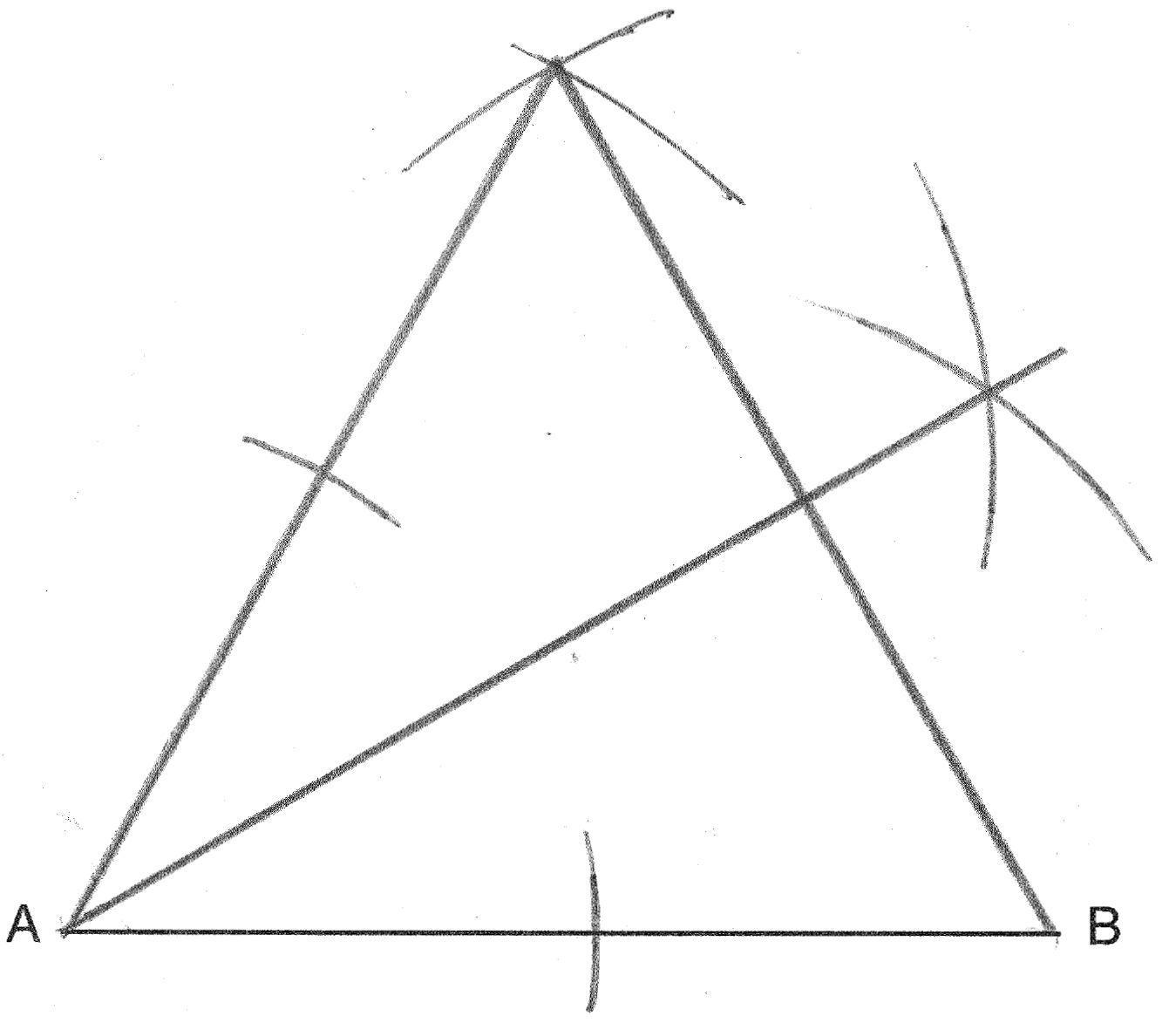

REF: 061437ge

