1 In the accompanying diagram, line a intersects line b.

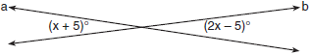

What is the value of x?
1)
2) | 5
3) | 10
4) | 90

2 In the accompanying diagram, parallel lines and are intersected by transversal at points G and H, respectively, , and .

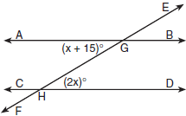

Which equation can be used to find the value of x?
1)
2)
3)
4)

3 In the accompanying diagram, lines a and b are parallel, and lines c and d are transversals.

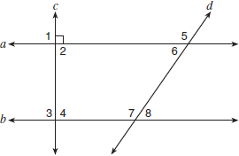

Which angle is congruent to angle 8?
1) | 6
2) | 5
3) | 3
4) | 4

4 In the accompanying diagram, line n is parallel to line m, line t is a transversal, and .

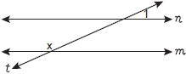

What does x equal, in degrees?
1) | 24
2) | 66
3) | 114
4) | 156

5 In the accompanying figure, what is one pair of alternate interior angles?

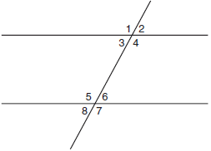
1) | 1 and 2
2) | 4 and 5
3) | 4 and 6
4) | 6 and 8

6 In the accompanying diagram, line is parallel to line m, and line t is a transversal.

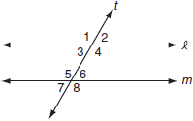

Which must be a true statement?
1)
2)
3)
4)

7 In the diagram below, is parallel to . Transversal intersects and at G and H, respectively. If and , what is the value of x?

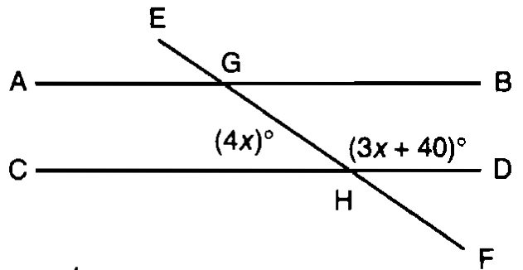
1) | 20
2) | 40
3) | 80
4) | 160

8 The accompanying diagram shows a football player crossing the 20-yard line at an angle of 30° and continuing along the same path.

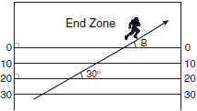

What is the measure of angle B, where the player crosses into the end zone?
1) | 30°
2) | 60°
3) | 150°
4) | 180°

9 The accompanying diagram shows two parallel streets, Main Street and Brooks Road, intersected by Jay Street. The obtuse angle that Jay Street forms with Brooks Road is three times the measure of the acute angle that Jay Street forms with Main Street.
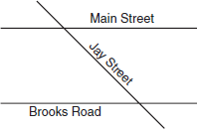

What is the measure of the acute angle formed by Jay Street and Main Street?
1) | 45°
2) | 60°
3) | 90°
4) | 135°

10 The accompanying diagram shows two parallel roads, Hope Street and Grand Street, crossed by a transversal road, Broadway.
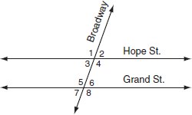

If , what is the measure of ?
1) | 40°
2) | 70°
3) | 110°
4) | 180°

11 Angle A and angle B are complementary angles. If , which expression represents the number of degrees in angle B?
1)
2)
3)
4)

12 If the measure of an angle is represented by 2x, which expression represents the measure of its complement?
1)
2)
3)
4)

13 The ratio of two supplementary angles is 2:7. What is the measure of the smaller angle?
1) | 10°
2) | 14°
3) | 20°
4) | 40°

14 The ratio of two supplementary angles is . What is the measure of the smaller angle?
1) | 10°
2) | 20°
3) | 30°
4) | 60°

15 and intersect at point E, , and . What is the value of x?
1)
2) | 5
3) | 10
4)

16 The measures of two complementary angles are represented by and . What is the value of x?
1) | 17
2) | 19
3) | 35
4) | 37

17 Two angles are complementary. The measure of one angle is 15° more than twice the other. What is the measure of the smaller angle?
1) | 25°
2) | 35°
3) | 55°
4) | 65°

18 The accompanying diagram shows intersecting lines and m. Solve for the value of x.

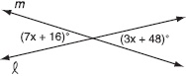

19 In the accompanying figure, two lines intersect, , and . Find the number of degrees in .

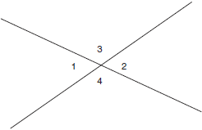

20 In the accompanying diagram, and intersect at E. If and , find the number of degrees in .

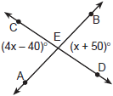

21 In the accompanying diagram, line m is parallel to line p, line t is a transversal, , and . Find the value of x.

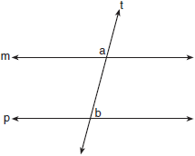

22 In the accompanying diagram, parallel lines and are intersected by transversal at points X and Y, and . Find .

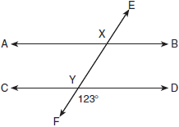

23 Two parallel roads, Elm Street and Oak Street, are crossed by a third, Walnut Street, as shown in the accompanying diagram. Find the number of degrees in the acute angle formed by the intersection of Walnut Street and Elm Street.

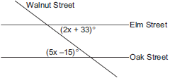

24 In the accompanying diagram, is a transversal, , and . Find the measure, in degrees, of .

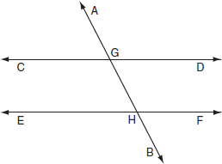

25 The support beams on a bridge intersect in the pattern shown in the accompanying diagram. If and intersect at point E, , and , find the value of x.

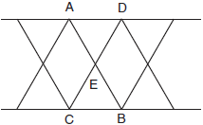

26 In the accompanying diagram, is a diameter of circle O, the measure of central angle ROY is , and the measure of central angle ROB is . Find the number of degrees in the measure of central angle ROY.

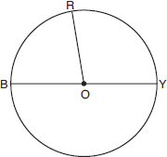

27 Two angles are complementary. One angle has a measure that is five times the measure of the other angle. What is the measure, in degrees, of the larger angle?

28 and intersect at E. If and , find, in degrees, .
1 ANS: 3
Vertical angles are complementary. 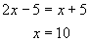

REF: 060601a

2 ANS: 1
and are congruent alternate interior angles.

REF: 010402a

3 ANS: 1
is congruent to because they are alternate interior angles.

REF: 010502a

4 ANS: 4
is supplementary to the angle of x degrees.

REF: 080808a

5 ANS: 2 REF: 010320a

6 ANS: 4
Since and are congruent vertical angles, and and are supplementary same side interior angles, and are also supplementary.

REF: 080613a

7 ANS: 2 REF: spring9815a

8 ANS: 1
Since and the 30° angle are corresponding angles,

REF: 080421a

9 ANS: 1
Let x represent the acute angle that Jay Street forms with Main Street. Then 3x represents the obtuse angle that Jay Street forms with Brooks Road. Since the two angles are supplementary, 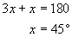.

REF: 080510a

10 ANS: 2
Same side exterior angles are supplementary.

REF: 010702a

11 ANS: 4
The sum of complementary angles is 90º.

REF: 060819a

12 ANS: 2
The sum of complementary angles is 90º.

REF: 010313a

13 ANS: 4
The sum of supplementary angles is 180º. 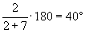

REF: 060414a

14 ANS: 4 REF: 010624a

15 ANS: 2
and are congruent vertical angles. 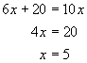

REF: 080407a

16 ANS: 1
The sum of complementary angles is 90º. 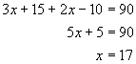

REF: 060621a

17 ANS: 1
The sum of complementary angles is 90º. 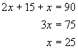

REF: 010823a

18 ANS:
8. Vertical angles are congruent. 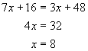

REF: 080832a

19 ANS:
120. and are supplementary angles on one side of a stright line. 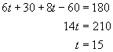. . and are congruent vertical angles.
REF: 010128a

20 ANS:
80. Vertical angles are congruent. 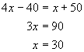
REF: 010229a

21 ANS:
31. and are supplementary. 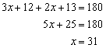
REF: 060324a

22 ANS:
57. Since and are congruent vertical angles, and and are supplementary same side interior angles, and are also supplementary.
REF: 060122a

23 ANS:
65. The acute angles are congruent alternate interior angles: 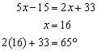
REF: 060226a

24 ANS:
146. and are congruent corresponding angles. 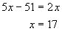. . Since and are supplementary angles,
REF: 010639a

25 ANS:
10. Vertical angles are congruent. 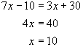
REF: 010932a

26 ANS:
95. and are supplementary angles on one side of a straight line. 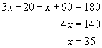. .
REF: 010836a

27 ANS:
75. The sum of supplementary angles is 180º. 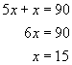.
REF: 080431a

28 ANS:
112.5. and are congruent vertical angles. 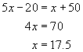. . and are supplementary angles on one side of a straight line. .
REF: 080638a

