1 Transversal intersects and , as shown in the diagram below.

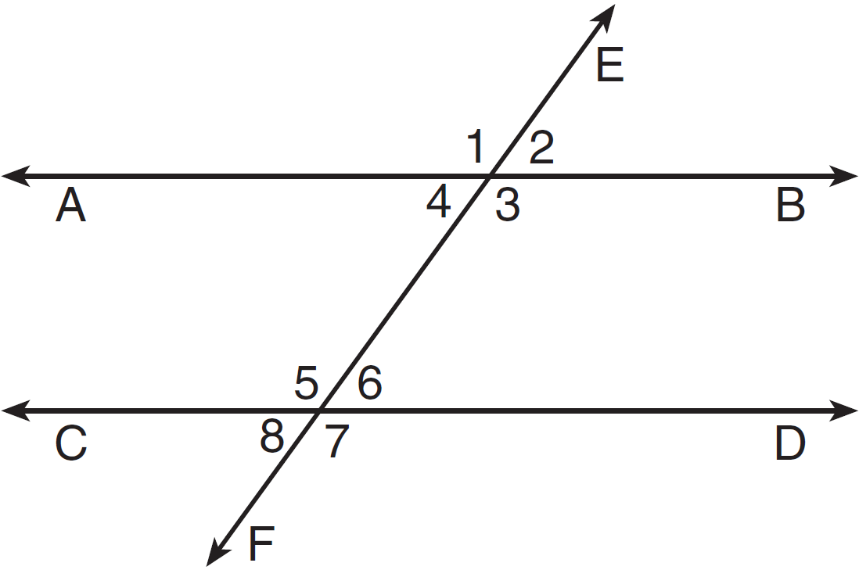

Which statement could always be used to prove ?
1)
2)
3) | and are supplementary
4) | and are supplementary

2 A transversal intersects two lines. Which condition would always make the two lines parallel?
1) | Vertical angles are congruent.
2) | Alternate interior angles are congruent.
3) | Corresponding angles are supplementary.
4) | Same-side interior angles are complementary.

3 Based on the diagram below, which statement is true?

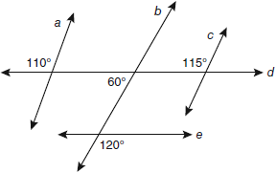
1)
2)
3)
4)

4 In the diagram below, transversal intersects and at V and W, respectively.

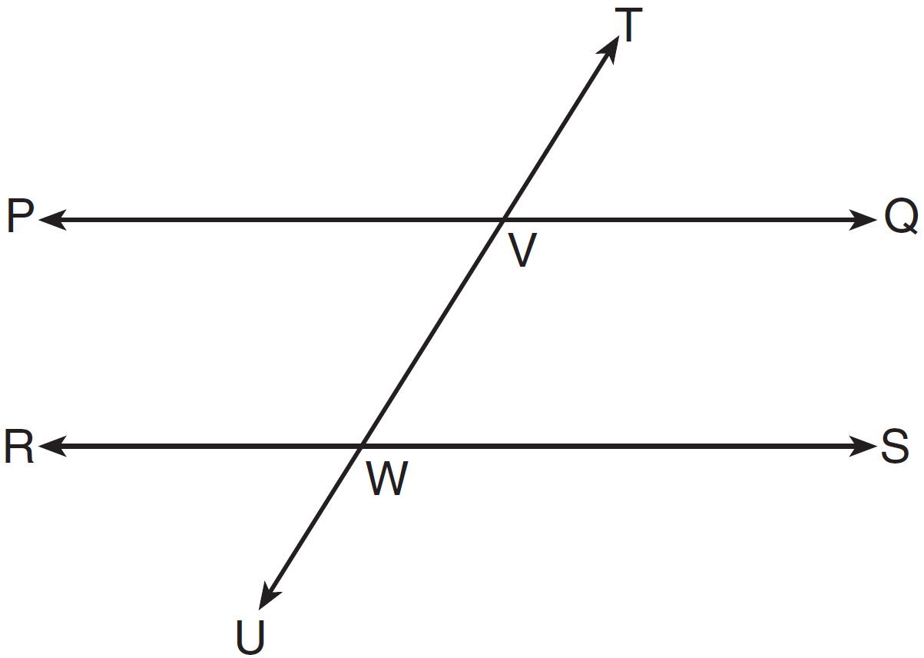

If and , for which value of x is ?
1) | 6
2) | 16
3) | 24
4) | 28

5 As shown in the diagram below, lines m and n are cut by transversal p.

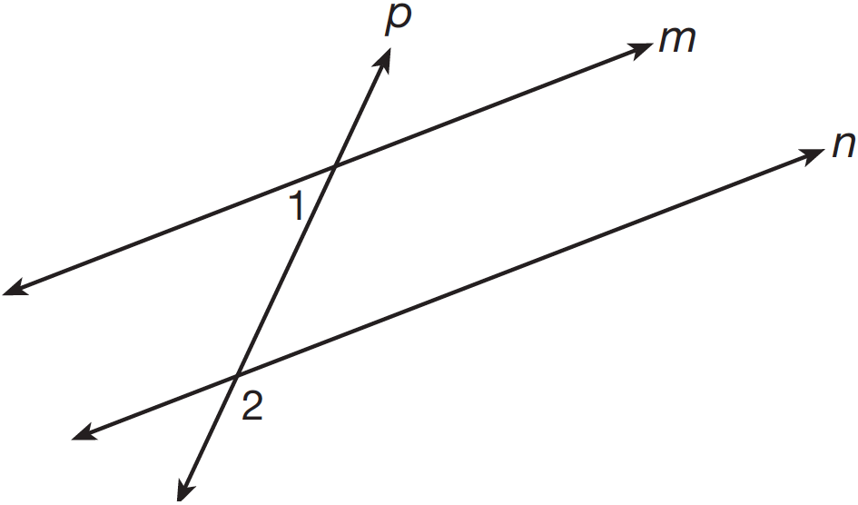

If and , lines m and n are parallel when x equals
1) | 1
2) | 6
3) | 13
4) | 17

6 In the diagram below, line p intersects line m and line n.

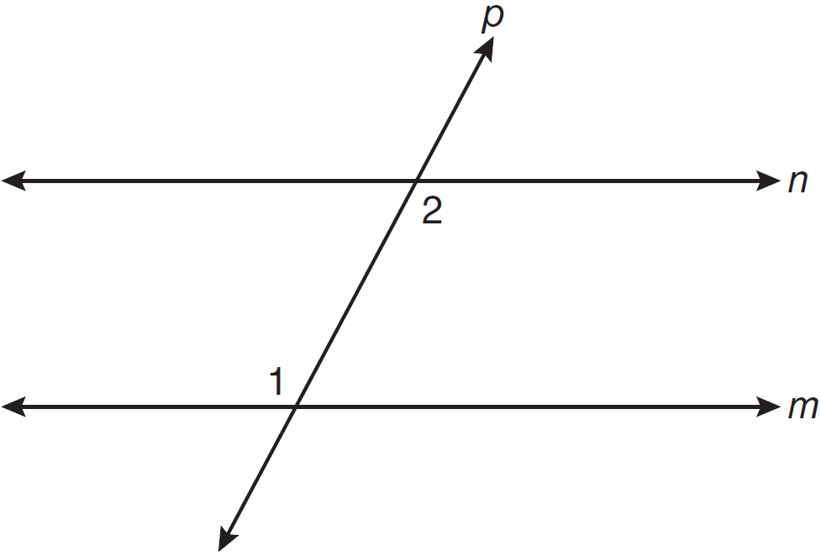

If and , lines m and n are parallel when x equals
1) | 12.5
2) | 15
3) | 87.5
4) | 105

7 Line n intersects lines l and m, forming the angles shown in the diagram below.

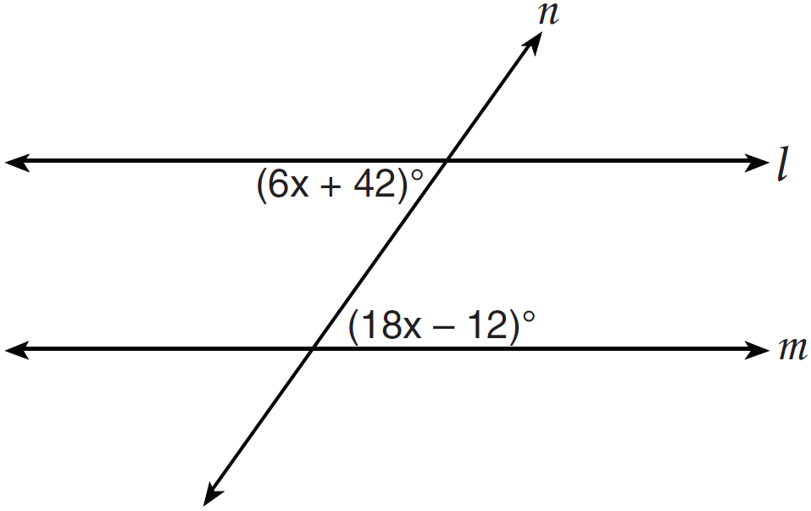

Which value of x would prove ?
1) | 2.5
2) | 4.5
3) | 6.25
4) | 8.75

8 Lines p and q are intersected by line r, as shown below.

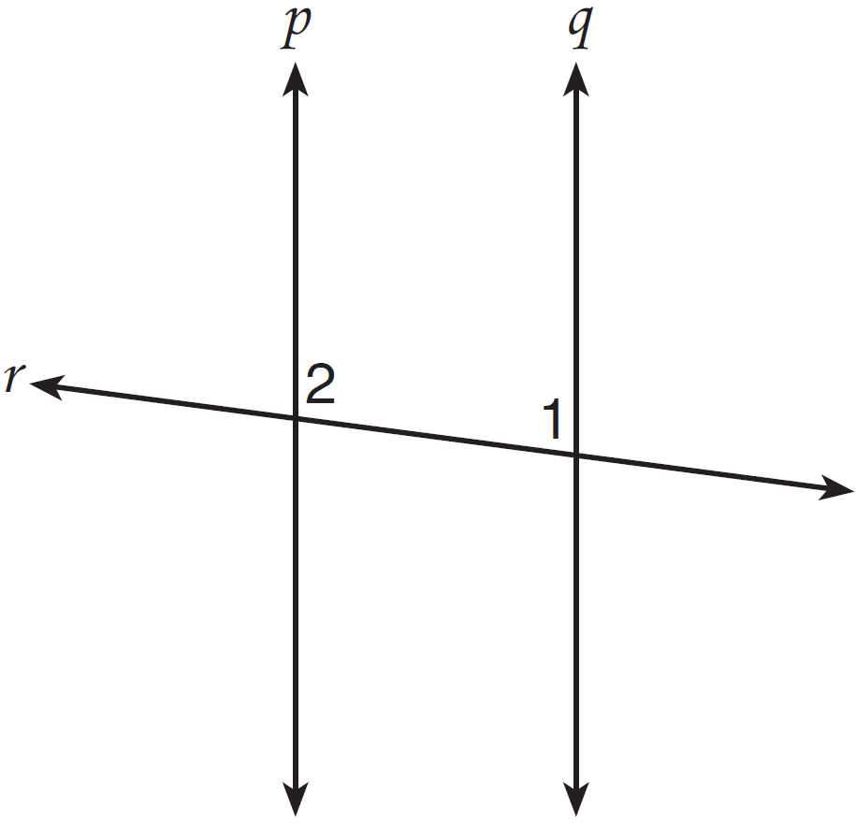

If and , for which value of x would ?
1) | 17
2) | 24
3) | 83
4) | 97

9 Peach Street and Cherry Street are parallel. Apple Street intersects them, as shown in the diagram below.

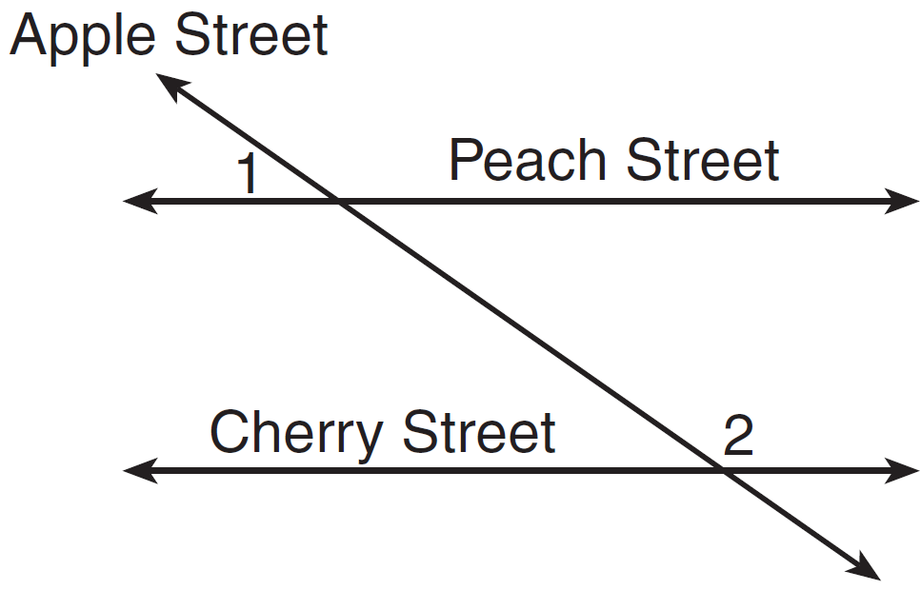

If and , what is ?
1) | 9
2) | 17
3) | 54
4) | 70

10 In the diagram below, line is parallel to line m, and line w is a transversal.

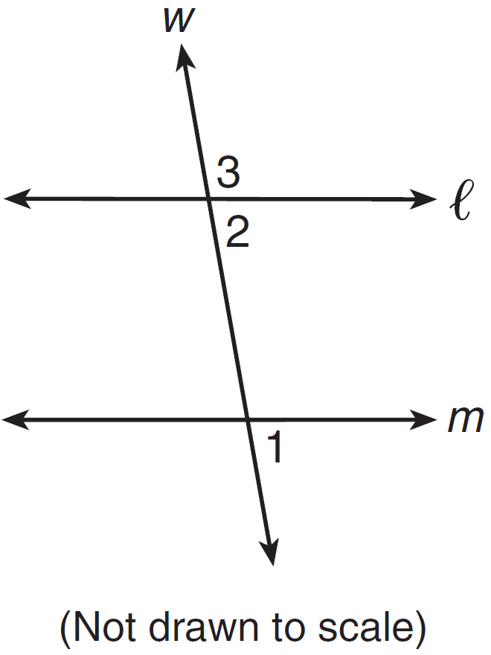

If and , what is ?
1) | 19
2) | 23
3) | 74
4) | 86

11 In the diagram below, lines n and m are cut by transversals p and q.

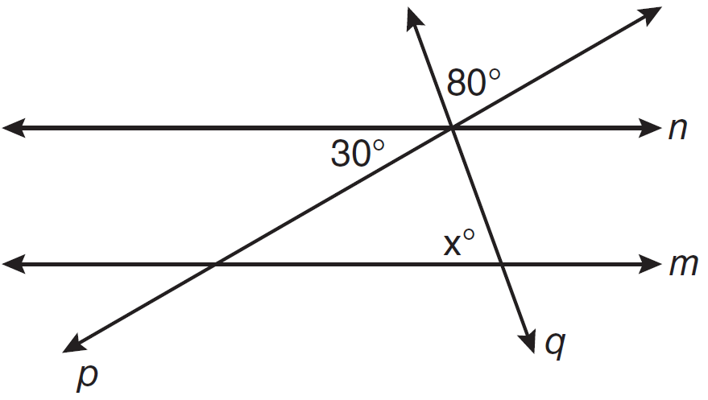

What value of x would make lines n and m parallel?
1) | 110
2) | 80
3) | 70
4) | 50

12 In the diagram below, . Transversal and line segment HF are drawn.

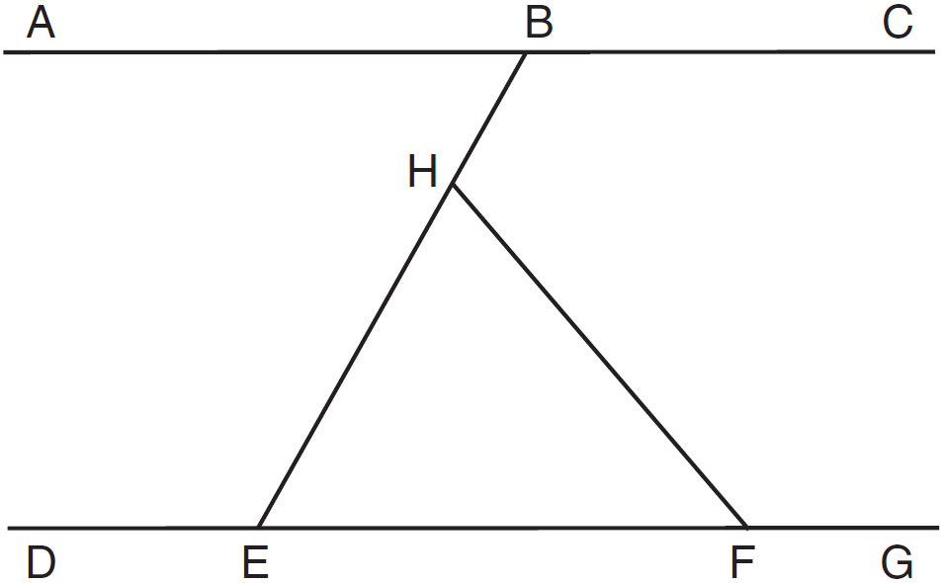

If and , what is ?
1) | 40
2) | 50
3) | 60
4) | 70

13 In the diagram below, and at R.

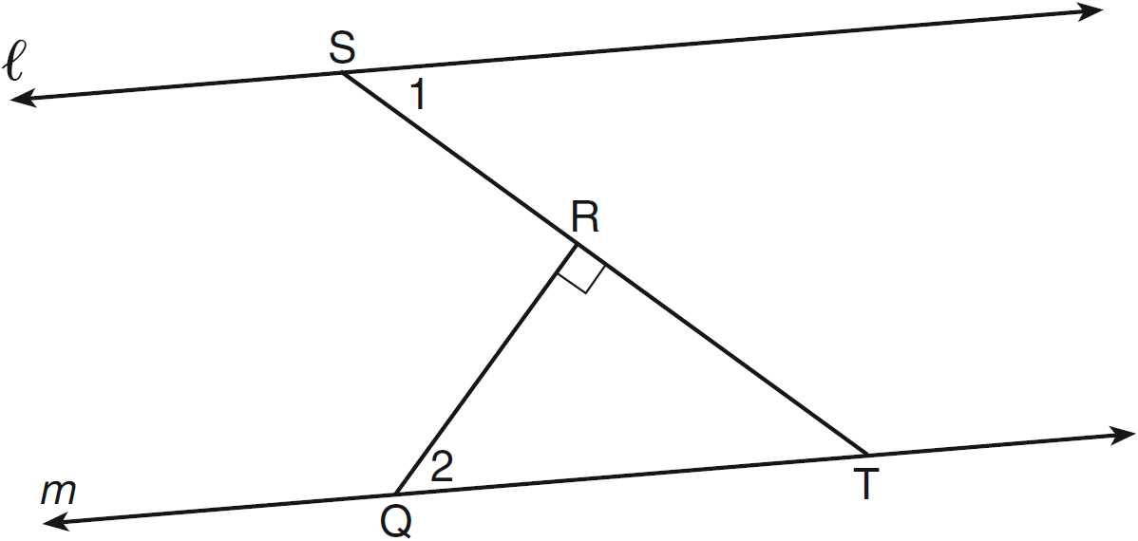

If , find .

14 In the diagram below of quadrilateral ABCD with diagonal , , , , , and . Determine if is parallel to . Explain your reasoning.

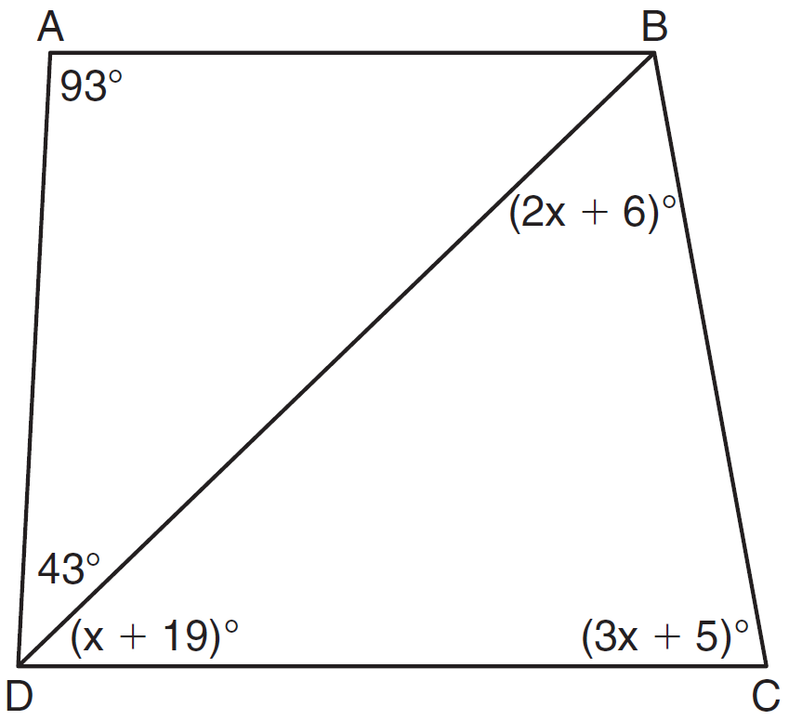
1 ANS: 3 REF: 061320ge

2 ANS: 2 REF: 061007ge

3 ANS: 4
The marked 60º angle and the angle above it are on the same straight line and supplementary. This unmarked supplementary angle is 120º. Because the unmarked 120º angle and the marked 120º angle are alternate exterior angles and congruent, .

REF: 080901ge

4 ANS: 2
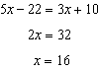

REF: 061403ge

5 ANS: 3
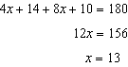

REF: 081213ge

6 ANS: 2
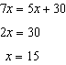

REF: 061106ge

7 ANS: 2
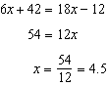

REF: 011201ge

8 ANS: 1
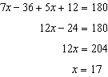

REF: 011422ge

9 ANS: 4
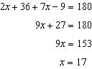

REF: 081427ge

10 ANS: 4
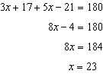

REF: 011513ge

11 ANS: 3

REF: 081109ge

12 ANS: 3 REF: 011612ge

13 ANS:

REF: 061230ge

14 ANS:
Yes, 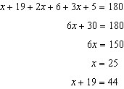. Because alternate interior angles and are congruent, is parallel to .

REF: 081035ge

