1 If the diagonals of a quadrilateral do not bisect each other, then the quadrilateral could be a
1) rectangle 2) rhombus 3) square 4) trapezoid

2 In trapezoid RSTV with bases and , diagonals and intersect at Q.

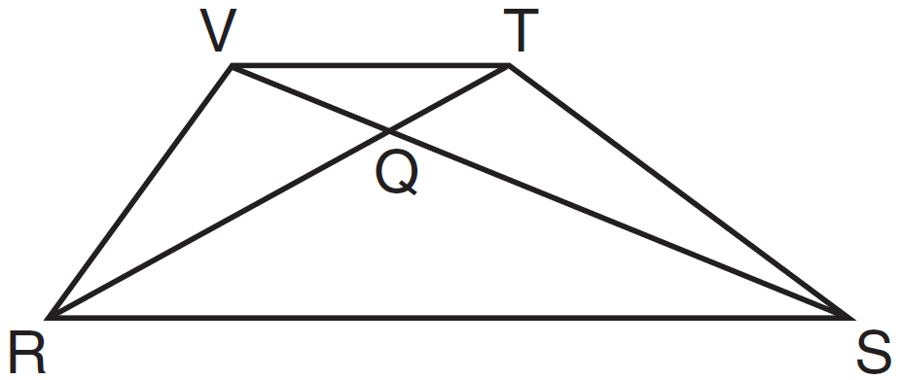

If trapezoid RSTV is not isosceles, which triangle is equal in area to ?
1) 2) 3) 4)

3 In the diagram below of isosceles trapezoid STAR, diagonals and intersect at O and , with nonparallel sides and .

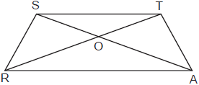

Which pair of triangles are not always similar?
1) and 2) and 3) and 4) and

4 Isosceles trapezoid ABCD has diagonals and . If and , what is the value of x?
1) 28 2) 3) 3 4)

5 In trapezoid ABCD below, .

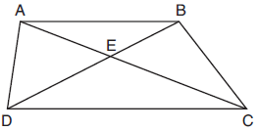

If , , and , what is the length of , to the nearest tenth?
1) 4.7 2) 6.5 3) 8.4 4) 13.1

6 In the diagram below, is the median of trapezoid ABCD.

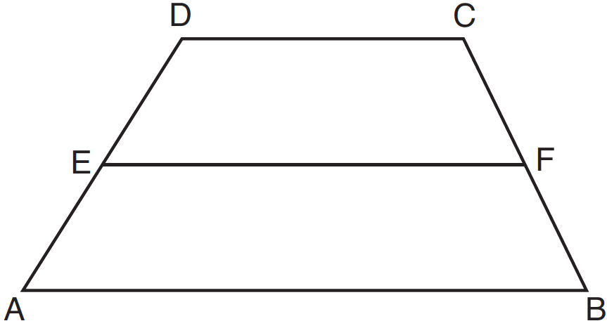

If , , and , what is the value of x?
1) 5 2) 2 3) 7 4) 8

7 In the diagram below of trapezoid RSUT, , X is the midpoint of , and V is the midpoint of .

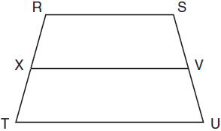

If and , what is the length of ?
1) 37 2) 58 3) 74 4) 118

8 In trapezoid LMNO below, median is drawn.

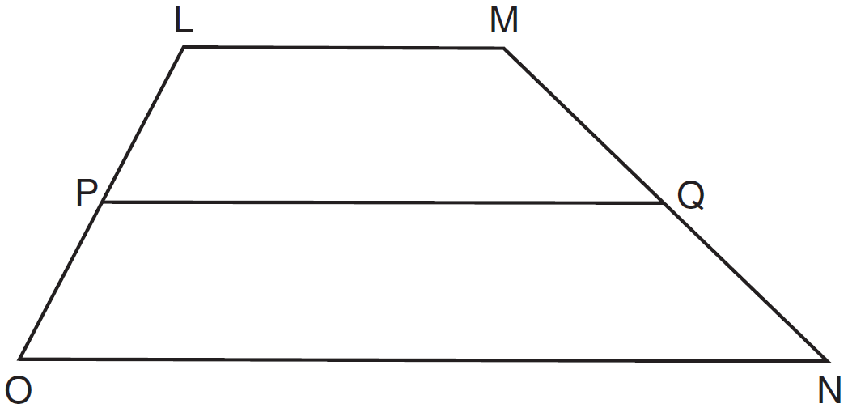

If , , and , what is the value of x?
1) 1.75 2) 3.5 3) 8 4) 17

9 In the diagram below, LATE is an isosceles trapezoid with , , , and . Altitudes and are drawn.

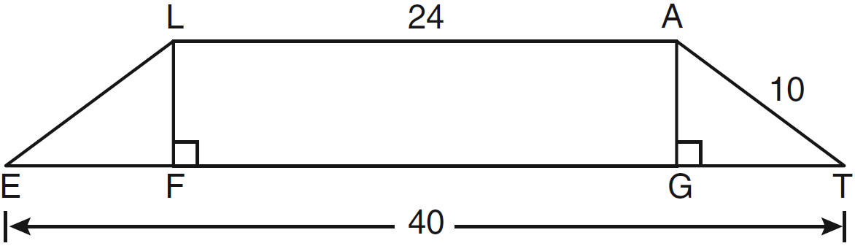

What is the length of ?
1) 6 2) 8 3) 3 4) 4

10 In the diagram below of isosceles trapezoid ABCD, , , and .

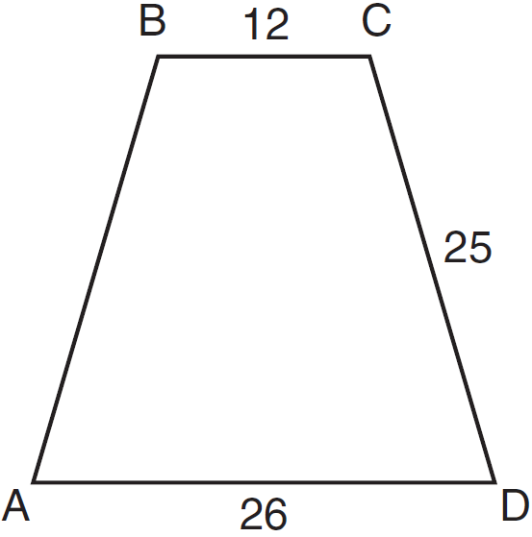

What is the length of an altitude of the trapezoid?
1) 7 2) 14 3) 19 4) 24

11 In isosceles trapezoid ABCD, . If , , and , what is the length of the altitude of the trapezoid?
1) 10 2) 12 3) 15 4) 16

12 In the diagram below, and are bases of trapezoid ABCD.

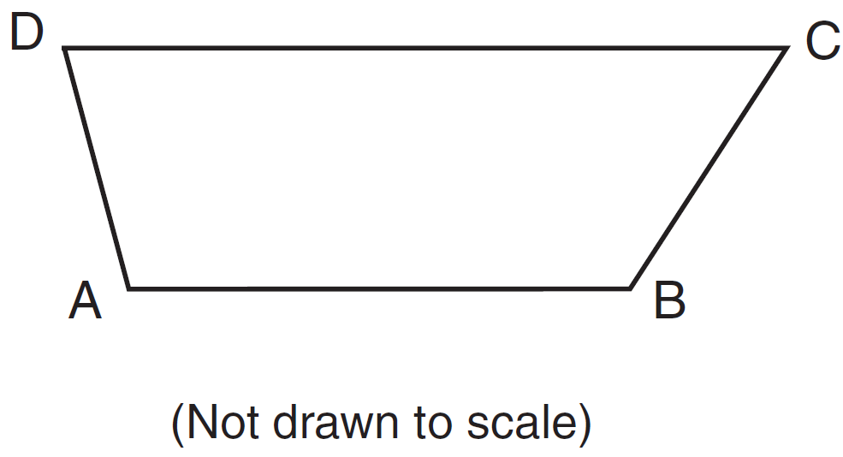

If and , what is ?
1) 57 2) 75 3) 105 4) 123

13 In the diagram of trapezoid ABCD below, , , , and .

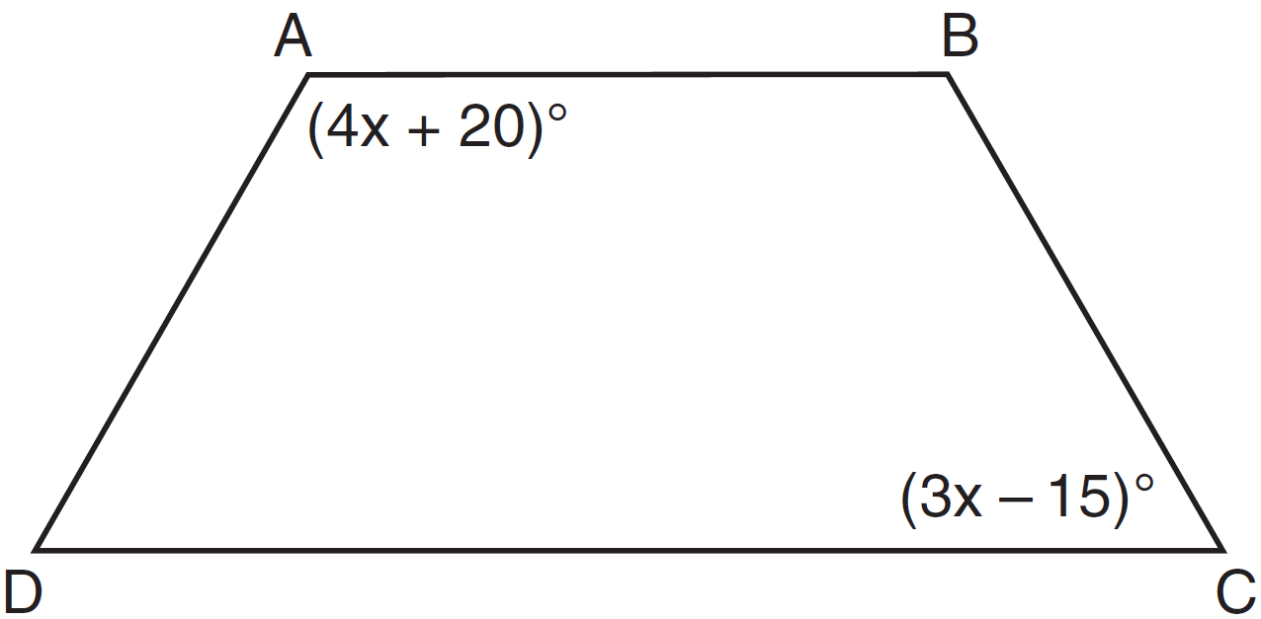

What is ?
1) 25 2) 35 3) 60 4) 90

14 In isosceles trapezoid QRST shown below, and are bases.

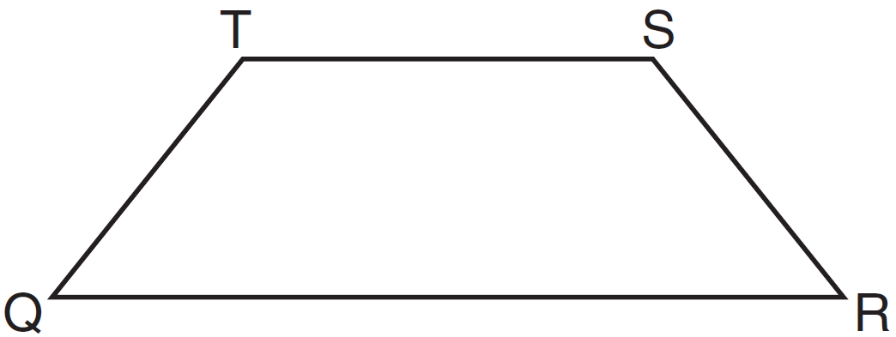

If and , what is ?
1) 83 2) 48 3) 16 4) 9

15 In the diagram below of isosceles trapezoid DEFG, , , , , and . Find the value of x.

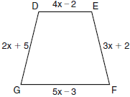

16 The cross section of an attic is in the shape of an isosceles trapezoid, as shown in the accompanying figure. If the height of the attic is 9 feet, feet, and feet, find the length of to the nearest foot.

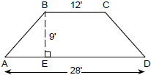

17 The accompanying diagram shows ramp leading to level platform , forming an angle of 45° with level ground. If platform measures 2 feet and is 6 feet above the ground, explain why the exact length of ramp is feet.

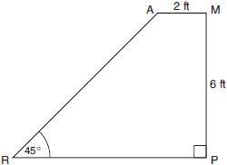

18 The diagram below shows isosceles trapezoid ABCD with and . If and , find .

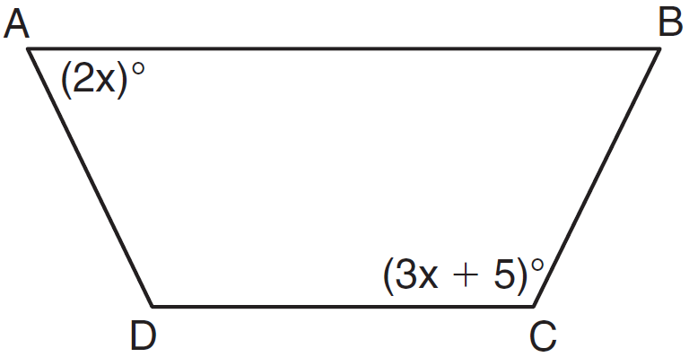

19 Trapezoid TRAP, with median , is shown in the diagram below. Solve algebraically for x and y.

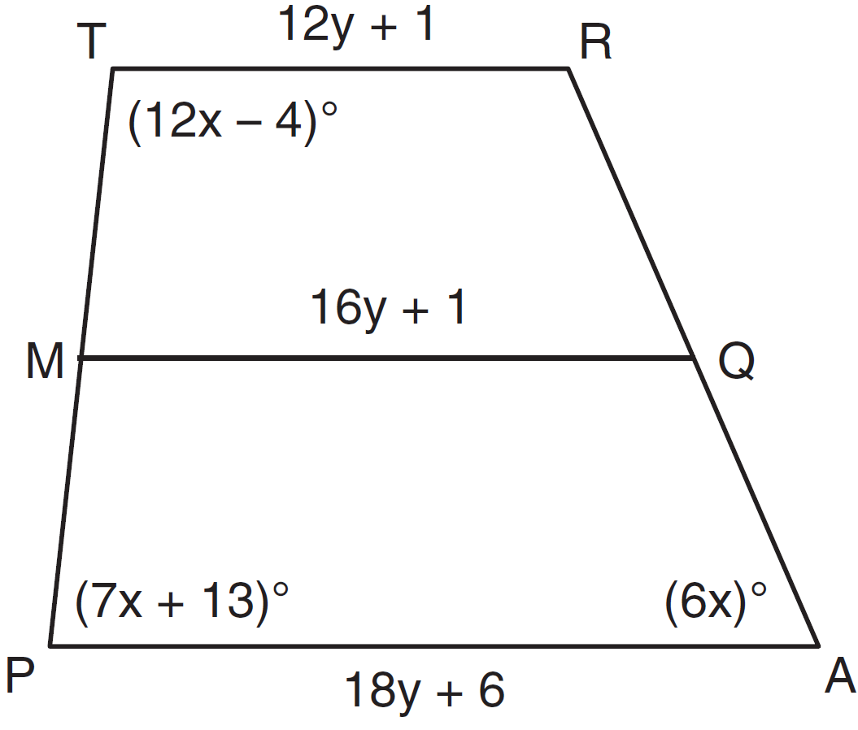
1 ANS: 4 REF: 061008ge

2 ANS: 2
Isosceles or not, and have a common base, and since and are bases, congruent altitudes.

REF: 061301ge

3 ANS: 3 REF: 062323geo

4 ANS: 3
The diagonals of an isosceles trapezoid are congruent. 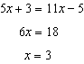.

REF: fall0801ge

5 ANS: 3
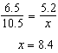

REF: 012006geo

6 ANS: 1
The length of the midsegment of a trapezoid is the average of the lengths of its bases. 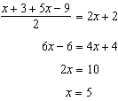.

REF: 081221ge

7 ANS: 2
The length of the midsegment of a trapezoid is the average of the lengths of its bases. 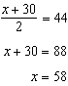.

REF: 011001ge

8 ANS: 3
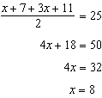

REF: 011608ge

9 ANS: 1
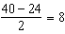. . 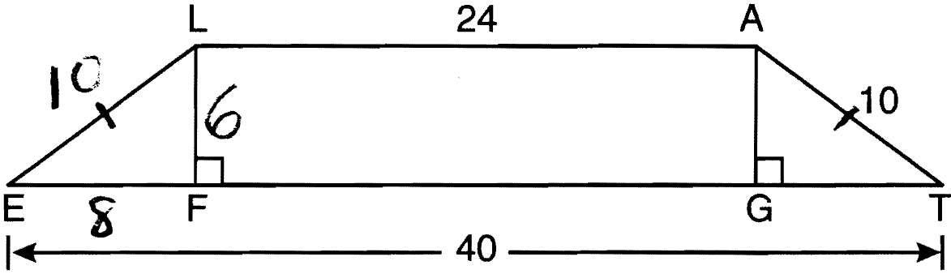

REF: 061204ge

10 ANS: 4
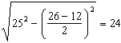

REF: 011219ge

11 ANS: 3
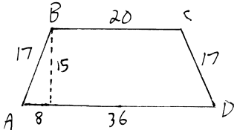 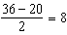.

REF: 061016ge

12 ANS: 1

REF: 061419ge

13 ANS: 3
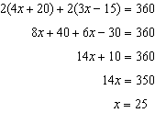.

REF: 011321ge

14 ANS: 2
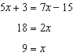

REF: 011515ge

15 ANS:
3. The non-parallel sides of an isosceles trapezoid are congruent. 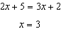

REF: 080929ge

16 ANS:
12. Because the shape is an isosceles trapezoid, 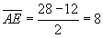. Using Pythagoras, 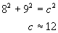

REF: 069933a

17 ANS:
Draw a line perpendicular to at T to A. is an isosceles right triangle with legs of 6. 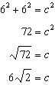

REF: 080726b

18 ANS:
70. 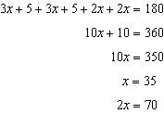

REF: 081029ge

19 ANS:
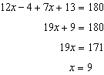. 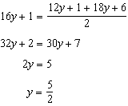

REF: 081337ge

