1 In the diagram below of quadrilateral ABCD, diagonals and are perpendicular at E.

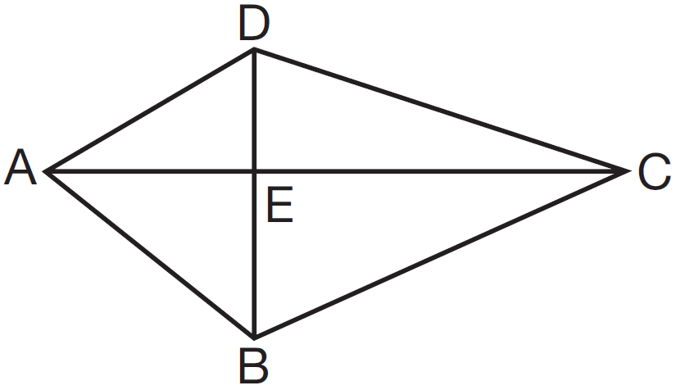

Which statement is always true based on the given information?
1)
2)
3)
4)

2 As shown in the diagram of rectangle ABCD below, diagonals and intersect at E.

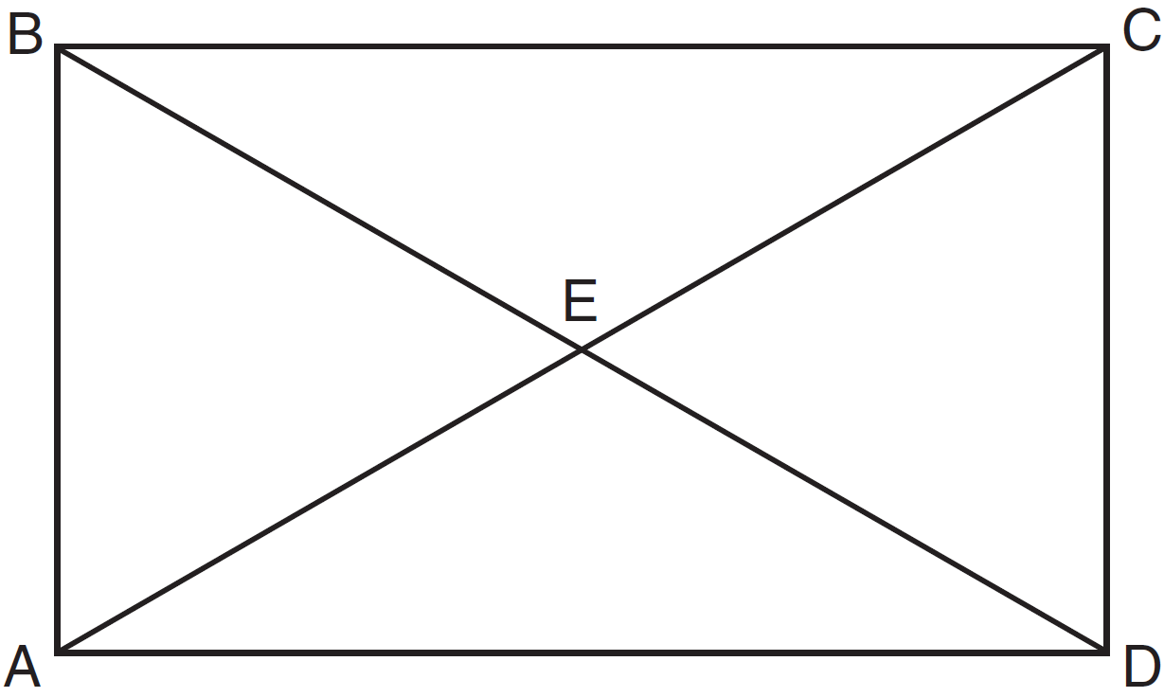

If and , then the length of is
1) | 6
2) | 10
3) | 12
4) | 24

3 In the diagram below of rectangle RSTU, diagonals and intersect at O.

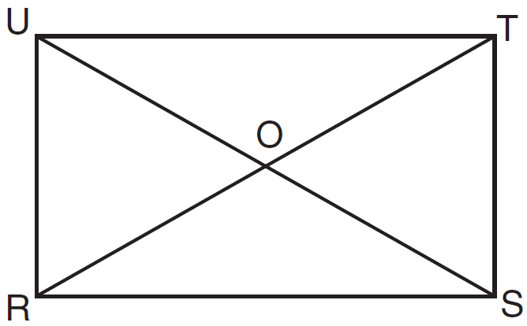

If and , what is the length of ?
1) | 8
2) | 2
3) | 16
4) | 32

4 In the accompanying diagram of rectangle ABCD, and .

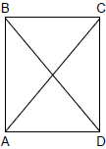

What is ?
1) | 12
2) | 37
3) | 40
4) | 50

5 A builder is building a rectangular deck with dimensions of 16 feet by 30 feet. To ensure that the sides form 90° angles, what should each diagonal measure?
1) | 16 ft
2) | 30 ft
3) | 34 ft
4) | 46 ft

6 As shown in the accompanying diagram, a rectangular gate has two diagonal supports. If , what is ?

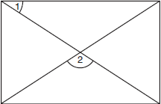

7 In rectangle ABCD, and . Find the length of .

8 Al says, “If ABCD is a parallelogram, then ABCD is a rectangle.” Sketch a quadrilateral ABCD that shows that Al’s statement is not always true. Your sketch must show the length of each side and the measure of each angle for the quadrilateral you draw.

9 In the diagram below of rhombus ABCD, .

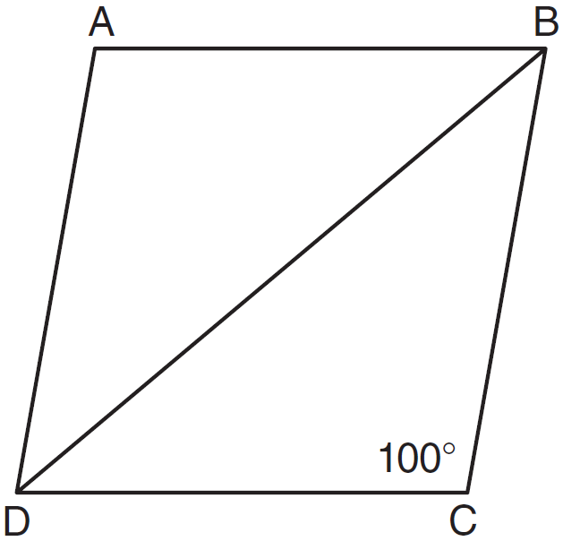

What is ?
1) | 40
2) | 45
3) | 50
4) | 80

10 In the diagram below, MATH is a rhombus with diagonals and .

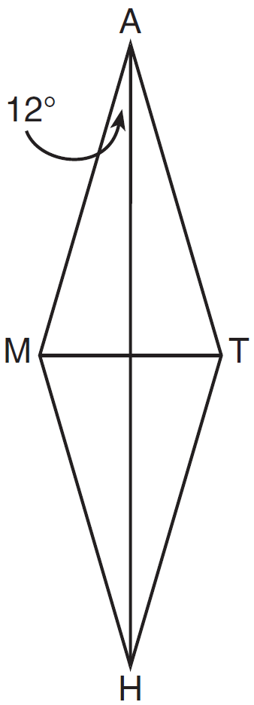

If , what is ?
1) | 12
2) | 78
3) | 84
4) | 156

11 In rhombus ABCD, with diagonals and , .

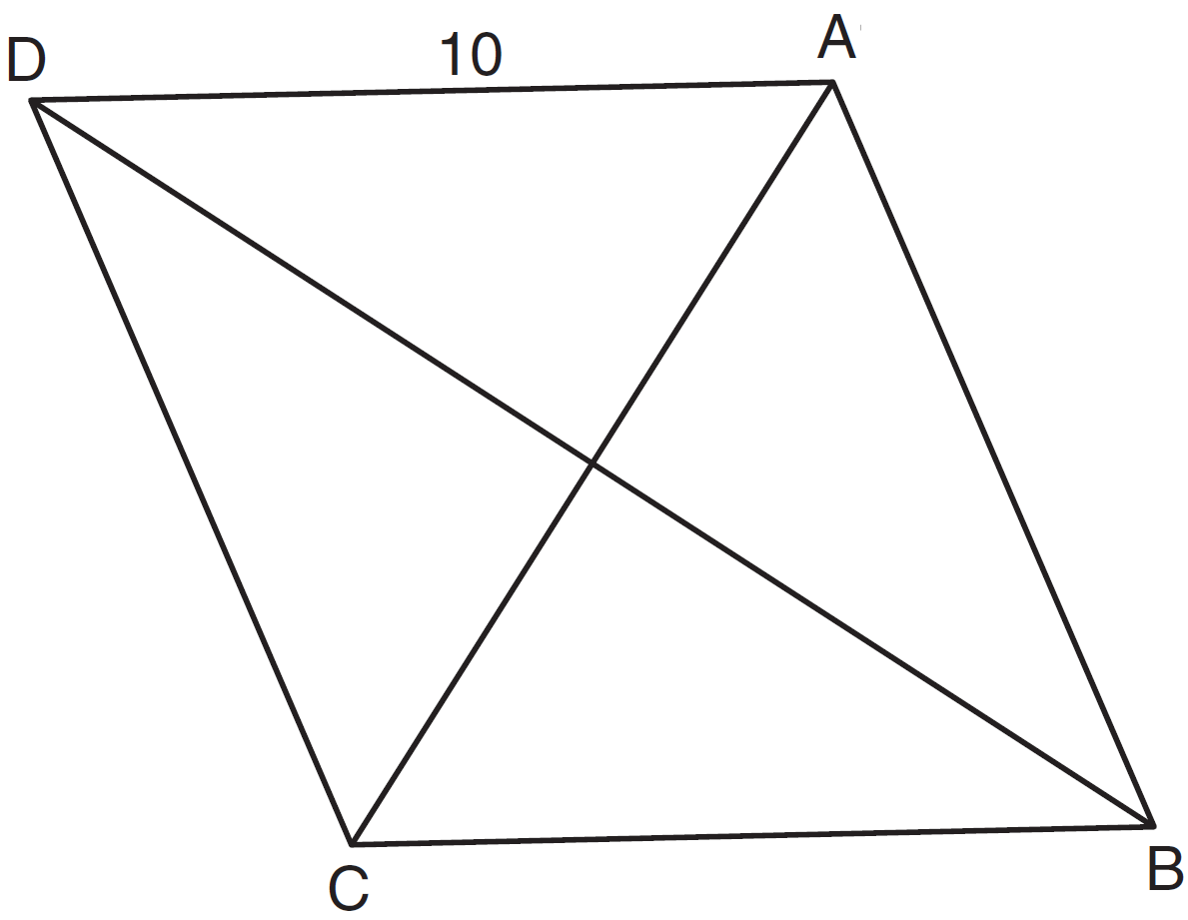

If the length of diagonal is 12, what is the length of ?
1) | 8
2) | 16
3)
4)

12 In the diagram below of rhombus ABCD, the diagonals and intersect at E.

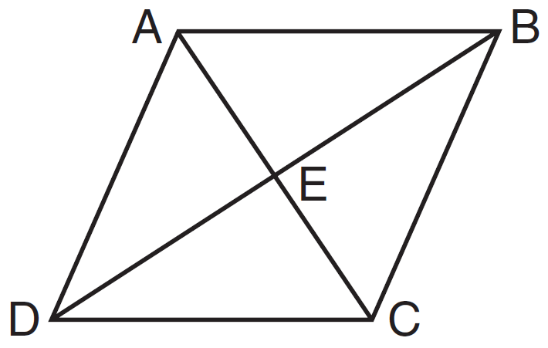

If and , what is the length of one side of rhombus ABCD?
1) | 15
2) | 18
3) | 24
4) | 30

13 In rhombus ABCD, the diagonals and intersect at E. If and , what is the length of ?
1) | 7
2) | 10
3) | 13
4) | 17

14 In the diagram below, quadrilateral STAR is a rhombus with diagonals and intersecting at E. , , , , , , and . Find SR, RT, and .

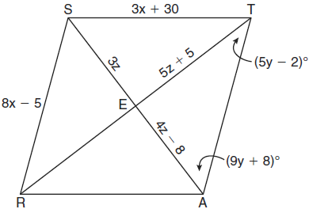

15 In rhombus ABCD, the measure, in inches, of is and is . Find the number of inches in the length of .

16 Which statement about quadrilaterals is true?
1) | All quadrilaterals have four right angles.
2) | All quadrilaterals have equal sides.
3) | All quadrilaterals have four sides.
4) | All quadrilaterals are parallelograms.

17 Which statement is false?
1) | All parallelograms are quadrilaterals.
2) | All rectangles are parallelograms.
3) | All squares are rhombuses.
4) | All rectangles are squares.

18 A quadrilateral whose diagonals bisect each other and are perpendicular is a
1) | rhombus
2) | rectangle
3) | trapezoid
4) | parallelogram

19 Which quadrilateral has diagonals that always bisect its angles and also bisect each other?
1) | rhombus
2) | rectangle
3) | parallelogram
4) | isosceles trapezoid

20 The diagonals of a quadrilateral are congruent but do not bisect each other. This quadrilateral is
1) | an isosceles trapezoid
2) | a parallelogram
3) | a rectangle
4) | a rhombus

21 In quadrilateral ABCD, the diagonals bisect its angles. If the diagonals are not congruent, quadrilateral ABCD must be a
1) | square
2) | rectangle
3) | rhombus
4) | trapezoid

22 Which quadrilateral has diagonals that are always perpendicular bisectors of each other?
1) | square
2) | rectangle
3) | trapezoid
4) | parallelogram

23 Which quadrilateral must have diagonals that are congruent and perpendicular?
1) | rhombus
2) | square
3) | trapezoid
4) | parallelogram

24 In a certain quadrilateral, two opposite sides are parallel, and the other two opposite sides are not congruent. This quadrilateral could be a
1) | rhombus
2) | parallelogram
3) | square
4) | trapezoid

25 Given three distinct quadrilaterals, a square, a rectangle, and a rhombus, which quadrilaterals must have perpendicular diagonals?
1) | the rhombus, only
2) | the rectangle and the square
3) | the rhombus and the square
4) | the rectangle, the rhombus, and the square

26 In quadrilateral ABCD, each diagonal bisects opposite angles. If , then ABCD must be a
1) | rectangle
2) | trapezoid
3) | rhombus
4) | square

27 A set of five quadrilaterals consists of a square, a rhombus, a rectangle, an isosceles trapezoid, and a parallelogram. Lu selects one of these figures at random. What is the probability that both pairs of the figure's opposite sides are parallel?
1) | 1
2)
3)
4)

1
3)
4)

G.CO.C.11: Special Quadrilaterals 2
Answer Section

1 ANS: 4 REF: 081417ge

2 ANS: 4
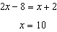. .

REF: 011327ge

3 ANS: 3
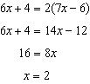

REF: 011603ge

4 ANS: 4
Because ABCD is a rectangle, and are parallel and is a transversal. ∠BAC and ∠ACD are equal alternate interior angles. 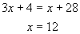. m∠BAC = 3(12) + 4 = 40. Since ∠BAC and ∠CAD are complementary, m∠CAD = 50.

REF: 089909a

5 ANS: 3
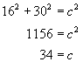. 16, 30, 34 is a multiple of the 8, 15, 17 triangle.

REF: 010615a

6 ANS:
96. 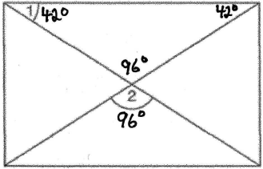

REF: 010835a

7 ANS:
75. The diagonals of a parallelogram are congruent. 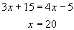. .

REF: 010533a

8 ANS:
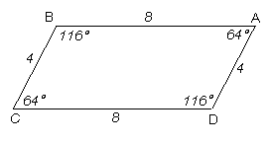

REF: 010025a

9 ANS: 1 REF: 011112ge

10 ANS: 2
The diagonals of a rhombus are perpendicular.

REF: 011204ge

11 ANS: 2
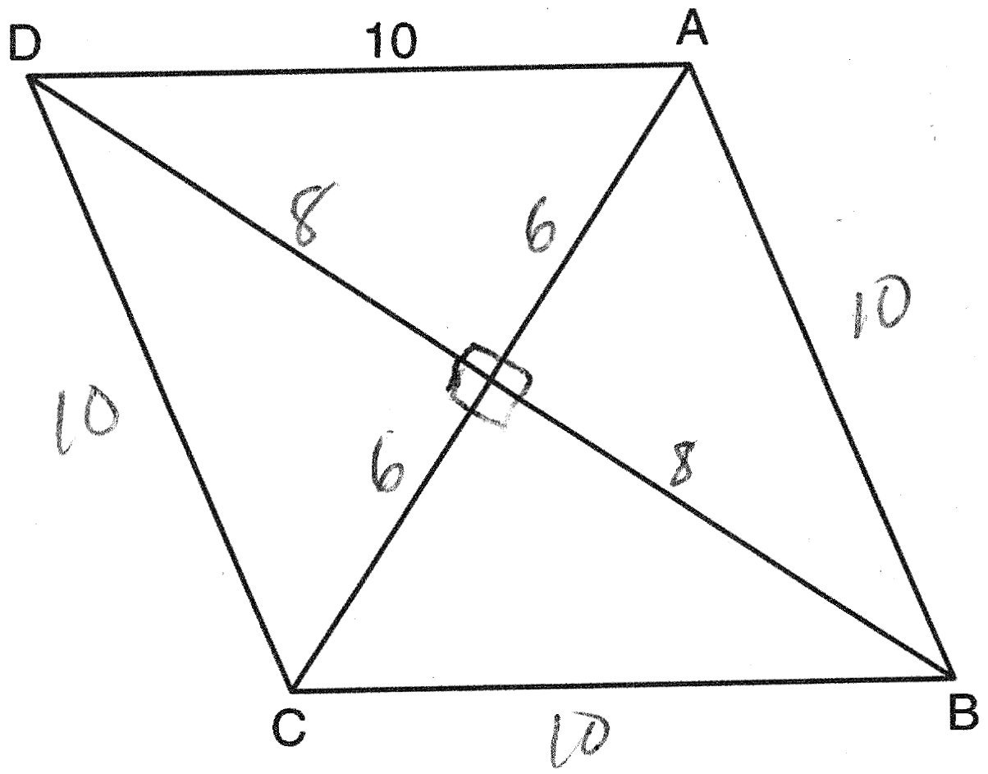

REF: 061414ge

12 ANS: 1
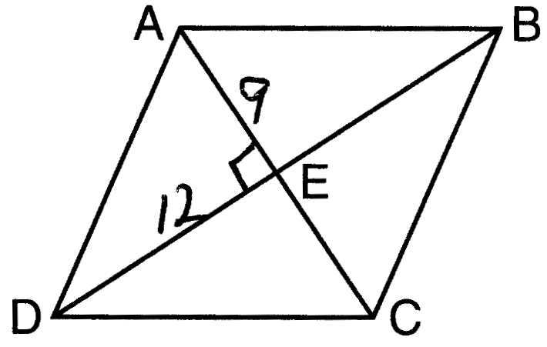

REF: 011505ge

13 ANS: 3

REF: 061116ge

14 ANS:
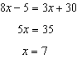. 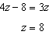. 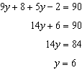. 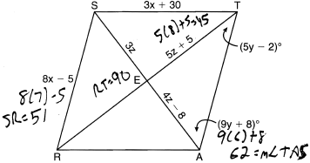

REF: 061038ge

15 ANS:
17. A rhombus has four congruent sides. 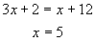. .

REF: 080735a

16 ANS: 3 REF: 010404a

17 ANS: 4
Not all rectangles are squares.

REF: 010919a

18 ANS: 1 REF: 080918ge

19 ANS: 1 REF: 061125ge

20 ANS: 1 REF: 081121ge

21 ANS: 3 REF: 081419ge

22 ANS: 1 REF: 081517ge

23 ANS: 2 REF: 060526a

24 ANS: 4 REF: 080517a

25 ANS: 3 REF: 081128ge

26 ANS: 3

Diagonals of rectangles and trapezoids do not bisect opposite angles. if ABCD is a square.

REF: 061511ge

27 ANS: 2
In an isosceles trapezoid, only one pair of opposite sides is parallel.

REF: 010721a

