1 In the diagram below of quadrilateral ABCD, E and F are points on and , respectively, , and .

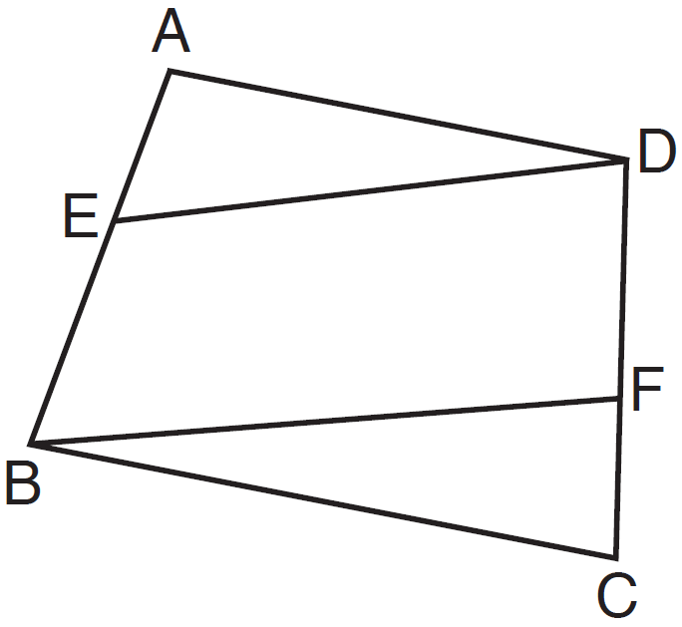

Which conclusion can be proven?
1)
2)
3)
4)

2 Given: parallelogram ABCD, diagonal , and

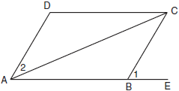

Prove:

3 In parallelogram ABCD shown below, diagonals and intersect at E.

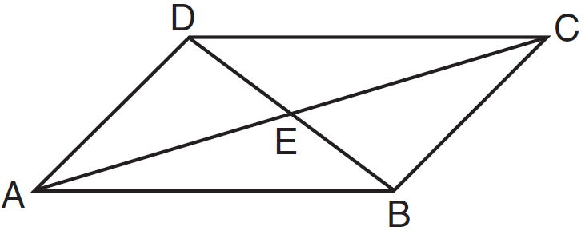

Prove:

4 Given: JKLM is a parallelogram.
Prove: JKLM is a rhombus.

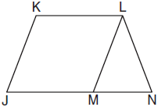

5 Given: Quadrilateral ABCD with diagonals and that bisect each other, and

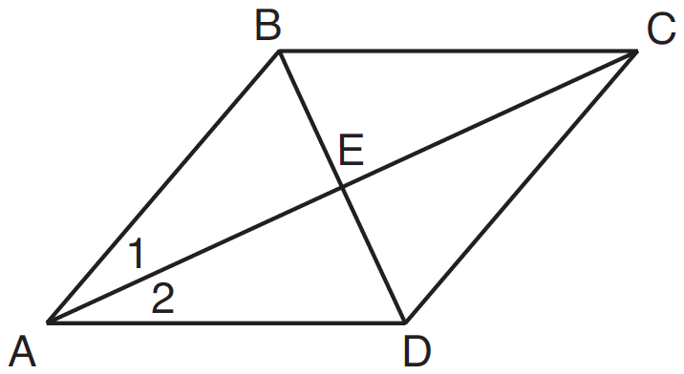

Prove: is an isosceles triangle and is a right triangle

6 Given: Parallelogram ABCD, , and

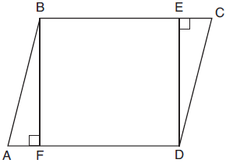

Prove: BEDF is a rectangle
1 ANS: 2 REF: 011411ge

2 ANS:
Because ABCD is a parallelogram, and since is a transversal, and are corresponding angles and congruent. If , then , using substitution.

REF: 060533b

3 ANS:
Parallelogram ABCD, diagonals and intersect at E (given). (opposite sides of a parallelogram are parallel). (alternate interior angles formed by parallel lines and a transversal are congruent).

REF: 081528geo

4 ANS:
because opposite sides of a parallelogram are congruent. because of the Isosceles Triangle Theorem. because of the transitive property. JKLM is a rhombus because all sides are congruent.

REF: 011036ge

5 ANS:
Quadrilateral ABCD with diagonals and that bisect each other, and (given); quadrilateral ABCD is a parallelogram (the diagonals of a parallelogram bisect each other); (opposite sides of a parallelogram are parallel); and (alternate interior angles are congruent); and (substitution); is an isosceles triangle (the base angles of an isosceles triangle are congruent); (the sides of an isosceles triangle are congruent); quadrilateral ABCD is a rhombus (a rhombus has consecutive congruent sides); (the diagonals of a rhombus are perpendicular); is a right angle (perpendicular lines form a right angle); is a right triangle (a right triangle has a right angle).

REF: 061635geo

6 ANS:
Parallelogram ABCD, , and (given); (opposite sides of a are ); (parts of lines are ); (two lines to the same line are ); BEDF is (a quadrilateral with both pairs of opposite sides is a ); is a right ( lines form right ); BEDF is a rectangle (a with one right is a rectangle).

REF: 061835geo

