1 In the diagram below, parallelogram ABCD has diagonals and that intersect at point E.

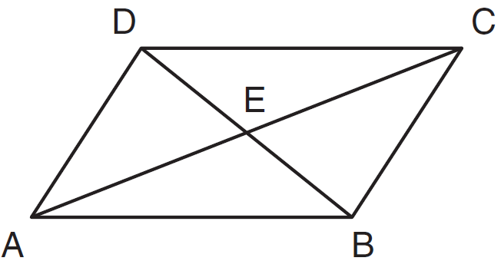

Which expression is not always true?
1)
2)
3)
4)

2 Parallelogram ABCD with diagonals and intersecting at E is shown below.

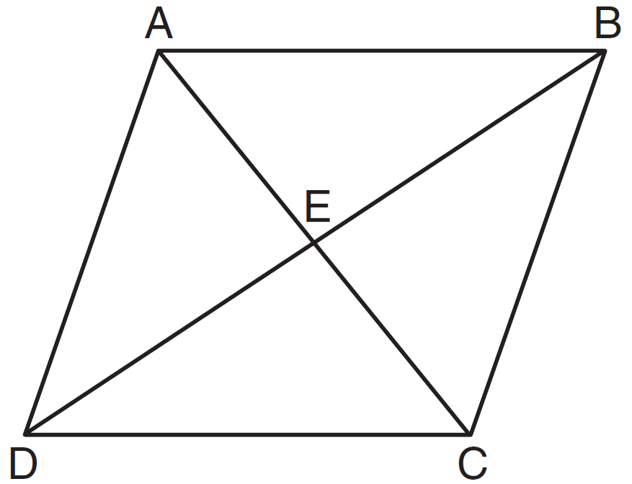

Which statement must be true?
1)
2)
3)
4)

3 Which statement is true about every parallelogram?
1) | All four sides are congruent.
2) | The interior angles are all congruent.
3) | Two pairs of opposite sides are congruent.
4) | The diagonals are perpendicular to each other.

4 In parallelogram QRST, diagonal is drawn. Which statement must always be true?
1) | is an isosceles triangle.
2) | is an acute triangle.
3)
4)

5 Which statement is not always true about a parallelogram?
1) | The diagonals are congruent.
2) | The opposite sides are congruent.
3) | The opposite angles are congruent.
4) | The opposite sides are parallel.

6 In the accompanying diagram of parallelogram ABCD, and . Find the number of degrees in .

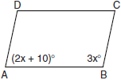

7 In the accompanying diagram of parallelogram ABCD, , and . Find the number of degrees in .

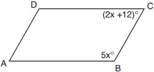

8 In parallelogram JKLM, exceeds by 30 degrees. What is the measure of ?
1) | 75°
2) | 105°
3) | 165°
4) | 195°

9 The measures of two consecutive angles of a parallelogram are in the ratio . What is the measure of an obtuse angle of the parallelogram?
1) | 20°
2) | 80°
3) | 100°
4) | 160°

10 In parallelogram RSTU, and . Determine and state the value of x.

11 In the diagram below of parallelogram ABCD with diagonals and , and .

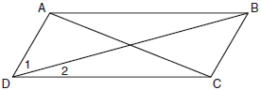

What is the measure of ?
1) | 15º
2) | 30º
3) | 45º
4) | 60º

12 In the diagram below of parallelogram STUV, , , and .

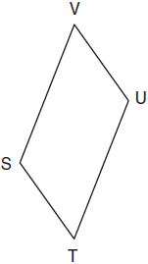

What is the length of ?
1) | 5
2) | 2
3) | 7
4) | 4

13 In the accompanying diagram of parallelogram ABCD, diagonals and intersect at E, 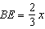, and .

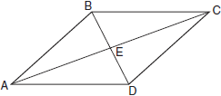

What is the value of x?
1)
2) | 30
3)
4) | 6

14 In the accompanying diagram of parallelogram ABCD, diagonals and intersect at E, , and .

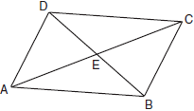

What is the value of x?
1) | 8
2) | 16
3) | 20
4) | 40

15 As shown in the diagram below, the diagonals of parallelogram QRST intersect at E. If , , and , determine TE algebraically.

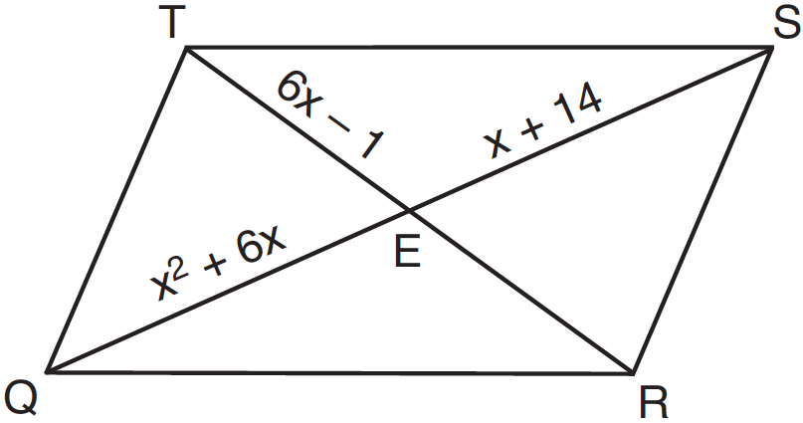

16 In parallelogram ABCD, with diagonal drawn, , , , and . Determine .
1 ANS: 3 REF: 061111ge

2 ANS: 2 REF: 011522ge

3 ANS: 3 REF: 011104ge

4 ANS: 3
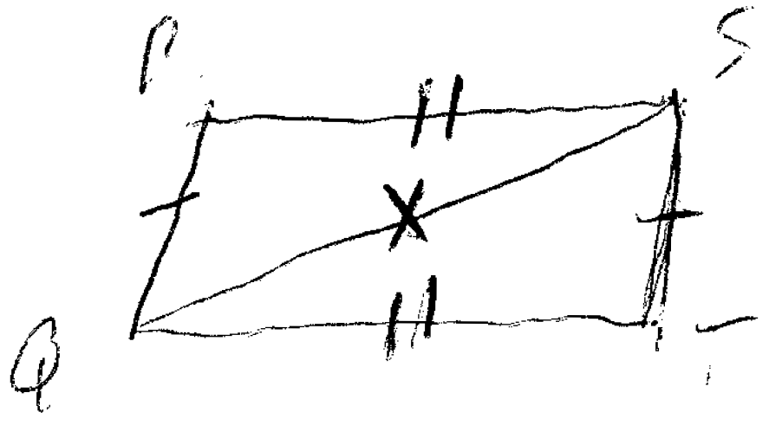

REF: 081402ge

5 ANS: 1
Only rectangles have congruent diagonals.

REF: 060106a

6 ANS:
102. Adjacent angles in a parallelogram are supplementary. 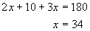.

REF: 060126a

7 ANS:
120. Adjacent angles in a parallelogram are supplementary. 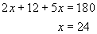. . Opposite angles in a parallelogram are congruent, so .

REF: 060736a

8 ANS: 2
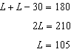

REF: 081519ge

9 ANS: 3
Adjacent angles in a parallelogram are supplementary. 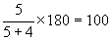.

REF: 080618a

10 ANS:
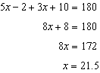

REF: 011631ge

11 ANS: 1
and are supplementary adjacent angles of a parallelogram. .

REF: 080907ge

12 ANS: 1
Opposite sides of a parallelogram are congruent. 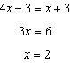. .

REF: 011013ge

13 ANS: 2
The diagonals of a parallelogram bisect each other. 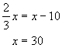.

REF: 060626a

14 ANS: 1
The diagonals of a parallelogram bisect each other. 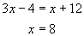.

REF: 080202a

15 ANS:
11. 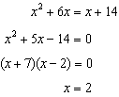.

REF: 081235ge

16 ANS:
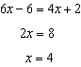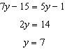

REF: 061536ge

