1 In quadrilateral BLUE shown below, .
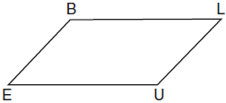
Which information would be sufficient to prove quadrilateral BLUE is a parallelogram?
1)
2)
3)
4)

2 In the diagram below, lines k and intersect lines m and n at points A, B, C, and D.
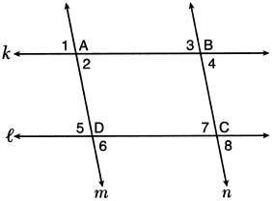
Which statement is sufficient to prove ABCD is a parallelogram?
1)
2)
3) | and
4) | and

3 In the diagram below, lines and m intersect lines n and p to create the shaded quadrilateral as shown.
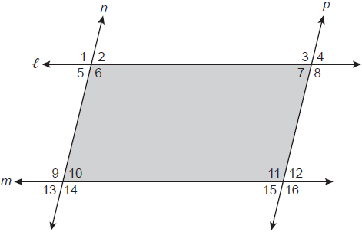
Which congruence statement would be sufficient to prove the quadrilateral is a parallelogram?
1) | and
2) | and
3) | and
4) | and

4 Quadrilateral ABCD with diagonals and is shown in the diagram below.

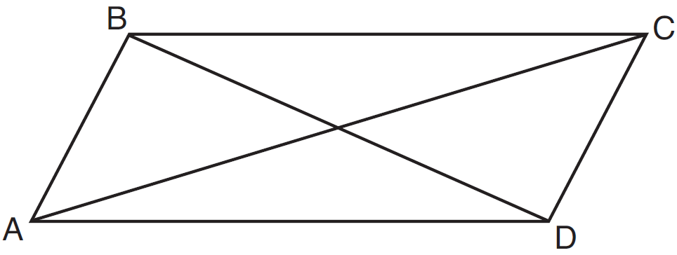

Which information is not enough to prove ABCD is a parallelogram?
1) | and
2) | and
3) | and
4) | and

5 In the diagram below of parallelogram RSTV, diagonals and intersect at E.

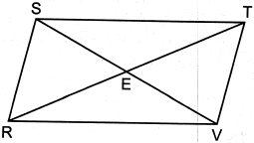
Which statement is always true?
1)
2)
3)
4)

6 Parallelogram HAND is drawn below with diagonals and intersecting at S.

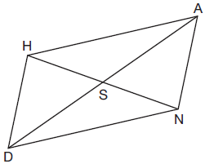

Which statement is always true?
1) | 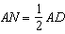
2) | 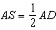
3)
4)

7 Which statement about parallelograms is always true?
1) | The diagonals are congruent.
2) | The diagonals bisect each other.
3) | The diagonals are perpendicular.
4) | The diagonals bisect their respective angles.

8 A quadrilateral must be a parallelogram if
1) | one pair of sides is parallel and one pair of angles is congruent
2) | one pair of sides is congruent and one pair of angles is congruent
3) | one pair of sides is both parallel and congruent
4) | the diagonals are congruent

9 Quadrilateral ABCD has diagonals and . Which information is not sufficient to prove ABCD is a parallelogram?
1) | and bisect each other.
2) | and
3) | and
4) | and

10 Quadrilateral BEST has diagonals that intersect at point D. Which statement would not be sufficient to prove quadrilateral BEST is a parallelogram?
1) | and
2) | and
3) | and
4) | and

11 In quadrilateral QRST, diagonals and intersect at M. Which statement would always prove quadrilateral QRST is a parallelogram?
1) | and are supplementary.
2) | and
3) | and
4) | and

12 Quadrilateral MATH has both pairs of opposite sides congruent and parallel. Which statement about quadrilateral MATH is always true?
1)
2)
3)
4)

13 In parallelogram ABCD with , and . What is the perimeter of ABCD?
1) | 10
2) | 24
3) | 40
4) | 56

1 ANS: 2 REF: 061720geo

2 ANS: 3
Therefore . Since opposite angles are congruent, ABCD is a parallelogram.

REF: 062209geo

3 ANS: 4
and are alternate interior angles; since congruent, . and are corresponding angles; since congruent, . Both pairs of opposite sides are parallel.

REF: 082319geo

4 ANS: 3
(3) Could be a trapezoid.

REF: 081607geo

5 ANS: 4 REF: 082404geo

6 ANS: 2 REF: 011802geo

7 ANS: 2 REF: 011912geo

8 ANS: 3 REF: 061912geo

9 ANS: 4 REF: 061513geo

10 ANS: 3
3) Could be an isosceles trapezoid.

REF: 012318geo

11 ANS: 3 REF: 081913geo

12 ANS: 4 REF: 081813geo

13 ANS: 3
The half diagonals have lengths of 6 and 8, so each side of ABCD is 10.

REF: 012417geo

