1 Which type of figure is shown in the accompanying diagram?

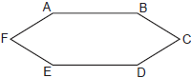
1) | hexagon
2) | octagon
3) | pentagon
4) | quadrilateral

2 What is the measure of each interior angle of a regular hexagon?
1)
2)
3)
4)

3 Determine, in degrees, the measure of each interior angle of a regular octagon.

4 Determine and state the measure, in degrees, of an interior angle of a regular decagon.

5 In the diagram below of regular pentagon ABCDE, is drawn.
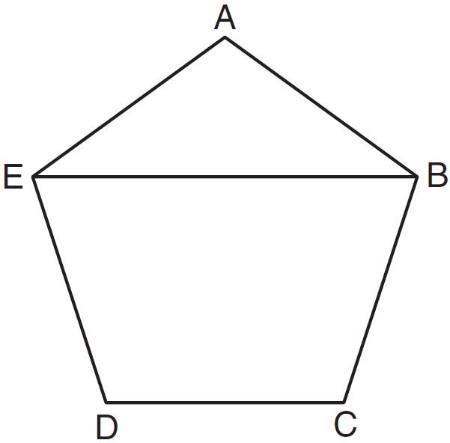

What is the measure of ?
1) | 36º
2) | 54º
3) | 72º
4) | 108º

6 What is the measure, in degrees, of each exterior angle of a regular hexagon?
1) | 45
2) | 60
3) | 120
4) | 135

7 A stop sign in the shape of a regular octagon is resting on a brick wall, as shown in the accompanying diagram.

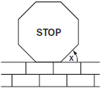

What is the measure of angle x?
1) | 45°
2) | 60°
3) | 120°
4) | 135°

8 One piece of the birdhouse that Natalie is building is shaped like a regular pentagon, as shown in the accompanying diagram.
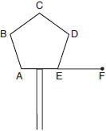

If side AE is extended to point F, what is the measure of exterior angle DEF?
1) | 36°
2) | 72°
3) | 108°
4) | 144°

9 What is the difference between the sum of the measures of the interior angles of a regular pentagon and the sum of the measures of the exterior angles of a regular pentagon?
1) | 36
2) | 72
3) | 108
4) | 180

10 Find, in degrees, the measures of both an interior angle and an exterior angle of a regular pentagon.

11 The sum of the interior angles of a regular polygon is 720°. How many sides does the polygon have?
1) | 8
2) | 6
3) | 5
4) | 4

12 The measure of an interior angle of a regular polygon is 120°. How many sides does the polygon have?
1) | 5
2) | 6
3) | 3
4) | 4

13 Melissa is walking around the outside of a building that is in the shape of a regular polygon. She determines that the measure of one exterior angle of the building is 60°. How many sides does the building have?
1) | 6
2) | 9
3) | 3
4) | 12

14 A regular polygon has an exterior angle that measures 45°. How many sides does the polygon have?
1) | 10
2) | 8
3) | 6
4) | 4

15 A regular polygon with an exterior angle of 40° is a
1) | pentagon
2) | hexagon
3) | nonagon
4) | decagon

16 What is the measure of the largest exterior angle that any regular polygon can have?
1) | 60º
2) | 90º
3) | 120º
4) | 360º

17 The sum of the interior angles of a regular polygon is 540°. Determine and state the number of degrees in one interior angle of the polygon.

18 The sum of the interior angles of a polygon of n sides is
1) | 360
2)
3)
4) | 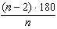

19 The sum of the measures of the interior angles of an octagon is
1) | 180°
2) | 360°
3) | 540°
4) | 1,080°

20 What is the sum, in degrees, of the measures of the interior angles of a pentagon?
1) | 180
2) | 360
3) | 540
4) | 900

21 The number of degrees in the sum of the interior angles of a pentagon is
1) | 72
2) | 360
3) | 540
4) | 720

22 In which polygon does the sum of the measures of the interior angles equal the sum of the measures of the exterior angles?
1) | triangle
2) | hexagon
3) | octagon
4) | quadrilateral

23 For which polygon does the sum of the measures of the interior angles equal the sum of the measures of the exterior angles?
1) | hexagon
2) | pentagon
3) | quadrilateral
4) | triangle

24 The pentagon in the diagram below is formed by five rays.

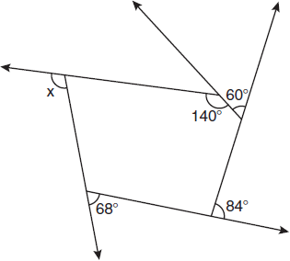

What is the degree measure of angle x?
1) | 72
2) | 96
3) | 108
4) | 112

25 The measures of five of the interior angles of a hexagon are 150°, 100°, 80°, 165°, and 150°. What is the measure of the sixth interior angle?
1) | 75°
2) | 80°
3) | 105°
4) | 180°

26 If the sum of the interior angles of a polygon is 1440°, then the polygon must be
1) | an octagon
2) | a decagon
3) | a hexagon
4) | a nonagon

1 ANS: 1 REF: 060802a

2 ANS: 2
. 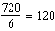.
REF: 081125ge

3 ANS:
. 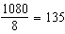.
REF: 061330ge

4 ANS:
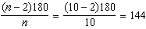
REF: 011531ge

5 ANS: 1
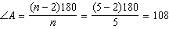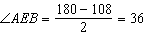
REF: 081022ge

6 ANS: 2
. . .
REF: 060213a

7 ANS: 1
. . .
REF: 080507a

8 ANS: 2
. 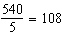. .
REF: 060718a

9 ANS: 4
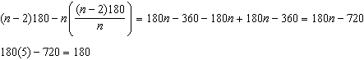.
REF: 081322ge

10 ANS:
. interior. exterior
REF: 011131ge

11 ANS: 2
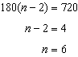
REF: 061521ge

12 ANS: 2
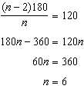.
REF: 011326ge

13 ANS: 1
Find an interior angle. 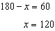. Find n. .
REF: 060423a

14 ANS: 2
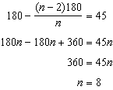
REF: 061413ge

15 ANS: 3
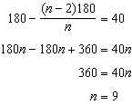
REF: 061519ge

16 ANS: 3
The regular polygon with the smallest interior angle is an equilateral triangle, with 60º.
REF: 011417ge

17 ANS:
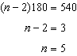.
REF: 081434ge

18 ANS: 3 REF: 061218ge

19 ANS: 4
REF: 080109a

20 ANS: 3
REF: 010514a

21 ANS: 3
REF: 011223ge

22 ANS: 4
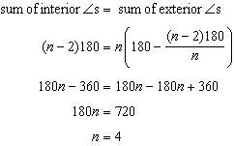
REF: 081016ge

23 ANS: 3
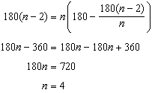
REF: 081223ge

24 ANS: 3
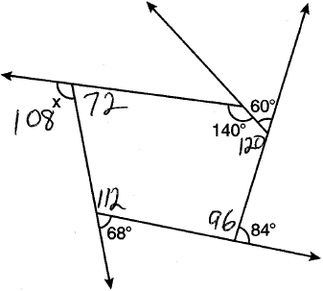. The sum of the interior angles of a pentagon is .
REF: 011023ge

25 ANS: 1
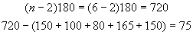
REF: 080820a

26 ANS: 2
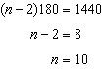
REF: 011618ge

