1 In the diagram of parallelogram FRED shown below, is extended to A, and is drawn such that .

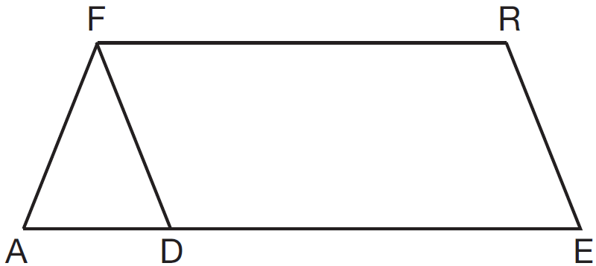

If , what is ?
1) | 124°
2) | 112°
3) | 68°
4) | 56°

2 In the diagram below, ABCD is a parallelogram, is extended through B to E, and is drawn.

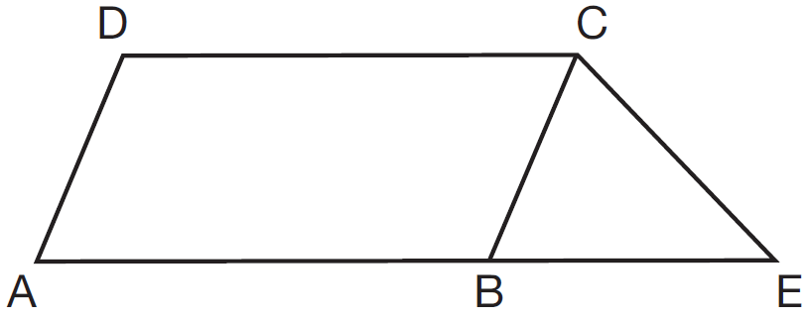

If and , what is ?
1) | 44°
2) | 56°
3) | 68°
4) | 112°

3 In parallelogram PQRS, is extended to point T and is drawn.

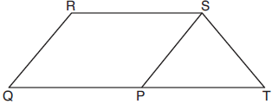

If and , what is ?
1) | 130°
2) | 80°
3) | 65°
4) | 50°

4 In the diagram below of parallelogram ROCK, is 70° and is 65°.

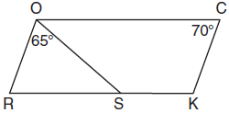
What is ?
1) | 45º
2) | 110º
3) | 115º
4) | 135º

5 In parallelogram ABCD shown below, bisects .
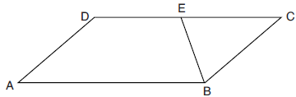

If , then is
1) | 40°
2) | 70°
3) | 110°
4) | 140°

6 In parallelogram QRST shown below, diagonal is drawn, U and V are points on and , respectively, and intersects at W.
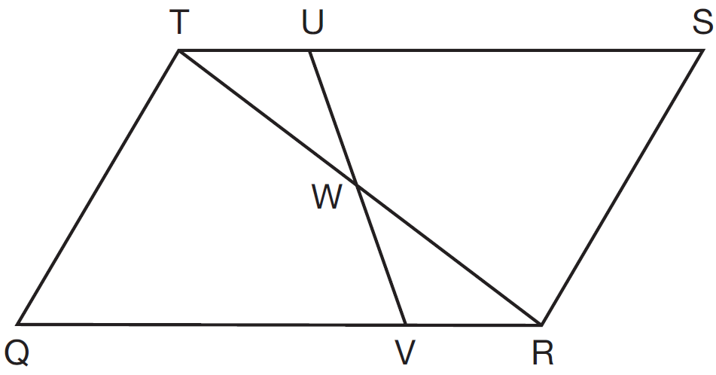

If , , and , what is ?
1) | 37º
2) | 60º
3) | 72º
4) | 83º

7 In the diagram below of parallelogram ABCD, , bisects , bisects , and and intersect at E.

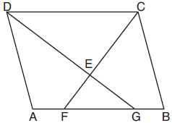

If , then the measure of is
1) | 142.5°
2) | 127.5°
3) | 52.5°
4) | 37.5°

8 In the diagram below of parallelogram ABCD, diagonal and are drawn, , , and .

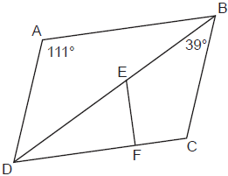

What is ?
1) | 30º
2) | 51º
3) | 60º
4) | 120º

9 In the diagram below, point E is located inside square ABCD such that is equilateral, and is drawn.

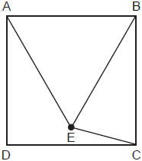

What is ?
1) | 30°
2) | 60º
3) | 75º
4) | 90º

10 Quadrilateral EBCF and are drawn below, such that ABCD is a parallelogram, , and .

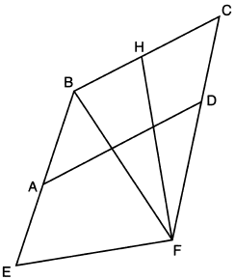

If and , what is ?
1) | 79º
2) | 76º
3) | 73º
4) | 62º

11 The diagram below shows parallelogram LMNO with diagonal , , and .

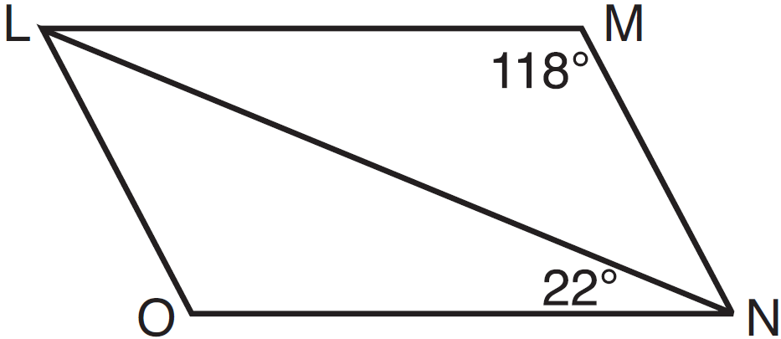

Explain why is 40 degrees.

12 In parallelogram ABCD shown below, and .

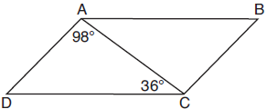

What is the measure of angle B? Explain why.

13 In parallelogram ABCD shown below, the bisectors of and meet at E, a point on .

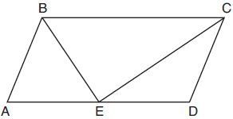

If , determine and state .

14 Parallelogram ABCD is adjacent to rhombus DEFG, as shown below, and intersects at H.

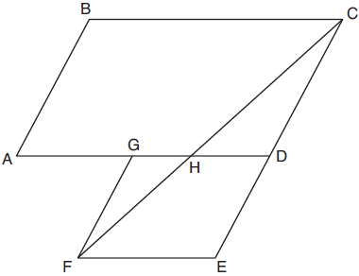

If and , determine and state .

15 Trapezoid ABCD, where , is shown below. Diagonals and intersect at E, and .

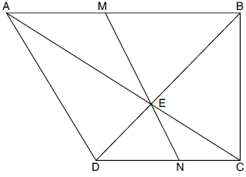

If , , and , determine and state .
1 ANS: 3
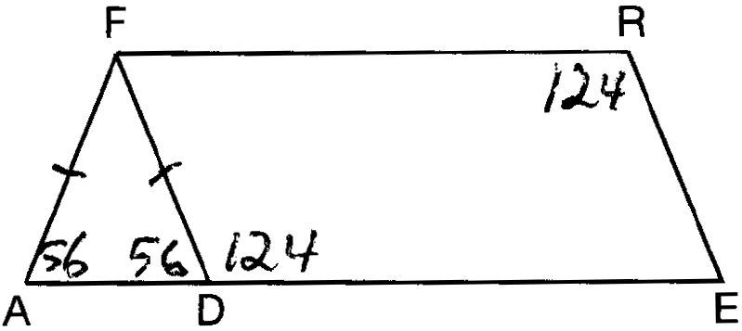

REF: 081508geo

2 ANS: 1

REF: 081624geo

3 ANS: 2
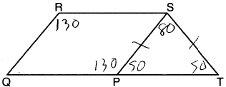

REF: 061921geo

4 ANS: 4
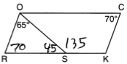

REF: 081708geo

5 ANS: 3
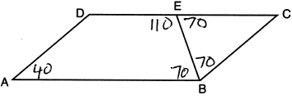

REF: 082215geo

6 ANS: 3
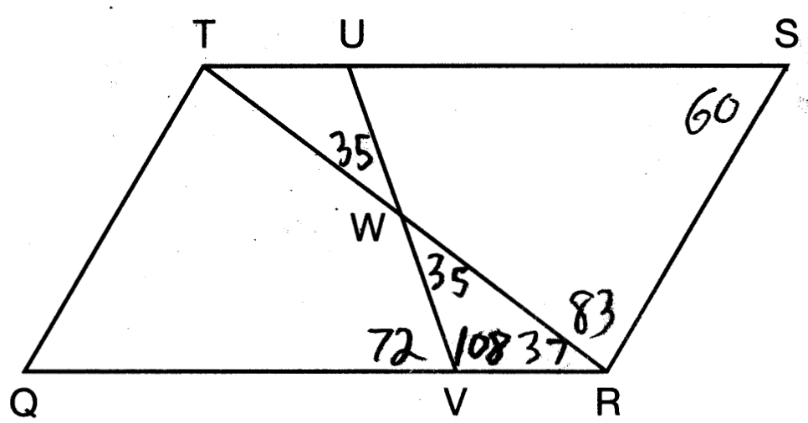

REF: 011603geo

7 ANS: 2
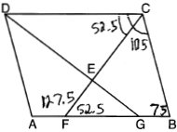

REF: 081907geo

8 ANS: 3
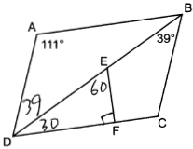

REF: 062306geo

9 ANS: 3
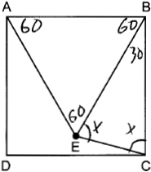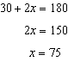

REF: 082315geo

10 ANS: 1
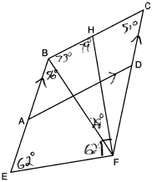

REF: 062221geo

11 ANS:
Opposite angles in a parallelogram are congruent, so . The interior angles of a triangle equal 180°. .

REF: 061526geo

12 ANS:
because the angles of a triangle equal 180°. because opposite angles of a parallelogram are congruent.

REF: 081925geo

13 ANS:
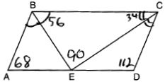

REF: 081826geo

14 ANS:
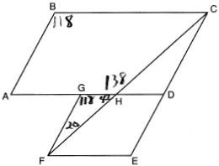20º

REF: 011926geo

15 ANS:
47.5° 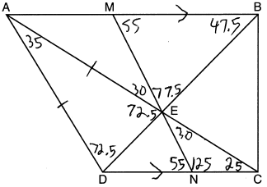

REF: 082230geo

