1 In the diagram below of , D, E, and F are the midpoints of , , and , respectively.

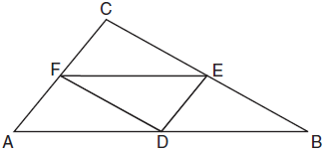

What is the ratio of the area of to the area of ?
1) | 1:1
2) | 1:2
3) | 1:3
4) | 1:4

2 The area of is 36 cm². A second triangle, JOE, is formed by connecting the midpoints of each side of . What is the area of , in square centimeters?
1) | 9
2) | 12
3) | 18
4) | 27

3 In the diagram below, the vertices of are the midpoints of the sides of equilateral triangle ABC, and the perimeter of is 36 cm.

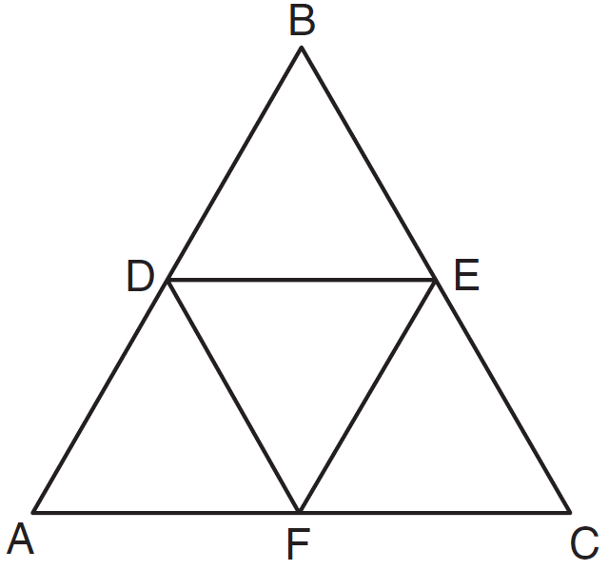

What is the length, in centimeters, of ?
1) | 6
2) | 12
3) | 18
4) | 4

4 In the diagram of equilateral triangle ABC shown below, E and F are the midpoints of and , respectively.

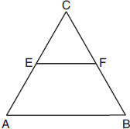

If and , what is the perimeter of trapezoid ABFE?
1) | 36
2) | 60
3) | 100
4) | 120

5 In the diagram below of , D is the midpoint of , O is the midpoint of , and G is the midpoint of .

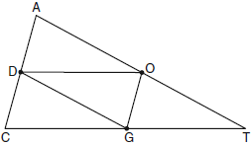

If , , and , what is the perimeter of parallelogram CDOG?
1) | 21
2) | 25
3) | 32
4) | 40

6 In the diagram of shown below, D is the midpoint of , E is the midpoint of , and F is the midpoint of .

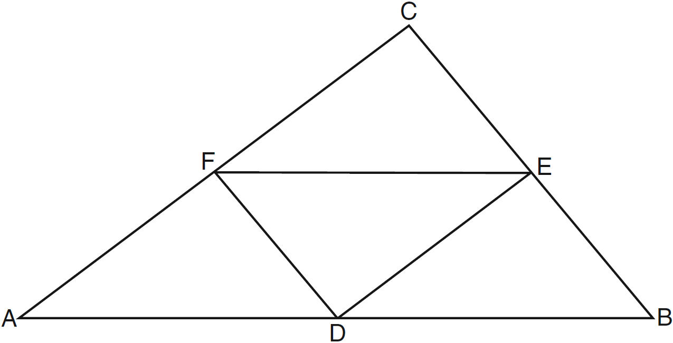

If , , and , what is the perimeter of trapezoid ABEF?
1) | 24
2) | 36
3) | 40
4) | 44

7 In shown below, L is the midpoint of , M is the midpoint of , and N is the midpoint of .

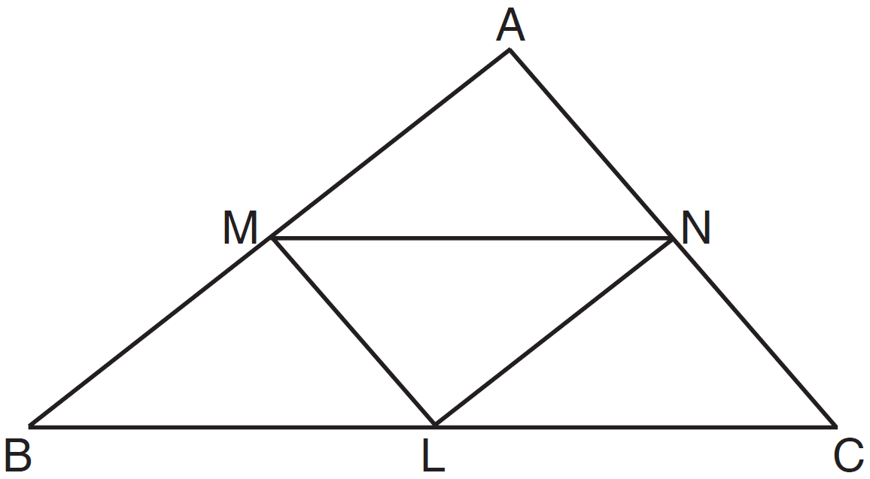

If , , and , the perimeter of trapezoid BMNC is
1) | 35
2) | 31
3) | 28
4) | 26

8 As shown in the diagram below, M, R, and T are midpoints of the sides of .

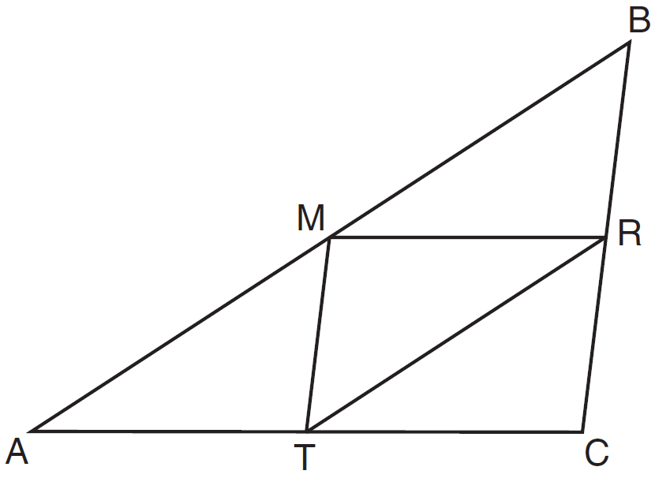

If , , and , what is the perimeter of quadrilateral ACRM?
1) | 35
2) | 32
3) | 24
4) | 21

9 In the diagram below, , , and are midsegments of .

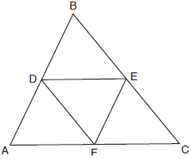

The perimeter of quadrilateral ADEF is equivalent to
1)
2) | 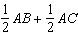
3)
4)

10 In the diagram below of , D is the midpoint of , and E is the midpoint of .

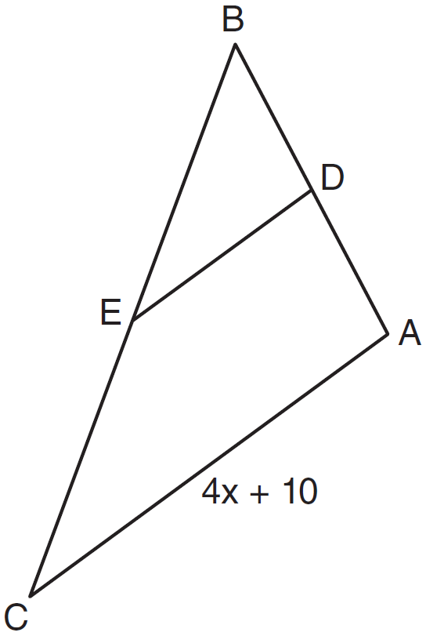

If , which expression represents DE?
1)
2)
3)
4)

11 In , D is the midpoint of and E is the midpoint of . If and , what is the value of x?

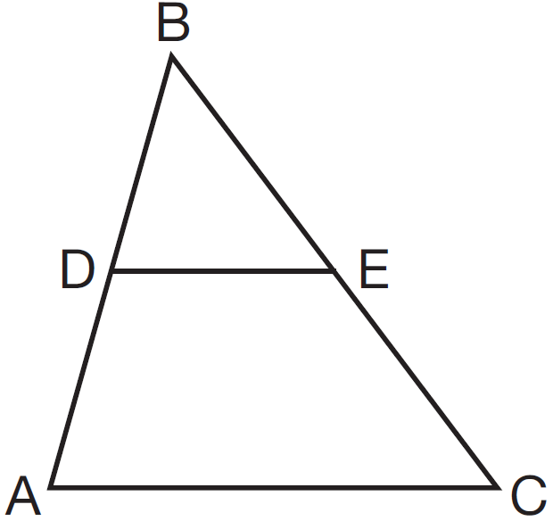
1) | 6
2) | 7
3) | 9
4) | 12

12 In the diagram of below, A is the midpoint of , B is the midpoint of , C is the midpoint of , and and are drawn.

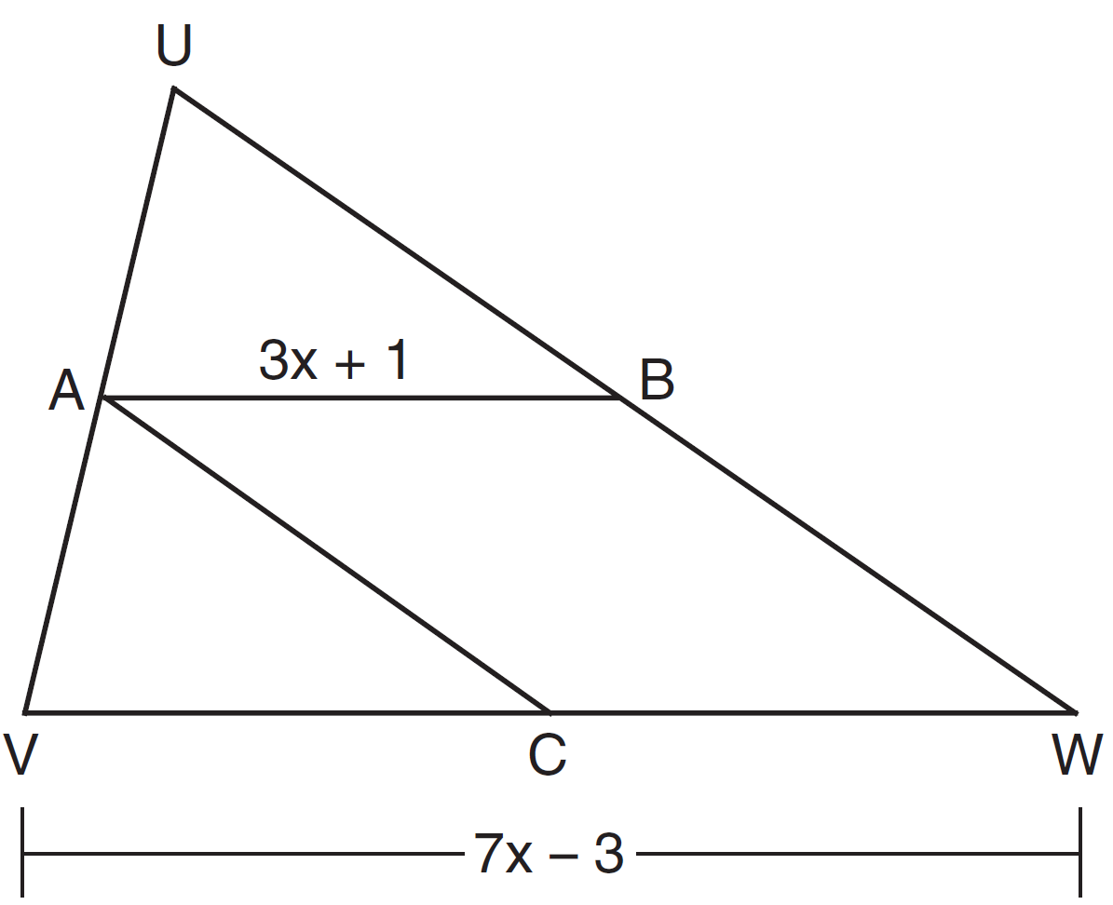

If and , what is the length of ?
1) | 5
2) | 13
3) | 16
4) | 32

13 In quadrilateral ABCD below, , and E, H, and F are the midpoints of , , and , respectively.
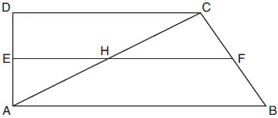

If , , and , then FH is
1) | 9
2) | 10
3) | 12
4) | 21

14 In , M is the midpoint of and N is the midpoint of . If and , what is the length of ?
1) | 3.5
2) | 9
3) | 16.5
4) | 22

15 Triangle ABC is shown in the diagram below.

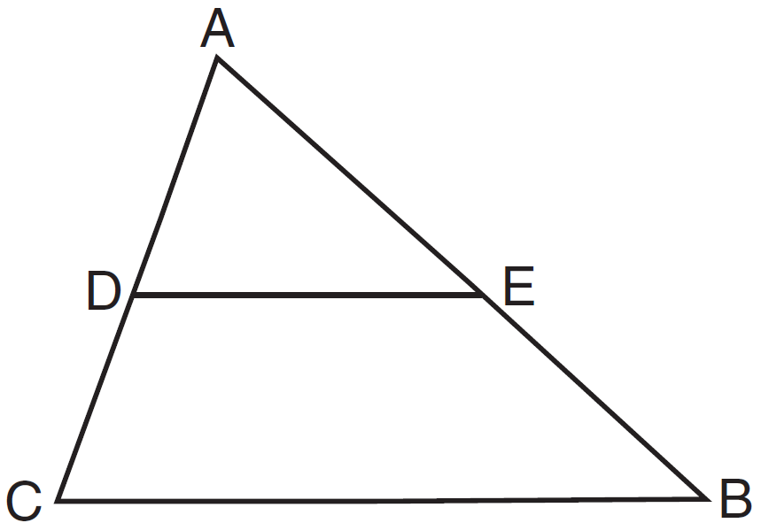

If joins the midpoints of and , which statement is not true?
1) | 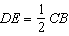
2)
3) | 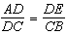
4)

16 In the diagram below, joins the midpoints of two sides of .

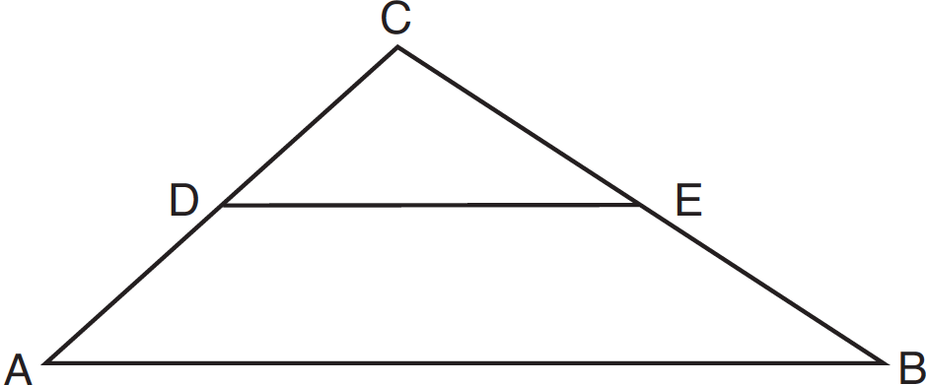

Which statement is not true?
1) | 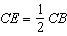
2) | 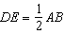
3) | area of 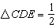 area of
4) | perimeter of perimeter of

17 In below, N and E are the midpoints of and , respectively, is drawn.

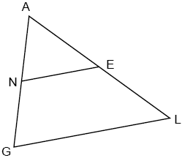

If and , determine and state the value of x.

18 In isosceles triangle RST shown below, , M and N are midpoints of and , respectively, and is drawn. If and the perimeter of is 25, determine and state the length of .

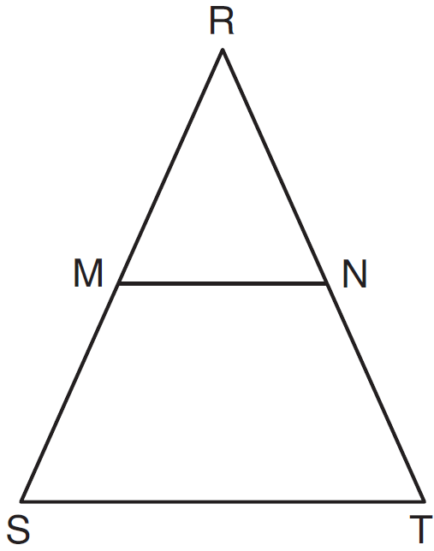

19 In the diagram below of , is a midsegment of , , , and . Find the perimeter of .

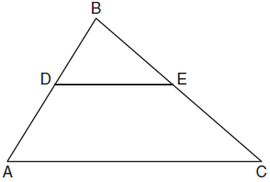

20 In the diagram of below, , , and . Find the perimeter of the triangle formed by connecting the midpoints of the sides of .

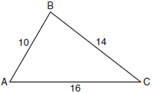

21 In the diagram below of , and are midsegments.

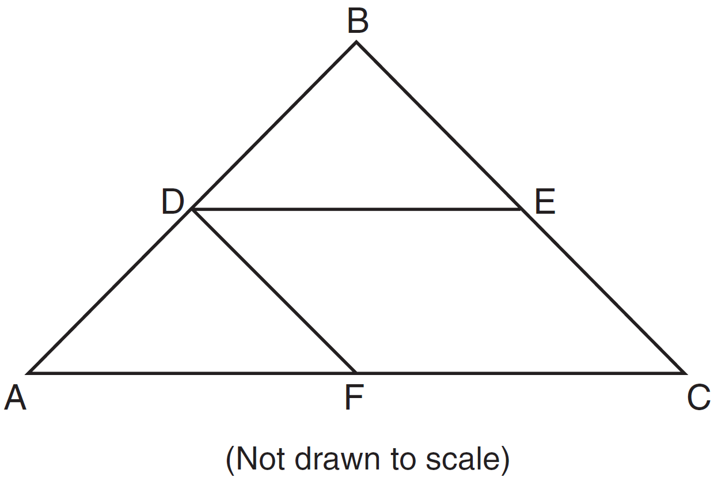

If , and , determine and state the perimeter of quadrilateral FDEC.

22 On the set of axes below, graph and label with vertices at , , and . If G is the midpoint of and H is the midpoint of , state the coordinates of G and H and label each point on your graph. Explain why .

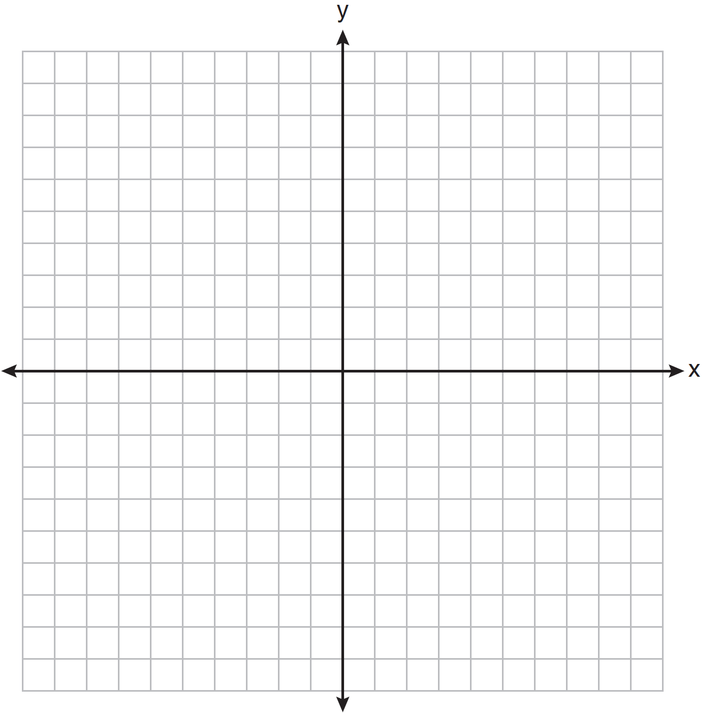

23 Triangle HKL has vertices , , and . The midpoint of is M and the midpoint of is N. Determine and state the coordinates of points M and N. Justify the statement: is parallel to . [The use of the set of axes below is optional.]

1 ANS: 4 REF: 081716geo

2 ANS: 1
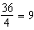

REF: 012321geo

3 ANS: 1
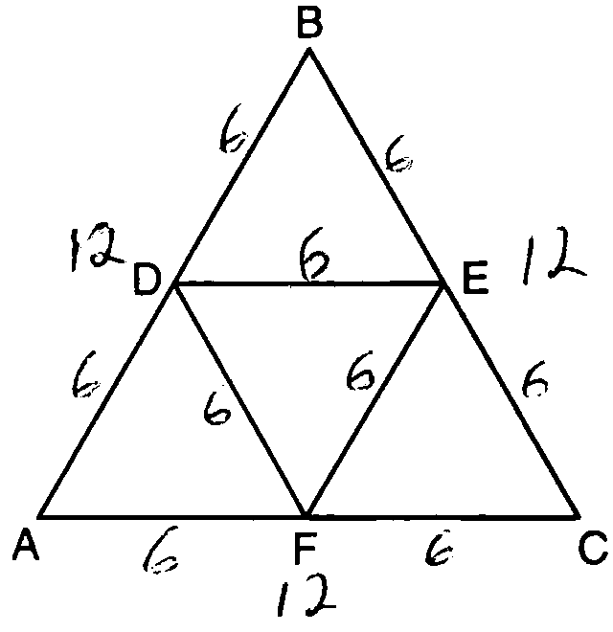

REF: 081003ge

4 ANS: 3
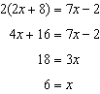 . Since is a midsegment, 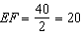. Since is equilateral, 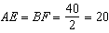.

REF: 061923geo

5 ANS: 3
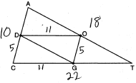

REF: 080920ge

6 ANS: 4
. 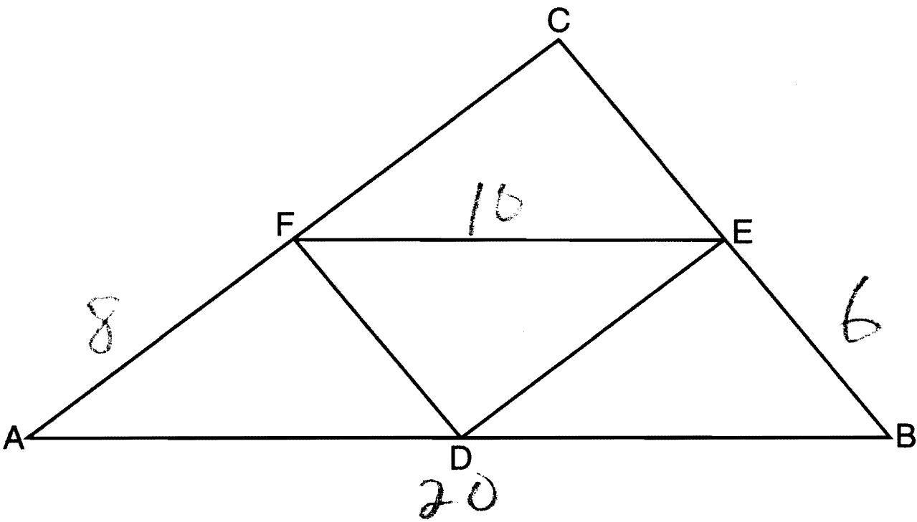

REF: 061211ge

7 ANS: 1
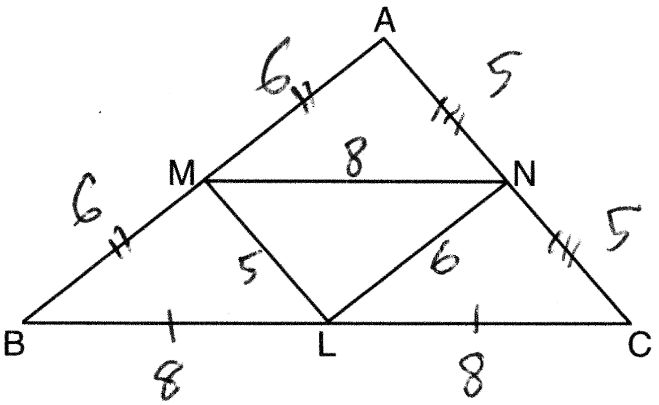

REF: 011413ge

8 ANS: 1
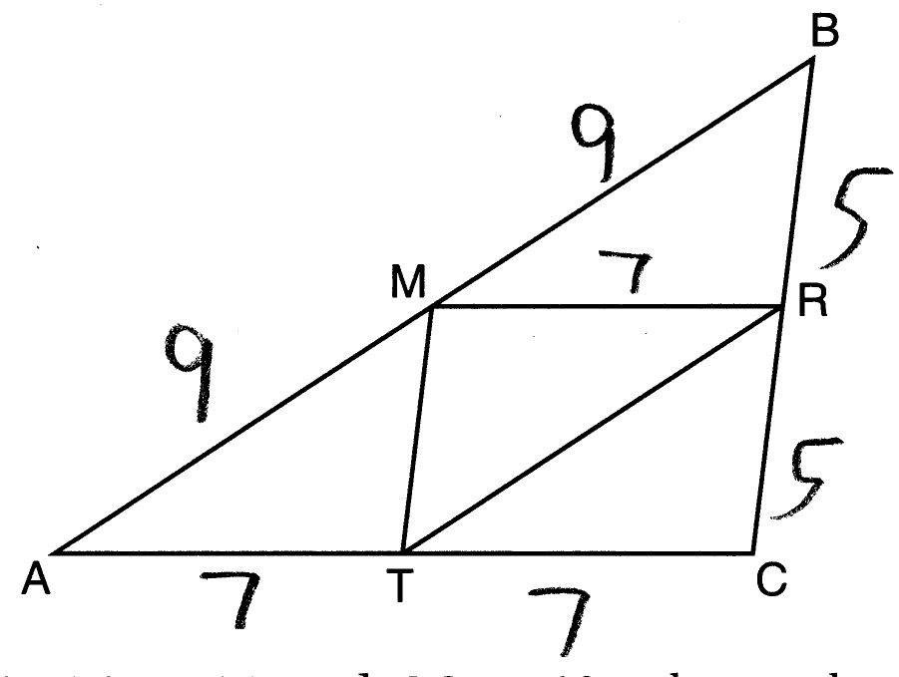

REF: 011611ge

9 ANS: 4 REF: 011704geo

10 ANS: 2
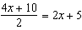

REF: 011103ge

11 ANS: 3
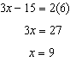

REF: 061311ge

12 ANS: 3 REF: 081320ge

13 ANS: 3
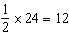

REF: 012009geo

14 ANS: 4
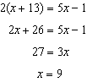

REF: 062322geo

15 ANS: 3 REF: 011311ge

16 ANS: 3 REF: 081227ge

17 ANS:
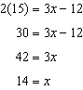

REF: 082429geo

18 ANS:
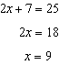

REF: 081531ge

19 ANS:
37. Since is a midsegment, .

REF: 061030ge

20 ANS:
20. The sides of the triangle formed by connecting the midpoints are half the sides of the original triangle. . 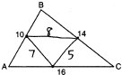

REF: 060929ge

21 ANS:
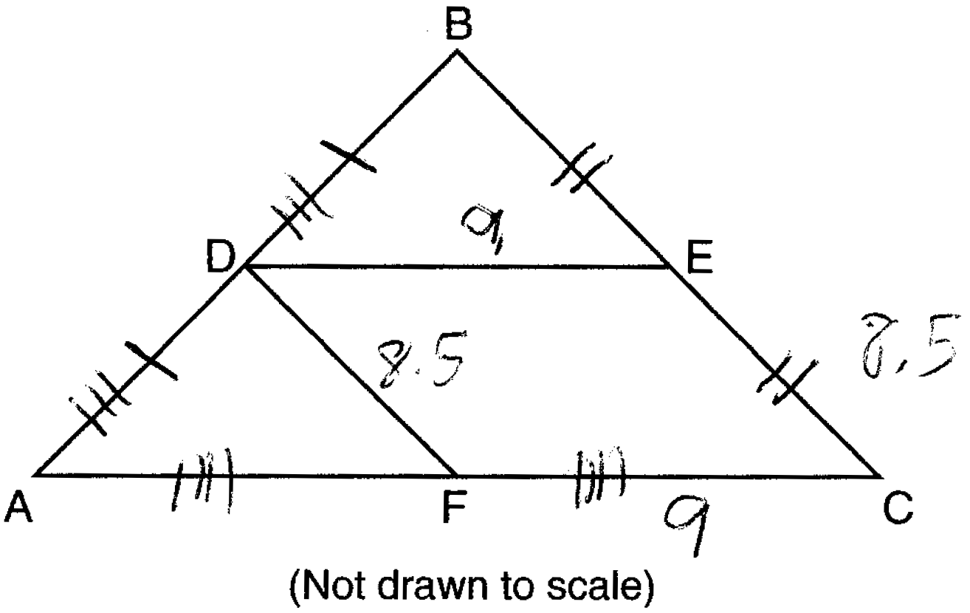

REF: 081430ge

22 ANS:
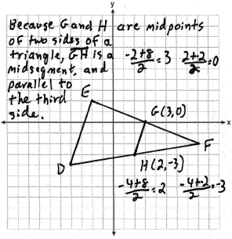

REF: fall0835ge

23 ANS:
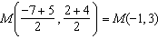. 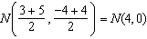. is a midsegment. 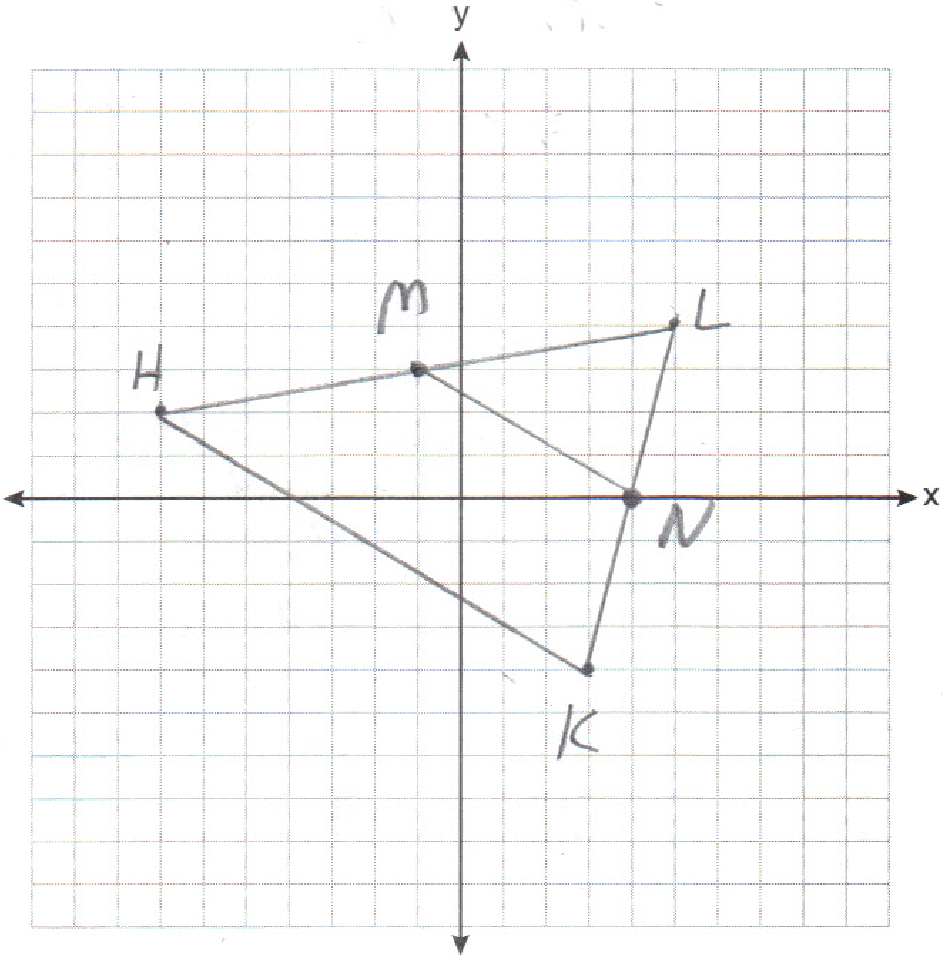

REF: 011237ge

