1 In the diagram of below, and . Line segment MS connects points M and S on the triangle, such that .

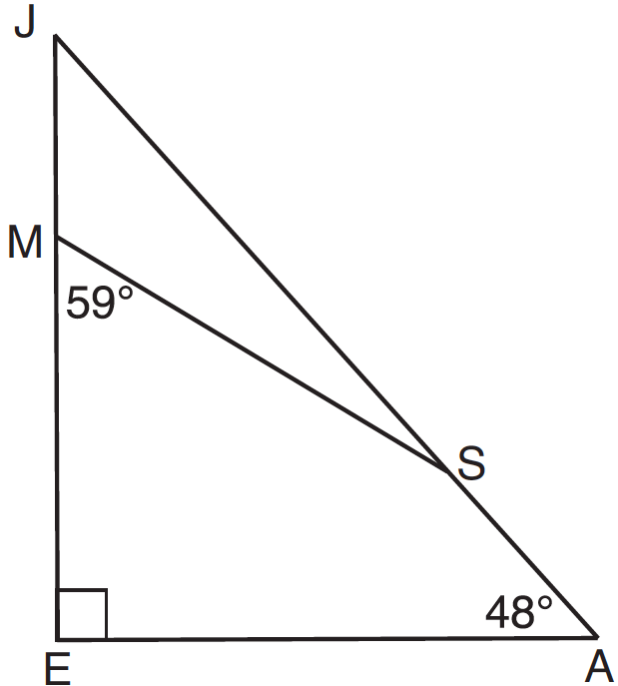

What is ?
1) | 163
2) | 121
3) | 42
4) | 17

2 The diagram below shows , with , , and .

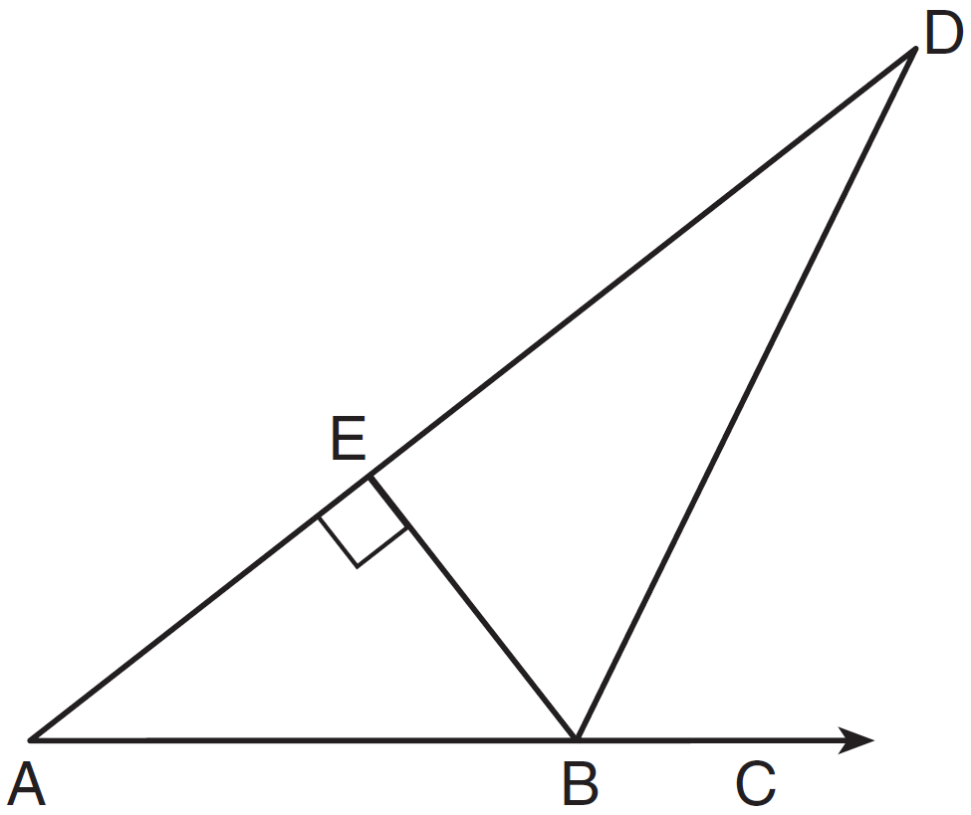

If , what is ?
1) | 26
2) | 38
3) | 52
4) | 64

3 In the diagram of below, is drawn to side .
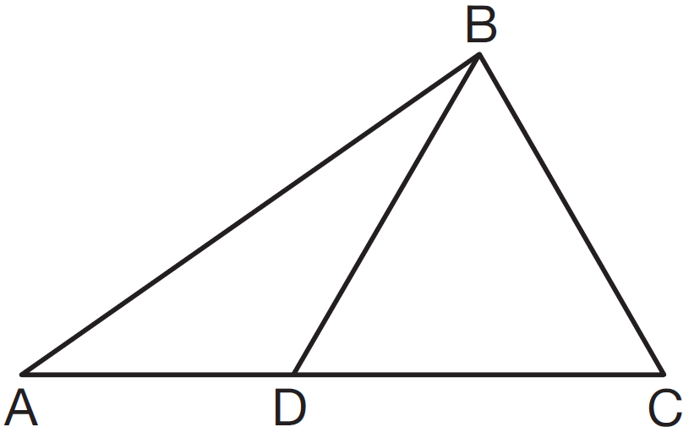
If , , and , which type of triangle is ?
1) | equilateral
2) | scalene
3) | obtuse
4) | right

4 What is the measure of the largest angle in the accompanying triangle?
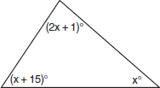
1) | 41
2) | 46.5
3) | 56
4) | 83

5 In which of the accompanying figures are segments XY and YZ perpendicular?
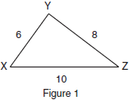

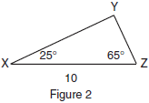
1) | figure 1, only
2) | figure 2, only
3) | both figure 1 and figure 2
4) | neither figure 1 nor figure 2

6 Juliann plans on drawing , where the measure of can range from 50° to 60° and the measure of can range from 90° to 100°. Given these conditions, what is the correct range of measures possible for ?
1) | 20° to 40°
2) | 30° to 50°
3) | 80° to 90°
4) | 120° to 130°

7 In , , , and . What is the value of x?
1) | 29
2) | 31
3) | 59
4) | 61

8 The angles of triangle ABC are in the ratio of . What is the measure of the smallest angle?
1) | 12º
2) | 24º
3) | 36º
4) | 72º

9 The measures of the angles of a triangle are in the ratio . In degrees, the measure of the largest angle of the triangle is
1) | 20
2) | 40
3) | 80
4) | 100

10 In , , , and . Which statement is true?
1)
2)
3)
4)

11 In , , , and . Which type of triangle is ?
1) | right
2) | scalene
3) | isosceles
4) | equilateral

12 In right triangle ABC, , , and . What type of right triangle is triangle ABC?
1) | scalene
2) | isosceles
3) | equilateral
4) | obtuse

13 If the measures of the angles of a triangle are represented by , , and , the triangle is
1) | an isosceles triangle
2) | a right triangle
3) | an acute triangle
4) | an equiangular triangle

14 If the measures, in degrees, of the three angles of a triangle are x, , and , the triangle must be
1) | isosceles
2) | equilateral
3) | right
4) | scalene

15 Triangle PQR has angles in the ratio of . Which type of triangle is ?
1) | acute
2) | isosceles
3) | obtuse
4) | right

16 Which phrase does not describe a triangle?
1) | acute scalene
2) | isosceles right
3) | equilateral equiangular
4) | obtuse right

17 In an equilateral triangle, what is the difference between the sum of the exterior angles and the sum of the interior angles?
1) | 180°
2) | 120°
3) | 90°
4) | 60°

18 A billboard on level ground is supported by a brace, as shown in the accompanying diagram. The measure of angle A is 15° greater than twice the measure of angle B. Determine the measure of angle A and the measure of angle B.

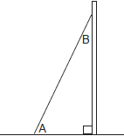

19 The degree measures of the angles of are represented by x, 3x, and . Find the value of x.

20 In right , and is 12 degrees less than twice . Find .

21 In , the measure of angle A is fifteen less than twice the measure of angle B. The measure of angle C equals the sum of the measures of angle A and angle B. Determine the measure of angle B.

22 In , the measure of is 21 less than four times the measure of , and the measure of is 1 more than five times the measure of . Find the measure, in degrees, of each angle of .

23 The measures of the angles of a triangle are in the ratio . Determine the measure, in degrees, of the smallest angle of the triangle.
1 ANS: 4 REF: 081206ge

2 ANS: 1
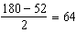.

REF: 011314ge

3 ANS: 1
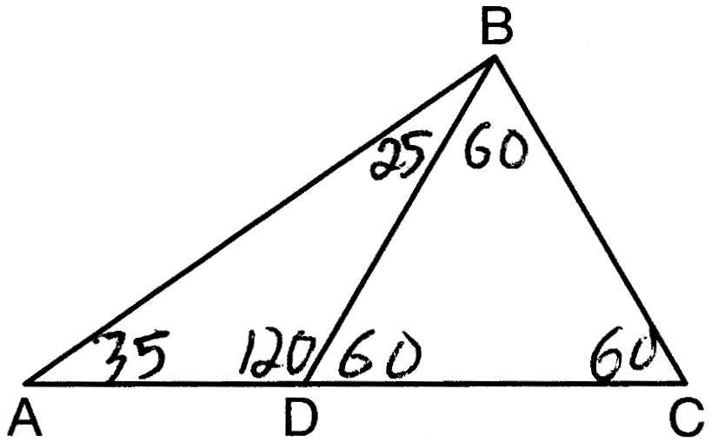

REF: 011504ge

4 ANS: 4
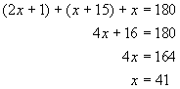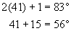

REF: 080216a

5 ANS: 3
Because the sides of the triangle in Figure 1 are 6, 8 and 10, which is a multiple of a Pythagorean triple, the triangle is a right triangle. The side with a length of 10 is longest and is the hypotenuse. Angle Y is a right angle because it is opposite the hypotenuse. Therefore segments XY and YZ are perpendicular in Figure 1. In Figure 2, the sum of the two angles equals 90°, so the third angle, Y, must equal 90°. Therefore segments XY and YZ are perpendicular in Figure 2.

REF: 010119a

6 ANS: 1
If is at minimum (50°) and is at minimum (90°), is at maximum of 40° (180° - (50° + 90°)). If is at maximum (60°) and is at maximum (100°), is at minimum of 20° (180° - (60° + 100°)).

REF: 060901ge

7 ANS: 1
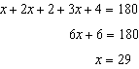

REF: 011002ge

8 ANS: 3
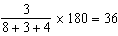

REF: 011210ge

9 ANS: 3
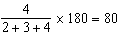

REF: 061404ge

10 ANS: 1
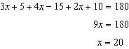. . .

REF: 061119ge

11 ANS: 3
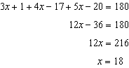. 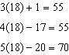

REF: 061308ge

12 ANS: 1
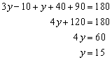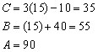

REF: 010102a

13 ANS: 1
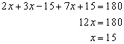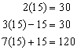

REF: 010722a

14 ANS: 4
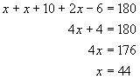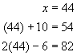

REF: 010810a

15 ANS: 4
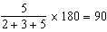

REF: 081119ge

16 ANS: 4
If a triangle has a right angle, neither of the other angles can be obtuse.

REF: 060417a

17 ANS: 1
In an equilateral triangle, each interior angle is 60° and each exterior angle is 120° (180° - 120°). The sum of the three interior angles is 180° and the sum of the three exterior angles is 360°.
REF: 060909ge

18 ANS:
. 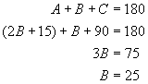. 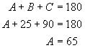
REF: 080837a

19 ANS:
26. 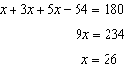
REF: 080933ge

20 ANS:
34. 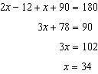
REF: 061031ge

21 ANS:
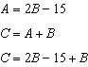. 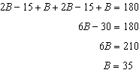
REF: 081332ge

22 ANS:
. 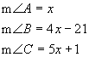. 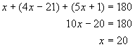. 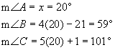
REF: 010538a

23 ANS:
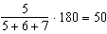
REF: 061529ge

