1 In the diagram below of , is a median to , and .
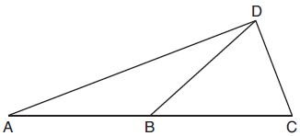
If , what is ?
1) | 32º
2) | 52º
3) | 58º
4) | 64º

2 In the diagram below, divides and proportionally, , , and bisects .
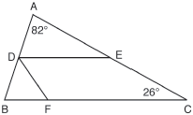
The measure of angle is
1) | 36°
2) | 54°
3) | 72°
4) | 82°

3 In the diagram below of triangle MNO, and are bisected by and , respectively. Segments MS and intersect at T, and .
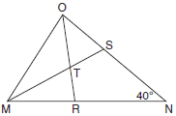
If , the measure of angle OTS is
1) | 40º
2) | 50º
3) | 60º
4) | 70º

4 In the diagram of below, bisects angle BAC, and altitude is drawn.

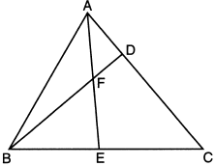

If and , is
1) | 35º
2) | 40º
3) | 55º
4) | 85º

5 In the diagram below of , is drawn, bisects , and .

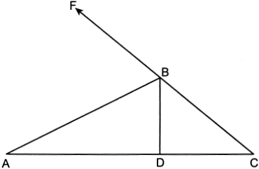

If what is ?
1) | 24º
2) | 33º
3) | 48º
4) | 66º

6 In the diagram below, , , and .

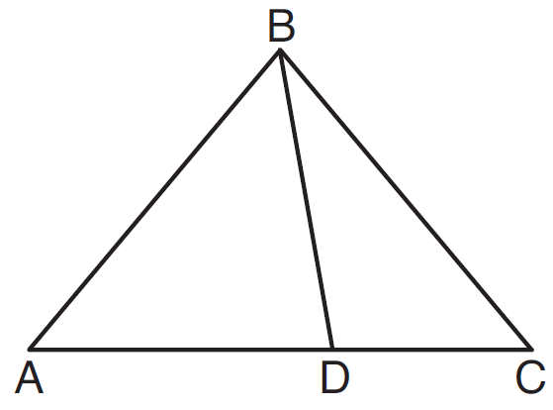

Which statement is true?
1) | is obtuse.
2) | is isosceles.
3)
4) | is scalene.

1 ANS: 3
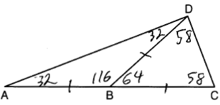
REF: 081905geo

2 ANS: 2
; ; ; 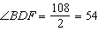;
REF: 061710geo

3 ANS: 4
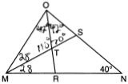
REF: 061717geo

4 ANS: 4
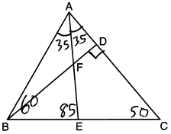
REF: 012305geo

5 ANS: 1
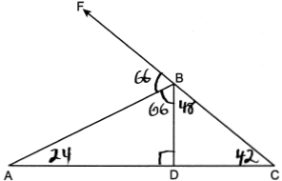
REF: 062410geo

6 ANS: 2
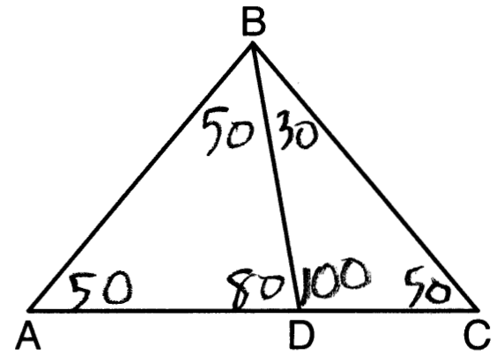
REF: 081604geo

