1 In the accompanying diagram of , is extended to D, exterior angle CBD measures 145°, and .

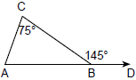

What is ?
1) | 35
2) | 70
3) | 110
4) | 220

2 In the diagram below, and . What is ?

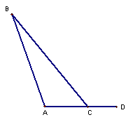
1) | 50
2) | 70
3) | 110
4) | 150

3 In the accompanying diagram of , is extended through D, , and .

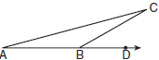

What is the measure of ?
1) | 15°
2) | 30°
3) | 75°
4) | 150°

4 Triangle ABC, with side extended to D, is shown in the accompanying diagram. If and , what is ?

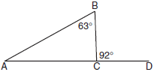

5 In the accompanying diagram of , , , and side is extended to A and to E. Find .

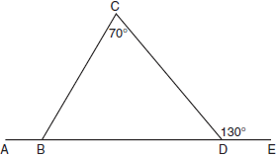

6 In the accompanying diagram of isosceles triangle ABC, , and exterior angle . What is ?

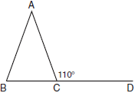

7 In the accompanying diagram of , is an equilateral triangle and . What is the value of x, in degrees?

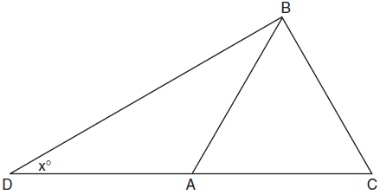

8 In the accompanying diagram, is a straight line, and angle E in triangle BEC is a right angle.

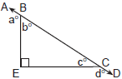

What does equal?
1) | 135°
2) | 160°
3) | 180°
4) | 270°

9 In the accompanying diagram, . From point E on , transversals and are drawn, intersecting at H and I, respectively.

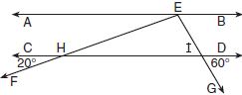

If and , what is ?
1) | 60
2) | 80
3) | 100
4) | 120

1 ANS: 2
If then because the angles are supplementary. Since the measure of the three interior angles must equal 180,
REF: 069912a

2 ANS: 3 REF: spring9810a

3 ANS: 1
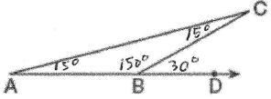
REF: 010613a

4 ANS:
29. If then because the angles are supplementary. Since the measure of the three interior angles must equal 180,
REF: 080121a

5 ANS: 120. If then because the angles are supplementary. Since the measure of the three interior angles must equal 180, Therefore because the angles are supplementary.
REF: 060431a

6 ANS:
40. 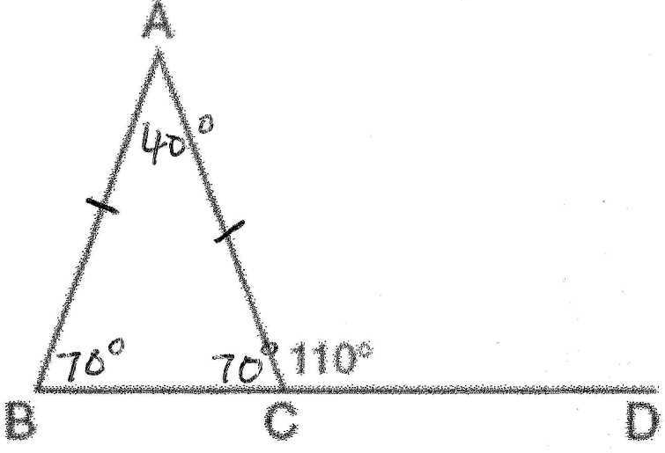
REF: 080734a

7 ANS:
30. 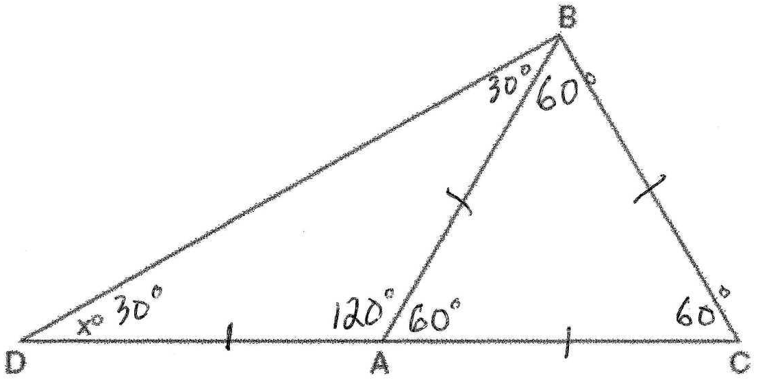
REF: 080221a

8 ANS: 4 Because angle E is a right angle, the sum of b° + c° equals 90°. The sum of a° + b° equals 180° and the sum of c° + d° equals 180° because the angles are supplementary. If a° + b° + c° + d° equals 360°, and b° + c° equals 90°, then a° + d° equals 270°.
REF: 010216a

9 ANS: 3 If then because they are vertical angles. If then because they are vertical angles. Because the sum of the interior angles equals 180º,
REF: 060606a

