1 In the diagram of below, , , and is extended through N.
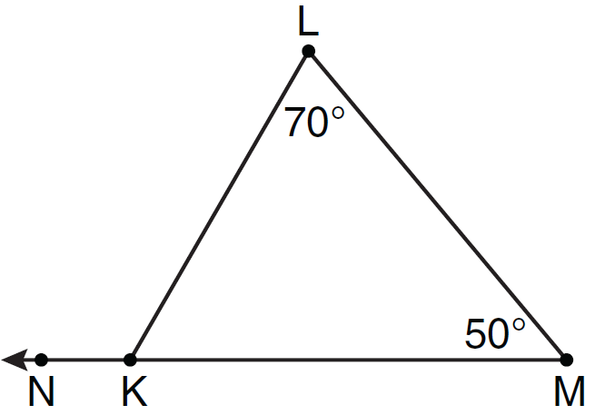
What is the measure of ?
1) | 60º
2) | 120º
3) | 180º
4) | 300º

2 In the diagram below, and are shown with and .
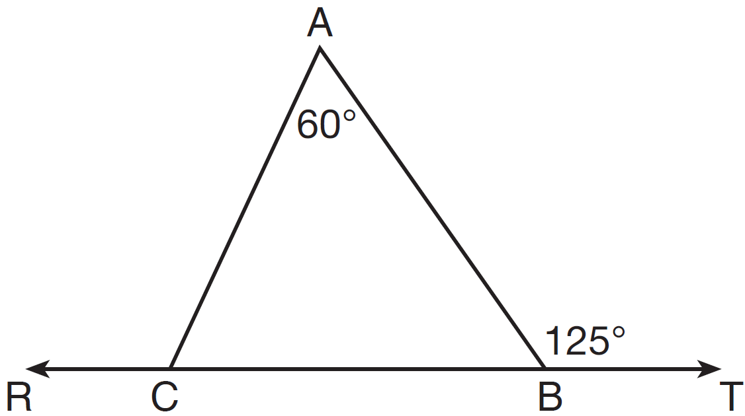
What is ?
1) | 125
2) | 115
3) | 65
4) | 55

3 Given with and side extended to D, as shown below.
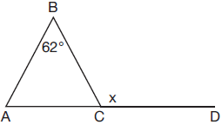
Which value of x makes ?
1) | 59º
2) | 62º
3) | 118º
4) | 121º

4 The measure of one of the base angles of an isosceles triangle is 42°. The measure of an exterior angle at the vertex of the triangle is
1) | 42°
2) | 84°
3) | 96°
4) | 138°

5 In , and an exterior angle at vertex H has a measure of 104. What is ?
1) | 34
2) | 62
3) | 76
4) | 146

6 In the diagram below of , side is extended to point D, , , and .
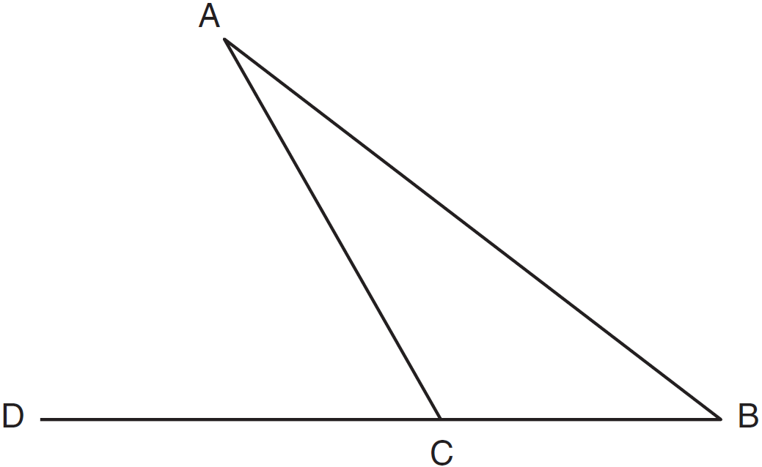
What is ?
1) | 5
2) | 20
3) | 25
4) | 55

7 In the diagram of below, is extended to point D.
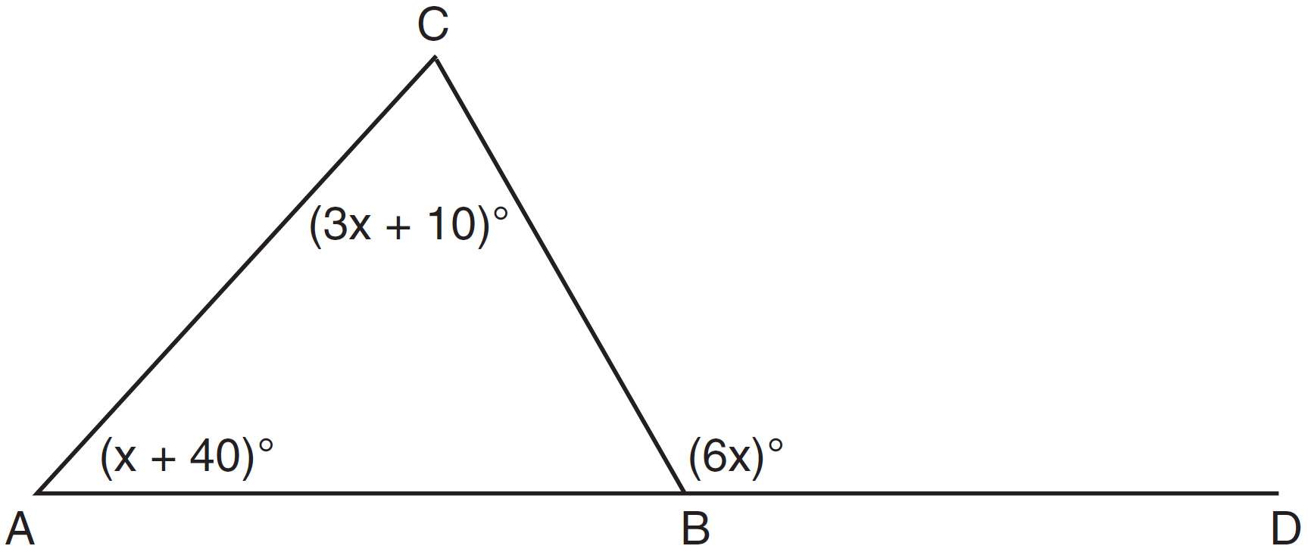
If , , , what is ?
1) | 13
2) | 25
3) | 53
4) | 65

8 In the diagram below, is shown with extended through point D.

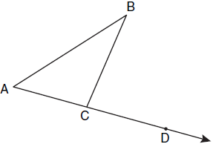

If , , and , what is the value of x?
1) | 12
2) | 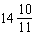
3) | 16
4)

9 In the diagram below of , side is extended through P to T, , , and . Find .

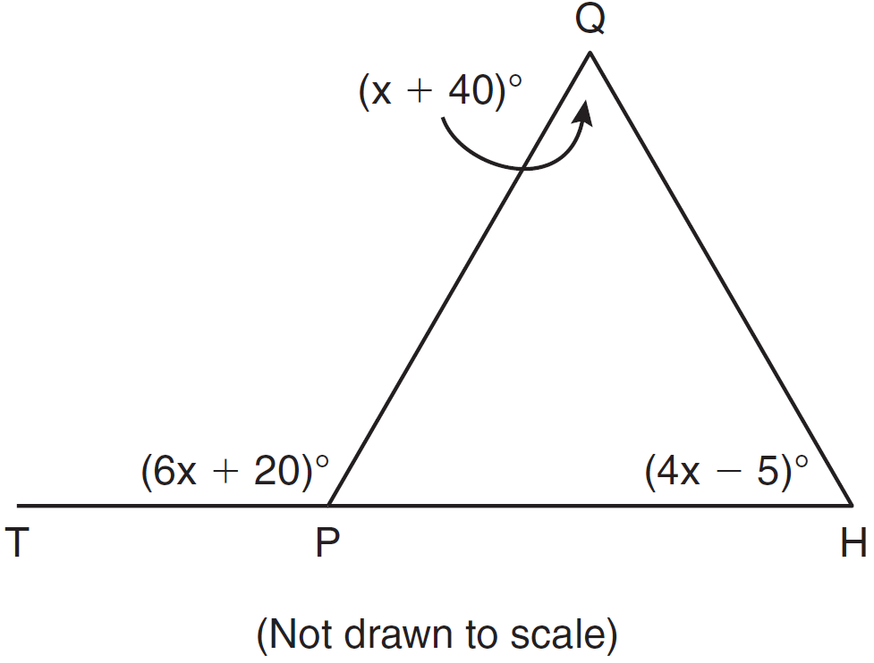

10 In shown below, side is extended to point D with , , and .
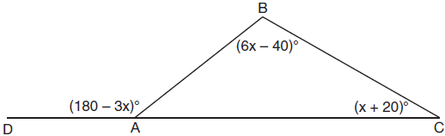
What is ?
1) | 20º
2) | 40º
3) | 60º
4) | 80º

11 In the diagram below of , is extended to D.
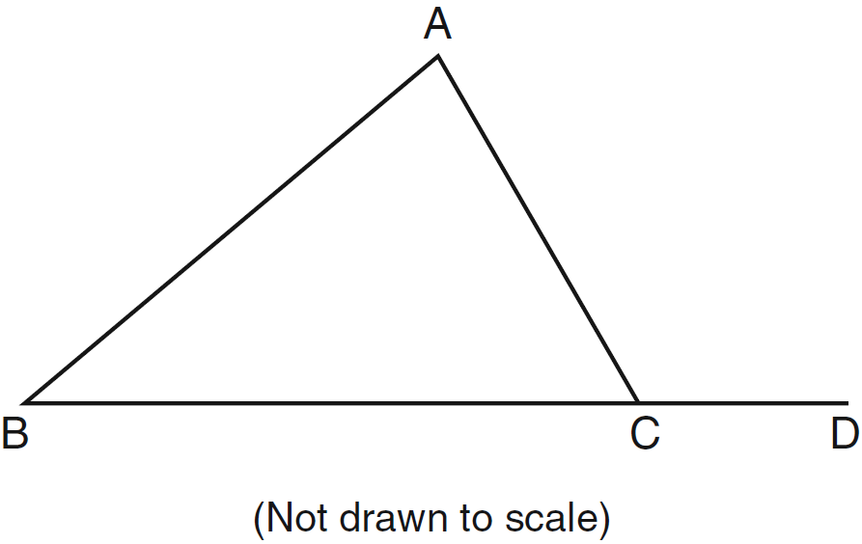
If , , and , what is the value of x?
1) | 10
2) | 2
3) | 3
4) | 15

12 In the diagram of shown below, is extended to S, , , and .
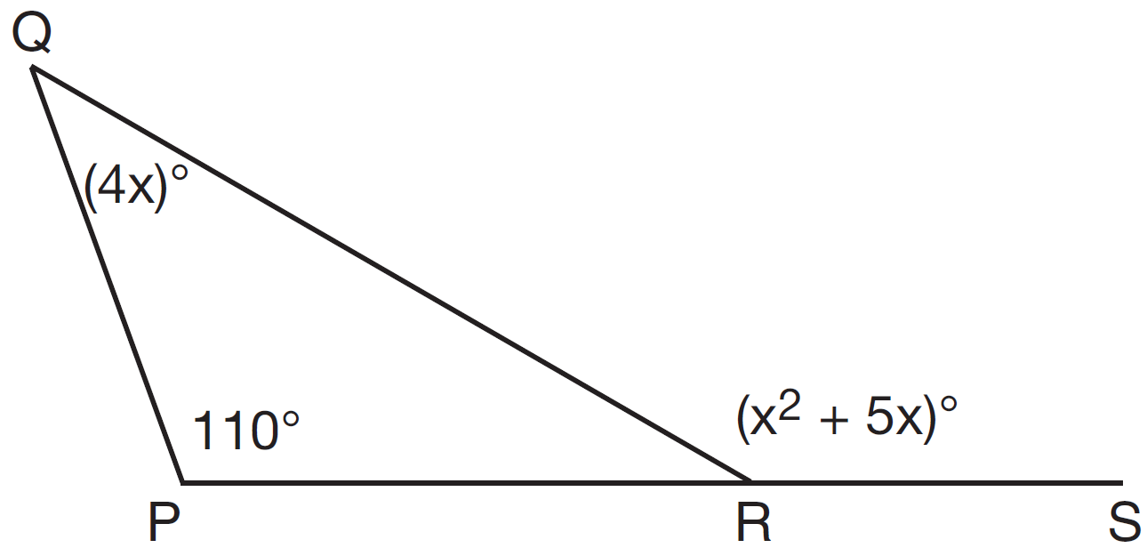
What is ?
1) | 44
2) | 40
3) | 11
4) | 10

13 In , and . If is extended through point B to point D, . What is the value of x?
1) | 25
2) | 30
3) | 40
4) | 46

14 In the diagram below of triangle ABC, is extended through point C to point D, and is drawn to .

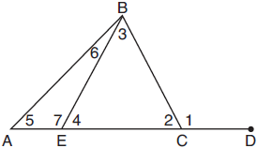

Which equation is always true?
1)
2)
3)
4)

15 In the diagram below of , side is extended to point A.

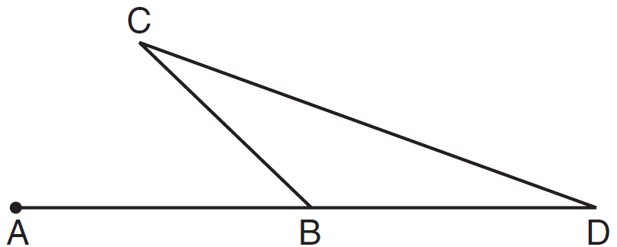

Which statement must be true?
1)
2)
3)
4)

16 Side of is extended through Q to point T. Which statement is not always true?
1)
2)
3)
4)

17 In , an exterior angle at C measures 50º. If . which inequality must be true?
1)
2)
3)
4)

18 In all isosceles triangles, the exterior angle of a base angle must always be
1) | a right angle
2) | an acute angle
3) | an obtuse angle
4) | equal to the vertex angle

19 If one exterior angle of a triangle is acute, then the triangle must be
1) | right
2) | acute
3) | obtuse
4) | equiangular

1 ANS: 2 REF: 061107ge

2 ANS: 2
, so
REF: 011414ge

3 ANS: 4
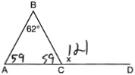
REF: 081711geo

4 ANS: 2
REF: 062317geo

5 ANS: 2 REF: 011206ge

6 ANS: 3
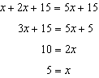
REF: 011127ge

7 ANS: 4
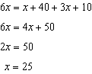.
REF: 081310ge

8 ANS: 1
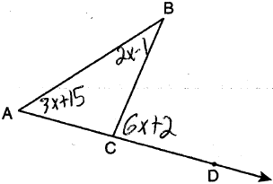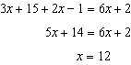
REF: 011021ge

9 ANS:
110. 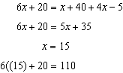
REF: 081031ge

10 ANS: 3
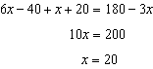
REF: 011809geo

11 ANS: 4
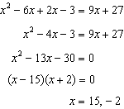
REF: 061225ge

12 ANS: 2
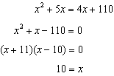
REF: 061425ge

13 ANS: 3
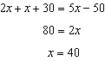
REF: 011615ge

14 ANS: 4 REF: 011916geo

15 ANS: 3 REF: 081111ge

16 ANS: 4
(4) is not true if is obtuse.
REF: 060924ge

17 ANS: 1 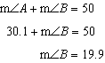
REF: 081424ge

18 ANS: 3 REF: 061508ge

19 ANS: 3 REF: 062215geo

