1 Which geometric principle is used in the construction shown below?

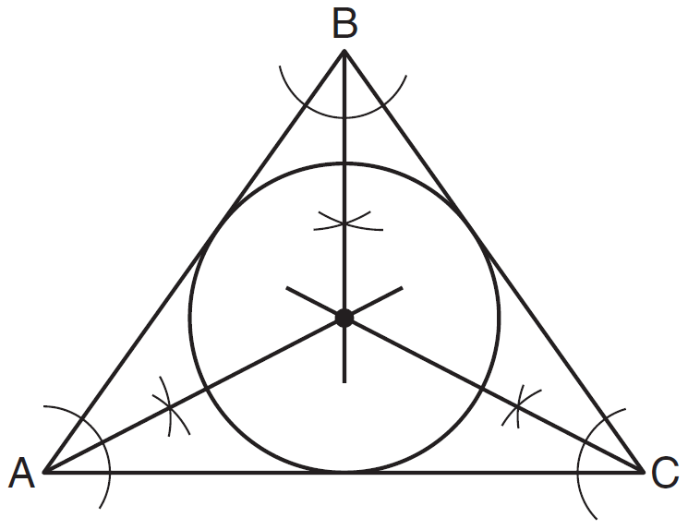
1) | The intersection of the angle bisectors of a triangle is the center of the inscribed circle.
2) | The intersection of the angle bisectors of a triangle is the center of the circumscribed circle.
3) | The intersection of the perpendicular bisectors of the sides of a triangle is the center of the inscribed circle.
4) | The intersection of the perpendicular bisectors of the sides of a triangle is the center of the circumscribed circle.

2 In the diagram below of , is the bisector of , is the bisector of , and is drawn.
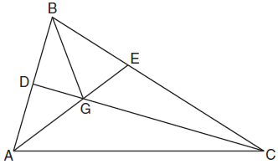

Which statement must be true?
1)
2)
3)
4)

3 In the diagram below, point B is the incenter of , and , , and are drawn.
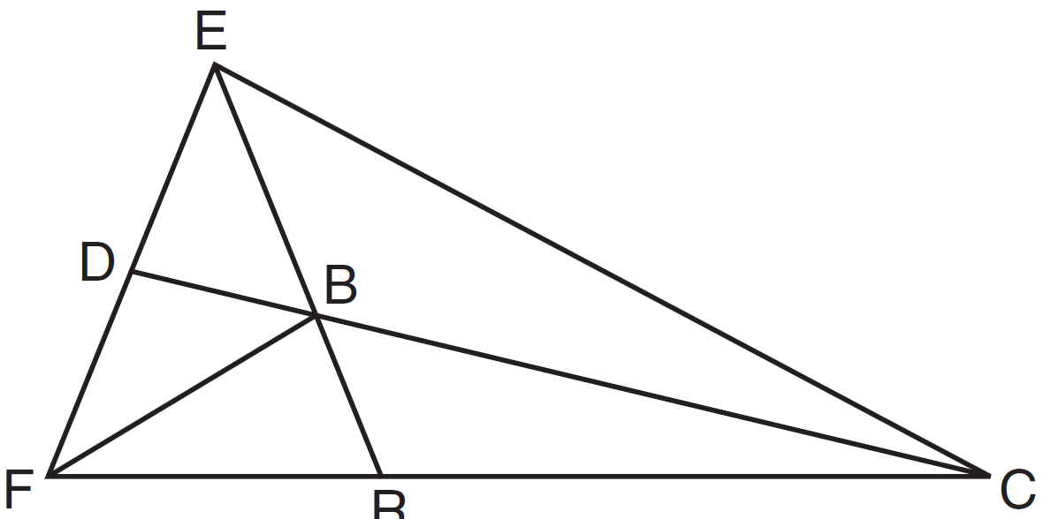

If and , determine and state .

4 In the diagram below of isosceles triangle ABC, and angle bisectors , , and are drawn and intersect at X.

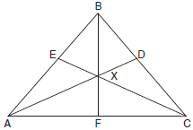

If , find .

5 The diagram below shows the construction of the center of the circle circumscribed about .

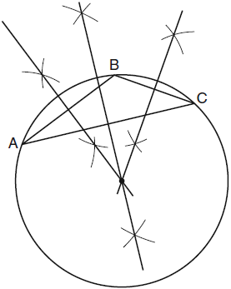

This construction represents how to find the intersection of
1) | the angle bisectors of
2) | the medians to the sides of
3) | the altitudes to the sides of
4) | the perpendicular bisectors of the sides of

6 If the altitudes of a triangle meet at one of the triangle’s vertices, then the triangle is
1) | a right triangle
2) | an acute triangle
3) | an obtuse triangle
4) | an equilateral triangle

7 In which triangle do the three altitudes intersect outside the triangle?
1) | a right triangle
2) | an acute triangle
3) | an obtuse triangle
4) | an equilateral triangle

8 For a triangle, which two points of concurrence could be located outside the triangle?
1) | incenter and centroid
2) | centroid and orthocenter
3) | incenter and circumcenter
4) | circumcenter and orthocenter

9 Triangle ABC is graphed on the set of axes below.
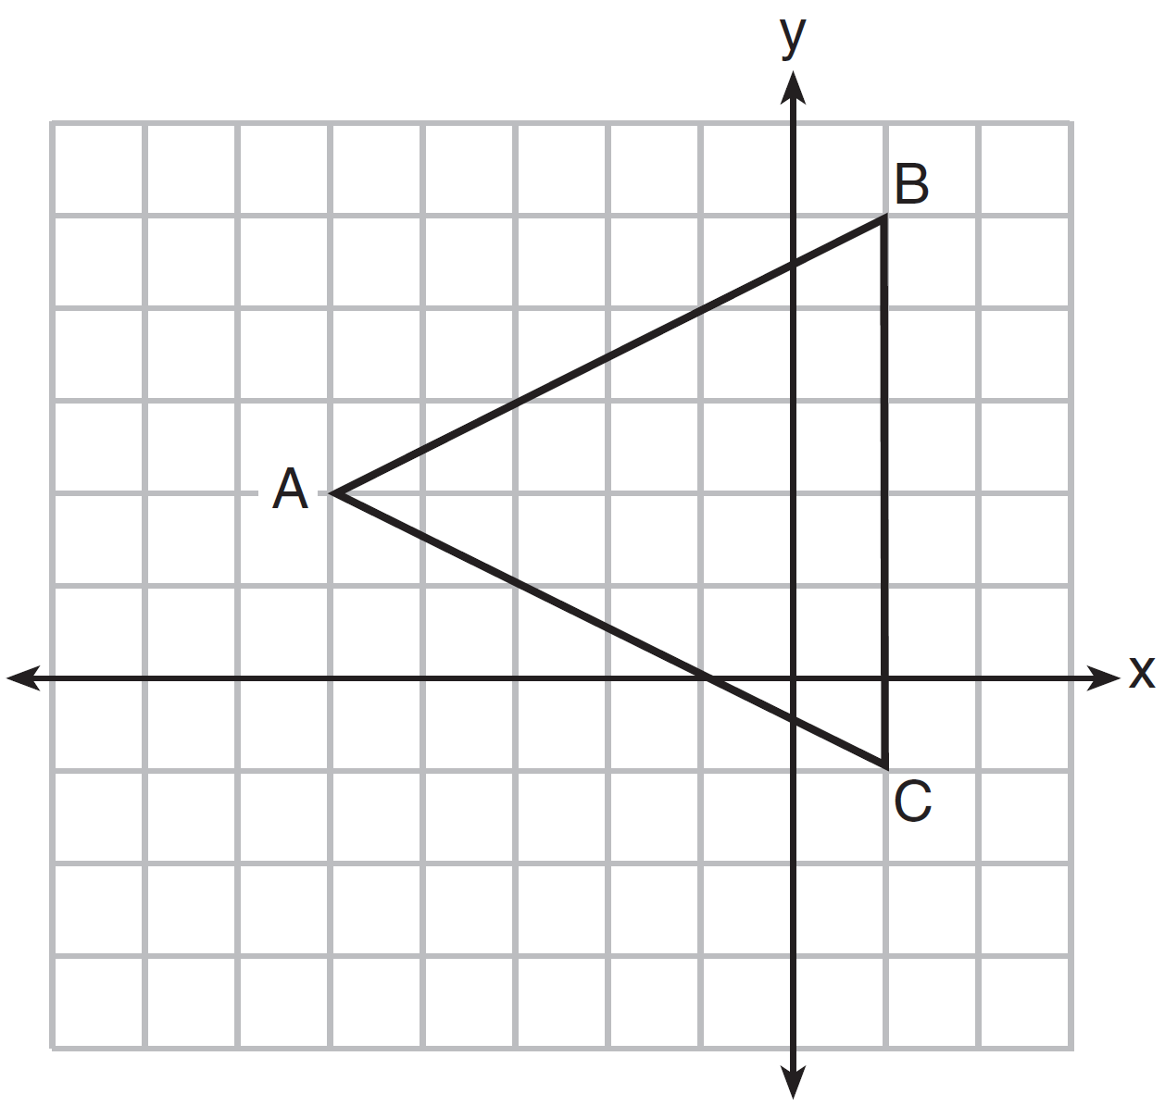

What are the coordinates of the point of intersection of the medians of ?
1)
2)
3)
4)

10 The vertices of the triangle in the diagram below are , , and .
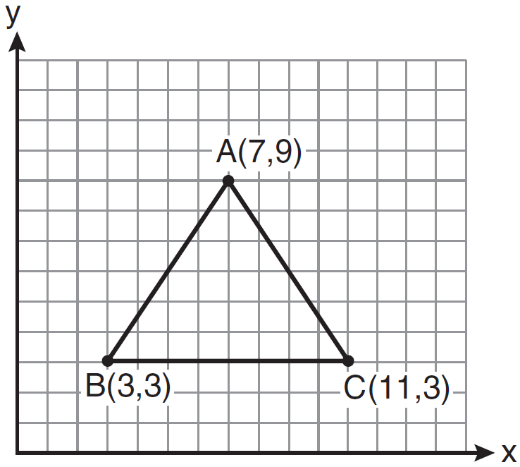

What are the coordinates of the centroid of ?
1)
2)
3)
4)

11 In a given triangle, the point of intersection of the three medians is the same as the point of intersection of the three altitudes. Which classification of the triangle is correct?
1) | scalene triangle
2) | isosceles triangle
3) | equilateral triangle
4) | right isosceles triangle

12 Triangle ABC has vertices , , and . Determine the point of intersection of the medians, and state its coordinates. [The use of the set of axes below is optional.]
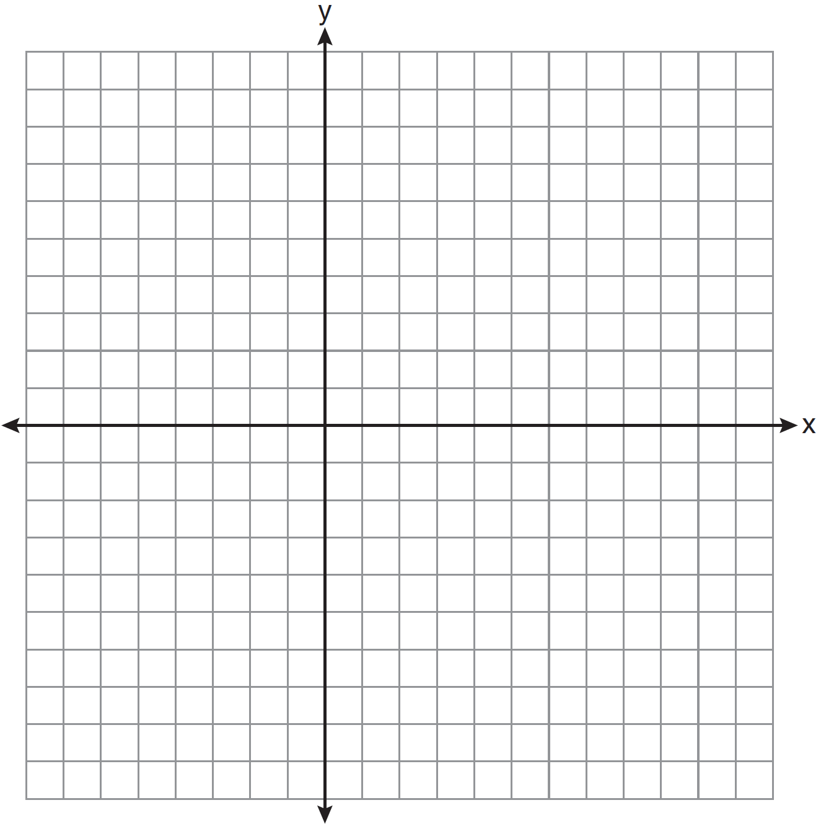

13 In the diagram below of , , , and .
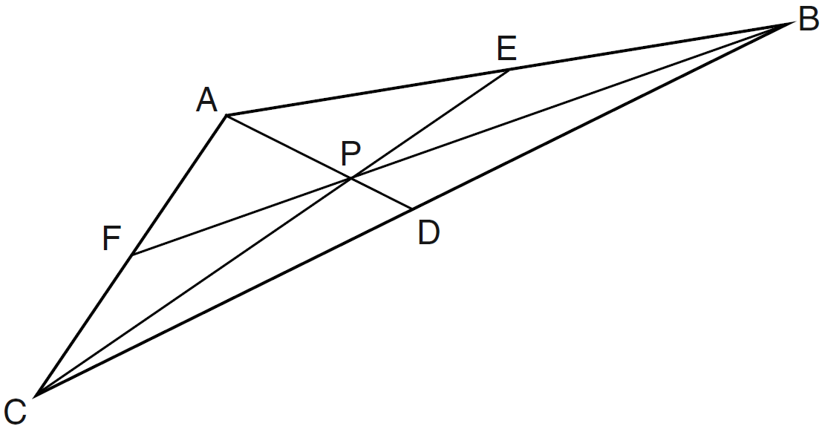
Point P must be the
1) | centroid
2) | circumcenter
3) | incenter
4) | orthocenter

14 In triangle SRK below, medians , , and intersect at M.
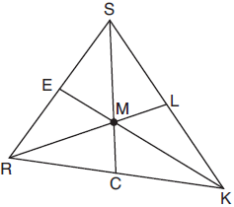
Which statement must always be true?
1)
2) | 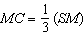
3)
4)

15 In the diagram below of , medians , , and intersect at G. The length of is 12 cm.
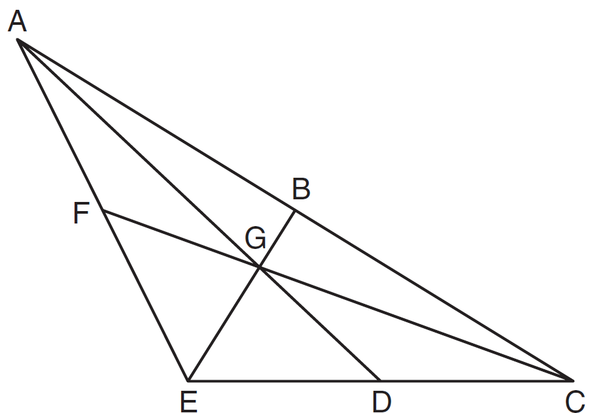
What is the length, in centimeters, of ?
1) | 24
2) | 12
3) | 6
4) | 4

16 In the diagram of below, medians and intersect at point F.
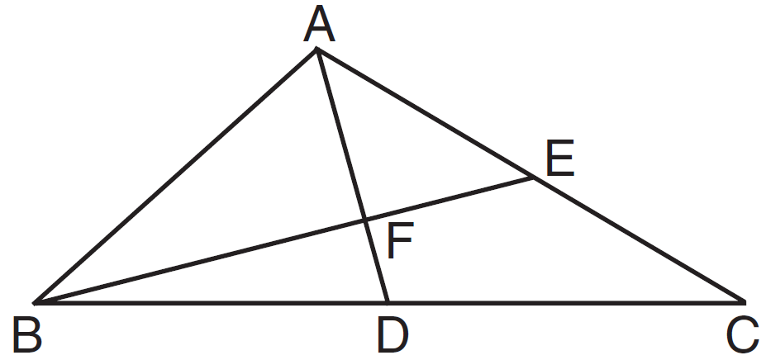
If , what is the length of ?
1) | 6
2) | 2
3) | 3
4) | 9

17 In shown below, P is the centroid and .
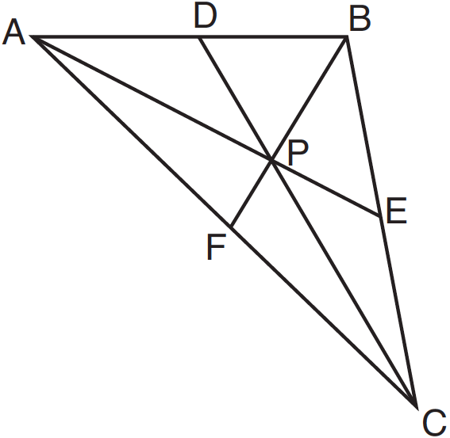
What is the length of ?
1) | 6
2) | 9
3) | 3
4) | 12

18 In the diagram below of , medians , , and intersect at G.

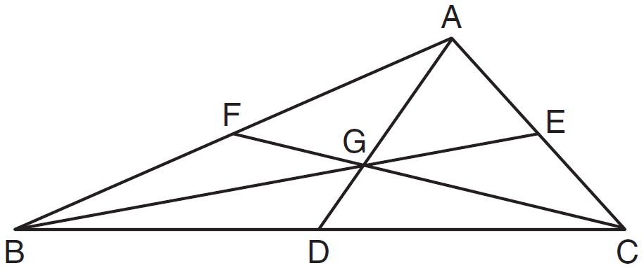

If , what is the length of ?
1) | 8
2) | 10
3) | 12
4) | 16

19 As shown below, the medians of intersect at D.

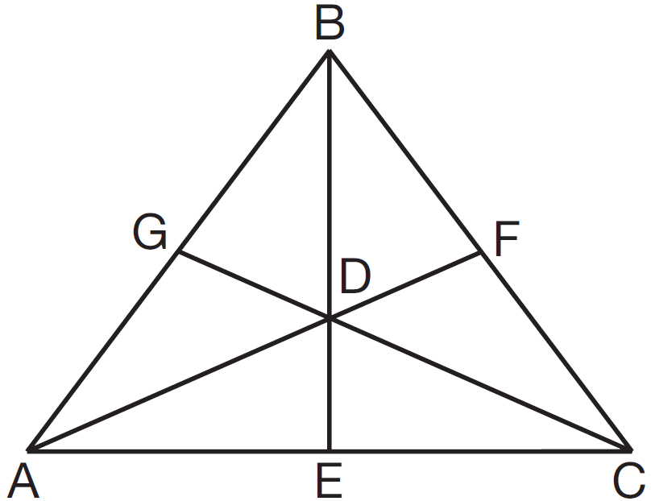

If the length of is 12, what is the length of ?
1) | 8
2) | 9
3) | 3
4) | 4

20 In the diagram below of , medians , , and intersect at O.

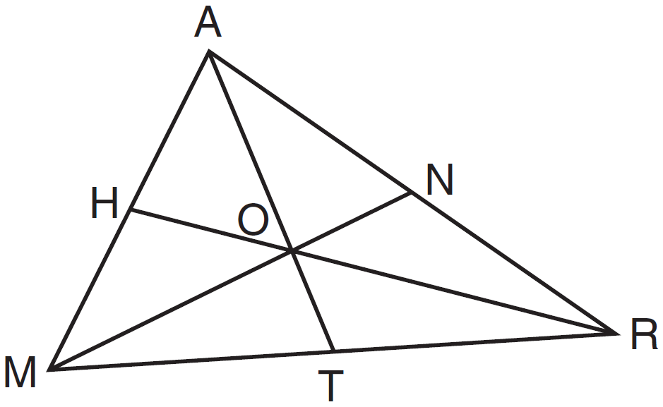

If , what is the length of ?
1) | 30
2) | 25
3) | 20
4) | 15

21 In the diagram below of , point H is the intersection of the three medians.
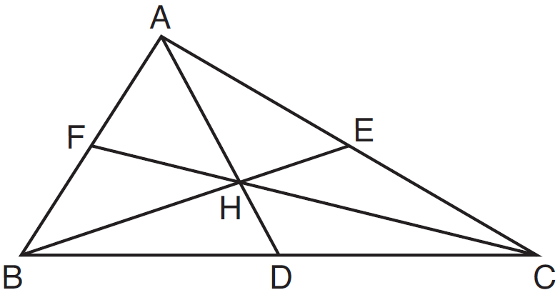
If measures 2.4 centimeters, what is the length, in centimeters, of ?
1) | 3.6
2) | 4.8
3) | 7.2
4) | 9.6

22 In the diagram of below, Jose found centroid P by constructing the three medians. He measured and found it to be 6 inches.
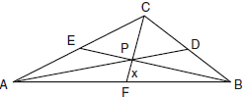

If , which equation can be used to find x?
1)
2)
3)
4) | 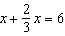

23 In shown below, medians , , and intersect at point R.

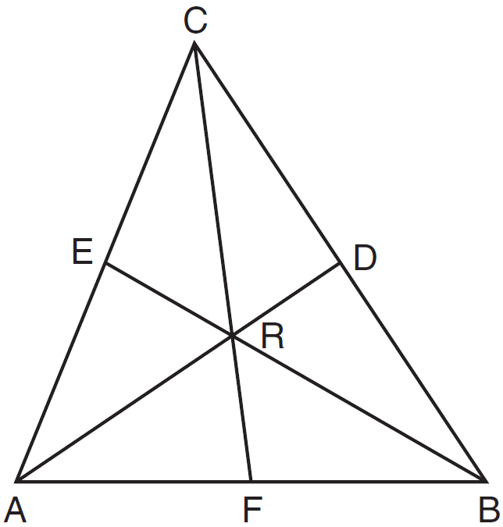

If and , what is the value of x?
1) | 9
2) | 12
3) | 15
4) | 27

24 In the diagram below, point P is the centroid of .

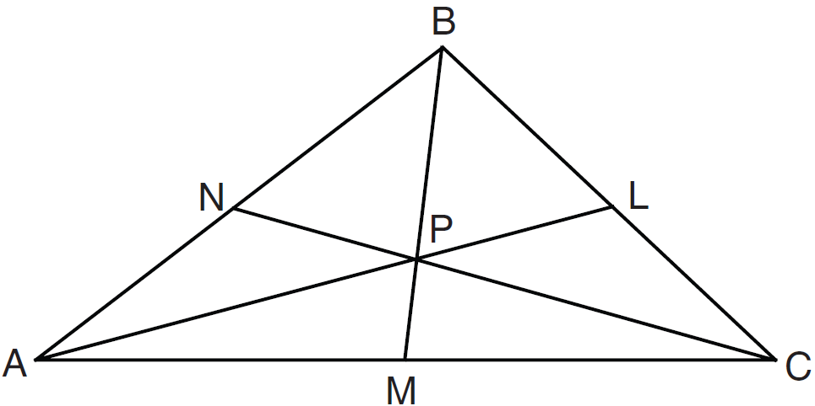

If and , what is the length of ?
1) | 9
2) | 2
3) | 18
4) | 27

25 The three medians of a triangle intersect at a point. Which measurements could represent the segments of one of the medians?
1) | 2 and 3
2) | 3 and 4.5
3) | 3 and 6
4) | 3 and 9

26 In the diagram below, has medians , , and that intersect at point P.

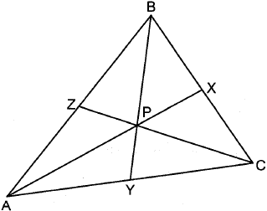

If , , and , what is the perimeter of ?
1) | 57
2) | 65
3) | 70
4) | 73

27 In the diagram below of , medians , , and intersect at D, and . Find the length of .

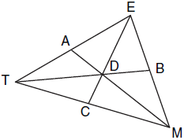

28 In the diagram below, is a median of triangle PQR and point C is the centroid of triangle PQR.

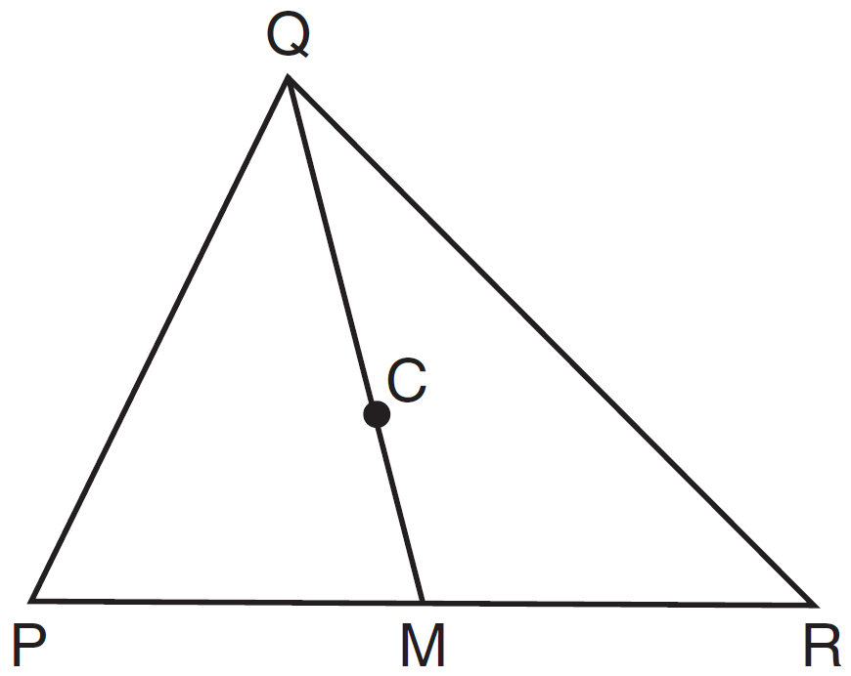

If and , determine and state the length of .

29 In , shown below, medians , , and intersect at C.

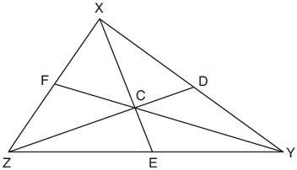

If , , and , determine and state the perimeter of triangle CFX.
1 ANS: 1 REF: 081028ge

2 ANS: 4
is also an angle bisector since it intersects the concurrence of and

REF: 061025ge

3 ANS:
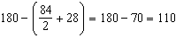

REF: 061534ge

4 ANS:

REF: 011730geo

5 ANS: 4 REF: 080925ge

6 ANS: 1 REF: 081904geo

7 ANS: 3 REF: fall0825ge

8 ANS: 4 REF: 081224ge

9 ANS: 1
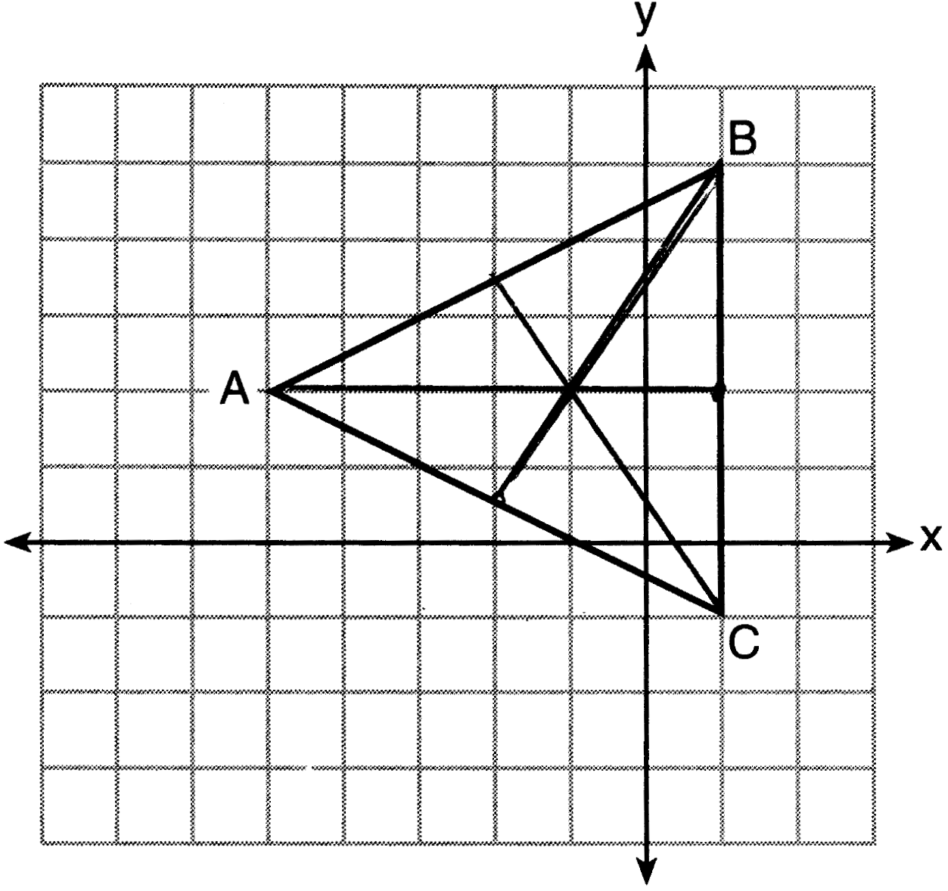

REF: 011516ge

10 ANS: 3 REF: 011110ge

11 ANS: 3 REF: 011202ge

12 ANS:
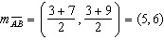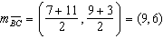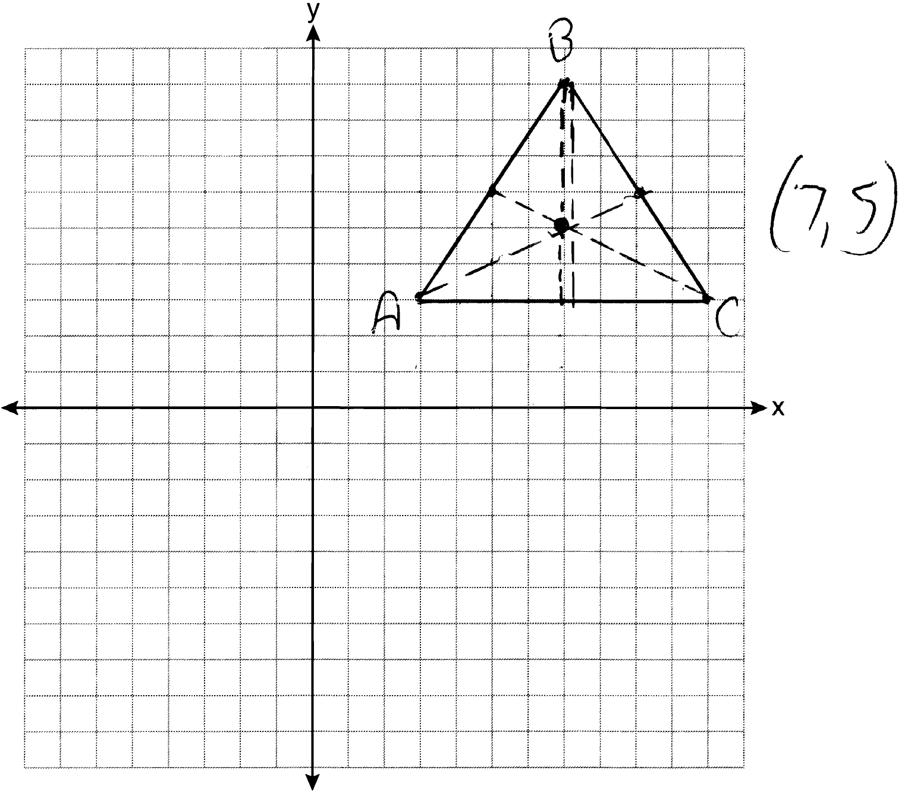

REF: 081134ge

13 ANS: 1 REF: 061214ge

14 ANS: 1
M is a centroid, and cuts each median .

REF: 061818geo

15 ANS: 1 REF: 061104ge

16 ANS: 3
The centroid divides each median into segments whose lengths are in the ratio 2 : 1.

REF: 081307ge

17 ANS: 4
The centroid divides each median into segments whose lengths are in the ratio 2 : 1.

REF: 081220ge

18 ANS: 1
The centroid divides each median into segments whose lengths are in the ratio 2 : 1. 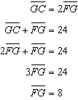

REF: 081018ge

19 ANS: 1
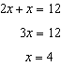.

REF: 011408ge

20 ANS: 1 REF: 061527ge

21 ANS: 3

REF: 081526ge

22 ANS: 2
The centroid divides each median into segments whose lengths are in the ratio 2 : 1.

REF: 060914ge

23 ANS: 1
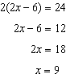

REF: 011619ge

24 ANS: 1
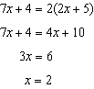.

REF: 011226ge

25 ANS: 3 REF: 061424ge

26 ANS: 2
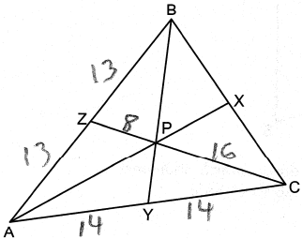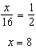

REF: 082408geo

27 ANS:
6. The centroid divides each median into segments whose lengths are in the ratio 2 : 1. and

REF: 011034ge

28 ANS:
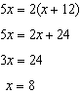

REF: 081433ge

29 ANS:
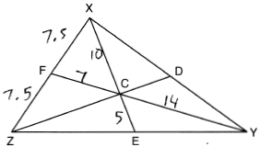

REF: 012030geo

