1 On the banks of a river, surveyors marked locations A, B, and C. The measure of and the measure of .

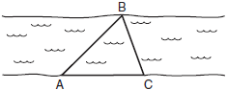

Which expression shows the relationship between the lengths of the sides of this triangle?
1) 2) 3) 4)

2 As shown in the diagram below of , is extended through D, , and .

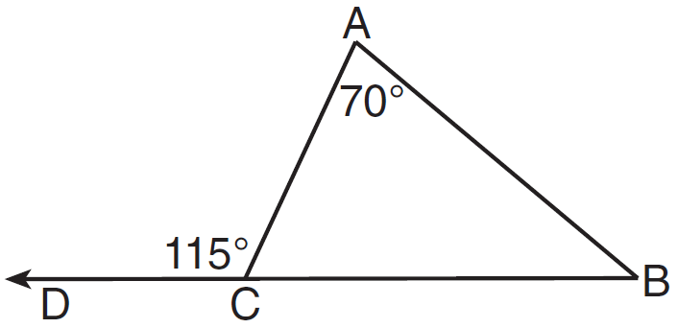

Which statement is true?
1) 2) 3) 4)

3 As shown in the diagram of below, B is a point on and is drawn.

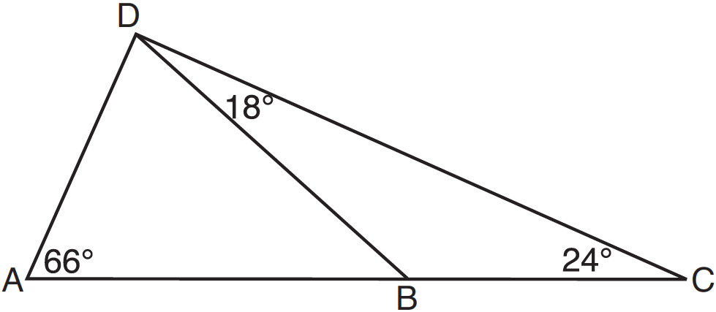

If , , and , what is the longest side of ?
1) 2) 3) 4)

4 In the diagram of quadrilateral NAVY below, , , , and .
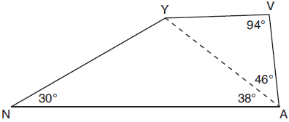
Which segment has the shortest length?
1) 2) 3) 4)

5 In , . Which statement is false?
1) 2) 3) 4)

6 In , , , and . Which inequality is true?
1) 2) 3) 4)

7 In , , , and . Which expression correctly relates the lengths of the sides of this triangle?
1) 2) 3) 4)

8 In , and . Which inequality is true?
1) 2) 3) 4)

9 In scalene triangle ABC, and . What is the order of the sides in length, from longest to shortest?
1) , , 2) , , 3) , , 4) , ,

10 In , and is greater than . The lengths of the sides of in order from smallest to largest are
1) , , 2) , , 3) , , 4) , ,

11 For which measures of the sides of is angle B the largest angle of the triangle?
1) 2) 3) 4)

12 In , side is extended through C to D. If and , what is the longest side of ?
1) 2) 3) 4)

13 In , , , and B is a point on side , such that . Which line segment is shortest?
1) 2) 3) 4)

14 In , and is an obtuse angle. Which statement is true?
1) and is the longest side. 2) and is the longest side. 3) and is the shortest side. 4) and is the shortest side.

15 In , , , and . Which list has the angles of in order from smallest to largest?
1) 2) 3) 4)

16 In , , , and . Which statement about the angles of must be true?
1) 2) 3) 4)

17 In , , , and . Which statement is true?
1) 2) 3) 4)

18 In the diagram below of with side extended through D, and . Which side of is the longest side? Justify your answer.

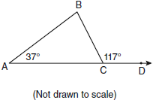

19 As shown in the diagram below, is a diagonal of trapezoid STAR, , , , and .
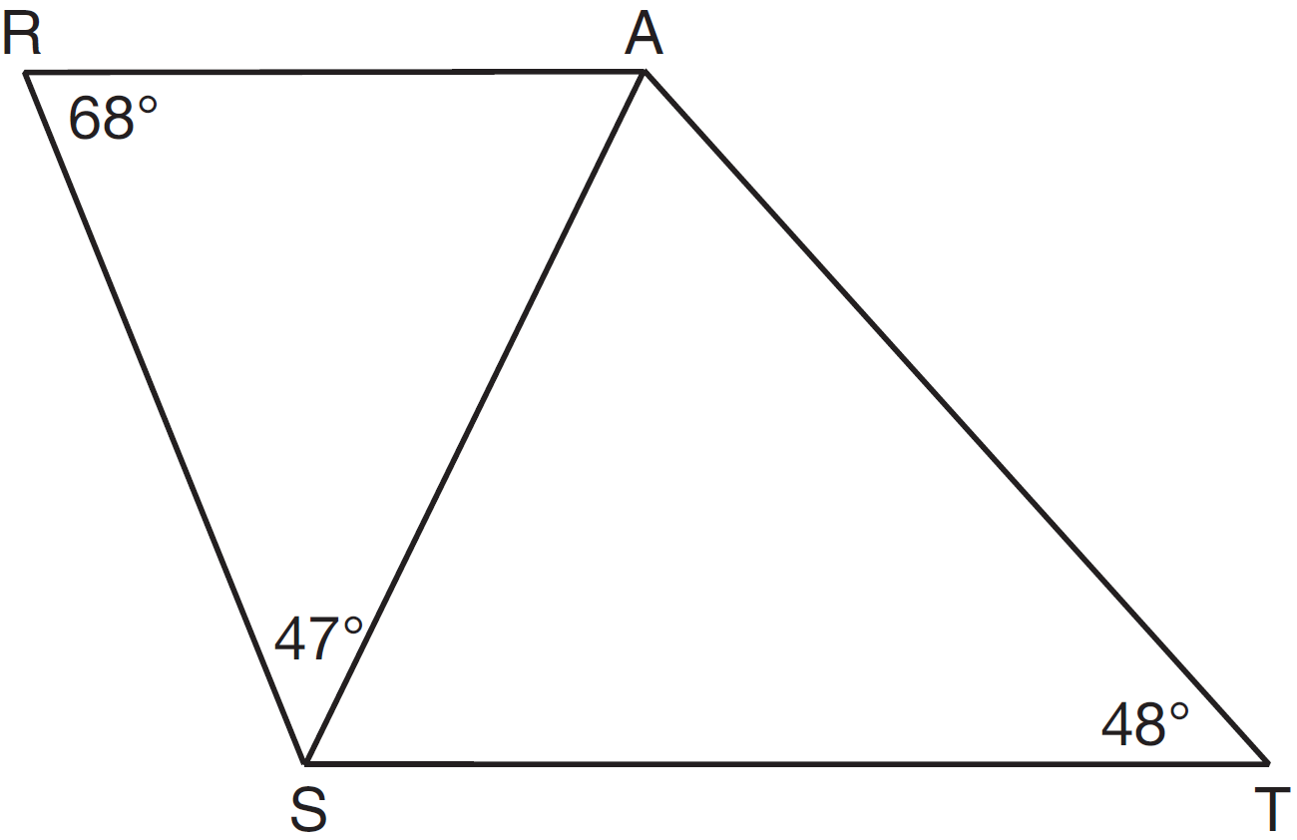

Determine and state the longest side of .

20 In , , , and . Determine the longest side of .
1 ANS: 3
If and then because The longest side is opposite the largest angle and the shortest side is opposite the smallest angle. BC < AC < AB

REF: 060629a

2 ANS: 4 REF: 011607ge

3 ANS: 1
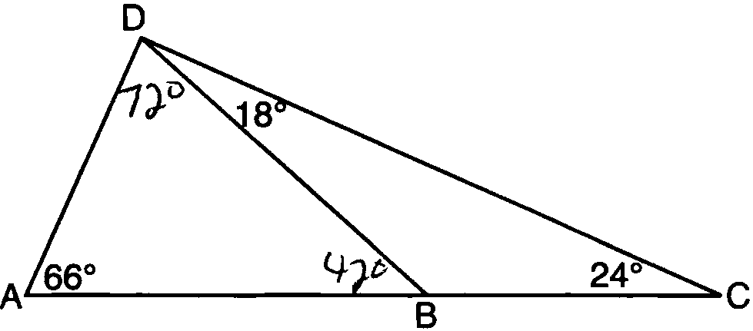

REF: 081219ge

4 ANS: 3
is the smallest angle in , so side is the shortest side of . is the smallest angle in , so side is the shortest side of both triangles.

REF: 011919geo

5 ANS: 1 REF: 081524ge

6 ANS: 2 REF: 061321ge

7 ANS: 2
Longest side of a triangle is opposite the largest angle. Shortest side is opposite the smallest angle.

REF: 060911ge

8 ANS: 4 REF: 011222ge

9 ANS: 4

REF: 011115ge

10 ANS: 1 REF: 061523ge

11 ANS: 1 REF: 011416ge

12 ANS: 1
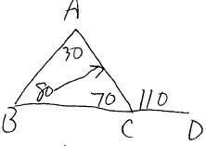

REF: 082310geo

13 ANS: 2
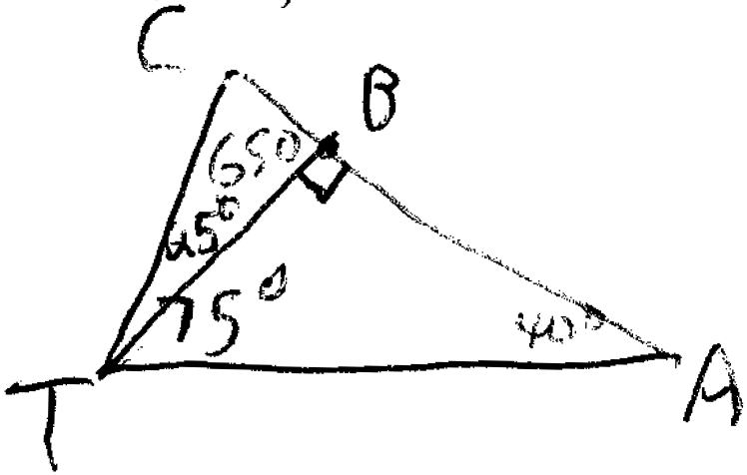

REF: 081422ge

14 ANS: 2 REF: 081306ge

15 ANS: 4
Longest side of a triangle is opposite the largest angle. Shortest side is opposite the smallest angle.

REF: 081011ge

16 ANS: 1 REF: 061010ge

17 ANS: 2 REF: 011510ge

18 ANS:
. and . is the longest side as it is opposite the largest angle.

REF: 080934ge

19 ANS:
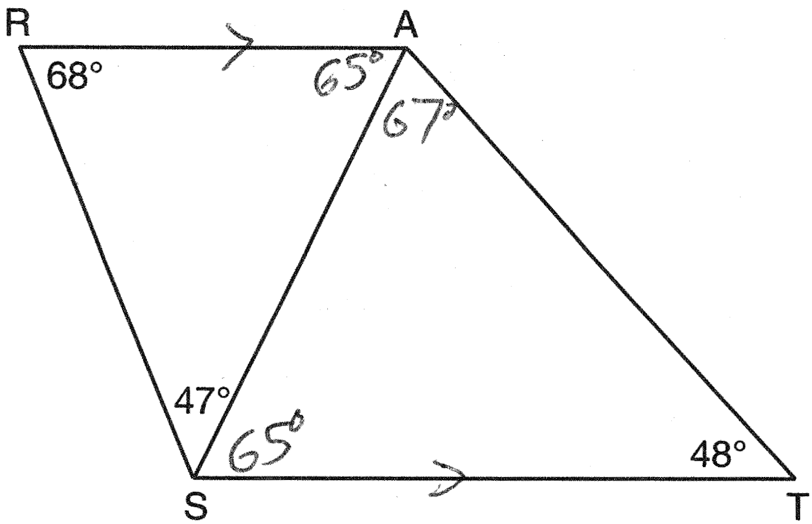

REF: 061430ge

20 ANS:
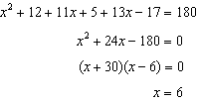. 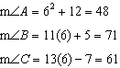. is the largest angle, so in the longest side.

REF: 011337ge

