1 Which statement is sufficient evidence that is congruent to ?

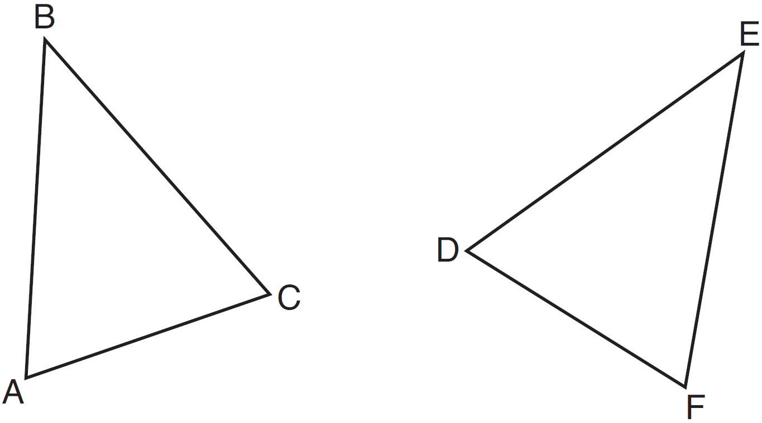
1) | and
2) | , ,
3) | There is a sequence of rigid motions that maps onto , onto , and onto .
4) | There is a sequence of rigid motions that maps point A onto point D, onto , and onto .

2 Triangles JOE and SAM are drawn such that and . Which mapping would not always lead to ?
1) | maps onto
2) | maps onto
3) | maps onto
4) | maps onto

3 In the two distinct acute triangles ABC and DEF, Triangles ABC and DEF are congruent when there is a sequence of rigid motions that maps
1) | onto , and onto
2) | onto , and onto
3) | onto , and onto
4) | point A onto point D, and onto

4 Triangles YEG and POM are two distinct non-right triangles such that . Which statement is sufficient to prove is always congruent to ?
1) | and
2) | and
3) | There is a sequence of rigid motions that maps onto and onto .
4) | There is a sequence of rigid motions that maps point Y onto point P and onto .

5 In the diagram below, right triangle PQR is transformed by a sequence of rigid motions that maps it onto right triangle NML.

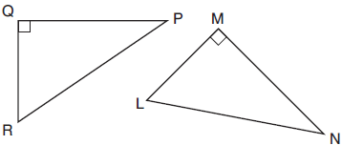

Write a set of three congruency statements that would show ASA congruency for these triangles.

6 Given right triangles ABC and DEF where and are right angles, and . Describe a precise sequence of rigid motions which would show .

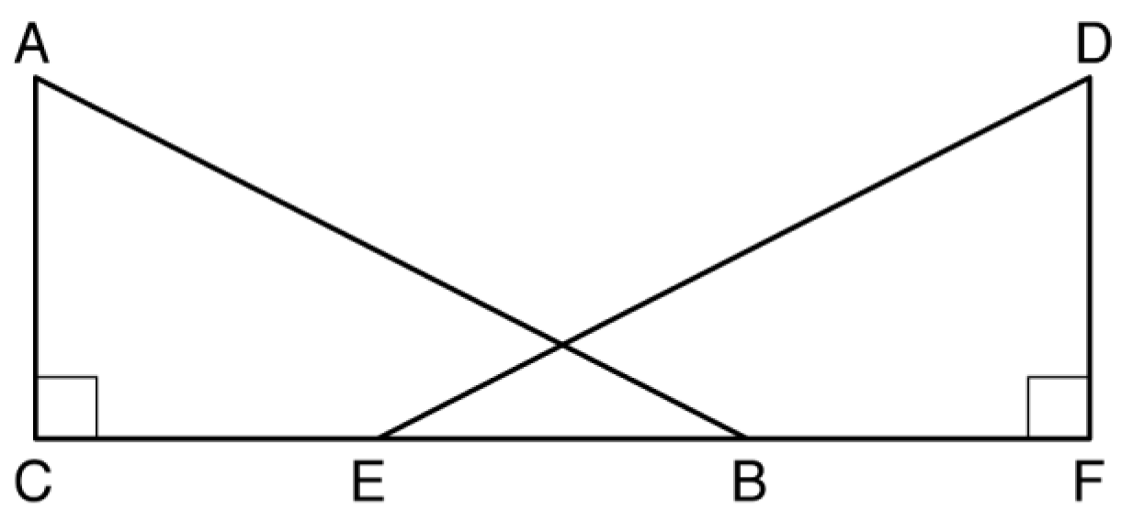

7 In the diagram below, and are graphed.

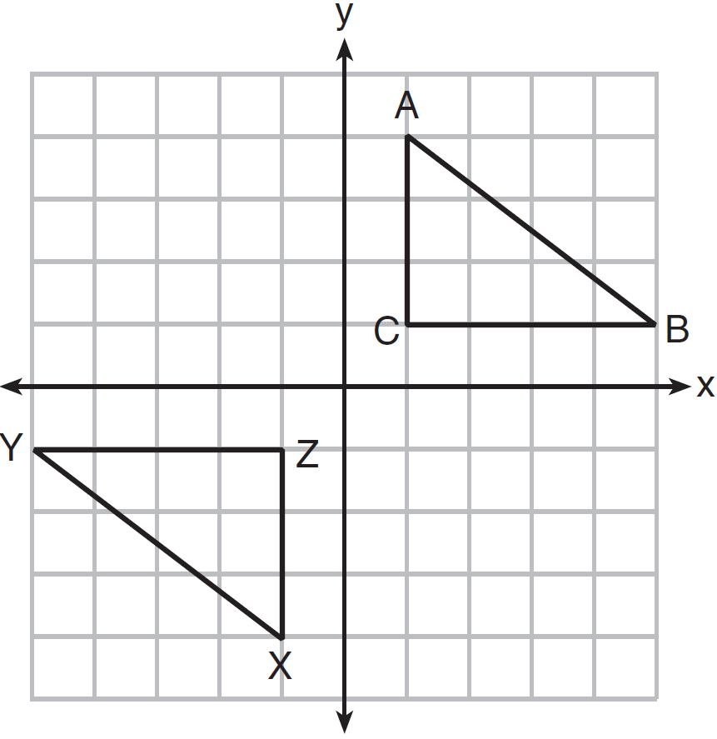

Use the properties of rigid motions to explain why .

8 As graphed on the set of axes below, is the image of after a sequence of transformations.

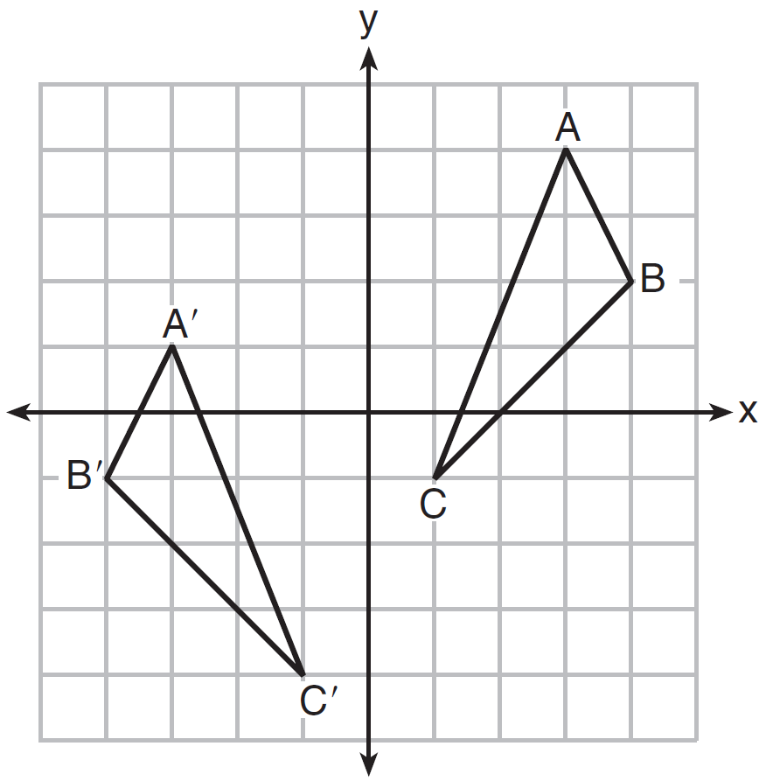

Is congruent to ? Use the properties of rigid motion to explain your answer.

9 In the diagram below, and points A, C, D, and F are collinear on line .

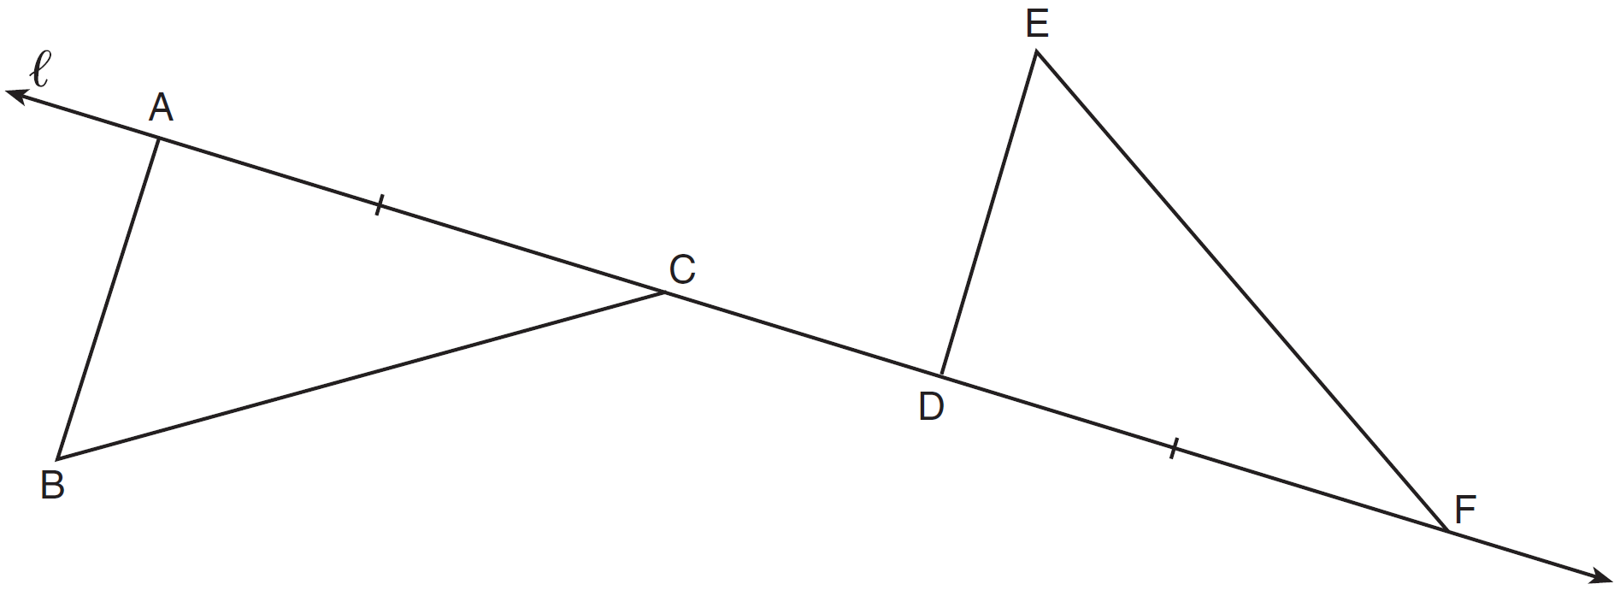

Let be the image of after a translation along , such that point D is mapped onto point A. Determine and state the location of F'. Explain your answer. Let be the image of after a reflection across line . Suppose that E" is located at B. Is congruent to ? Explain your answer.

10 Given: D is the image of A after a reflection over .
is the perpendicular bisector of
and are drawn
Prove:

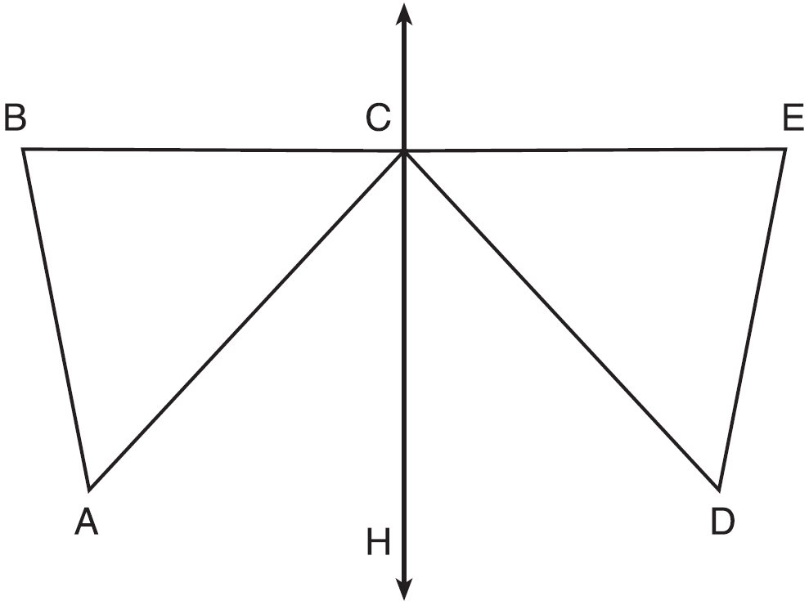

11 After a reflection over a line, is the image of . Explain why triangle ABC is congruent to triangle .

12 In the diagram below of and , a sequence of rigid motions maps onto ,
onto , and onto .

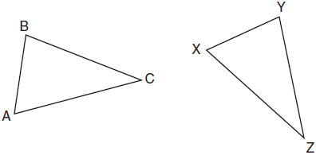

Determine and state whether . Explain why.

13 In the graph below, has coordinates , , and , and has coordinates , , and .

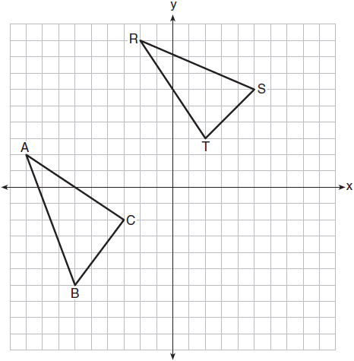

Is congruent to ? Use the properties of rigid motions to explain your reasoning.
1 ANS: 3 REF: 061524geo

2 ANS: 4
d) is SSA

REF: 061914geo

3 ANS: 3
NYSED has stated that all students should be awarded credit regardless of their answer to this question.

REF: 061722geo

4 ANS: 3
(3) is AAS, which proves congruency. (1) is AAA, (2) is SSA and (4) is AS.

REF: 012422geo

5 ANS:

REF: 012025geo

6 ANS:
Translate along such that point C maps onto point F, resulting in image . Then reflect over such that maps onto .
or
Reflect over the perpendicular bisector of such that maps onto .

REF: fall1408geo

7 ANS:
The transformation is a rotation, which is a rigid motion.

REF: 081530geo

8 ANS:
Yes. The sequence of transformations consists of a reflection and a translation, which are isometries which preserve distance and congruency.

REF: 011628geo

9 ANS:
Translations preserve distance. If point D is mapped onto point A, point F would map onto point C. as and points are collinear on line and a reflection preserves distance.

REF: 081534geo

10 ANS:
It is given that point D is the image of point A after a reflection in line CH. It is given that is the perpendicular bisector of at point C. Since a bisector divides a segment into two congruent segments at its midpoint, . Point E is the image of point B after a reflection over the line CH, since points B and E are equidistant from point C and it is given that is perpendicular to . Point C is on , and therefore, point C maps to itself after the reflection over . Since all three vertices of triangle ABC map to all three vertices of triangle DEC under the same line reflection, then because a line reflection is a rigid motion and triangles are congruent when one can be mapped onto the other using a sequence of rigid motions.

REF: spr1414geo

11 ANS:
Reflections are rigid motions that preserve distance.

REF: 061530geo

12 ANS:
Yes. , , after a sequence of rigid motions which preserve distance and angle measure, so by ASA. by CPCTC.

REF: 081730geo

13 ANS:
No. Since and are not congruent, the two triangles are not congruent. Since rigid motions preserve distance, there is no rigid motion that maps onto .

REF: 011830geo

