1 Which expression best describes the transformation shown in the diagram below?

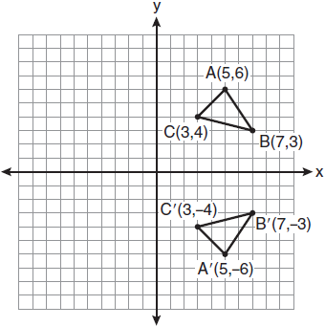
1) | same orientation; reflection
2) | opposite orientation; reflection
3) | same orientation; translation
4) | opposite orientation; translation

2 Right triangle ABC is shown in the graph below.

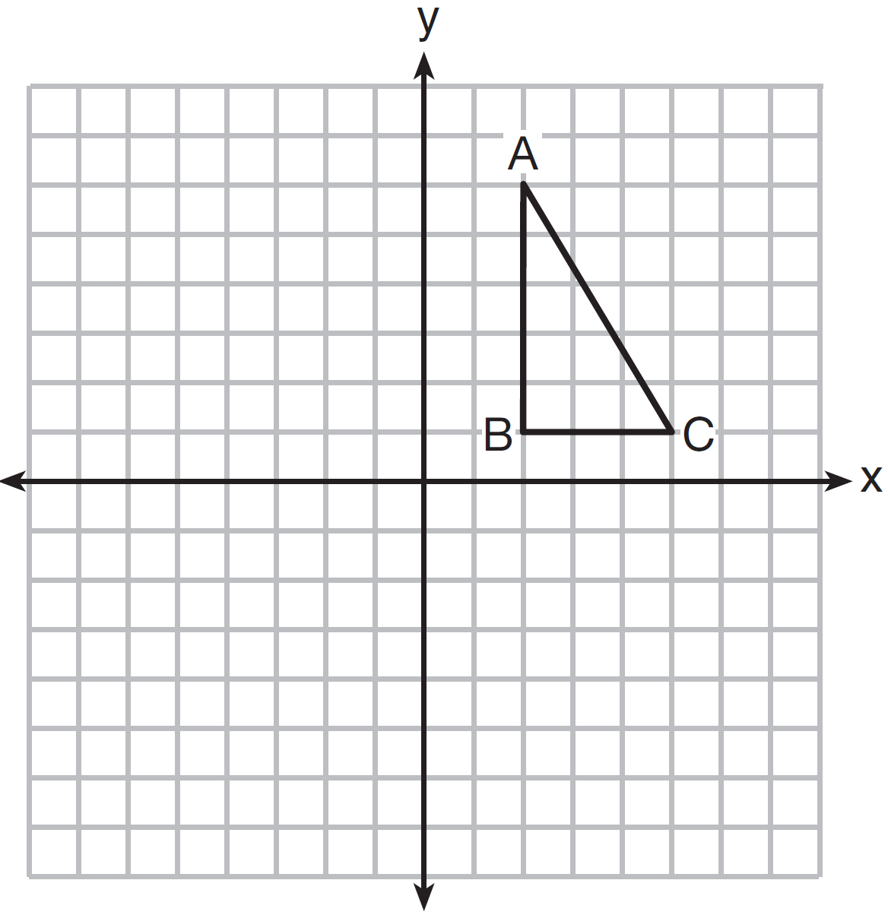

After a reflection over the y-axis, the image of is . Which statement is not true?
1)
2)
3)
4)

3 As shown in the diagram below, when right triangle DAB is reflected over the x-axis, its image is triangle DCB.

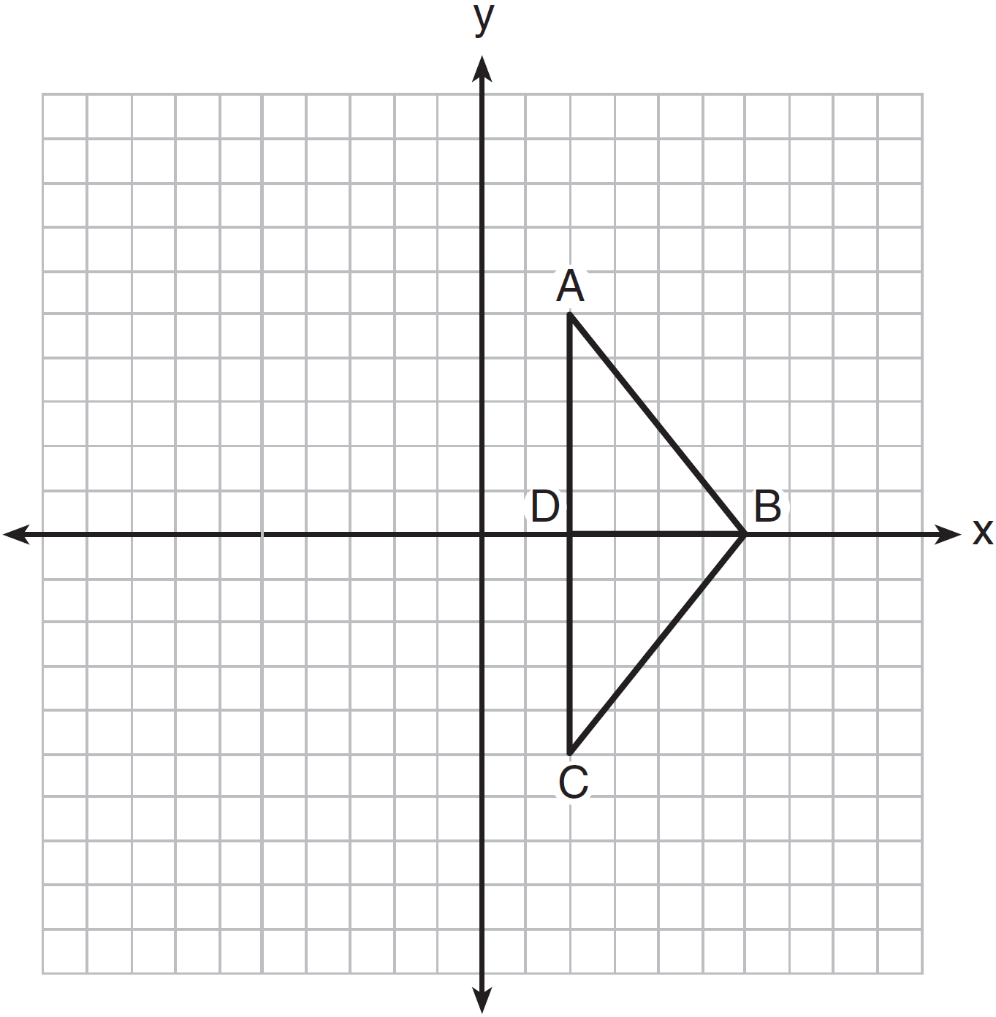

Which statement justifies why ?
1) | Distance is preserved under reflection.
2) | Orientation is preserved under reflection.
3) | Points on the line of reflection remain invariant.
4) | Right angles remain congruent under reflection.

4 The rectangle ABCD shown in the diagram below will be reflected across the x-axis.

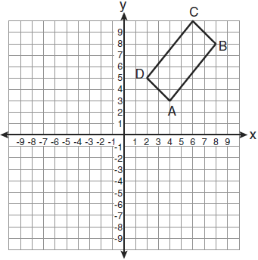

What will not be preserved?
1) | slope of
2) | parallelism of and
3) | length of
4) | measure of

5 As shown in the diagram below, when hexagon ABCDEF is reflected over line m, the image is hexagon A'B'C'D'E'F'.

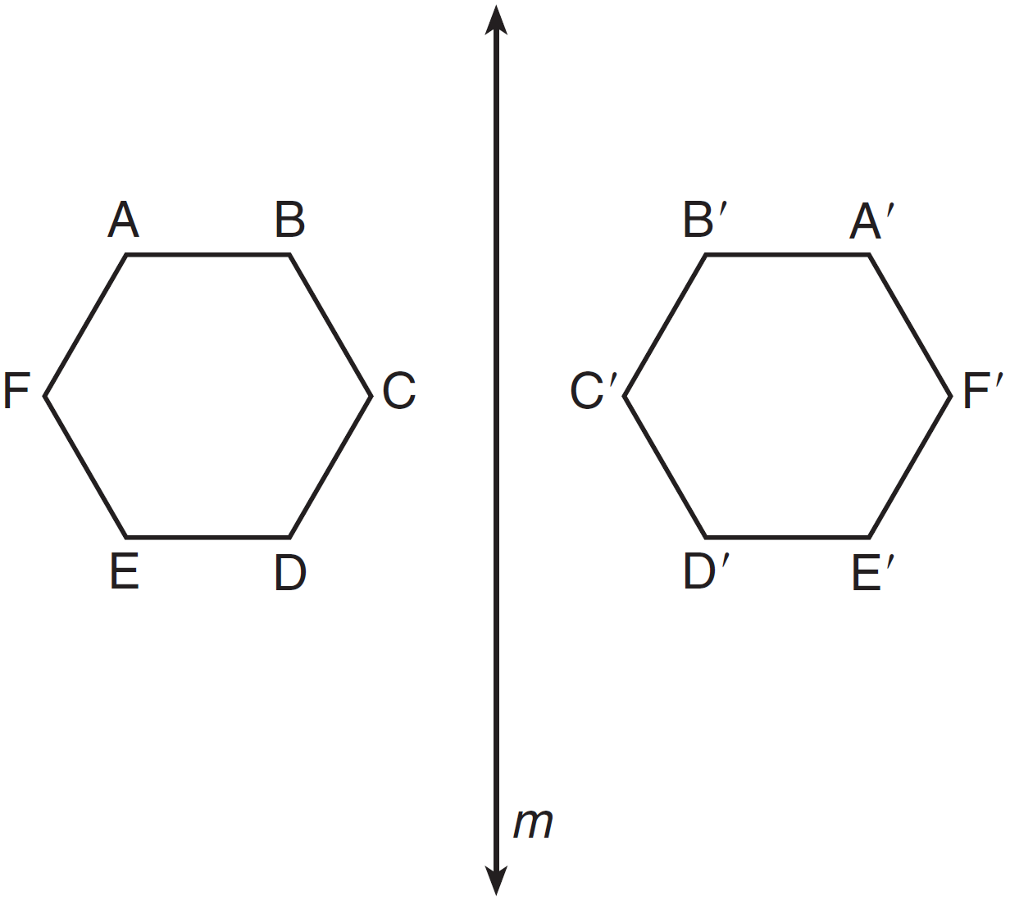

Under this transformation, which property is not preserved?
1) | area
2) | distance
3) | orientation
4) | angle measure

6 Which property is not preserved by a glide reflection?
1) | betweenness
2) | angle measure
3) | orientation
4) | collinearity

7 The image of after the transformation is . Which property is not preserved?
1) | distance
2) | orientation
3) | collinearity
4) | angle measure

8 A property not preserved under a line reflection is
1) | angle measure
2) | collinearity
3) | distance
4) | orientation

9 A line reflection preserves
1) | distance and orientation
2) | angle measurement and orientation
3) | distance, but not angle measurement
4) | distance and angle measurement

10 When a quadrilateral is reflected over the line , which geometric relationship is not preserved?
1) | congruence
2) | orientation
3) | parallelism
4) | perpendicularity

11 If is the image of after the transformation , which statement is false?
1)
2)
3)
4)

12 Triangle ABC has the coordinates , , and . If is reflected over the line , which statement is true about the image of ?
1) | One point remains fixed.
2) | The size of the triangle changes.
3) | The orientation does not change.
4) | One side of is parallel to the line .

13 Triangle ABC has the coordinates , , and . Triangle ABC is rotated 180° about the origin to form triangle . Triangle is
1) | acute
2) | isosceles
3) | obtuse
4) | right

14 Quadrilateral MNOP is a trapezoid with . If is the image of MNOP after a reflection over the x-axis, which two sides of quadrilateral are parallel?
1) | and
2) | and
3) | and
4) | and

15 The vertices of parallelogram ABCD are , , , and . If ABCD is reflected over the x-axis, how many vertices remain invariant?
1) | 1
2) | 2
3) | 3
4) | 0

16 The image of rhombus VWXY preserves which properties under the transformation ?
1) | parallelism, only
2) | orientation, only
3) | both parallelism and orientation
4) | neither parallelism nor orientation

17 Pentagon PQRST has parallel to . After a translation of , which line segment is parallel to ?
1)
2)
3)
4)

18 The vertices of are , , and . Identify and graph a transformation of such that its image, , results in .



19 Triangle DEG has the coordinates , , and . Triangle DEG is rotated 90° about the origin to form . On the grid below, graph and label and . State the coordinates of the vertices D', E', and G'. Justify that this transformation preserves distance.



20 Triangle ABC has coordinates , , and . Triangle is the image of under . On the set of axes below, graph and label and its image, . Determine the relationship between the area of and the area of . Justify your response.

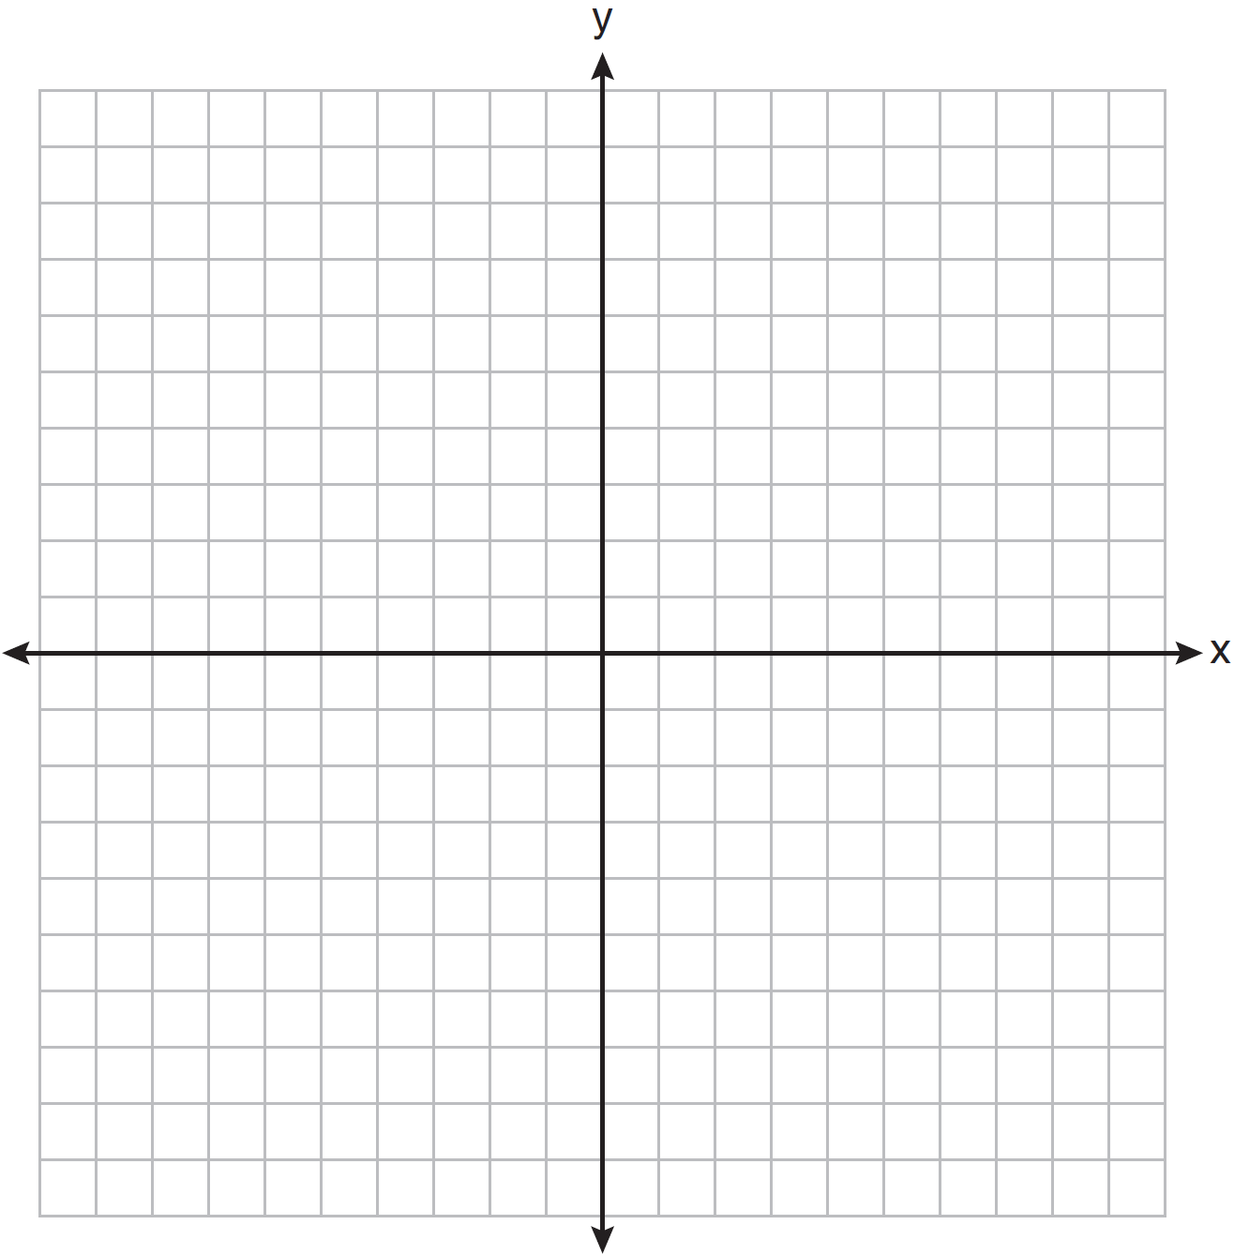

21 In the accompanying diagram of square ABCD, F is the midpoint of , G is the midpoint of , H is the midpoint of , and E is the midpoint of .

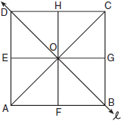

Find the image of after it is reflected in line . Is this isometry direct or opposite? Explain your answer.

22 A pentagon is drawn on the set of axes below. If the pentagon is reflected over the y-axis, determine if this transformation is an isometry. Justify your answer. [The use of the set of axes is optional.]

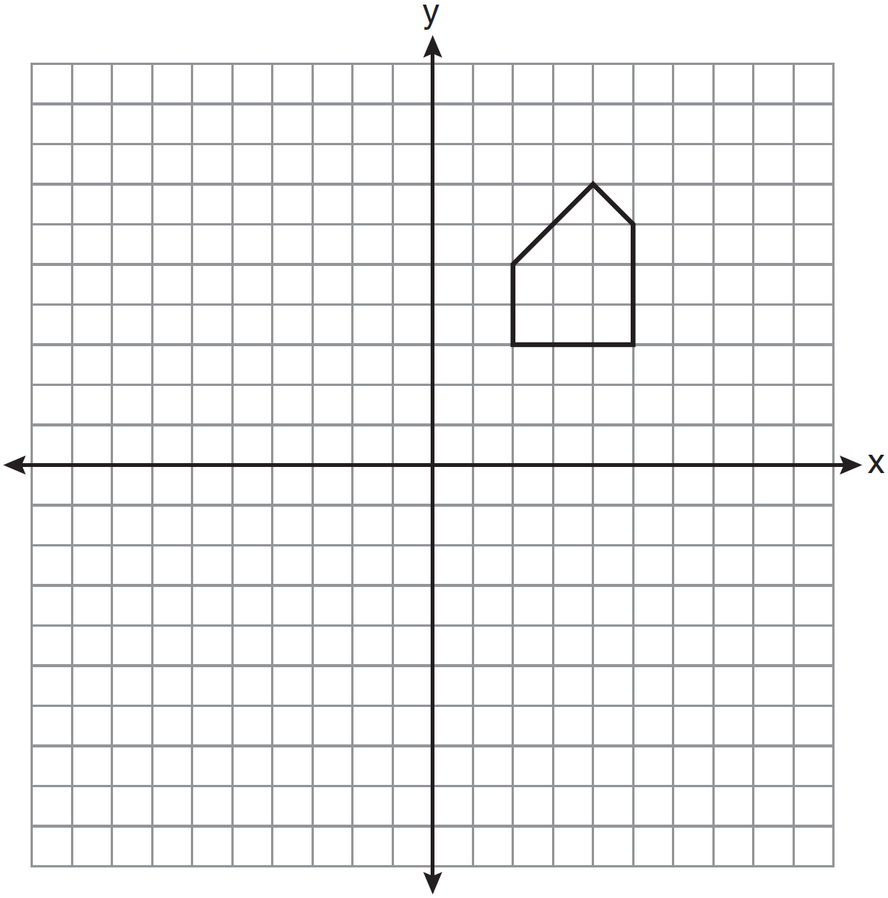

23 After the transformation , the image of is . If and , find the value of x.
1 ANS: 2 REF: 011003ge

2 ANS: 4 REF: 081408ge

3 ANS: 1 REF: 061307ge

4 ANS: 1 REF: 061005ge

5 ANS: 3 REF: 011503ge

6 ANS: 3 REF: 088617siii

7 ANS: 2 REF: 081515ge

8 ANS: 4 REF: 068030siii

9 ANS: 4 REF: 088421siii

10 ANS: 2 REF: 011211ge

11 ANS: 2 REF: 061509ge

12 ANS: 1
remains fixed after the reflection.

REF: 011622ge

13 ANS: 4
Distance is preserved after a rotation.

REF: 081304ge

14 ANS: 1 REF: 011102ge

15 ANS: 2 REF: 081202ge

16 ANS: 3 REF: 061421ge

17 ANS: 3 REF: 081104ge

18 ANS:
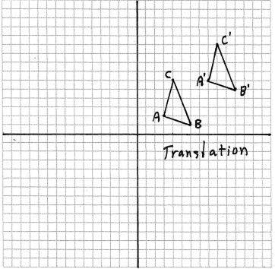

REF: fall0830ge

19 ANS:
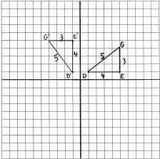 , ,

REF: 080937ge

20 ANS:
. The areas are equal because translations preserve distance. 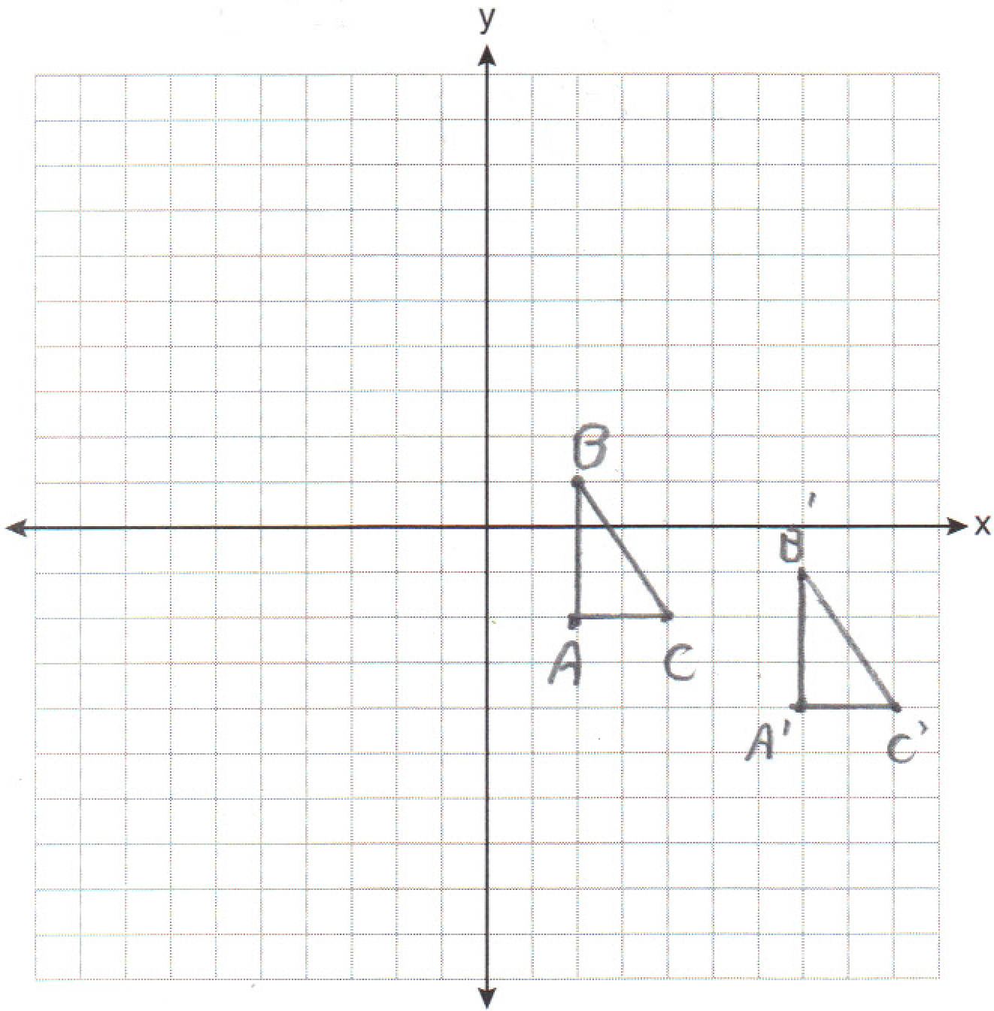

REF: 011235ge

21 ANS:
. This reflection is an opposite isometry because the orientation of is different from .

REF: 060424b

22 ANS:
Yes. A reflection is an isometry.

REF: 061132ge

23 ANS:
Distance is preserved after the reflection. 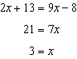

REF: 011329ge

