1 What is the image of the point under the translation ?
1)
2)
3)
4)

2 When the transformation is performed on point A, its image is point . What are the coordinates of A?
1)
2)
3)
4)

3 A translation moves to . What are the coordinates of the image of point under the same translation?
1)
2)
3)
4)

4 The image of point under translation T is . What is the image of point under the same translation?
1)
2)
3)
4)

5 The image of the origin under a certain translation is the point . The image of point under the same translation is the point
1)
2)
3) | 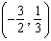
4)

6 Triangle ABC has vertices , , and . Under a translation, , the image point of A, is located at . Under this same translation, point is located at
1)
2)
3)
4)

7 The image of under a translation is . Under this translation, maps onto . Using this translation, the coordinates of image are . Determine and state the coordinates of point A.

8 A design was constructed by using two rectangles ABDC and . Rectangle is the result of a translation of rectangle ABDC. The table of translations is shown below. Find the coordinates of points B and .

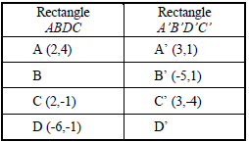
1 ANS: 3

REF: 011107ge

2 ANS: 2 REF: 011617ge

3 ANS: 1

REF: 060309a

4 ANS: 4

REF: 010614a

5 ANS: 4

REF: 080508b

6 ANS: 1

REF: fall0803ge

7 ANS:

REF: 081431ge

8 ANS:
.

REF: spring9823a

