1 Which geometric figure has one and only one line of symmetry?
1) 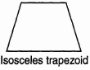 2) 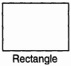 3) 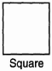 4) 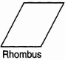

2 Which geometric shape does not have any lines of symmetry?
1) 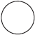 2) 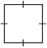 3) 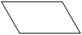 4) 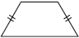

3 Which diagram shows a dotted line that is not a line of symmetry?
1) 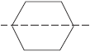 2) 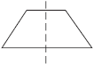 3) 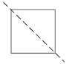 4) 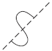

4 How many lines of symmetry does the accompanying figure have?

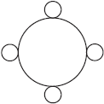
1) an infinite number 2) 2 3) 8 4) 4

5 Which graph is symmetric with respect to the y-axis?
1) 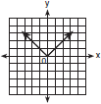 2) 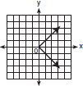 3) 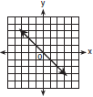 4) 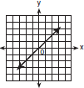

6 Helen is using a capital H in an art design. The H has
1) only one line of symmetry 2) only two points of symmetry 3) two lines of symmetry and only one point of symmetry 4) two lines of symmetry and two points of symmetry

7 Which letter has point symmetry?
1) A 2) B 3) H 4) W

8 Which letter has both point and line symmetry?
1) Z 2) T 3) C 4) H

9 Which letter has both line and point symmetry?
1) B 2) T 3) S 4) H

10 Which letter below has point symmetry, but does not have line symmetry?
1) H 2) N 3) A 4) E

11 Which letter has point symmetry but not line symmetry?
1) H 2) S 3) T 4) X

12 Which letter demonstrates line symmetry but not point symmetry?
1) T 2) N 3) H 4) S

13 Which shape does not have rotational symmetry?
1) trapezoid 2) regular pentagon 3) circle 4) square

14 On the accompanying square, draw all the lines of symmetry.

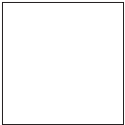

15 Draw all the symmetry lines on the accompanying figure.

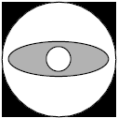
1 ANS: 1 REF: 060002a

2 ANS: 3 REF: 080709a

3 ANS: 4 REF: 080401a

4 ANS: 4 REF: 060817a

5 ANS: 1 REF: 010411a

6 ANS: 3 REF: 010110a

7 ANS: 3 REF: 060209a

8 ANS: 4 REF: 060701a

9 ANS: 4 REF: 080802a

10 ANS: 2 REF: 080106a

11 ANS: 2 REF: 010510a

12 ANS: 1 REF: 080519a

13 ANS: 1 REF: 060304a

14 ANS:
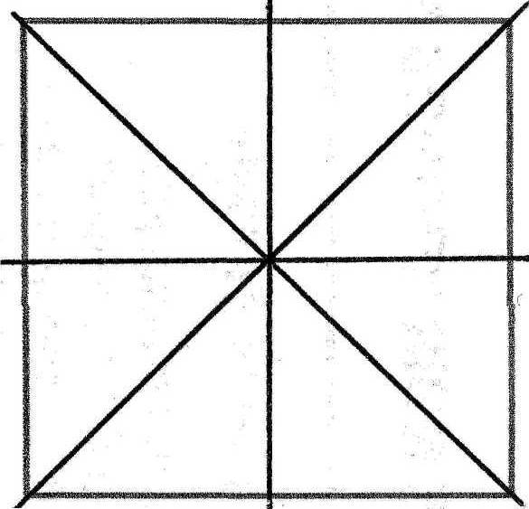

REF: 060635a

15 ANS:
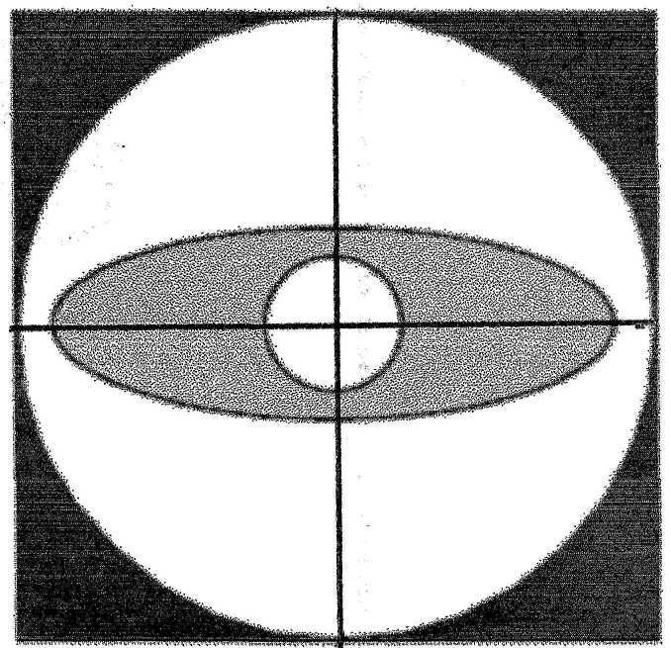

REF: 069921a

